__________________

**Q.1) WRITE A C++ PROGRAM TO PRINT HELLO WORLD.**

**CODE :**

#include <iostream.h>

#include <conio.h>

void main()

{

clrscr();

cout<<"Hello World"<<endl;

getch();

}

**OUTPUT :**

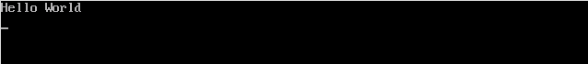

**___________________________________________________________________________________________________________________________________________**

**Q.2) WRITE A PROGRAM TO PRINT VALUES OF INT, DOUBLE AND CHAR DATA TYPES.**

**CODE :**

#include <iostream.h>

#include <conio.h>

void main()

{

clrscr();

int a = 5;

double b = 24.446;

char c = 'W';

cout<<a<<endl<<b<<endl;

cout<<"Your character is a "<<c;

getch();

}

**OUTPUT :**

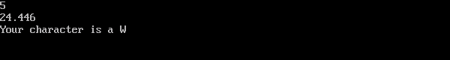

**Q.3) WRITE A PROGRAM TO DATA VALUES FROM USER AND PRINT THEM.**

**CODE :**

#include <iostream.h>

#include <conio.h>

void main()

{

clrscr();

int num;

char chr;

cout<<"Enter a number"<<endl;

cin>>num;

cout<<"Enter a character"<<endl;

cin>>chr;

cout<<"Your number is "<<num<<endl;

cout<<"Your character is "<<chr<<endl;

getch();

}

**OUTPUT :**

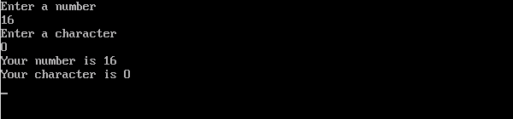

**Q.4) WRITE A PROGRAM TO FIND THE GREATER OF 2 NUMBERS.**

**CODE :**

#include <iostream.h>

#include <conio.h>

void main()

{

clrscr();

int a, b;

cout<<"Enter two numbers"<<endl;

cin>>a>>b;

if(a>b)

{

cout<<a<<" is greater"<<endl;

}

else

{

cout<<b<<" is greater"<<endl;;

}

getch();

}

**OUTPUT :**

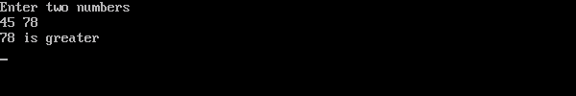

**Q.5) WRITE A PROGRAM TO FIND THE GREATER OF 3 NUMBERS.**

**CODE :**

#include <iostream.h>

#include <conio.h>

void main()

{

clrscr();

int a, b, c;

cout<<"Enter any three integers"<<endl;

cin>>a>>b>>c;

if(a>=b && a>=c)

{

cout<<a<<" is largest"<<endl;

}

else if (b>=a && b>=c)

{

cout<<b<<" is largest"<<endl;

}

else

{

cout<<c<<" is largest"<<endl;

}

getch();

}

**OUTPUT :**

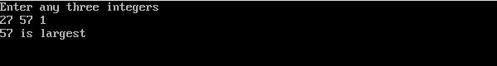

**Q.6) PRINT THE MULTIPLICATION TABLE OF A NUMBER WITH USER INPUT.**

**CODE :**

#include <iostream.h>

#include <conio.h>

void main()

{

clrscr();

int a;

cout<<"Enter a number you like"<<endl;

cin>>a;

for(int i=1; i<11; i++)

{

cout<<a*i<<endl;

}

getch();

}

**OUTPUT :**

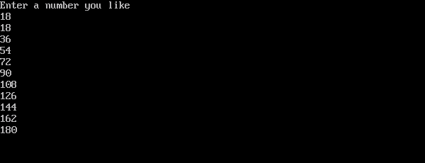

**_______________________________________________________________________________________________________________________________________________________________________________________________________________________________________________________________________________________________________________________________________________________________________________________________________________________________________________________________________**

**Q.7) WRITE A C++ PROGRAM TO FIND THE FACTORIAL OF A NUMBER.**

**CODE :**

#include <iostream.h>

#include <conio.h>

void main()

{

clrscr();

int a, total=1;

cout<<"Enter a number you like"<<endl;

cin>>a;

for(int i=1; i<=a; i++)

{

total = total*i;

}

cout<<"Factorial is "<<total;

getch();

}

**OUTPUT :**

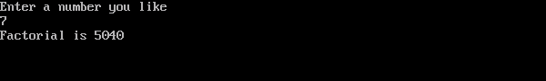

**Q.8) WRITE A C++ PROGRAM TO FIND THE SUM OF N NATURAL NUMBERS.**

**CODE :**

#include <iostream.h>

#include <conio.h>

void main()

{

clrscr();

int a, total=0;

cout<<"Enter a number you like"<<endl;

cin>>a;

for(int i=1; i<=a; i++)

{

total = total + i;

}

cout<<"Sum is : "<<total<<endl;

getch();

}

**OUTPUT :**

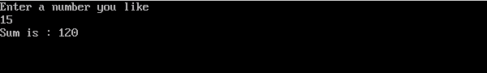

**Q.9)MAKE AN ARITHMATIC CALCULATOR USING C++.**

**CODE :**

#include <iostream.h>

#include <conio.h>

void main()

{

clrscr();

double num1, num2;

char opr;

cout<<"Enter two numbers"<<endl;

cin>>num1>>num2;

cout<<"Select an operator among (+,-,*,/)"<<endl;

cin>>opr;

switch(opr)

{

case '+' : cout<<num1<<" + "<<num2<<" = "<<num1+num2<<endl;

break;

case '-' : cout<<num1<<" - "<<num2<<" = "<<num1-num2<<endl;

break;

case '*' : cout<<num1<<" * "<<num2<<" = "<<num1*num2<<endl;

break;

case '/' : cout<<num1<<" / "<<num2<<" = "<<num1/num2<<endl;

break;

default : cout<<"Select a valid operator plz"<<endl;

}

getch();

}

**OUTPUT :**

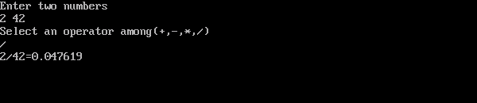

**Q.10) PRINT A MULTIPLICATION TABLE USING DO-WHILE LOOP.**

**CODE :**

#include <iostream.h>

#include <conio.h>

void main()

{

clrscr();

int a, n=1;

cout<<"Enter a number you like"<<endl;

cin>>a;

do

{

cout<<a*n<<endl;

n++;

} while(n<11);

getch();

}

**OUTPUT :**

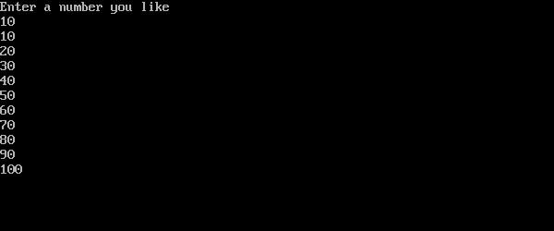

**Q.11) GIVEN AN INGETER U DENOTING THE AMOUNT OF KWh UNITS OF ELECTRICITTY CONSUMED, CALCULATE THE AMOUNT OF BILL WITH THE HELP OF BELOW CHARGES :**

**BELOW 100 UNITS - ₹10/UNIT**

**100 - 200 UNITS - ₹15/UNIT**

**200 - 300 UNITS - ₹20/UNIT**

**ABOVE 300 UNITS - ₹25/UNIT**

**CODE :**

#include <iostream.h>

#include <conio.h>

void main()

{

clrscr();

int u, amt;

cout<<"Enter the units of electricity consumed by you"<<endl;

cin>>u;

if( (u>0) && (u<=100) )

{

amt = u*10;

cout<<"Your bill total is : "<<amt<<endl;

}

else if(u<=200)

{

amt = (100*10) + (u-100) * 15;

cout<<"Your bill total is : "<<amt<<endl;

}

else if(u<=300)

{

amt = (100*10) + (100*15) + (u-200) * 20;

cout<<"Your bill total is : "<<amt<<endl;

}

else if(u>300)

{

amt = (100*10) + (100*15) + (100*20) + (u-300) * 25;

cout<<"Your bill total is : "<<amt<<endl;

}

else

{

cout<<"Your input was invalid"<<endl;

}

getch();

}

**OUTPUT :**

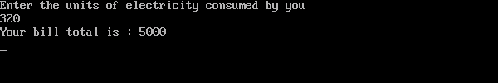

**Q.12) REWRITE THE PROGRAM OF ARITHMATIC CALCULATOR MAKING USE OF FUNCTIONS.**

**CODE :**

#include <iostream.h>

#include <conio.h>

double sum(double num1, double num2)

{

return num1+num2;

}

double sub(double num1, double num2)

{

return num1-num2;

}

double mul(double num1, double num2)

{

return num1*num2;

}

double div(double num1, double num2)

{

return num1/num2;

}

void main()

{

clrscr();

double num1, num2;

cout<<"Enter two numbers"<<endl;

cin>>num1>>num2;

char opr;

cout<<"Select an operator amongst(+,-,*,/)"<<endl;

cin>>opr;

switch(opr)

{

case '+' : cout<<sum(num1, num2)<<endl;

break;

case '-' : cout<<sub(num1, num2)<<endl;

break;

case '*' : cout<< mul(num1, num2)<<endl;

break;

case '/' : cout<<div(num1, num2)<<endl;

break;

default : cout<<"Select a valid operator plz"<<endl;

}

getch();

}

**OUTPUT :**

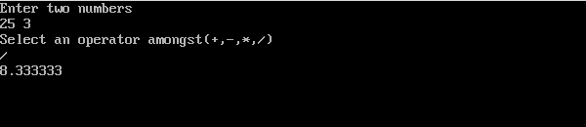

**Q.13) TAKE AN ARRAY AS USER INPUT. PRINT THE ARRAY, IT'S SUM AND AVERAGE.**

**CODE :**

#include <iostream.h>

#include <conio.h>

void main(){

clrscr();

double total=0, avg;

int nm[5];

cout<<"Enter 5 numbers"<<endl;

for(int i=0; i<5; i++)

{

cin>>nm[i];

}

cout<<"The array is : "<<endl;

for(int j=0; j<5; j++)

{

cout<<nm[j]<<endl;

}

for(int k=0; k<5; k++)

{

total = total + nm[k];

}

cout<<"Total of the array is : "<<total<<endl;

avg = total/5;

cout<<"Average of the array is : "<<avg<<endl;

getch();

}

**OUTPUT :**

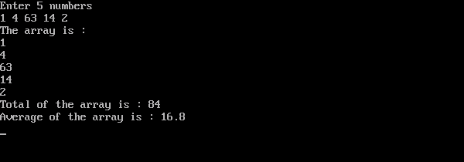

**Q.14) USE CLASS AND FUNCTIONS TO PRINT THE AREA AND PERIMETER OF A ROOM.**

**CODE :**

#include <iostream.h>

#include <conio.h>

class room

{

public :

double l, b;

double area()

{

return l*b;

}

double peri()

{

return 2*l+2*b;

}

};

void main(){

clrscr();

room r1, r2;

r1.l = 5;

r1.b = 34;

cout<<"Area of room 1 is : "<<r1.area()<<endl;

cout<<"Perimeter of room 1 is : "<<r1.peri()<<endl;

cout<<"Enter two numbers"<<endl;

cin>>r2.l>>r2.b;

cout<<"Area of room 2 is : "<<r2.area()<<endl;

cout<<"Perimeter of room 2 is : "<<r2.peri()<<endl;

getch();

}

**OUTPUT :**

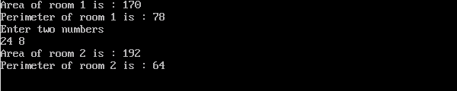

**Q.15) TAKE STUDENTS' NAME, ROLL NO. AND PERCENTAGE AS INPUT AND PRINT IT. MAKE USE OF CLASSES.**

**CODE :**

#include <iostream.h>

#include <conio.h>

class student

{

public :

int roll;

double per;

char name[];

void getdata()

{

cout<<"Enter your roll no"<<endl;

cin>>roll;

cout<<"Enter your name"<<endl;

cin>>name;

cout<<"Enter your percentage"<<endl;

cin>>per;

}

void display()

{

cout<<"Your name is "<<name<<endl;

cout<<"Your roll no is "<<roll<<endl;

cout<<"Your percentage is "<<per<<endl;

}

};

void main()

{

clrscr();

student st1, st2;

st1.getdata();

st1.display();

st2.getdata();

st2.display();

getch();

}

**OUTPUT :**

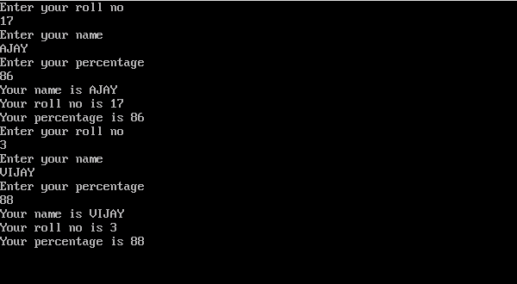

**Q.16) CREATE A WALL WITH IT'S LENGTH AND HEIGHT DIMENSIONS. KEEP THE DIMENSIONS PRIVATE AND ACCESS THEM USING DIFFERENT TYPES OF CONSTRUCTORS.**

**CODE :**

#include <iostream.h>

#include <conio.h>

class wall

{

double l, b;

public :

wall()

{

l = 10;

b = 12;

}

wall(double len, double bre)

{

l = len;

b = bre;

}

wall(wall &copy)

{

l = copy.l;

b = copy.b;

}

double area()

{

return l*b;

}

double peri()

{

return 2*l+2*b;

}

};

void main()

{

clrscr();

wall w1, w2(5, 9);

wall w3 = w2;

cout<<"Area of wall 1 is : "<<w1.area()<<endl;

cout<<"Perimeter of wall 1 is : "<<w1.area()<<endl<<endl;

cout<<"Area of wall 2 is : "<<w2.area()<<endl;

cout<<"Perimeter of wall 2 is : "<<w2.peri()<<endl<<endl;

cout<<"Wall 3 has the same variables as wall 2"<<endl;

cout<<"Area of wall 3 is : "<<w3.area()<<endl;

cout<<"Perimeter of wall 3 is : "<<w3.peri()<<endl;

getch();

}

**OUTPUT :**

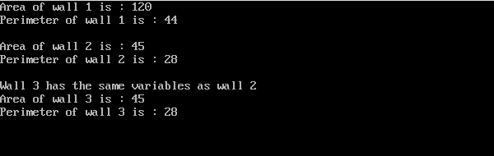

**Q. 17) WRITE A PROGRAM IN C++ TO SWAP 2 NUMBERS USING CALL BY VALUE**

**CODE :**

#include <iostream.h>

#include <conio.h>

void swap(int a, int b)

{

int temp = a;

a = b;

b = temp;

cout<<"Inside function"<<endl;

cout<<a<<endl<<b<<endl;

}

void main()

{

clrscr();

int a=1, b=2;

cout<<"Before swap"<<endl;

cout<<a<<endl<<b<<endl;

swap(a ,b);

cout<<"In main again"<<endl;

cout<<a<<endl<<b<<endl;

getch();

}

**OUTPUT :**

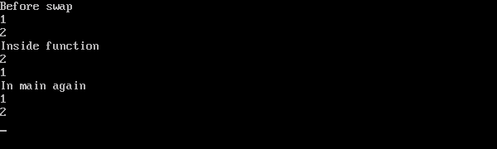

**Q. 18) WRITE A PROGRAM IN C++ TO SWAP 2 NUMBERS USING CALL BY REFERENCE.**

**CODE :**

#include <iostream.h>

#include <conio.h>

void swap(int& a, int& b)

{

int temp = a;

a = b;

b = temp;

cout<<"Inside function"<<endl;

cout<<a<<endl<<b<<endl;

}

void main()

{

clrscr();

int a=1, b=2;

cout<<"Before swap"<<endl;

cout<<a<<endl<<b<<endl;

swap(a ,b);

cout<<"In main again"<<endl;

cout<<a<<endl<<b<<endl;

getch();

}

**OUTPUT :**

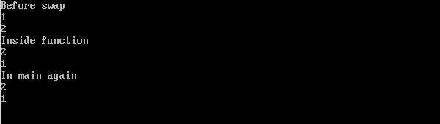

**Q.19) WRITE A PROGRAM TO FIND THE FACTORIAL OF A NUMBER USING RECURSION.**

**CODE :**

#include <iostream.h>

#include <conio.h>

int fact(double i)

{

if(i<1)

{

return 1;

}

return i * fact(i-1);

}

void main()

{

clrscr();

double i;

cout<<"Enter a positive integer"<<endl;

cin>>i;

cout<<"Factorial is : "<<fact(i)<<endl;

getch();

}

**OUTPUT :**

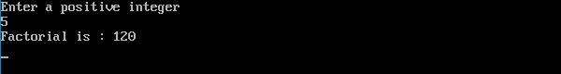

**Q. 20) WRITE A PROGRAM TO DEMONSTRATE THE USE OF SINGLE INHERITANCE.**

**CODE :**

#include <iostream.h>

#include <conio.h>

class A

{

int a,b;

public :

A()

{

a = 4;

b = 5;

}

int mul()

{

return a*b;

}

};

class B : public A

{

public :

void display()

{

cout<<"Product of a and b is : "<<mul()<<endl;

}

};

void main()

{

clrscr();

B b;

b.display();

getch();

}

**OUTPUT :**



**Q.21) WRITE A PROGRAM TO DEMONSTRATE THE USE OF MULTILEVEL INHERITANCE.**

**CODE :**

#include <iostream.h>

#include <conio.h>

class Animal

{

public :

void eat()

{

cout<<"Eating..."<<endl;

}

};

class Dog : public Animal

{

public :

void bark()

{

cout<<"Barking..."<<endl;

}

};

class Babydog : public Dog

{

public :

void weep()

{

cout<<"Weeping..."<<endl;

}

};

void main()

{

clrscr();

Babydog b1;

b1.eat();

b1.bark();

b1.weep();

getch();

}

**OUTPUT :**

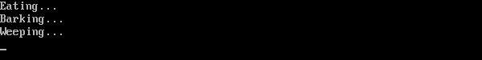

**Q.22) WRITE A PROGRAM TO DEMONSTRATE THE USE OF HIERARCHICAL INHERITANCE.**

**CODE :**

#include <iostream.h>

#include <conio.h>

class Shape

{

public :

float a, b;

void getdata(float n, float m)

{

a = n;

b = m;

}

};

class Rectangle : public Shape

{

public :

float rarea()

{

return a*b;

}

};

class Triangle : public Shape

{

public :

float tarea()

{

return 0.5*a*b;

}

};

void main()

{

clrscr();

Rectangle r1;

Triangle t1;

float length, breadth, base, height;

cout<<"Enter the length and breadth of a rectangle"<<endl;

cin>>length>>breadth;

r1.getdata(length, breadth);

cout<<r1.rarea();

cout<<"\nEnter the base and height of a triangle"<<endl;

cin>>base>>height;

t1.getdata(base, height);

cout<<t1.tarea();

getch();

}

**OUTPUT :**

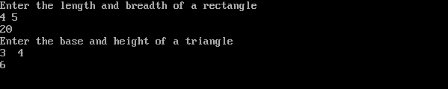

**Q.23) WRITE A PROGRAM TO DEMONSTRATE THE USE OF MULTIPLE INHERITANCE**

**CODE :**

#include <iostream.h>

#include <conio.h>

class A

{

protected :

int a;

public :

void get_a(int n)

{

a = n;

}

};

class B

{

protected :

int b;

public :

void get_b(int m)

{

b = m;

}

};

class C : public A, public B

{

public :

void display()

{

cout<<"The value of a is : "<<a<<endl;

cout<<"The value of b is : "<<b<<endl;

cout<<"The sum of a and b is : "<<a+b<<endl;

}

};

void main()

{

clrscr();

C c1;

c1.get_a(10);

c1.get_b(20);

c1.display();

getch();

}

**OUTPUT :**

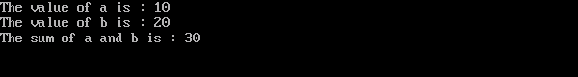

**Q.24) DESIGN A C++ CODE TO OVERLOAD A BINARY OPERATOR(+,-).**

**CODE :**

#include <iostream.h>

#include <conio.h>

class complex_num

{

int x, y;

public :

void input()

{

cout<<"Input two complex numbers"<<endl;

cin>>x>>y;

}

//overloading binary operators + and - .

complex_num operator + (complex_num obj)

{

complex_num A;

A.x = x + obj.x;

A.y = y + obj.y;

return (A);

}

complex_num operator - (complex_num obj)

{

complex_num A;

A.x = x - obj.x;

A.y = y - obj.y;

return (A);

}

void print()

{

cout<<x<<"+"<<y<<"i"<<endl;

}

void print2()

{

cout<<x<<"-"<<y<<"i"<<endl;

}

};

void main()

{

clrscr();

complex_num x1, y1, sum, sub;

x1.input();

y1.input();

sum = x1 + y1;

sub = x1 - y1;

//displaying the complex numbers.

cout<<"\nThe entered values are "<<endl;

x1.print();

y1.print();

cout<<endl;

//displaying the sum and difference of these numbers.

cout<<"The sum of two complex numbers is :"<<endl;

sum.print();

cout<<"The difference of two complex numbers is :"<<endl;

sub.print2();

getch();

}

**OUTPUT :**

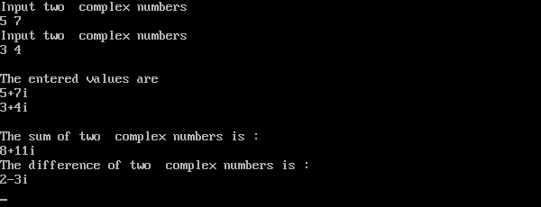

**Q.25)** **WRITE A PROGRAM TO PRINT PYRAMID PATTERN.**

**CODE :**

#include <iostream.h>

#include <conio.h>

void main()

{

clrscr();

int n;

cout<<"Enter the value for row\n";

cin>>n;

for(int i=1; i<=n; i++)

{

for(int j=1; j<=i; j++)

{

cout<<"*";

}

cout<<endl;

}

getch();

}

**OUTPUT :**

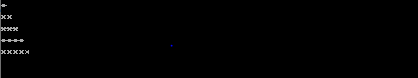

**Q.26)** **DESIGN A C++ PROGRAM TO DEMONSTRATE FRIEND FUNCTION.**

**CODE :**

#include <iostream.h>

#include <conio.h>

class B;

class A

{

int x;

public :

void setdata(int i)

{

x = i;

}

friend void min(A,B);

};

class B

{

int y;

public :

void setdata(int i)

{

y = i;

}

friend void min(A,B);

};

void min(A a, B b)

{

if(a.x >= b.y)

{

cout<<a.x<<" is greater"<<endl;

}

else

{

cout<<b.y<<" is greater"<<endl;

}

}

void main()

{

clrscr();

A a;

B b;

a.setdata(10);

b.setdata(15);

min(a,b);

getch();

}

**OUTPUT :**

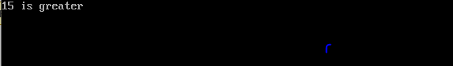

**Q.27)** **IMPLEMENT A CLASS TO SHOW THE USE OF VIRTUAL FUNCTION.**

**CODE :**

#include <iostream.h>

#include <conio.h>

class A

{

public :

virtual void display()

{

cout<<"This is class A\n";

}

};

class B : public A

{

public :

void display()

{

cout<<"This is class B\n";

}

};

void main()

{

clrscr();

A *a;

B b;

a = &b;

a->display();

getch();

}

**OUTPUT :**

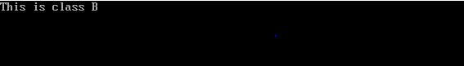

**Q.28)** **SHOW THE IMPLEMENTATION OF ABSTRACT CLASS**

**CODE :**

#include <iostream.h>

#include <conio.h>

class database

{

public :

virtual void show()=0;

};

class manager : public database

{

public :

void show()

{

cout<<"I am the manager\n";

}

};

class accountant : public database

{

public :

void show()

{

cout<<"I am the accountant\n";

}

};

class customer : public database

{

public :

void show()

{

cout<<"I am the customer\n";

}

};

void main()

{

clrscr();

manager m;

accountant a;

customer c;

m.show();

a.show();

c.show();

getch();

}

**OUTPUT :**

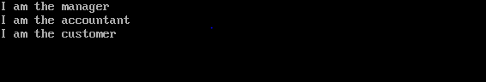

**Q.29)** **SHOW THE IMPLEMENTATION FOR SHOWING FOR EXCEPTION HANDLING**

**CODE :**

#include <iostream>

using namespace std;

int main()

{

double num1, num2;

cout<<"Enter two numbers for numerator and denominator\n";

cin>>num1>>num2;

try

{

if(num2 == 0)

{

throw 0;

}

cout<<num1<<" / "<<num2<<" = "<<num1/num2<<endl;

}

catch(int exc)

{

cout<<"Error : Cannot divide by "<<exc<<endl;

}

return 0;

}

**OUTPUT :**

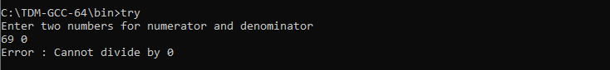

**Q.30) PERFORM VARIOUS STRING FUNCTIONS ON A C++ PROGRAM.**

**CODE :**

#include <iostream>

#include <string>

using namespace std;

int main()

{

string str;

cout<<"Input the string"<<endl;

getline(cin, str);

cout<<"\nString entered is : "<<str;

int len = str.length();

cout<<"\nLength of the string is : "<<len;

string str1 = "SoftwareTestingHelp";

if(str.compare(str1) == 0)

cout<<"\nThe strings are equal\n";

else

cout<<"\nThe strings are not equal\n";

str1.append(".com");

cout<<"\nNew String is : "<<str1;

str.clear();

cout<<"\n\nstr new length : "<<str.length();

return 0;

}

**OUTPUT :**

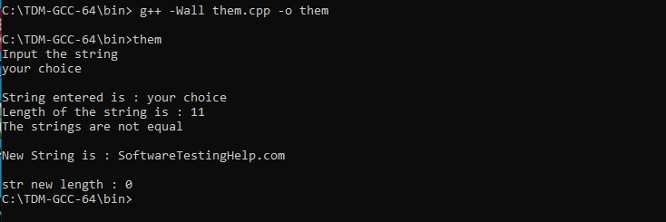

**Q.31) DEMONSTRATE STRING CONCATENATION ON A STRING PROGRAM.**

**CODE :**

#include <iostream>

#include <string>

using namespace std;

int main()

{

string str1 = "Hello";

string str2 = "World";

string str3, str4;

cout<<str1<<" "<<str2<<endl;

str3 = str1;

cout<<"String 3 is : "<<str3<<endl;

str4 = str1 + str2;

cout<<"String 4 is : "<<str4<<endl;

return 0;

}

**OUTPUT :**

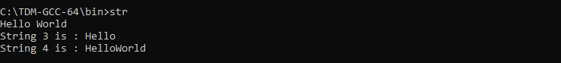

**Q.32) WRITE A C++ PROGRAM TO SHOW THE USE OF STATIC FUNCTION.**

**CODE :**

#include <iostream.h>

#include <conio.h>

class box

{

double l, b, h;

public :

static int count;

box(double len=2.0, double bre=2.0, double hei=2.0)

{

l = len;

b = bre;

h = hei;

count++;

}

double vol()

{

return l*b*h;

}

static int getcount()

{

return count;

}

};

int box::count=0;

void main()

{

clrscr();

cout<<"Initial value of count : "<<box::count<<endl;

box b1(4, 5, 6), b2(8,9,10);

cout<<"Final value of count : "<<box::count;

getch();

}

**OUTPUT :**

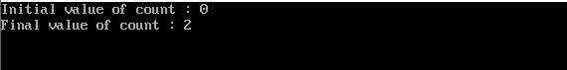

**AQ.33)WRITE A C++ PROGRAM THAT COUNTS THE TOTAL NUMBER OF CHARACTERS, WORDS AND LINES IN THE FILE.**

**CODE :**

#include <iostream>

#include <fstream>

#include <string>

#include <cstdlib>

using namespace std;

int main()

{

int noc=0, now=0, nol=0;

FILE *fr;

char fname[20], ch;

cout<<"\nEnter Source File Name : ";

gets(fname);

fr=fopen(fname,"r");

if(fr==NULL)

{

cout<<"\nInvalid File Name.\n No such File or Directory";

exit(0);

}

ch=fgetc(fr);

while(ch!=EOF)

{

if(ch!=' ' && ch!='\n')

noc++;

if(ch==' ')

now++;

if(ch=='\n')

{

nol++;

now++;

}

ch=fgetc(fr);

}

fclose(fr);

cout<<"--------------------------------------";

cout<<"\nTotal No. of Characters : "<<noc;

cout<<"\nTotal No. of Words : "<<now;

cout<<"\nTotal No. of Lines : "<<nol;

return 0;

}

**OUTPUT :**

