**Day 23: Standalone Components and Routing in Angular**

**What is a Standalone Component in Angular?**

A component that can work independently without being declared inside any NgModule.

**How to define routing in Angular with standalone components?**

By using app.routes.ts and configuring it with RouterModule.forRoot(routes) in app.config.ts.

**What is the purpose of main.ts in this project?**

It bootstraps the app using provideRouter and the app component with routing configuration.

**Is app.module.ts required in this assignment?**

No, because we are using standalone components, so we don’t need app.module.ts.

**Code Screenshot:**

**Main.ts**

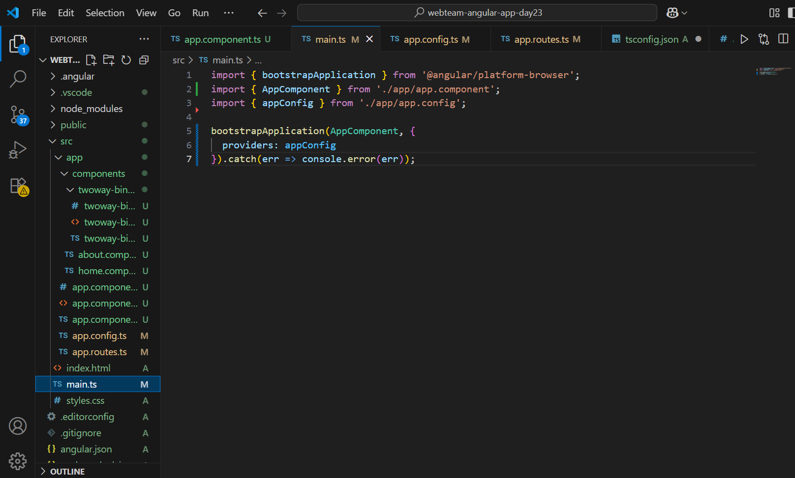

**App.routes.ts:**

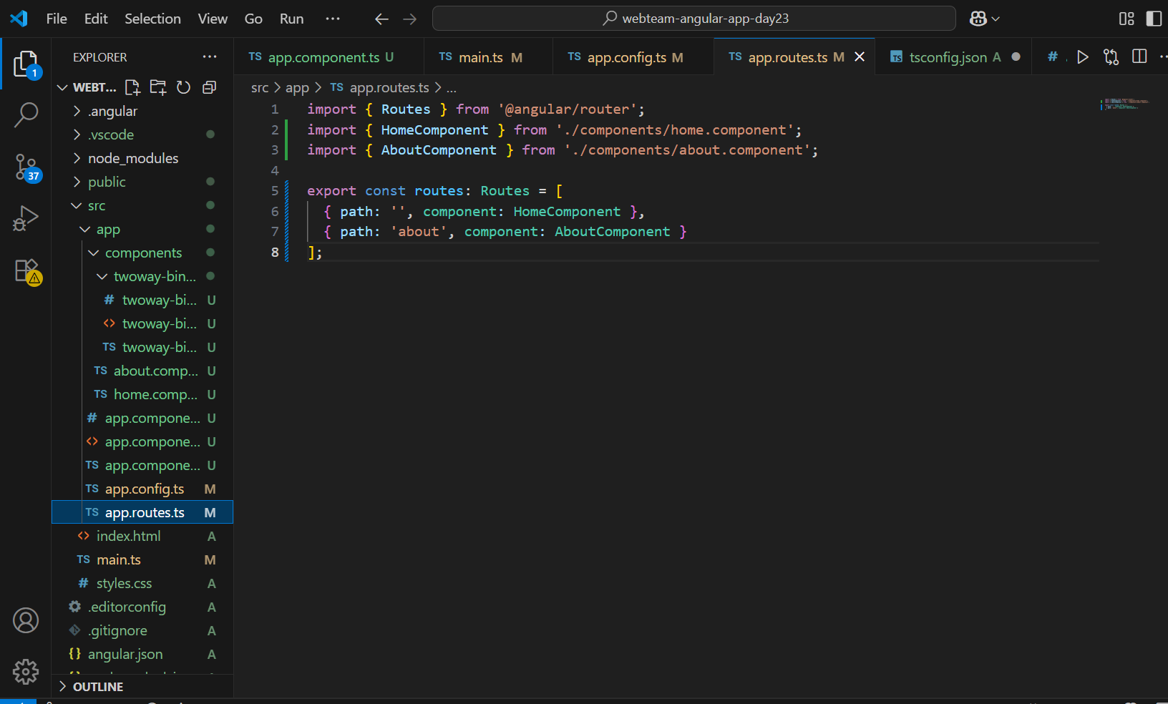

**App.config.ts:**

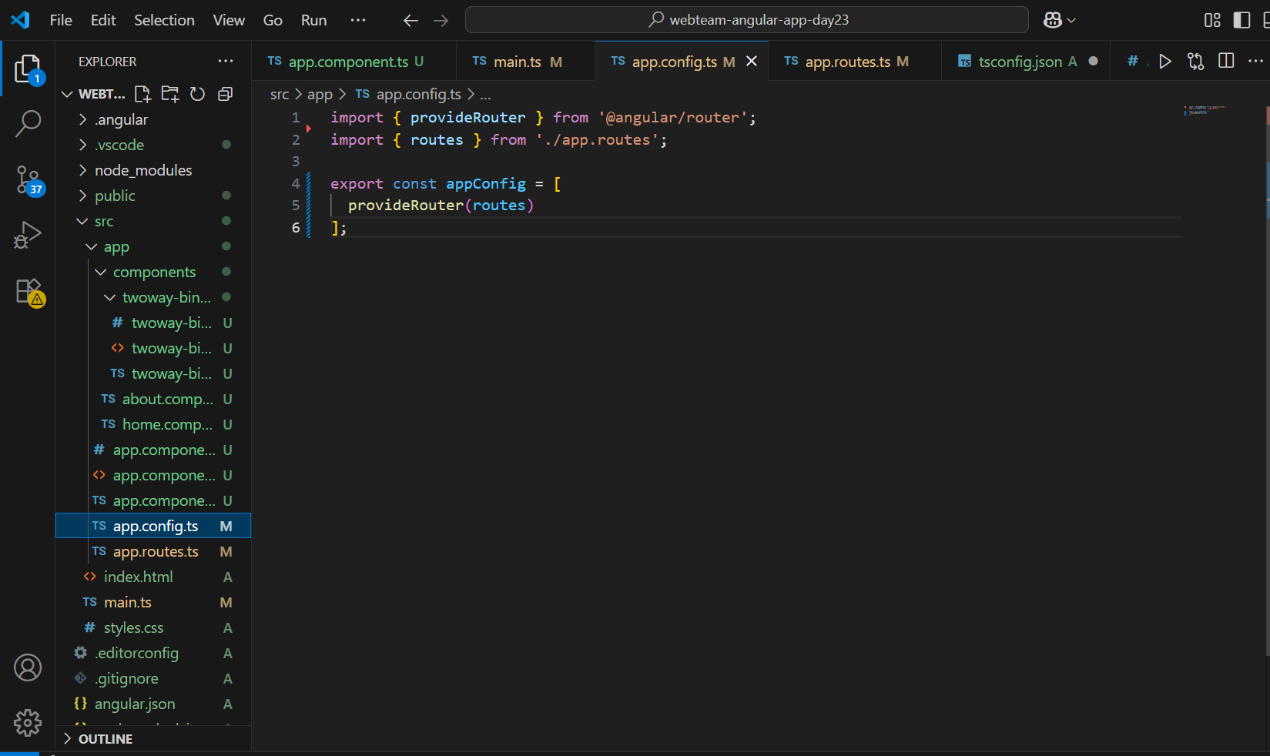

**App.component.ts:**

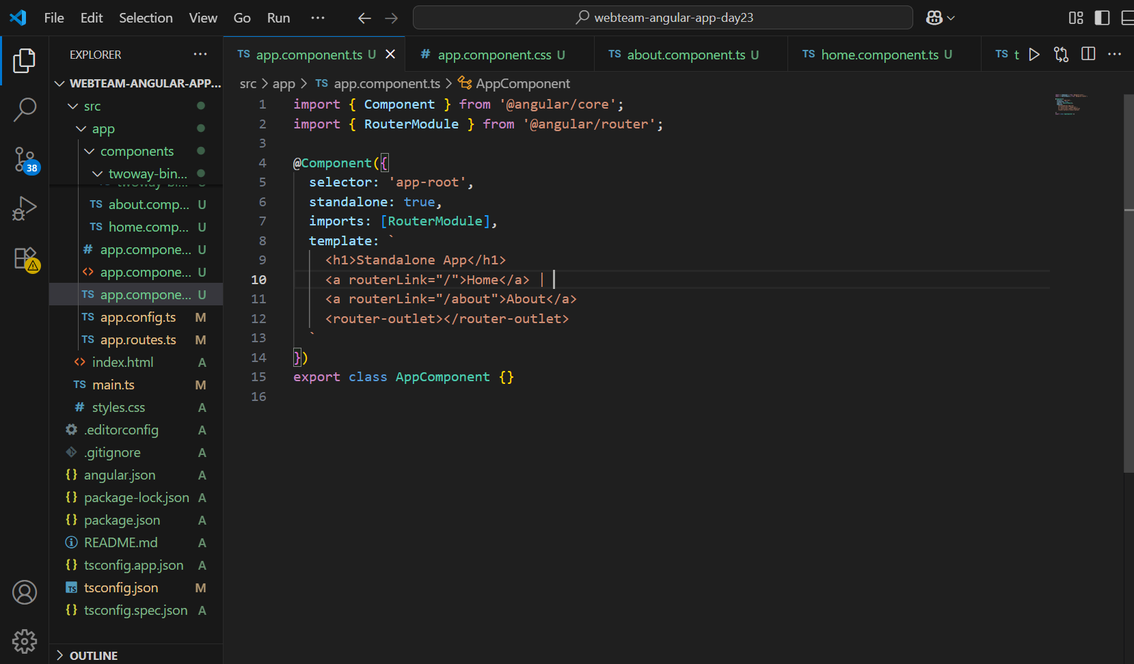

**App.component.html**

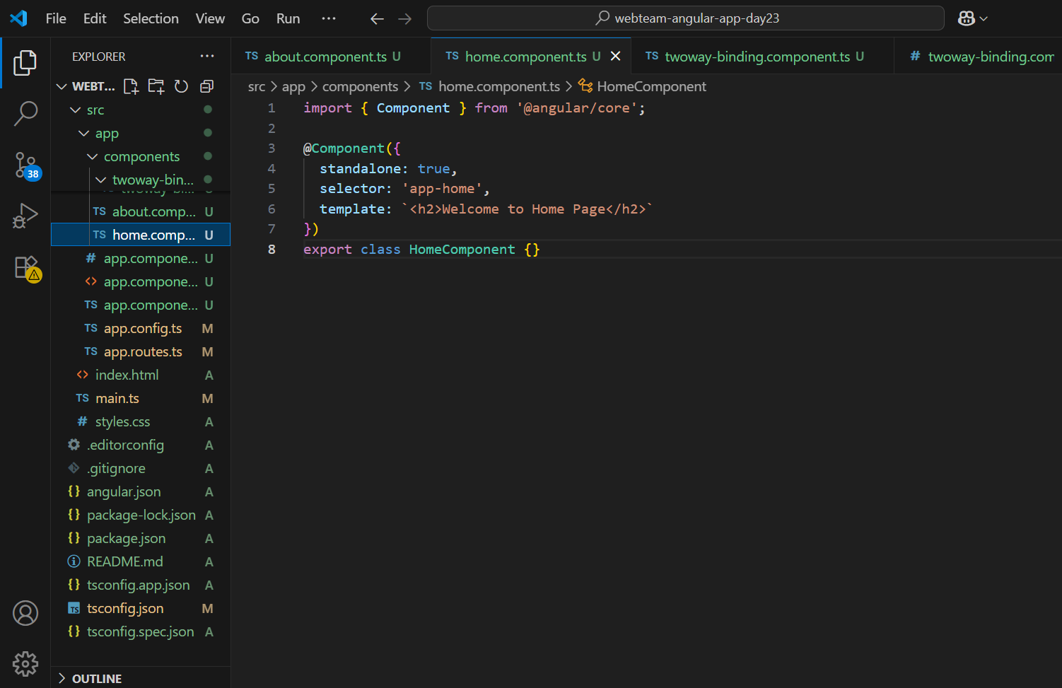

[**Home.component.ts**](http://Home.component.ts)**:**



**About.component.ts:**

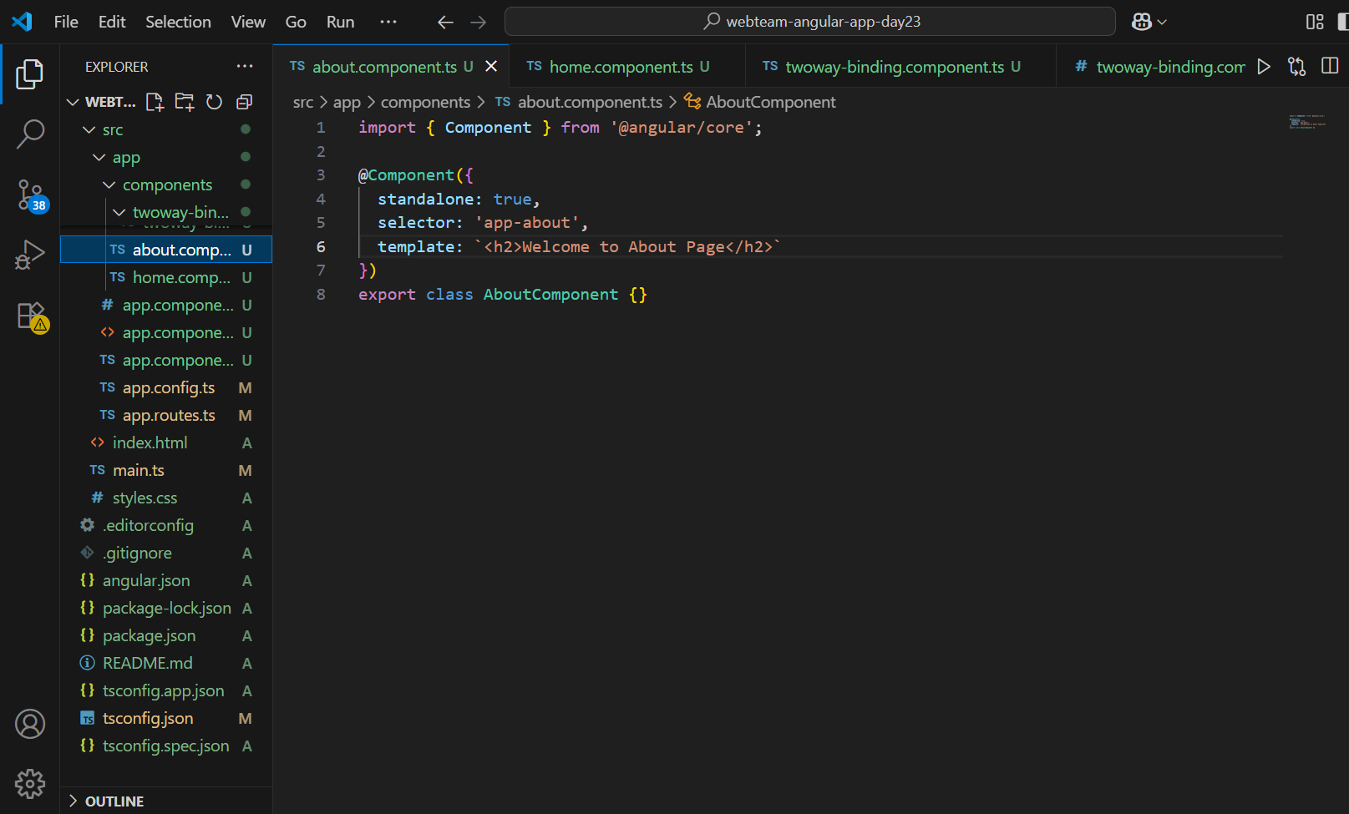

**Browser Output:**

**Home:**

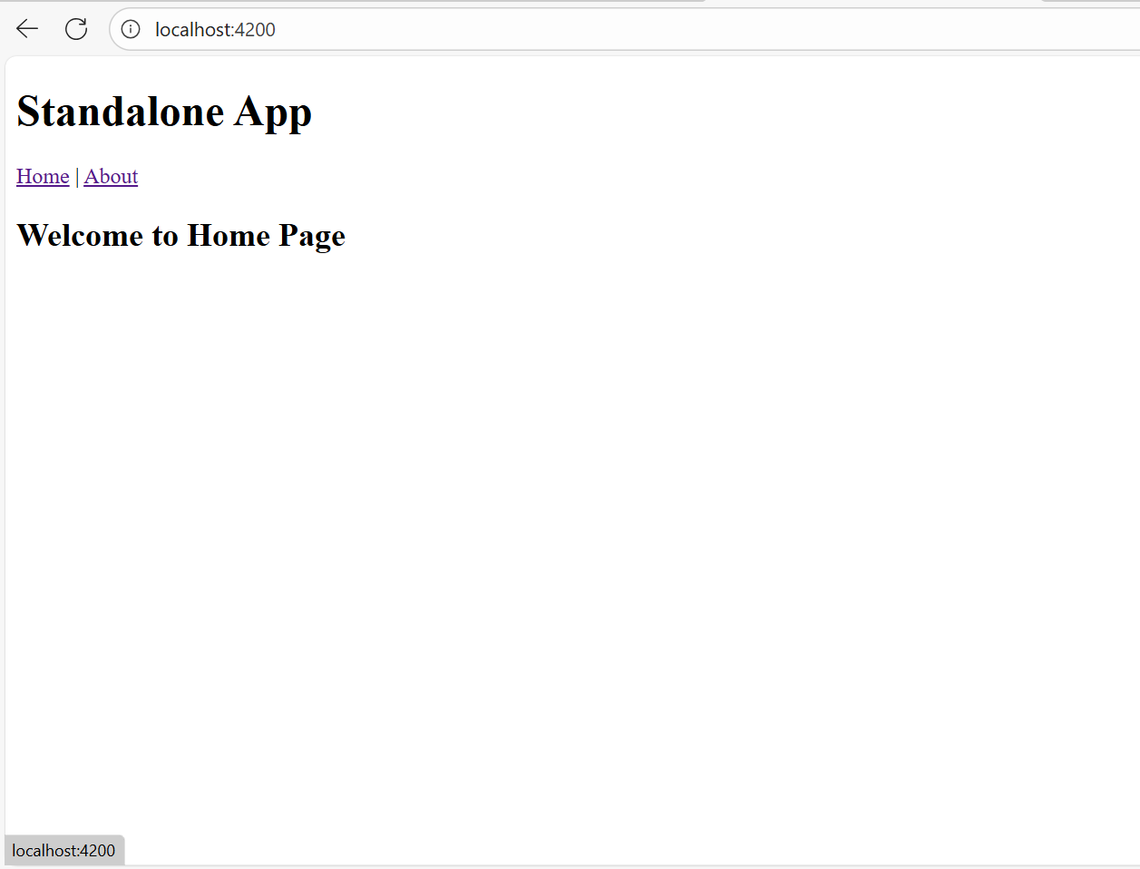

**About:**

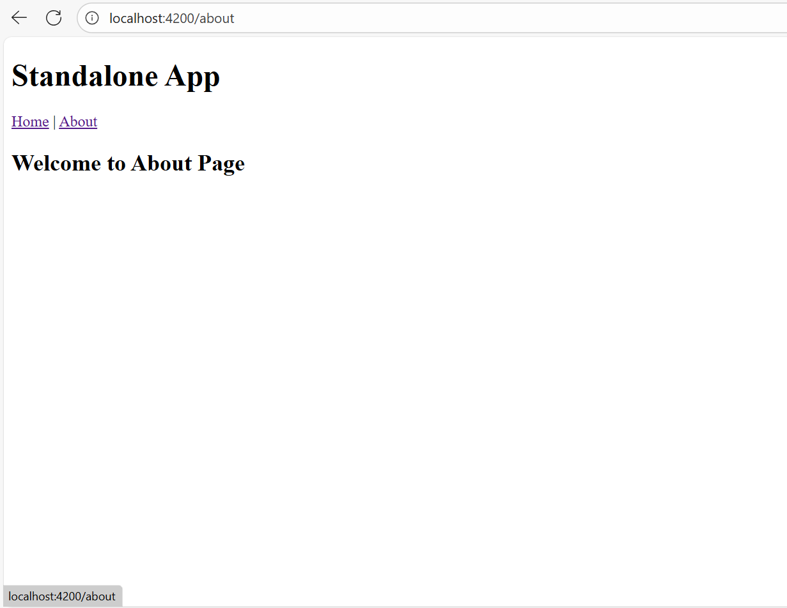

**App.component.html:**

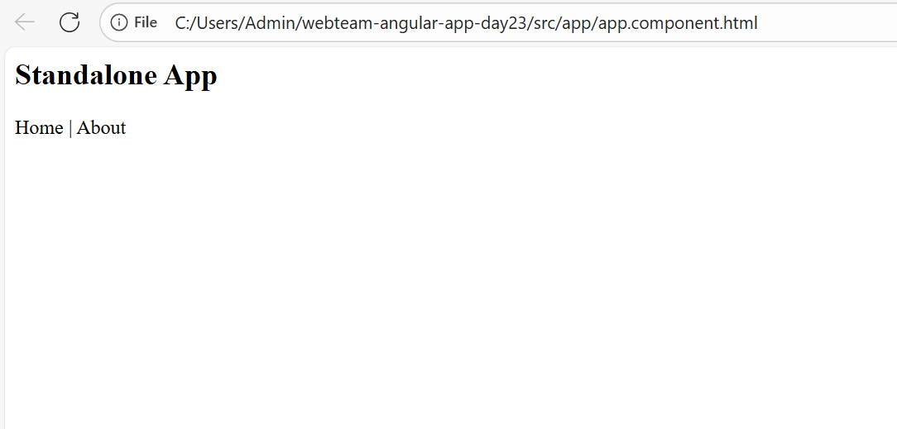

**CMD Successfully:**

