
COMSATS ISLAMABAD UNIVERSITY
ATTOCK CAMPUS

Computer networks lab project:
Company Area network
Submitted to :
Shehzad rizwan
Submitted by :
Tazeem fatima

Company networking Project
This enterprise centre employs 600 staff. They have recently expanded and as a result, need to move to a new building. A building has been identified but has no network. This means that before they can make to move out, new network service needs to be designed and implemented in the new building. Existing Network comprises of the following elements:
The new building is expected to have three floors with two departments in each for example:
- First floor (Sales and Marketing Department-120 users expected. Human Resource and Logistics Department-120 users expected)
- Second floor (Finance and Accounts Department-120 users expected, Administrator and Public Relations Department-120 users expected)
- Third floor (ICT-120 users expected, Server Room-12 devices expected)
Therefore, as a key member of the Networks Team, We have been tasked to design a network for the new building. At this stage, logical design is required, which shows the measures that we would put in place to ensure that the new network meets the current business need and is future-proofed.

Requirements:
- Use Cisco Packet Tracer to design and implement the network solution.
- Use hierarchical model providing redundancy at every layer i.e. two routers and two multilayer switches are expected to be used to provide redundancy.
- The network is also expected to connect to at least two ISPs to provide redundancy and each router to the connected to the two ISPs.
- Each department is required to have a wireless network for the users.
- Each department should be in a different VLAN and in different sub network.
- Provided a base network of 172.16.1.0, carry out subnetting to allocate the correct number of IP addresses to each department.
- The company network is connected to the static, public IP addresses (Internet Protocol) 195.136.17.0/30, 195.136.17.4/30, 195.136.17.8/30 and 195.136.17.12/30 connected to the two Internet providers.
- Configure basic device settings such as host-names, console password, enable password. banner messages, disable IP domain lookup.
- Devices in all the departments are required to communicate with each other with the respective multilayer switch configured for inter-VLAN routing.
- The Multilayer switches are expected to carry out both routing and switching functionalities thus will be assigned IP addresses.
- All devices in the network are expected to obtain an IP address dynamically from the dedicated DHCP servers located at the server room.
- Devices in the server room are to be allocated IP address statically.

IP Address Distribution Among The Floors:
- FLOOR 1:
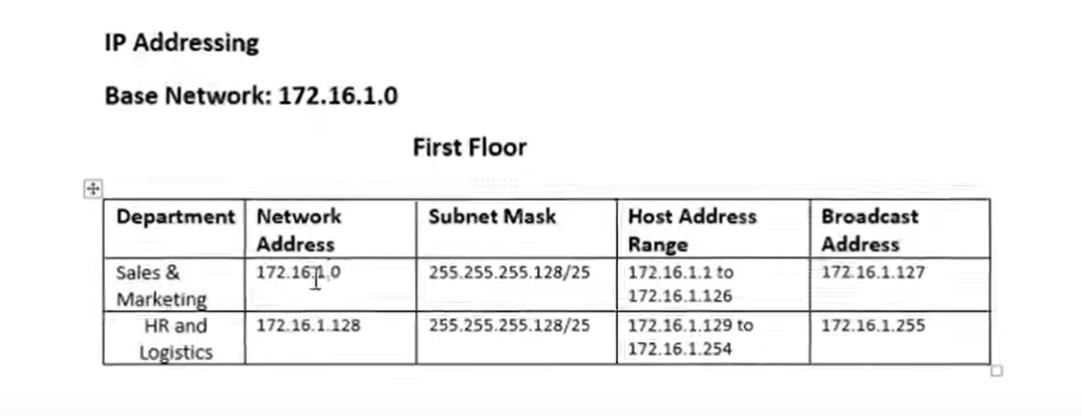

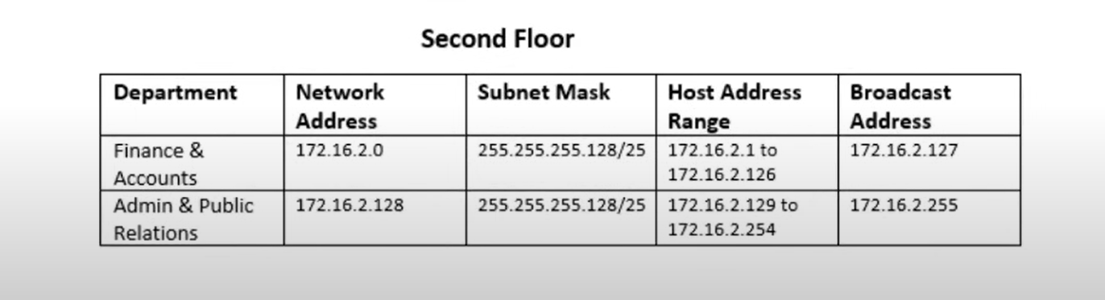
- FLOOR 2:

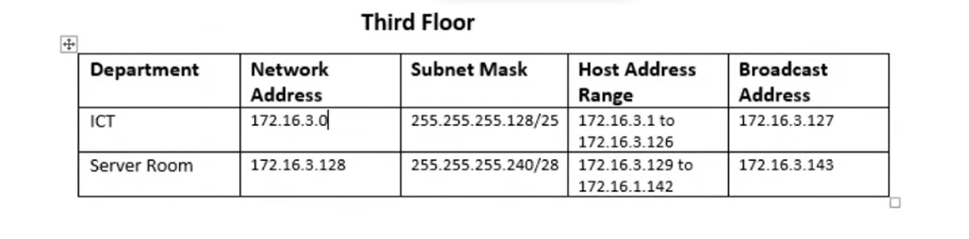
- FLOOR 3:

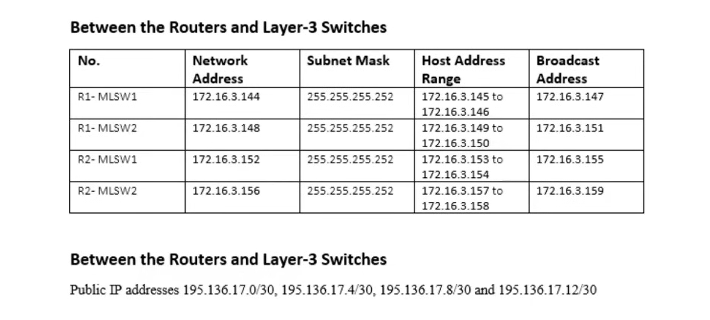
- FLOOR 4:

NETWORK BUILDING PROCESS:
- BUILDING TOPOLOGY:

1. Network Devices
- Routers:
  - 4 Cisco 2911 routers (Router0, Router1, Router2, Router4).
  - Connects to ISPs and facilitates inter-network routing.
- Switches:
  - Layer 3 Switch (3650): Acts as a multilayer switch for inter-VLAN routing.
  - Layer 2 Switches (2960):
    - Switch0, Switch1, Switch2, Switch3, and ICT switches for end devices within VLANs.
- Access Points:
  - Wireless Access Points for Sales, HR, Finance, Admin, and ICT departments.

2. End Devices
- Computers:
  - Desktop PCs for different departments (e.g., Sales, HR, ICT).
- Laptops and Tablets:
  - Mobile devices connected via wireless access points.
- Printers:
  - One or more printers per VLAN for department use.

3. Servers
- DHCP Server: For assigning dynamic IP addresses.
- DNS Server: Handles name resolution within the network.
- Email Server: Provides email services.
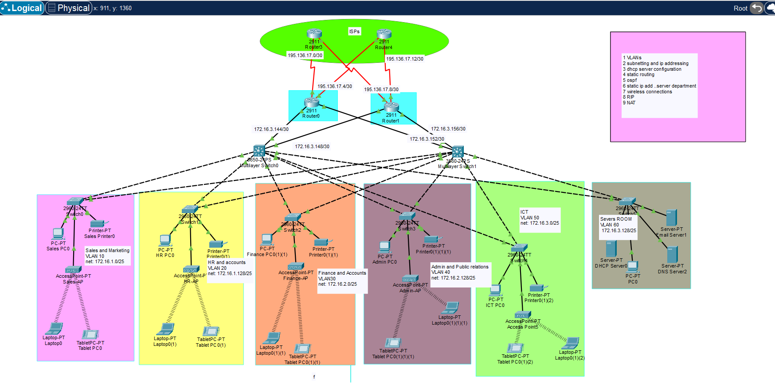

- CONFIGURING LAYER 2 SWITCHES:
en
conf t
hostname CORE_RW2
line console 0
password cisco
login
exit
enable password cisco
no ip domain-lookup
banner motd &NO UNAUTHORISED ACCESS!!!&
service password-encryption
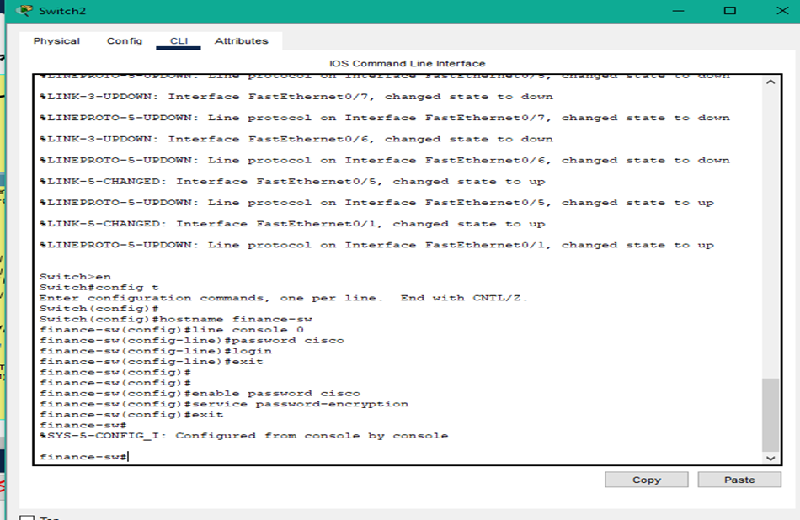

- CONFIGURING LAYER 3 SWITCHES plus ACL:
ip domain-name cisco.net
username admin password cisco
exit
do wr
access-list 1 permit 192.168.10.0 0.0.0.255
access-list 1 deny any
line vty 0 15

- CONFIGURING VLANs on both SWITCHES:
Layer 2 switches: Layer 3 switches:
int range gig1/0/3-24
switchport mode trunk
exit
vlan 10
name sales
vlan 20
name HR
vlan 30
name Admin
vlan 40
name finance
vlan 50
name MN-SW
vlan 60
name SERVERROOM-SW
exit

int range fa0/1-2
switchport mode trunk
exit
vlan 60
name SERVERROOM-SW
VLAN 99
name BlackHole
exit
int range fa0/3-24
switchport mode access
switchport access vlan 60
exit
int range gig0/1-2
switchport mode access
switchport access vlan 99
shutdown
exit

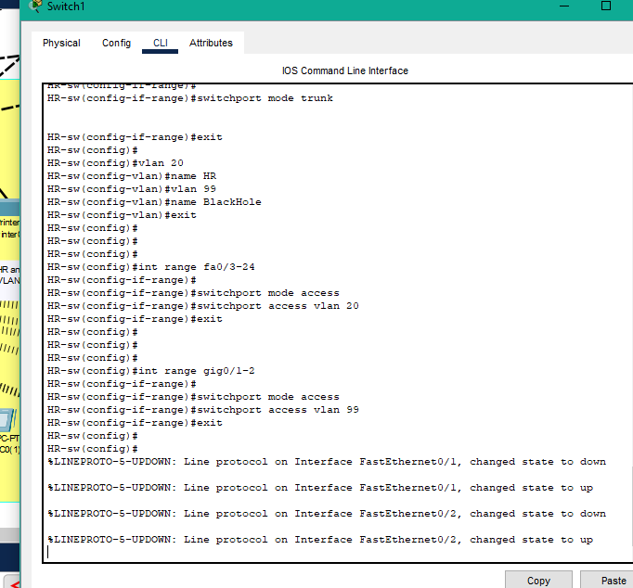
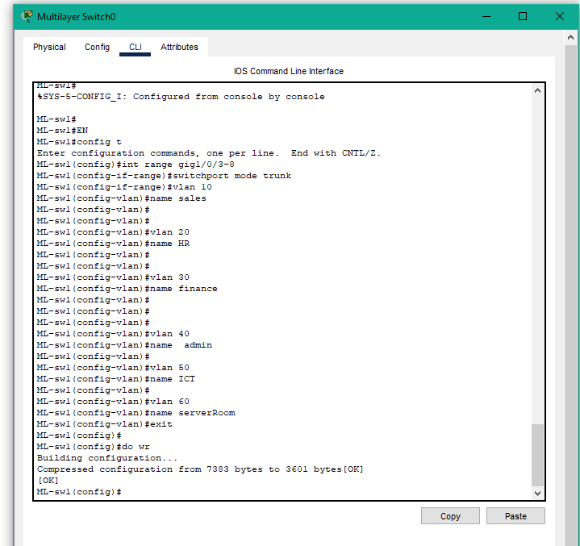

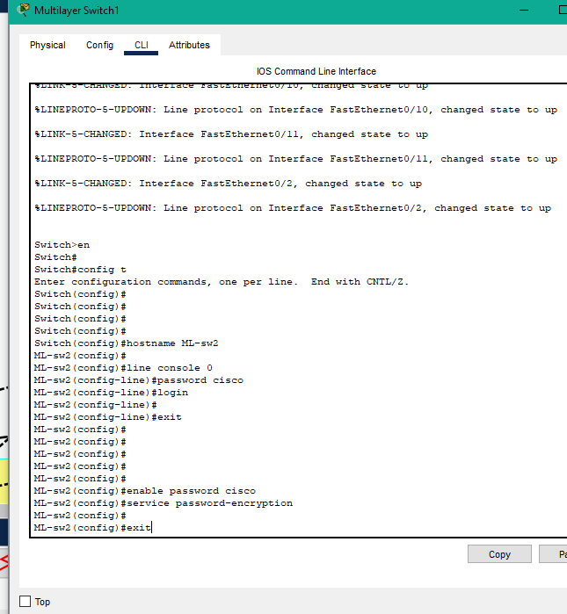
CLI FOR SWITCHES:

SUBNETTINGS on routers and DEC configurations:
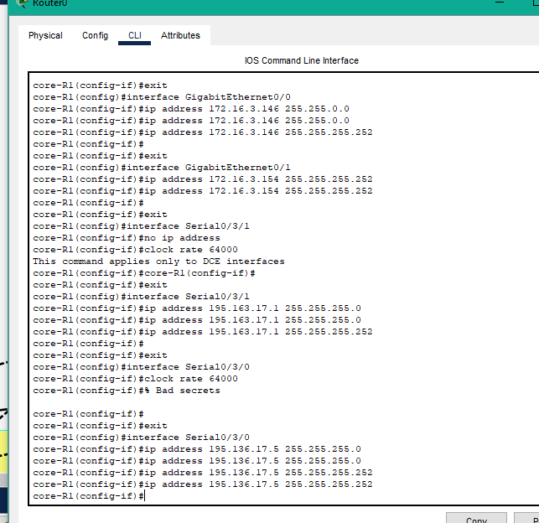
- Ospf configurations on multilayer switches:
ip routing
router ospf 10
router-id 2.2.2.2
network 172.16.1.0 0.0.0.127 area 0
network 172.16.1.128 0.0.0.127 area 0
network 172.16.2.0 0.0.0.127 area 0
network 172.16.2.128 0.0.0.127 area 0
network 172.16.3.0 0.0.0.127 area 0
network 172.16.3.128 0.0.0.127 area 0
network 172.16.3.128 0.0.0.15 area 0
network 172.16.3.144 0.0.0.3 area 0
network 172.16.3.148 0.0.0.3 area 0
exit

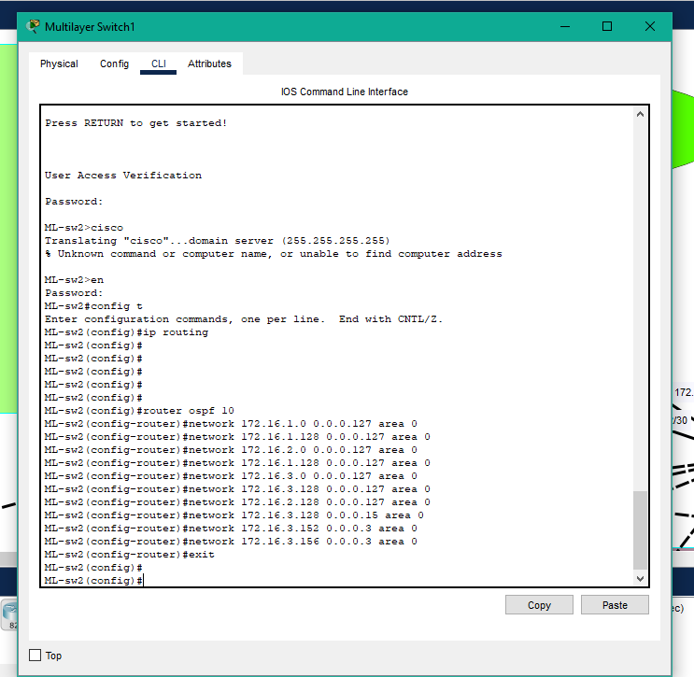

- RIP configurations on routers:
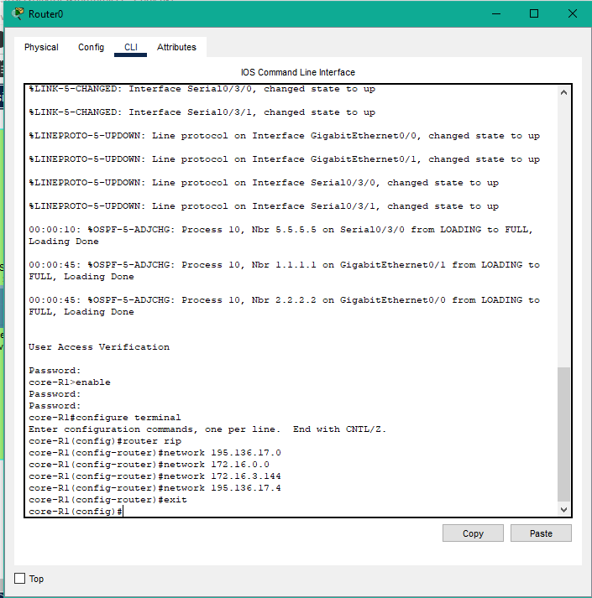

- DHCP configurations on DHCP SERVER:
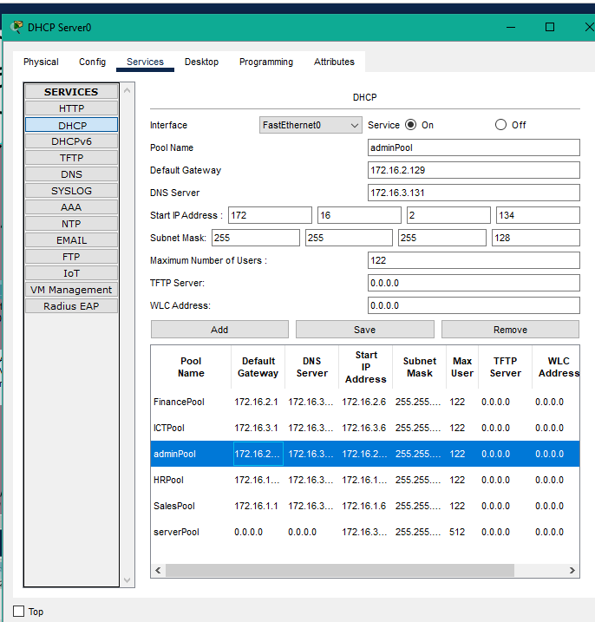

- DHCP helper configurations on switches:
int vlan 10
no sh
ip add 172.16.1.1 255.255.255.128
ip helper-address 172.16.3.130
ex

int vlan 20
no sh
ip add 172.16.1.129 255.255.255.128
ip helper-address 172.16.3.130
ex

int vlan 30
no sh
ip add 172.16.2.1 255.255.255.128
ip helper-address 172.16.3.130
ex

int vlan 40
no sh
ip add 172.16.2.129 255.255.255.128
ip helper-address 172.16.3.130
ex

int vlan 50
no sh
ip add 172.16.3.1 255.255.255.128
ip helper-address 172.16.3.130
ex

int vlan 60
no sh
ip add 172.16.3.129 255.255.255.128
ip helper-address 172.16.3.130
ex

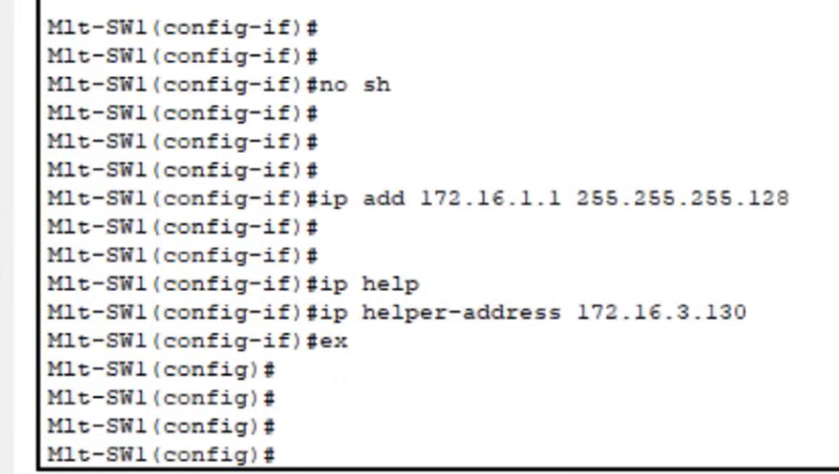

- Access point configurations for wireless devices:
- we will change the SSID of the respective access points accordingly.
- we will choose WPA2-PSK authentication.
- we will set up a password for access points respectfully.

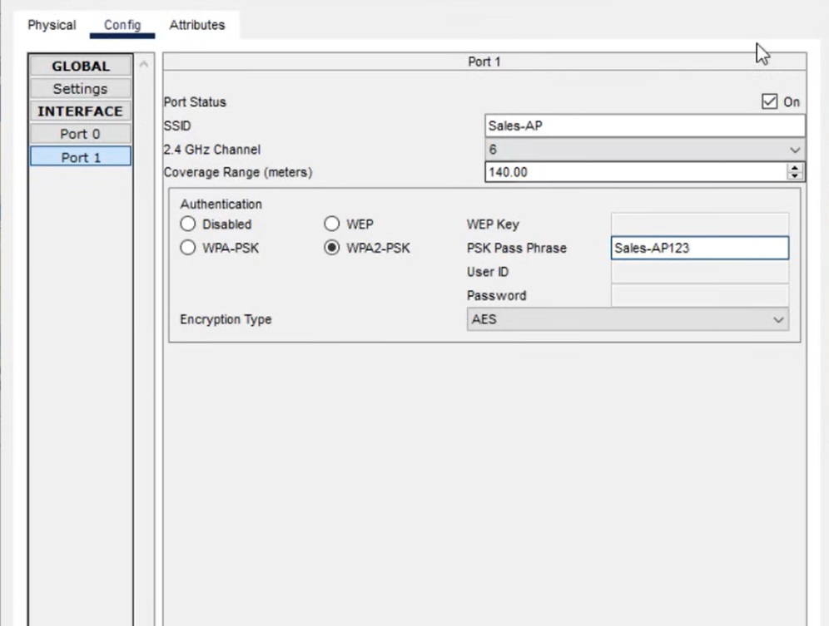
- Go to PC WIRLESS the CONNECT.
- Choose the SSID of the respective network and CONNECT.

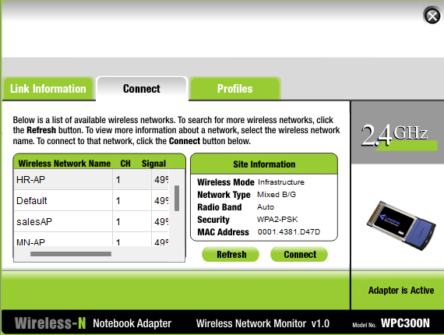

- NAT and ACL LIST CONFIGURATIONS:

