Task-1: Plot the sequence, {5, -2, 0, 3, 4, 6}

Solution:

%Plot the sequence, {5, -2, 0, 3, 4, 6}.

y = [5 -2 0 3 4 6];

stem(y);

title("Plot the sequence, {5, -2, 0, 3, 4, 6},'r'");

xlabel('n');

ylabel('y = x(n)');

grid on;

Output:

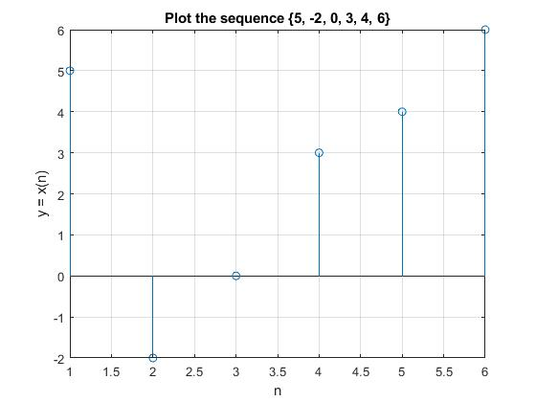

Observation: This is the discrete time sequence where n are the samples and x(n) are the corresponding discrete values. In where x-axis represents n samples and y-axis represents x(n) signal.

Task-1.1: Plot the sequence, x = {-2, 5, 5, 3, -1, 6, -3}

Solution:

%Plot the sequence {-2, 5, 5, 3, -1, 6, -3}.

%where x(n)= 3, when n = 0

y = [-2 5 5 3 -1 6 -3];

x = [-3:3]

stem(x,y)

xlabel('n')

ylabel('y = x(n)')

grid on

Output:

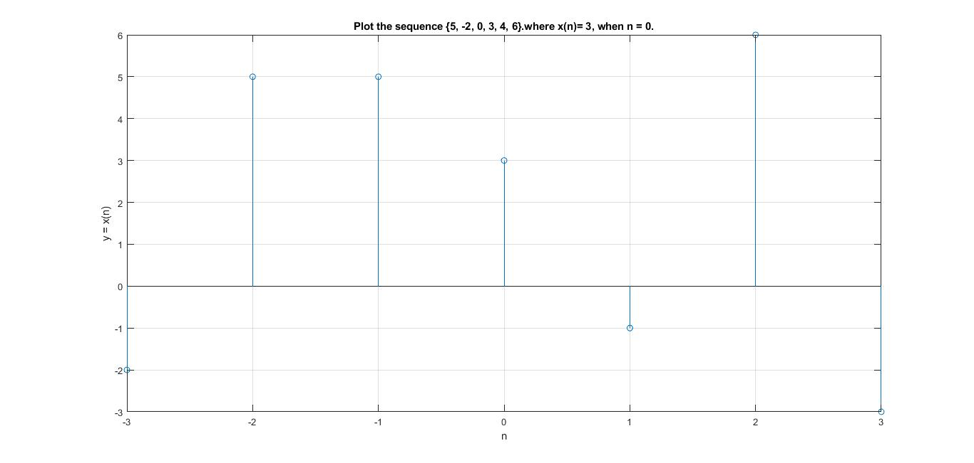

Observation: This is the discrete time sequence where n are the samples and x(n) are the corresponding discrete values. In where n = 0, and x(0) = 5. In where x-axis represents n samples and y-axis represents x(n) signal.

Task-2: Plot of the exponential sequence, *y*(*n*) *= arn* for *a* = 2, *r* = 0.8 and 1.2

Solution:

a = 2; % given

r = 0.8; % given

n = 0 : 1 : 20; % assume 0 to 20 [0 20] values increasing by 1

y = a\*r.^n; % notice r.^n

subplot(2, 1, 1);

stem(n , y);

title('y=ar^n , where r < 1 ');

xlabel('x = n ');

ylabel('y = x(n)');

grid on;

r = 1.2 ;

y = a\*r.^n;

subplot(2,1, 2);

stem(n, y);

title('y=ar^n , where r < 1 ');

xlabel('x = n');

ylabel('y(n)');

grid on;

Output:

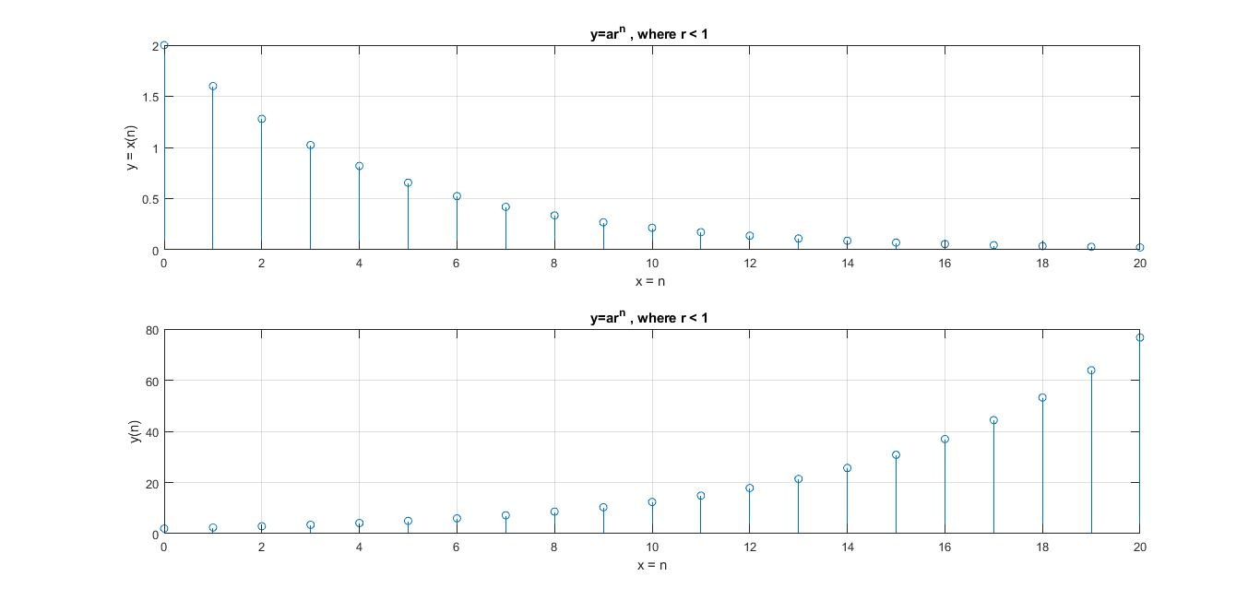

Observation: This is the exponential sequence *y*(*n*) *= arn* for *a* = 2, *r* = 0.8 and 1.2 where n are the samples and y(n) are the corresponding discrete values. In where x-axis represents n samples and y-axis represents y(n) signal. When n is increased then y(n) is also increased exponentially.

Task3: Plot the periodic sequence, *x*[*n*] = {….5,4,3,2,1, 5,4,3,2,1, 5,4,3,2,1, 5,4,3,2,1……..} for *n* = -10 to 9.

Solution:

% Plot the periodic sequence,

% x[n] = {….5,4,3,2,1, 5,4,3,2,1, 5,4,3,2,1, 5,4,3,2,1……..}

% for n = -10 to 9

n = [-10:9 ];

x=[5,4,3,2,1];

p=4;

xy=x' \* ones(1,p); % xy indicates, p=4 column of vectors of [ 5, 4 , 3, 2 , 1]

xy =(xy(:)); %a long column vector will be converted

stem(n,xy);

title("Periodic sequence");

xlabel('n');

ylabel('x(n)');

grid on;

Output:

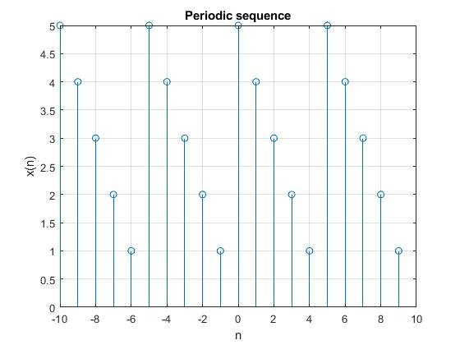

Observation: This is the periodic sequence *x*[*n*] = {….5,4,3,2,1, 5,4,3,2,1, 5,4,3,2,1, 5,4,3,2,1……..} for *n* = -10 to 9.where n are the samples and y(n) are the corresponding discrete values. In where x-axis represents n samples and y-axis represents y(n) signal. When n is increased then y(n) is also increased periodically.

Task4 :Plot the sequence of *x*(*n*)={0, -1, 2, 5, 7, -4, 3, -5, 6, -2 }, *y*(*n*) *= x*(*n-2*), and *z*(*n*) *= x*(*n*)*+y*(*n*).

Solution:

n = -4:5;

x=[0 -1 2 5 7 -4 3 -5 6 -2];

stem(n,x,'r\*');

hold on;

k=2;

m=n+k;

y=x;

stem(m,y,'bd');

hold on;

r=min(min(n),min(m)):max(max(n),max(m)); %duration of z

z1=zeros(1,length(r));

z2=z1; %initialization

z1(find((r>=min(n))&(r<=max(n))==1))=x; %x with duration of z

z2(find((r>=min(m))&(r<=max(m))==1))=y; %y with duration of z

z=z1+z2;

stem(r,z,'k>');

grid on;

xlabel('n');

ylabel('x(n),y(n),z(n)')

legend('x(n)','y(n)=x(n-2)', 'z(n)=x(n)+y(n)')

Output:

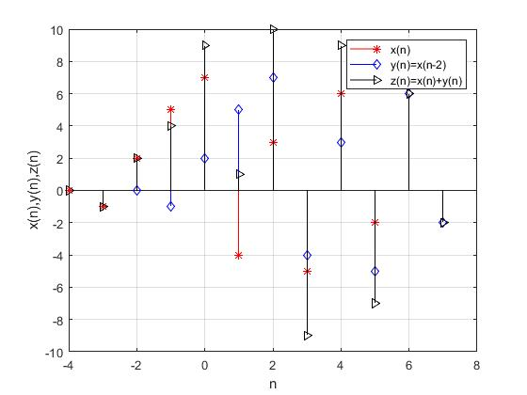

Observation: This is the shifting sequence of *x*(*n*)={0, -1, 2, 5, 7, -4, 3, -5, 6, -2 }, *y*(*n*) *= x*(*n-2*), and *z*(*n*) *= x*(*n*)*+y*(*n*).where n are the samples and y(n) are the corresponding discrete values. In where x-axis represents n samples and y-axis represents y(n) signal. y(n) shifted 2 times to the right.

Task5: For discrete time sequence, a sinusoidal wave is periodic if its frequency is a rational number like, *f = M / K*. Period of the wave is the denominator i.e. *K*.

Solution:

% For discrete time sequence, a sinusoidal wave is periodic

% if its frequency is a rational number like,

% f = M / K. Period of the wave is the denominator i.e. K.

% periodic sinusoidal wave

x = [0 : 1 : 50]; % assume 0 to 50 descrete values increasing by 1

N = 20; % assume cycle completed when x = 20 ,

% after 20, next cycle occurs, so period = 20

% so N = period

f = 1/N;

y = sin(2 \* pi \* f \* x); % sine wave = sin(2.pi.f.x)

subplot(2,1,1);

stem(x, y);

title(' sine wave = sin(2.pi.f.x)');

xlabel('x');

ylabel('y = x(n)');

grid on;

% Non-periodic sinusoidal wave

N = sqrt(20); % root(N) = irrational so it produces non periodic

f= 1/N;

y = sin(2\*pi\*f\*x);

subplot(2,1,2);

stem(x,y);

title('Non Periodic Sine wave');

xlabel('x');

ylabel('y = x(n)');

grid on;

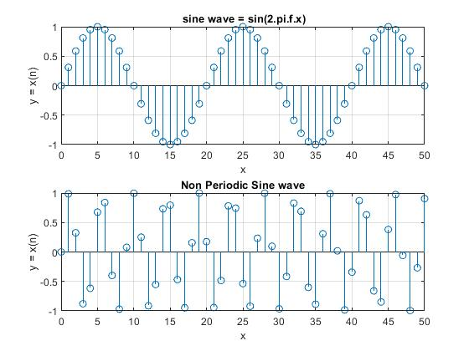Output:

Observation: This is the discrete time sequence of x(n). As we know a sinusoidal wave is periodic if its frequency is a rational number like, *f = M / K*. Period of the wave is the denominator i.e. *K*. Where n are the samples and y(n) are the corresponding discrete values. In where x-axis represents n samples and y-axis represents y(n) signal.

Task6: The sampling rate of *y*(*2n*) is half the rate of *y*(*n*) therefore y(2*n*) is called the under sampled version of *y*(*n*). Let us verify the phenomenon.

Solution:

a=0.2;

r=0.8;

N=10;

for n=1:N,

s(n)=n;

y(n)=a\*r.^n;

end

M=N/2;

for m=1:M,

m=2\*m;

p(m)=m;

z(m)= y(m);

end

stem(s,y,'ks')%Original sequence y(n)

hold on

stem(p,z,'k\*')%under sampled sequence y(2n)

xlabel('n')

ylabel('y(n) and y(2n)')

grid on

legend('Original sequence', 'Under sampled')

Output:

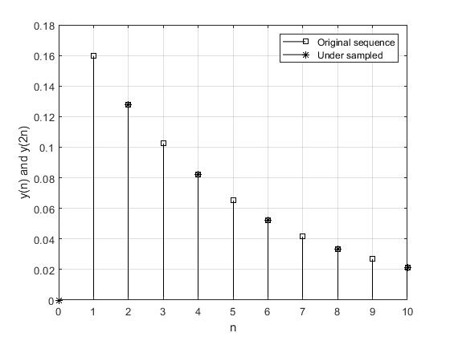

Observation: This is the discrete time sequence of x(n). The sampling rate of *y*(*2n*) is half the rate of *y*(*n*) therefore y(2*n*) is called the under sampled version of *y*(*n*). Where n are the samples and y(n) are the corresponding discrete values. In where x-axis represents n samples and y-axis represents y(n) signal.

Task7: Determine convolution of two sequences *A* = {6, 2, 0, 5, 6} and *B* = {-4, -2, 1, 0, 7} and find the length of resultant sequence.

Solution:

% Determine convolution of two sequences

% A = {6, 2, 0, 5, 6} and B = {-4, -2, 1, 0, 7}

% Find the length of resultant sequence.

A = [6 2 0 5 6];

B = [-4 -2 1 0 7];

Y = conv(A,B);

stem(A);

hold on;

stem(B);

hold on;

stem(Y);

title('Convolution Of two signal');

xlabel('n');

ylabel('Y = A\*B');

legend('Signal A', 'signal B', 'Convolution of A\*B');

grid on;

Output:

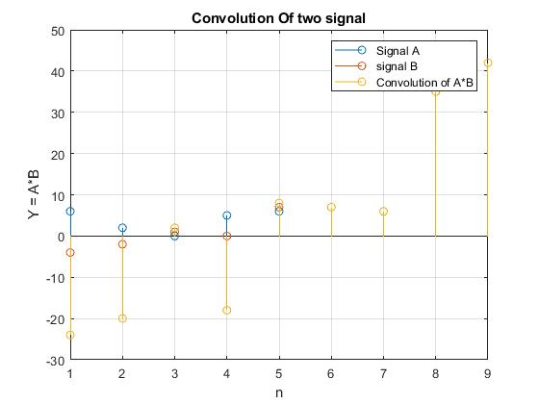

Observation: This is the discrete time sequence of x(n). Here I found convolution of two sequences *A* = {6, 2, 0, 5, 6} and *B* = {-4, -2, 1, 0, 7} and the length of resultant sequence. Where n are the samples and y(n) are the corresponding discrete values. In where x-axis represents n samples and y-axis represents y(n) signal.

Task-8: Generate 100 random numbers between 0 and 1. Add them with an exponential sequence as a random noise. Plot both noisy and noiseless signals.

Solution:

% Generate 100 random numbers between 0 and 1.

% Add them with an exponential sequence as a random noise.

% Plot both noisy and noiseless signals.

a = 0.5; % assume

r = 0.96; % assume

N = 100; % as we want to generate 100 random numbers

for n = 1:N

e(n) = n;

y(n) = a\*r.^n;

Y(n) = y(n) + 0.04\*rand(); % noise 0.04 adding with random number

end

stem(e,y)

hold on

stem(e,Y)

hold on

title('Original and Noisy Signal')

xlabel('n')

ylabel('Amplitude')

legend('Original Signal','Noisy Signal')

grid on

Output:

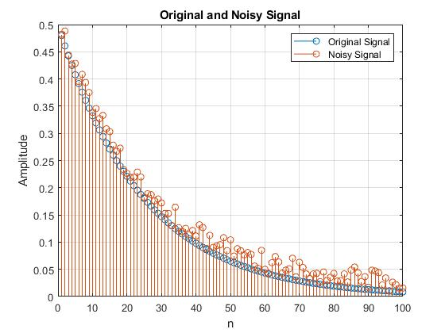

Observation: This is the discrete time sequence of x(n). Here I found 100 random numbers between 0 and 1. Add them with an exponential sequence as a random noise. Then plot both noisy and noiseless signals. Where n are the samples and y(n) are the corresponding discrete values. In where x-axis represents n samples and y-axis represents y(n) signal.

Task-9.1: Generate a unit step sequence for *n* = [-6, 6]

Solution:

%Generate a unit step sequence for n = [-6, 6]

n = [-6:6];

y = [0 0 0 0 0 0 1 1 1 1 1 1 1];

stem(n, y)

title('unit step signal')

xlabel('n')

ylabel('y = x(n)')

grid on

Output:

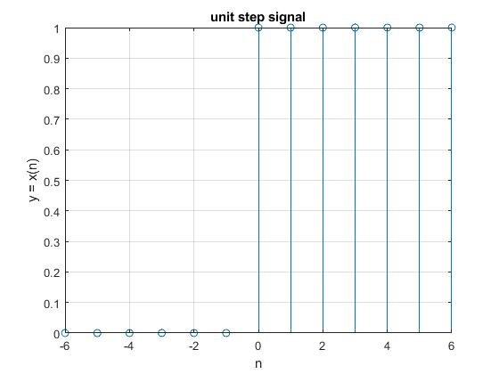

Observation: This is the unit step sequence for *n* = [-6, 6]. Where n are the samples and x(n) are the corresponding discrete values. In where x-axis represents n samples and y-axis represents x(n) signal.

Task-9.2: Generate a unit sample sequence for n = [-6, 6].

Solution:

n = [-6:6];

y = [0 0 0 0 0 0 1 0 0 0 0 0 0];

stem(n, y)

title('Unit sample signal')

xlabel('n')

ylabel('y = x(n)')

grid on

Output:

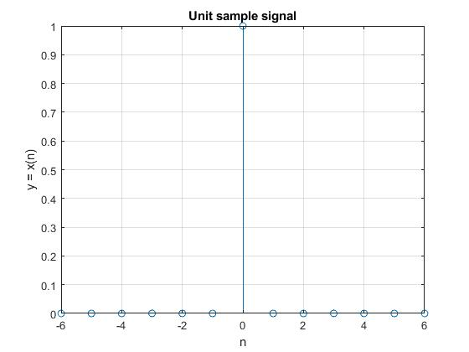

Observation: This is the unit sample sequence for *n* = [-6, 6]. Where n are the samples and x(n) are the corresponding discrete values. In where x-axis represents n samples and y-axis represents x(n) signal.

Task-10: Computes the two-dimensional convolution of matrices

| 1 -2 0 |

A =| 3 4 -11 |

| 6 -5 2 |

|-3 2 -8 |

B =| 2 -7 0 |

|-1 4 -1 |

Solution:

A = [ 1 -2 0; 3 4 -11; 6 -5 2]

B = [-3 2 -8; 2 -7 0; -1 4 -1]

Y = conv2(A,B) % for two dimentional we used conv2 , for 1 dimention used conv

mesh(Y)

% It is used to generate 3D surface plot of which x, y co-ordinates

% are decided by column and row indices of the input matrix ‘Z’.

Output:

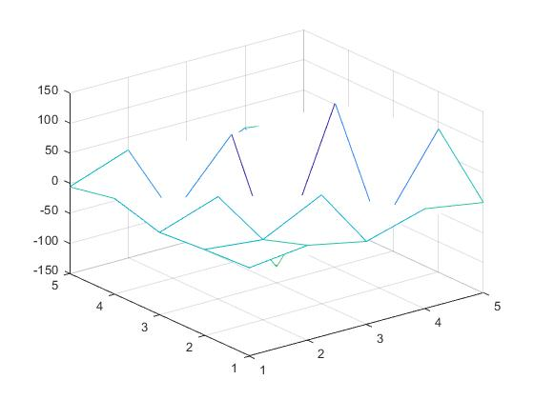

Observation: This is the discrete sequence of x(n). Here computing the two-dimensional convolution of matrices using mesh. Where n are the samples and x(n) are the corresponding discrete values. In where x-axis represents n samples and y-axis represents x(n) signal.

Task-11: Generate 50 random numbers in the range [1,-1] and add it with the sequence *x(n)* =2*n*(0.9)*n*. Pass the noisy signal through a moving average filter and observe the signalbefore and after filtering.

Solution:

N=50;%number of samples

m=0:1:N-1;

d=rand(N,1)-0.5;%noise with mean 0 and lies between -0.5 to 0.5

s=2\*m.\*(0.9.^m);%original Sequence

x=s+d'; %noisy sequence

subplot(2,2,1)

stem(m,s)

title('Original Message')

subplot(2,2,2)

stem(m,d)

title('Random Noise')

subplot(2,2,3)

stem(m, x)

title('Noisy Sequence')

subplot(2,2,4)

plot(m, d, 'r-', m, s, 'b--', m, x, 'm--')

legend('noise','original message', 'noisy message')

M=input('Value of M=');% Value of M from key board

b=ones(M, 1)/M;

y=filter(b,1,x);

plot(m,s,'r-',m,y,'b--')

legend('Original Sequence', 'Moving Average Filtered Signal')

grid on

xlabel('n')

ylabel('(y(n)')

Output:

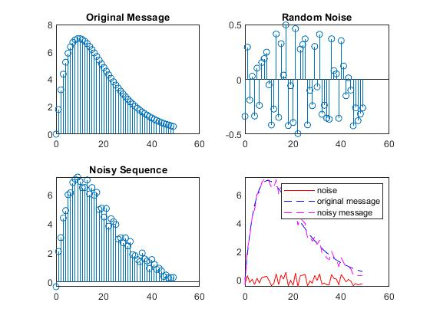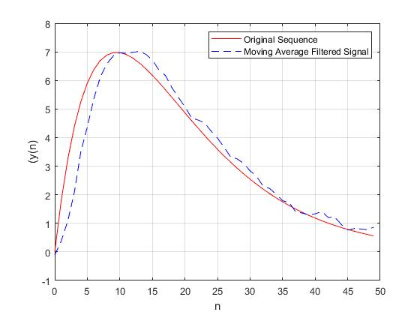

Observation: Here 50 random numbers in the range [1,-1] and adding it with the sequence *x(n)* =2*n*(0.9)*n*. Passing the noisy signal through a moving average filter and observe the signalbefore and after filtering. Where n are the samples and x(n) are the corresponding discrete values. In where x-axis represents n samples and y-axis represents x(n) signal.

Task-12: listen to the speech signal with noise removal.

Solution:

load handel %original music signal

u=y(1:20000);

sound(u);

d=0.5\*rand(length(u),1)-0.5;%noise with mean 0 and lies between -0.25 to 0.25

x=u+d; %noisy sequence

sound(x)

M=5;% Value of M

b=ones(M,1)/M;

z=2\*filter(b,1,x);

sound(z)

subplot(3,1,1)

plot(u)

subplot(3,1,2)

plot(x)

subplot(3,1,3)

plot(z)

Output:

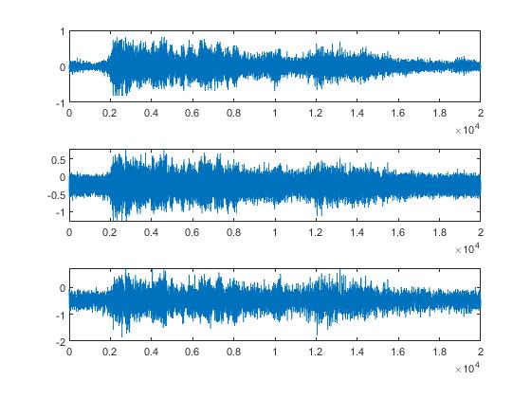

Observation: Here listening to the speech signal with noise removal. Where n are the samples and x(n) are the corresponding discrete values. In where x-axis represents n samples and y-axis represents x(n) signal.

Task-13: Elimination of noise by moving average method. Let us first load a voice or music signal and add some noise with it. Finally we will filter the signal and observe the signals and corresponding spectrograms.

Solution:

load handel %original signal

u=y(1:16000);

[num,den]=ellip(4,3,40,0.75,'high');

noise=filter(num,den,randn(length(u),1));

x=u+noise;

x=x/max(max(x));

M=5;% 5 sample will be averaged

b=ones(M,1)/M;

z=2\*filter(b,1,x);

figure(1)

subplot(1,3,1)

specgram(u,[],Fs)

title('Original wave')

subplot(1,3,2)

specgram(x,[],Fs)

title('Noisy wave')

subplot(1,3,3)

specgram(z,[],Fs)

title('Filtered wave')

figure(2)

subplot(3,1,1)

plot(u)

title('Original wave')

subplot(3,1,2)

plot(x)

title('Noisy wave')

subplot(3,1,3)

plot(z)

title('Filtered wave')

Output:

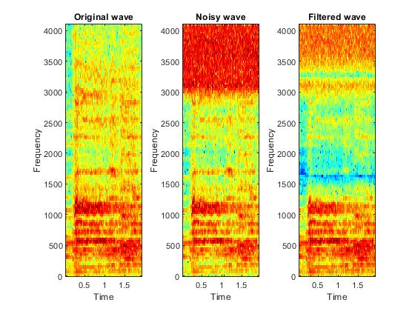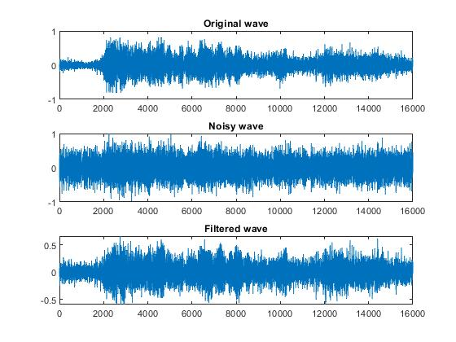

Observation: Here I am using elimination of noise by moving average method. At first load a voice or music signal and add some noise with it. Finally I will filter the signal and observe the signals and corresponding spectrograms. Where n are the samples and x(n) are the corresponding discrete values. In where x-axis represents n samples and y-axis represents x(n) signal.