Task-1: Consider a continuous time signal, x(t) = sin(2 $π$ 2000t) + $\frac{1}{2}$ sin(2 $π$ 200t + $\frac{3π}{4}$)

Determine sampled signal *x(n.Ts)* = *x(n)*, using matlab, taking *N* = 8 samples at sampling

rate, *Fs* = 8000Hz (samples/sec).

The sampled signal,

xs(n) = x(nTs) = sin(2 $π$ 2000nTs) + $\frac{1}{2}$ sin(2 $π$ 200nTs + $\frac{3π}{4}$); Where Ts = $\frac{1}{Fs}$ = $\frac{1}{8000}$ sec

is the sampling period. Let us use matlab code to determine sampled sequence *x(n)*.

Solution:

n=0:1:7;

Ts=1/8000;

xn=sin(2*pi*1000*n*Ts)+0.5*sin(2*pi*2000*n*Ts+3*pi/4);

xn;

Output:

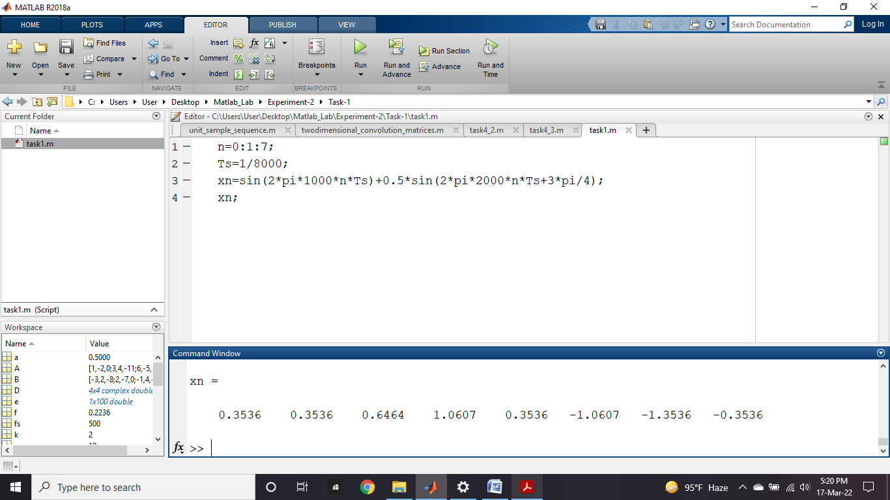

Observation: This is a continuous time signal x(t). After implementation of this signal it represents the sampled signal xn. In where x-axis represents n samples and y-axis represents x(n) signal.

Task-2: Determine DFT of above sequence using Matlab.

Solution:

X=fft(xn);

%IDFT of above sequence will retrieve the original sequence x(n) like.

Y=ifft(X);

Output:

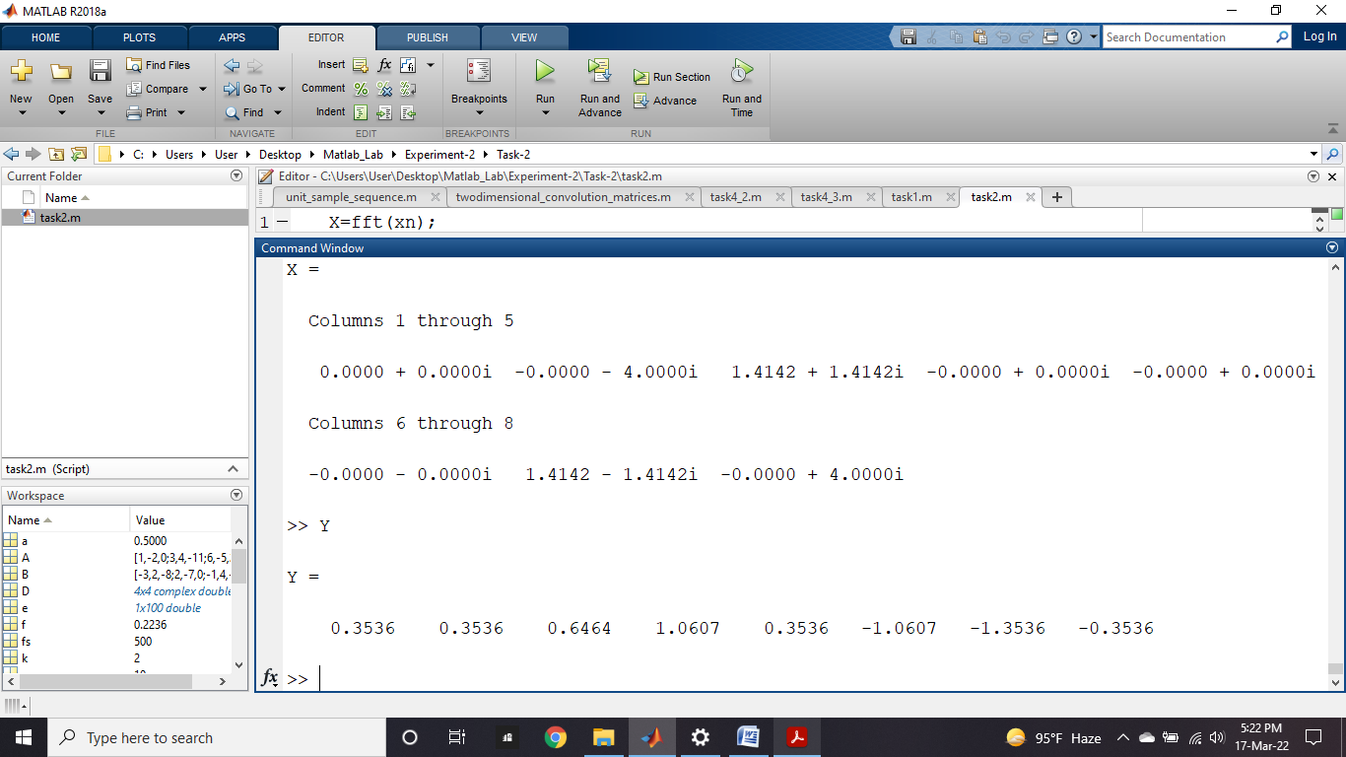

Observation: This is a continuous time signal x(t). After implementation of this signal it represents how inverse discrete time fourier transformation(IDFT) is worked. In where i represents the imaginary number.

Task-3: If *x(n)* ↔ *X(m);* both *x(n)* and *X(m)* are the vector of length *N* then their relation can be expressed in a different way like,

*X* = **D**N *x*

Where ***x*** *= [x(0) x(1) x(2) … … … x(N-1)]T* ***,***

*X = [X(0) X(1) X(2) … … … X(N-1)]T ,*

Determine the **D**N matrix of dimension of 4×4 using Matlab.

Solution:

D=dftmtx(4)

**Output:**

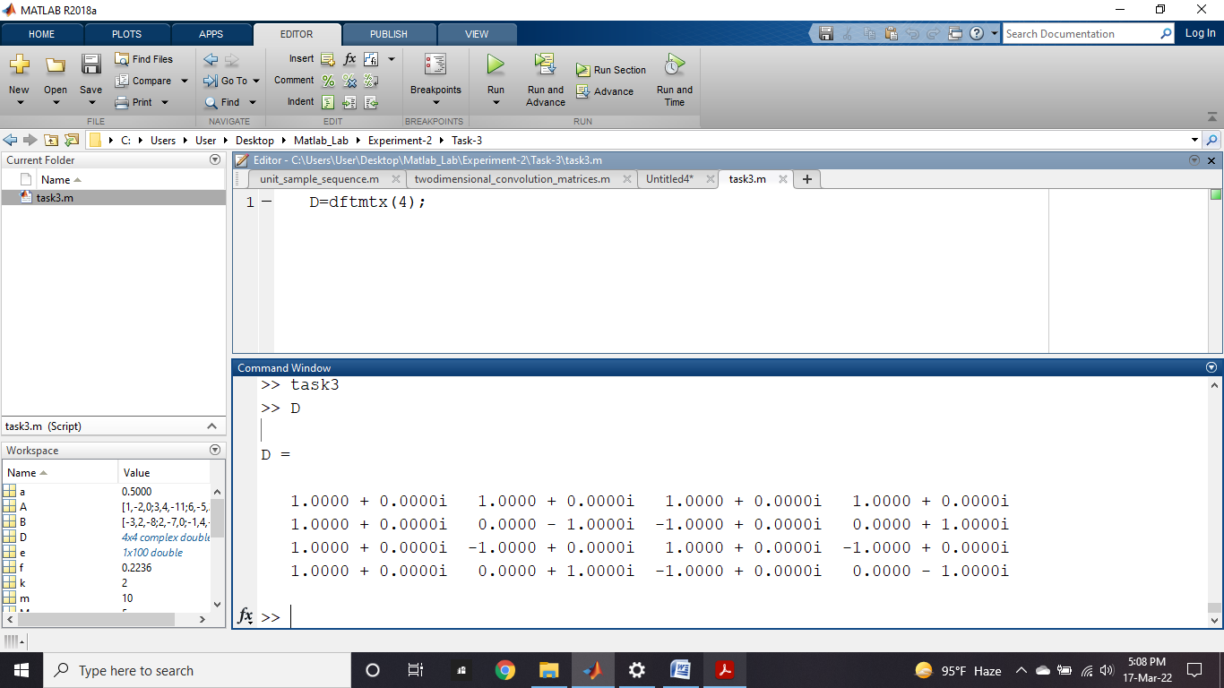

Observation: This is a continuous time signal x(t). After implementation of this signal it represents the **D**N matrix of dimension of 4×4. In where i represents the imaginary number.

Task-4.1: Write Matlab code to determine DFT of *x (n)* = {1, 0, 0, 1} hence show the plot of

*X(m)*.

Solution:

x=[1 0 0 1];

y=fft(x);

subplot(2,1,1)

stem(abs(y), 'k')

xlabel('m')

ylabel('X(m)')

title('Absolute value of DFT sequence')

subplot(2,1,2)

stem(angle(y), 'k')

xlabel('m')

ylabel('Angle(X(m))')

title('Angle of DFT sequence')

Output:

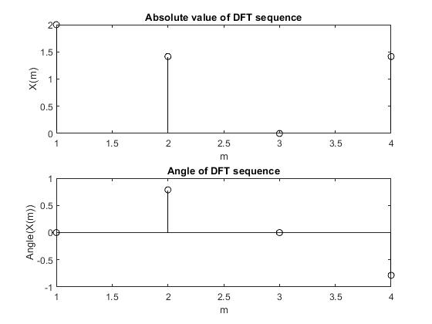

Observation: This is a continuous time signal x(t). After implementation of this signal it represents the absolute value of DFT and the angles of DFT. In where x-axis represents m samples and y-axis represents x(m) signal.

Task-4.2: DTFT on a rectangular pulse.

Solution:

fs = 500;

t = -1:1/fs:1;

x = rectpuls(t,0.12);

subplot(2,2,1)

plot(t, x)

grid on

y = fft(x);

y = fftshift(y);

subplot(2,2,2)

plot( abs(y))

grid on

x = rectpuls(t,0.02);

subplot(2,2,3)

plot(t, x)

grid on

y = fft(x);

y = fftshift(y);

subplot(2,2,4)

plot( abs(y))

grid on

Output:

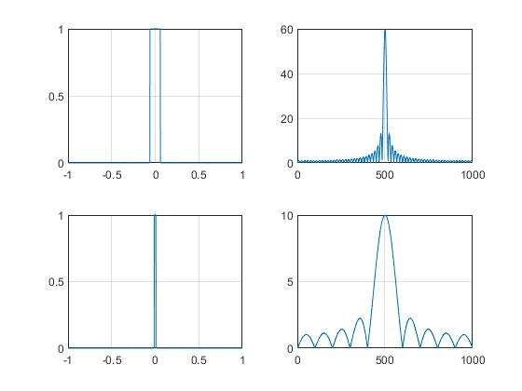

Observation: This is a continuous time signal x (t). After implementation of this signal, it represents the DTFT on a rectangular pulse. In where the x-axis represents m samples and the y-axis represents x (m) signal.

Task-4.3: DTFT on a 3D rectangular pulse.

Solution:

x=zeros(32);

x(12:17)=ones(6,1);

subplot(2,2,1)

title('2D rectangular pulse')

mesh(x)

x=fft(x);

x=fftshift(x);%Dc avlue is at the corner of the array

%let us move it at the middle

subplot(2,2,2)

mesh(abs(x))

title('2D sinc in frequency domain')

x=zeros(32);

x(12:17,12:17)=ones(6);

subplot(2,2,3)

title('3D rectangular pulse')

mesh(x)

x=fft2(x);

x=fftshift(x);%Dc avlue is at the corner of the array

%let us move it at the middle

subplot(2,2,4)

mesh(abs(x))

title('3D sinc in frequency domain')

Output:

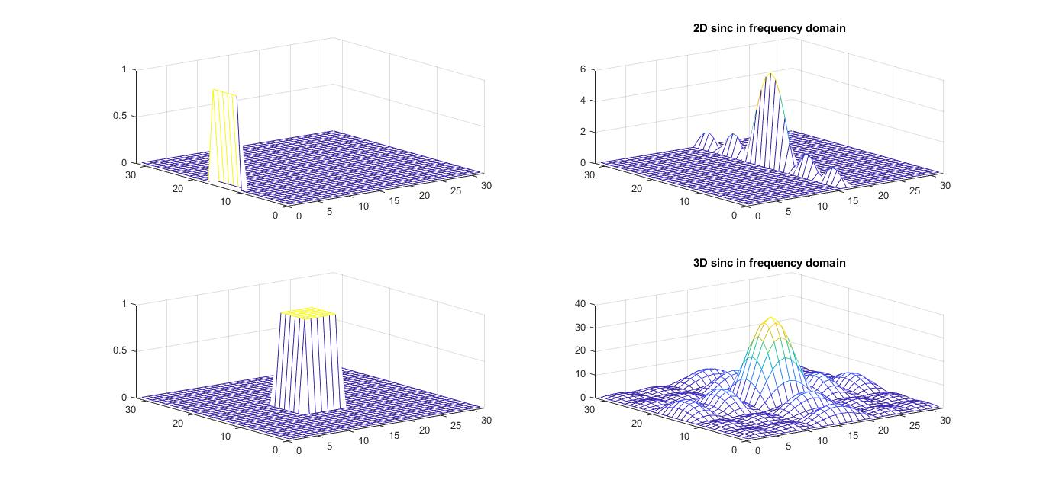

Observation: This is a continuous time signal x (t). After implementation of this signal, it represents the DTFT on a 3D rectangular pulse. In where the x-axis represents m samples and the y-axis represents x (m) signal.