**Quiz 2.1**

Quiz due Aug 4, 2020 20:05 +06

 Bookmark this page

Problem 1

1/1 point (graded)

The primary variable types in JavaScript are:

Number, String, Boolean, Null, Undefined

Integer, Floating Point, Character, Boolean, Byte

Number, Object, Pointer

byte, short, int, long, double, float, boolean, char

correct

**Answer : 1**

Correct:

JavaScript has five primary variable types.

Submit

You have used 1 of 3 attemptsSome problems have options such as save, reset, hints, or show answer. These options follow the Submit button.

Hint SaveSave Your Answer Show Answer

Correct (1/1 point)

Review

Problem 2

1/1 point (graded)

In JavaScript, what will happen if we attempt to change a variable’s type like this?   
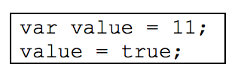

This will result in an error/exception because we cannot change the type of the variable value.

The variable value will not be changed and will still be equal to 11.

We are able to change the variable’s type so value will now equal “true”.

This will create another variable that is also named value.

correct

**Answer : 3**

Correct:

In JavaScript, it is okay to change a variable’s type, so here value becomes “true”.

**Quiz 2.2**

Quiz due Aug 4, 2020 20:05 +06

 Bookmark this page

Problem 1

1/1 point (graded)

Given the following JavaScript, what is printed to the console?  
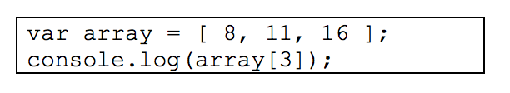

The value 16 since it is element #3 of the array.

undefined since there is no element #3.

Nothing is printed because an exception would occur.

All three elements are printed.

correct

**Answer : 2**

Correct:

The array indices are 0-based, meaning that there are elements #0, 1, and 2 but not #3. In JavaScript, accessing an index that does not exist in the array returns undefined.

Submit

You have used 1 of 3 attemptsSome problems have options such as save, reset, hints, or show answer. These options follow the Submit button.

Hint SaveSave Your Answer Show Answer

Correct (1/1 point)

Review

Problem 2

1/1 point (graded)

Given the following JavaScript, what behavior would you observe? 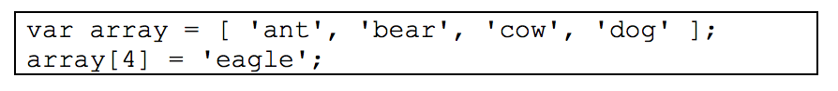

An exception would occur.

The string 'dog' would be replaced by the string 'eagle'.

The string 'eagle' would be added to the end of the array.

The string 'eagle' would be added to the front of the array.

correct

**Answer : 3**

Correct:

In JavaScript, it is possible to set elements using an index that is outside the bounds of the array, and the element will then be added to the array. Here, it is added to the end because the array already has 4 elements, so index #4 would come after the last element.

Submit

You have used 1 of 3 attemptsSome problems have options such as save, reset, hints, or show answer. These options follow the Submit button.

Hint SaveSave Your Answer Show Answer

Correct (1/1 point)

Review

Problem 3

1/1 point (graded)

I have a JavaScript object defined as follows:   
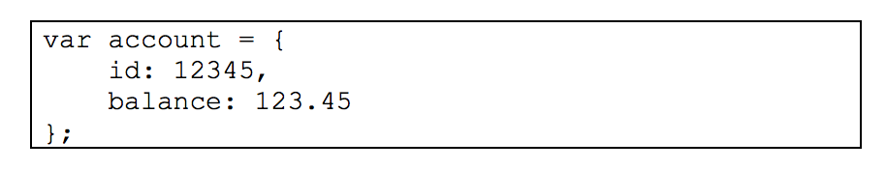   
What are the two ways of accessing the balance property?

account.balance and account.get('balance')

account.balance and account[1]

account.balance and account['balance']

account::balance and account->balance

correct

**Answer : 3**

Correct:

In JavaScript we can access an object’s properties using the “dot” notation or by using the “array” notation with the property name passed as a string.

**Quiz 2.3**

Quiz due Aug 4, 2020 20:05 +06

 Bookmark this page

Problem 1

1/1 point (graded)

I have some JavaScript code for which the expression a===b returns true. In this case, what will a==b return?

true

false

It depends on the variable types of a and b.

This will not execute because a==b is not legal JavaScript.

correct

**Answer : 1**

Correct:

In JavaScript, the triple-equals operator compares values as well as types, whereas double-equals only compares values. If a===b returns true, a and b must have the same value, so a==b will return true.

Submit

You have used 1 of 3 attemptsSome problems have options such as save, reset, hints, or show answer. These options follow the Submit button.

Hint SaveSave Your Answer Show Answer

Correct (1/1 point)

Review

Problem 2

1/1 point (graded)

In JavaScript the expression if(′false′) will evaluate to:

false because the string ′false′ is converted to the Boolean value false.

false because all strings are considered falsy.

true because all non-empty strings are considered truthy.

This will cause an exception because it is not possible to use a string in an if-statement.

correct

**Answer : 3**

Correct:

JavaScript allows all variable types to be evaluated in the conditions of if-statements. Any non-empty string is considered truthy, which will then evaluate to true.

**Quiz 2.4**

Quiz due Aug 4, 2020 20:05 +06

 Bookmark this page

Problem 1

1/1 point (graded)

If I have a JavaScript array called array and a function called fun, the array.forEach(fun) will:

return true if fun returns true for each element in array.

return a new array in which each element holds the output of invoking fun on the corresponding element in array.

modify array such that each element now holds the output of invoking fun on the corresponding original element in array.

invoke fun on each element of array.

correct

**Answer : 4**

Correct:

The forEach function does not return anything or modify the array; it simply applies the function to each element.

Submit

You have used 2 of 3 attemptsSome problems have options such as save, reset, hints, or show answer. These options follow the Submit button.

Hint SaveSave Your Answer Show Answer

Correct (1/1 point)

Review

Problem 2

1/1 point (graded)

A JavaScript prototype function is:

a function that can be used to create objects.

a function that can be used to create other functions.

a function that is automatically invoked as a result of invoking another function.

shorthand notation for specifying a function’s parameters.

correct

**Answer : 1**

Correct:

Prototype functions are invoked using the keyword new and return objects.

**Quiz 2.5**

Quiz due Aug 4, 2020 20:05 +06

 Bookmark this page

Problem 1

1/1 point (graded)

Given the following JavaScript, what would be printed to the console? 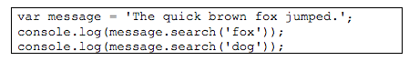

true and false

0 and -1

16 and -1

'fox' and null

correct

**Answer : 3**

Correct:

The search function determines whether the argument can be found within the string. If so, it returns the index at which the argument starts; if not, it returns -1.

Submit

You have used 1 of 3 attemptsSome problems have options such as save, reset, hints, or show answer. These options follow the Submit button.

Hint SaveSave Your Answer Show Answer

Correct (1/1 point)

Review

Problem 2

1/1 point (graded)

Given a string variable named str with value 'abc1', which of the following will return true?

/[a-z][a-z0-9][0-9]/.test(str)

/[0-9][a-z]/.test(str)

/[0-9][a-z0-9]/.test(str)

/[a-z][0-9][a-z0-9]/.test(str)

correct

**Answer : 1**

Correct:

This regular expression means “a lowercase letter; followed by a lowercase letter or digit; followed by a digit,” which matches “bc1” at the end of the string. None of the other regular expression patterns match this string.

Submit

You have used 1 of 3 attemptsSome problems have options such as save, reset, hints, or show answer. These options follow the Submit button.

Hint SaveSave Your Answer Show Answer

Correct (1/1 point)

Review

Problem 3

1/1 point (graded)

Given a string variable named str with value 'abc1def2', which of the following will return true?

/^[a-z][a-z0-9]*[0-9]$/.test(str)

/[0-9][a-z]$/.test(str)

/^[0-9][a-z0-9]*$/.test(str)

/[a-z][0-9][a-z0-9]$/.test(str)

correct

**Answer : 1**

Correct:

This regular expression means “starts with a lowercase letter; followed by 0 or more lowercase letters and digits; ends with a digit,” which matches this string. None of the other regular expression patterns match this string.

## Quiz 2.6

Quiz due Aug 4, 2020 20:05 +06

 Bookmark this page

### Problem 1

1/1 point (graded)

Given the HTML <span id='mySpan'>hello</span>, which of the following JavaScript code will use the DOM to access this HTML element?

document.get('#mySpan');

document.getElement('#mySpan');

document.getElementById('mySpan');

document.getElementById('span');

correct

**Answer :3**

Correct:

We can use the DOM to get an HTML element using the getElementById function and the id of the element.

Submit

You have used 1 of 3 attemptsSome problems have options such as save, reset, hints, or show answer. These options follow the Submit button.

Hint SaveSave Your Answer Show Answer

Correct (1/1 point)

Review

### Problem 2

1/1 point (graded)

The localStorage global variable can be used by JavaScript in an HTML page to:

Store data in the browser across multiple page requests.

Access data on the local computer’s file system.

Create global JavaScript variables for use in the page.

Share data between multiple users of a Web page.

correct

**Answer :1**

Correct:

The localStorage variable is an object that maintains the same value for different pages. It cannot, however, be used to access any data on the local computer.

### Problem 1

1/1 point (graded)

In JavaScript, a callback function is:

A function that is invoked as the result of some type of action or event.

A function that has no return value.

A function that can be used to call other functions.

A function that is used as part of another function.

correct

**Answer : 1**

Correct:

A callback function is one that you as the programmer implement but do not invoke; rather, the underlying system (in this case, the browser) invokes it after some event or action.

Submit

You have used 1 of 3 attemptsSome problems have options such as save, reset, hints, or show answer. These options follow the Submit button.

Hint SaveSave Your Answer Show Answer

Correct (1/1 point)

Review

### Problem 2

0/1 point (graded)

What is the result of the following JavaScript code? 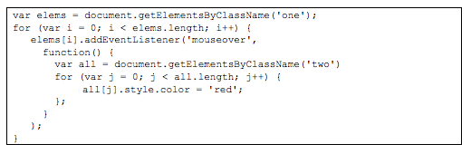

When the user places the mouse over any element in the “one” class, any element that is either in the “one” or “two” class becomes red.

When the user places the mouse over any element in the “one” class, any element that is in both the “one” and “two” classes becomes red.

When the user places the mouse over any element in the “two” class, all elements in the “one” class become red.

When the user places the mouse over any element in the “one” class, all elements of the “two” class become red.

Ans : 4

## Quiz 2.8

Quiz due Aug 4, 2020 20:05 +06

 Bookmark this page

### Problem 1

1/1 point (graded)

The command document.getElementsByClassName('something') is equivalent to which of the following jQuery commands?

$('something')

$('.something')

$('#something')

$('class:something')

correct

**Answer 2**

Correct:

To access a class in jQuery, use the “dot” notation as you would in CSS.

Submit

You have used 1 of 3 attemptsSome problems have options such as save, reset, hints, or show answer. These options follow the Submit button.

Hint SaveSave Your Answer Show Answer

Correct (1/1 point)

Review

### Problem 2

1/1 point (graded)

I have a variable mySpan that refers to an HTML element. Which of the following jQuery commands is equivalent to mySpan.innerHTML = 'hello';?

mySpan = 'hello';

mySpan.innerHTML('hello');

mySpan.html() = 'hello';

mySpan.html('hello');

correct

**Answer 4**

Correct:

Using jQuery, the html function allows us to modify an HTML element’s contents.

## Quiz 2.9

Quiz due Aug 4, 2020 20:05 +06

 Bookmark this page

### Problem 1

1/1 point (graded)

The purpose of the jQuery “on” function is to:

Specify the callback function to be invoked when the user places the mouse over the element.

Specify the callback function to be invoked when the element is first rendered in the page.

Specify a sequence of callback functions to be invoked when the user interacts with the element.

Specify an object that defines callback functions for different actions/events for a given element or elements.

correct

**Answer 4**

Correct:

The argument to the “on” function is an object in which the properties are the names of the different events, and their corresponding values are the corresponding callback functions.

Submit

You have used 2 of 3 attemptsSome problems have options such as save, reset, hints, or show answer. These options follow the Submit button.

Hint SaveSave Your Answer Show Answer

Correct (1/1 point)

Review

### Problem 2

1/1 point (graded)

Which of the following jQuery commands selects all <div> elements that are in the “fun” class?

$('div.fun')

$('fun.div')

$('div').find('.fun')

$('.fun').find('div')

correct

**Answer 1**

Correct:

This selector combines the div element type with the “fun” class using the '.fun' notation. Option #2 would attempt to select fun elements in the “div” class. Option #3 would select elements in the “fun” class that are children of “div” elements, but not the “div” elements themselves. Likewise for Option #4.

## Quiz 2.10

Quiz due Aug 4, 2020 20:05 +06

 Bookmark this page

### Problem 1

1/1 point (graded)

What HTML elements are selected with the jQuery command $("select[name='id']")?

All elements with the name “id” that are children of <select> elements.

All <select> elements that have the name “id”.

All elements with the name “id”.

All elements in the class “id”.

correct

**Answer 2**

Correct:

This notation allows us to select HTML elements but also specify their attributes; here, we’re selecting <select> elements but also specifying that we want the ones with the “name” attribute set to the value “id”.

Submit

You have used 2 of 3 attemptsSome problems have options such as save, reset, hints, or show answer. These options follow the Submit button.

Hint SaveSave Your Answer Show Answer

Correct (1/1 point)

Review

### Problem 2

1/1 point (graded)

In jQuery, the selector $(this) refers to:

A specific element that was selected as part of a group of elements.

All elements that were selected as part of a group of elements.

The current HTML page.

All elements in the HTML page.

correct

**Answer 1**

Correct:

Depending on the selector, we may choose many elements in a page, and any specified callback function will be applied to each element that is selected. In order to access each individual element in the callback function, we use $(this) within the function.