*Tyler Kim*

*DLD*

**Exercise 3 Verification Report**

**Component**

**Figure 1: Multiplexor Visual Schematic**

**Figure 2: Multiplexor Component Visual Schematic**

The purpose of this exercise was to create a multiplexor or MUX, a combinational circuit that connects 1 of N input signals to a single output. A MUX is a key component for designing the circuitry of a computer. For this particular exercise, a two input MUX component as shown in Figure 2: Multiplexor Component Visual Schematic was used as a component to form the main MUX as seen in Figure 1: Multiplexor Visual Schematic.

**MUX Signature**

* INPUTS:
  + Sel bus from 0 - 1
  + Input bus from 0 - 3
* OUTPUTS:
  + Z of either 0 or 1

**Verification Tests**

Port Mapping

sel[0..1] => sel_tb

input_n[3..0] => in_n_tb

Z => z_tb

|  |  |  |  |
| --- | --- | --- | --- |
| **sel_tb** | **in_n_tb** | **z_tb** | **z_expected** |
| 00 | 0000 | 0 | 0 |
| 00 | 0001 | 1 | 1 |
| 01 | 0000 | 0 | 0 |
| 01 | 0010 | 1 | 1 |
| 10 | 0000 | 0 | 0 |
| 10 | 0100 | 1 | 1 |
| 11 | 0000 | 0 | 0 |
| 11 | 1000 | 1 | 1 |

**Figure 3: Port Mapping and Truth Table**

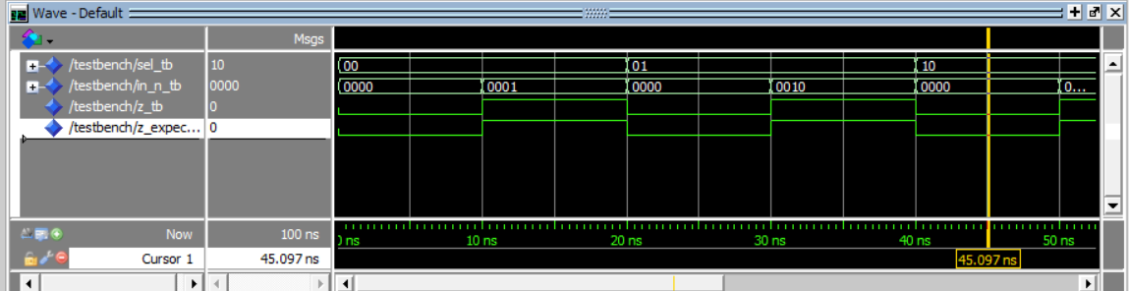

**Figure 4: Verification Test Results**

**Figure 5: Verification Test Results with Assert Statements**

Figure 3 – 5 displays the verification and testing process of the MUX schematic. The test results suggest that the verification test results from ModelSim match that of the expected output and the truth table; therefore, the MUX schematic is correct and passed all tests.