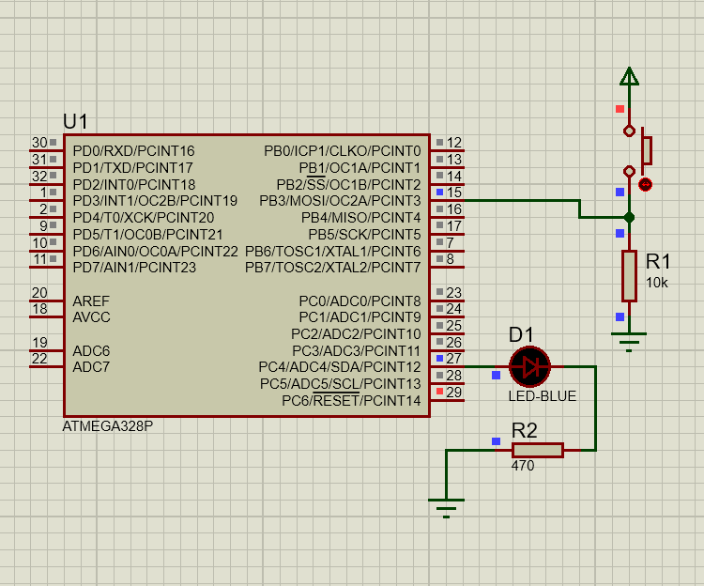

.include "m328pdef.inc"
.org 0
cbi ddrb, 3
sbi ddrc, 4
again: nop
wait: sbis pinb, 3
rjmp wait

sbi portc,4
call qdelay
cbi portc,4
call qdelay

rjmp again

QDELAY:
LDI R20, 5
D1: LDI R21, 250
D2: LDI R22, 250
D3: NOP
NOP
DEC R22
BRNE D3
DEC R21
BRNE D2
DEC R20
BRNE D1
RET

