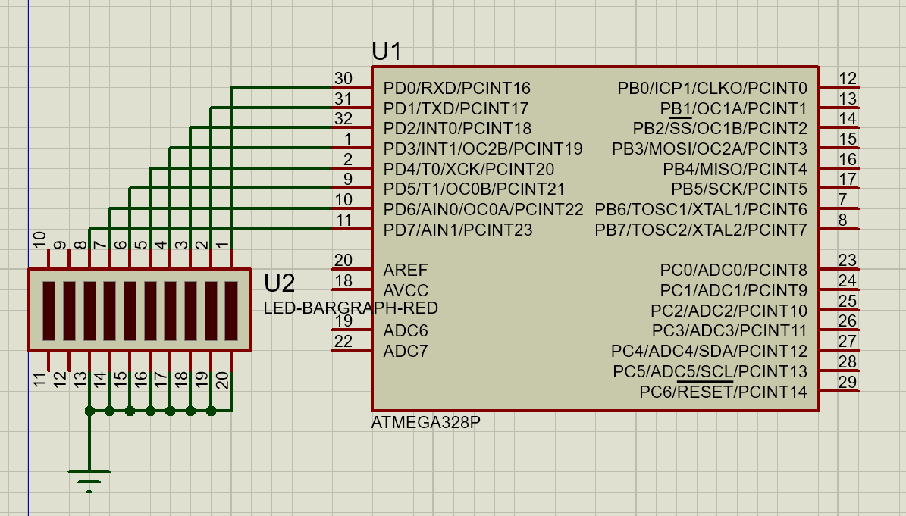

.INCLUDE"M328pDEF.INC"
.ORG 0
LDI R16, HIGH (RAMEND)
OUT SPH, R16
LDI R16, LOW (RAMEND)
OUT SPL, R16

LDI R19, 0xFF
OUT DDRD,R19

START:
LDI R20, 0x55
OUT PORTD,R20
RCALL DELAY1
LDI R20, 0x0AA
OUT PORTD,R20
RCALL DELAY2

JMP START
DELAY1:
LDI R16, 200
AGAIN4: LDI R17, 200
AGAIN5: LDI R18, 10
AGAIN6: DEC R18
BRNE AGAIN6
DEC R17
BRNE AGAIN5
DEC R16
BRNE AGAIN4
RET

DELAY2:
LDI R16, 200
AGAIN3: LDI R17, 200
AGAIN2: LDI R18, 1
AGAIN1: DEC R18
BRNE AGAIN1
DEC R17
BRNE AGAIN2
DEC R16
BRNE AGAIN3
RET

