**DEPARTMENT OF INFORMATION AND COMMUNICATION TECHNOLOGY**

**ISLAMIC UNIVERSITY, BANGLADESH**



Statistics for Communication Engineering Laboratory

**SUBMITTED TO:**

**Prof. Dr Zahidul Islam**

**Professor**

**Information & Communication Technology**

**Islamic University, Bangladesh**

**Sadia Afrin Kumu**| Roll No.: **2018056**| Reg. No.: **1331**| **10.02.2024**|

# Experiment N0. – 1

**Simulating a Normal Distribution**

## **objective:**

Generate and plot a normal distribution with specified mean and standard deviation.

**INPUT:**

%Parameters

mu=0;%Mean

sigma=1;%Standard Deviation

%Generate a normal distribution

x=-3*sigma:0.1:3*sigma;

y=normpdf(x,mu,sigma);

%Plot

figure;

plot(x,y);

title('Normal Distribution');

xlabel('Value');

ylabel('Probability Density');

**OUTPUT**:

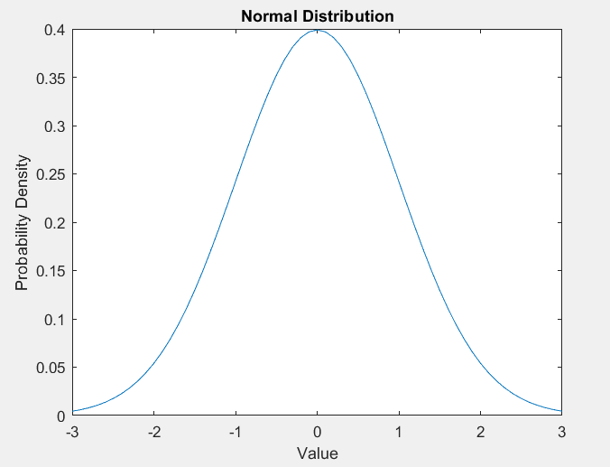

# Experiment N0. – 2

**Calculating Binomial Probabilities**

**OBJECTIVE**:

Calculate and plot the probabilities for a binomial distribution.

**INPUT:**

%Parameters

n=10;%Number of trials

p=0.5;%Probality of success

%Calculate binomial probabilities

x=0:n;

y=binopdf(x,n,p);

%Plot

figure;

bar(x,y);

title('Binomial Distribution');

xlabel('Number of Successes');

ylabel('Probability');

**OUTPUT**:

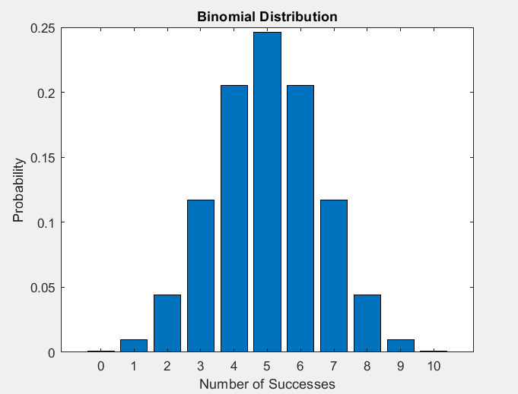

# Experiment N0. – 3

**Poisson Distribution**

## **oBJECTIVE:**

Plot the Poisson distribution for different mean values.

**INPUT:**

%Parameters

lambda=[2,4,6];%Different mean values

%Generate and plot Poissson distributions

figure;

for i=1:length(lambda)

x=0:15;

y=poisspdf(x,lambda(i));

subplot(1,length(lambda),i);

bar(x,y);

title(['Poisson Distribution with \lambda=',num2str(lambda(i))]);

xlabel('Number of Events');

ylabel('Probability');

end

**OUTPUT**:

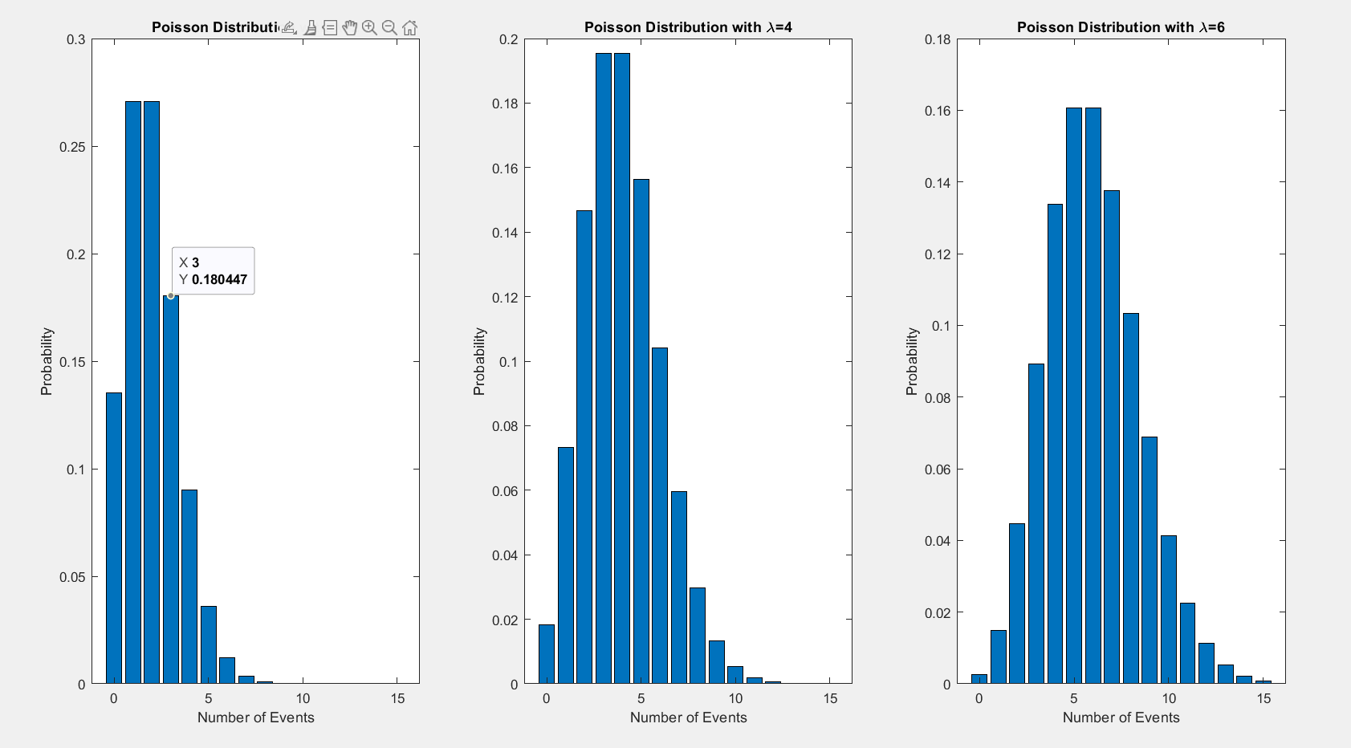

# Experiment N0. – 4

**Exponential Distribution**

## **oBJECTIVE:**

Generate an exponential distribution and plot its probability destiny function.

**INPUT:**

%Parameter

lambda=1;%Rate parameter

%Generate expotential distribution

x=0:0.1:10;

y=exppdf(x,1/lambda);

%Plot

figure;

plot(x,y);

title('Expotential Distribution');

xlabel('Value');

ylabel('Probability Density');

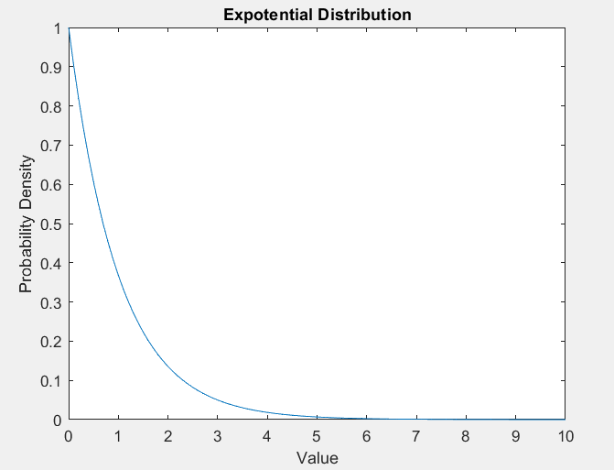**OUTPUT**:

# Experiment N0. – 5

**Uniform Distribution**

## **oBJECTIVE:**

Simulate and visualize a uniform distribution.

**INPUT:**

%Parameters

a=0;%Lower bound

b=1;%Upper bound

%Generate uniform distribution

x=a:0.01:b;

y=unifpdf(x,a,b);

%plot

figure;

plot(x,y);

title('Uniform Distribution');

xlabel('Value');

ylabel('Probability Density');

**OUTPUT**:

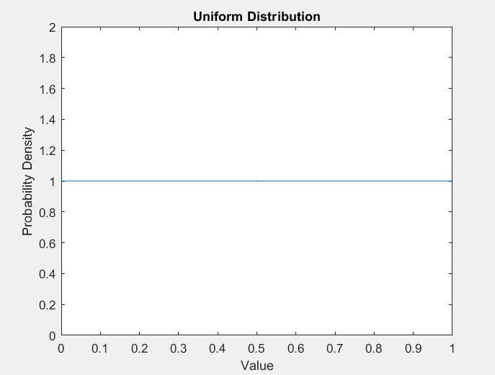

# Experiment N0. – 6

**Cumulative Distribution Function (CDF)**

## **oBJECTIVE:**

Plot the CDF of a normal distribution.

**INPUT:**

%Parameters

mu=0;%Mean

sigma=1;%Standard Deviation

%Generate CDF

x=-3*sigma:0.1:3*sigma;

y=normcdf(x,mu,sigma);

%Plot

figure;

plot(x,y);

title('CDF of Normal Distribution');

xlabel('Value');

ylabel('Cumulative Probability');

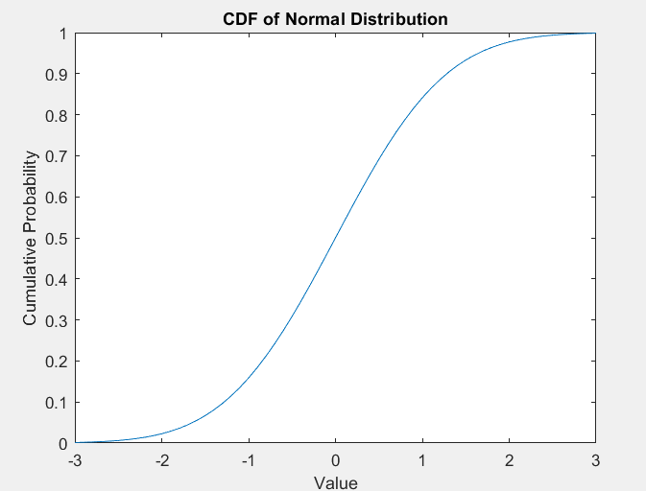**OUTPUT**:

# Experiment N0. – 7

Working with Random Variables

## **oBJECTIVE:**

Generate random numbers from a normal distribution and calculate their statistics.

**INPUT:**

%Generate random numbers

num_samples=1000;

samples=normrnd(0,1,[num_samples,1]);

%Calculate statistics

mean_val=mean(samples);

std_dev=std(samples);

%Display results

fprintf('Mean:%.2f\n',mean_val);

fprintf('Standard Deviation:%.2f\n',std_dev);

**OUTPUT**:

Mean:-0.03

Standard Deviation:1.00

# Experiment N0. – 8

Calculating Mean, Median and Mode

## **oBJECTIVE:**

Find the mean, median and mode of a given data set.

**INPUT:**

%Calculating Mean,median an mode of a given data set.

%Data

data=[15,9,26,13,14,12,22,19];

%Mean

mean_val=mean(data);

%Median

median_val=median(data);

%Mode

mode_val=mode(data);

%Display results

fprintf('Mean:%.2f\n',mean_val);

fprintf('Median:%.2f\n',median_val);

fprintf('Mode:%.2f\n',mode_val);

**OUTPUT**:

Mean:16.25

Median:14.50

Mode:9.00

# Experiment N0. – 9

**Standard Deviation and Variance**

## **oBJECTIVE:**

Compute the standard deviation and variance of a data set.

**INPUT:**

%Standard deviation and variance

%Data

data=[15,9,26,13,14,12,22,19];

%Standard Deviation

std_dev=std(data);

%Variance

variance=var(data);

%Display results

fprintf('Standard Deviation:%.2f\n',std_dev);

fprintf('variance:%.2f\n',variance);

**OUTPUT**:

Standard Deviation:5.65

variance:31.93

# Experiment N0. – 10

**Linear Correlation Coefficient**

## **oBJECTIVE:**

Determine the linear correlation coefficient (Pearson’s r) between two sets of data.

**INPUT:**

%Linear correlation Coefficient

%Data

data_x=[1,2,3,4,5];

data_y=[2,4,5,4,5];

%correlation Coefficient

corr_coeff=corrcoef(data_x,data_y);

%Display result

fprintf('Correlation Coefficient:%.2f\n',corr_coeff(1,2));

**OUTPUT**:

Correlation Coefficient:0.77

# Experiment N0. – 11

**Histogram Plotting**

## **oBJECTIVE:**

Create a Histogram to visualize the distribution of a data set.

**INPUT:**

%Histogram Plotting

%Data

data=[15,9,26,13,14,12,22,19];

%Plot

figure;

histogram(data);

title('Data Distribution');

xlabel('Value');

ylabel('frequency');

**OUTPUT**:

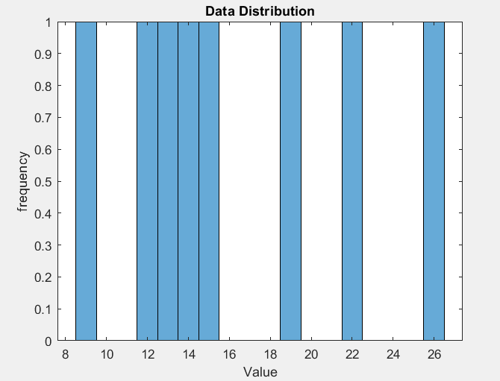

# Experiment N0. – 12

**Boxplot for Data Distribution**

## **oBJECTIVE:**

Generate a boxplot to observe the spread and skewness of data.

**INPUT:**

%Boxplot for Data Distribution

%Data

data=[15,9,26,13,14,12,22,19];

%Boxplot

figure;

boxplot(data);

title('Boxplot of Data');

**OUTPUT**:

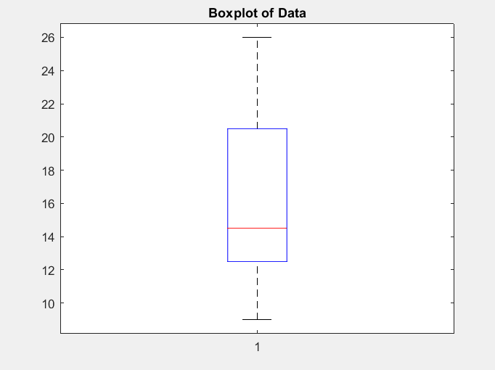

# Experiment N0. – 13

**Scatter Plot for Two Variables**

## **oBJECTIVE:**

Create a scatter plot to visualize the relationship between two variables.

**INPUT:**

%Scatter Plot for Two Variables

%Data

data_x=[1,2,3,4,5];

data_y=[2,4,5,4,5];

%Scatter plot

figure;

scatter(data_x,data_y);

title('Scatter plot');

xlabel('X-axis');

ylabel('Y-axis');

**OUTPUT**:

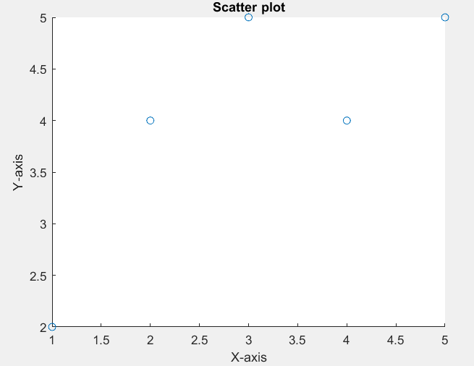

# Experiment N0. – 14

**Generating Random Data and Analyzing**

## **oBJECTIVE:**

Generate random data following a normal distribution and analyze it.

**INPUT:**

%Generating Random Data and Analyzing

%Generate random data

data=normrnd(0,1,[100,1]);%100 random numbers from N(0,1)

%Mean and Standard Deviation

mean_val=mean(data);

std_dev=std(data);

fprintf(' Random Data:%.2f\n',mean_val);

fprintf('Standard Deviation of Random Data:%.2f\n',std_dev);

%Plot Histogram

figure;

histogram(data);

title('Histogram of Random Data');

**OUTPUT**:

Random Data:0.08

Standard Deviation of Random Data:1.07

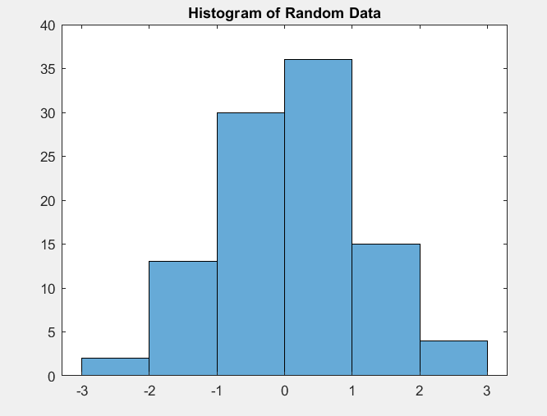

# Experiment N0. – 15

**Simple Linear Regression**

## **oBJECTIVE:**

Simple linear regression involves a single independent variable. Let’s say we have some data x and y, and we want to fit a line y = a*x+b.

**INPUT:**

%Simple Linear Regression

%Sample Data

x=[1,2,3,4,5];

y=[2,3,4,6,5];

%Perform Linear Regression

p = polyfit(x,y,1); %p(1) is slope, p(2) is intercept

%Create a linear model

y_fit = polyval(p,x);

%Plot

figure;

plot(x,y,'o'); %Original data

hold on;

plot(x,y_fit,'-'); %Fitted Line

title('Simple Linear Regression');

xlabel('x');

ylabel('y');

legend('Data','Fitted Line');

**OUTPUT**:

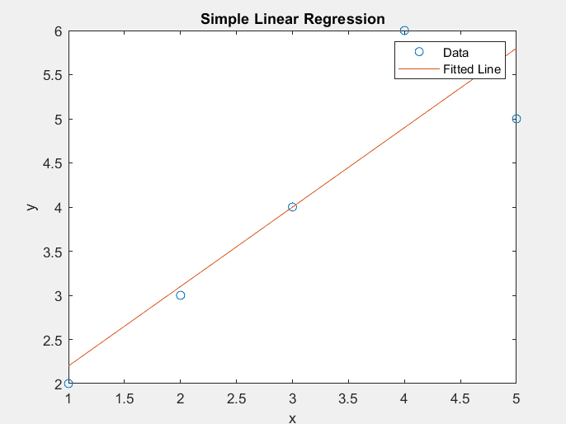

# Experiment N0. – 16

**Multiple Linear Regression**

## **oBJECTIVE:**

In multiple linear regression, we predict a dependent variable based on multiple independent variables.

**INPUT:**

%Multiple Linear Regression

%Sample Data

X=[1 2 3; 2 3 4; 3 4 5; 4 5 6; 5 6 7]; %Each Row is an observation

y=[2;3;4;6;5]; %Dependent variable

%Add a column of ones to X for the intercepts

X=[ones(size(X,1),1),X];

%Perform regression

b = regress(y,X); %Returns the regression coefficients

%Predicted Values

y_pred = X*b;

%Display the coefficients

disp('Coefficients(including intercept:');

disp(b);

%Plot-only practical if you have 1 or 2 independent variables

%For more variables, consider #D plots or partial regression plots

**OUTPUT**:

Coefficients (including intercept:

0

0.2500

0

0.6500

# Experiment N0. – 17

**Polynomial Regression**

## **oBJECTIVE:**

Polynomial regression fits a nonlinear relationship between the value of x and the corresponding conditional mean of y.

**INPUT:**

%Polynomial Regression

%Sample Data

x=[1,2,3,4,5];

y=[2,4,6,8,10];

%Polynomial Degree

degree =2;

%Perform polynomial regression

p= polyfit(x,y,degree);

%Create a polynomial model

x_fit = linspace(min(x),max(x),100); %100 points for a smoother plot

y_fit = polyval(p,x_fit);

%Plot

figure;

plot(x,y,'o'); %Original Data

hold on;

plot(x_fit,y_fit,'-'); %Fitted polynomial

title('Polynomial Regression');

xlabel('x');

ylabel('y');

legend('Data','Fitted polynomial');

**OUTPUT**: