# 3. External Interface Requirements

## 3.1 User Interfaces

**3.1.1 Home**

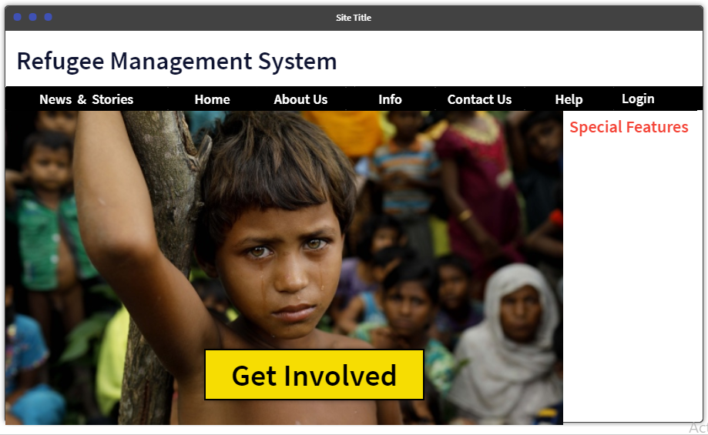

**3.1.2 Admin**

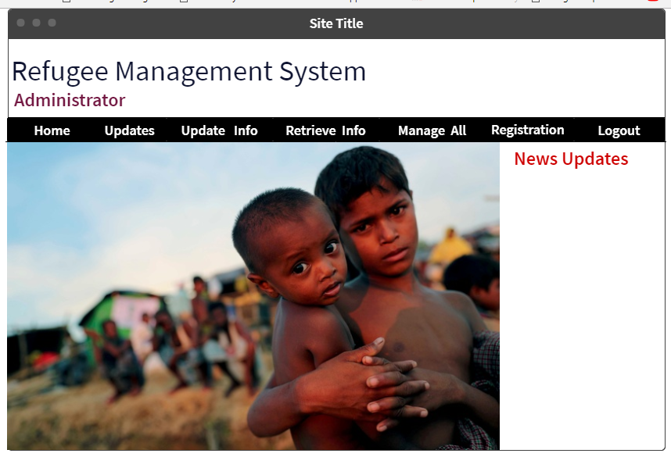

**3.1.2.1 Registration**

* **Refugee Registration**
* **Volunteer Registration**
* **Donor Registration**
* **Doctor Registration**
* **Home**

**3.1.2.2 Update Information**

* **Admin Info**
* **Refugee Info**
* **Volunteer Info**
* **Donor Info**

**3.1.2.3 Retrieve Information**

* **Admin Info**
* **Refugee Info**
* **Volunteer Info**
* **Donor Info**

**3.1.3 Volunteer**

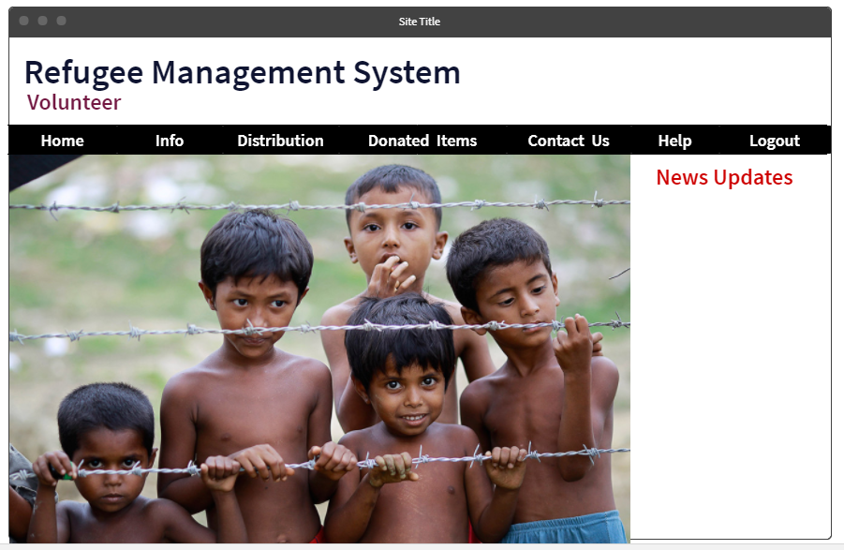

**3.1.3.1 Distribution**

All the donated items distributed to the refugees by the volunteers and their requirement information will be found here. It will show a statistics about the distributed food items, medical facilities, clothes, preliminary treatment provided to the refugees which will fetch data from the database.

**3.1.4 Donator**

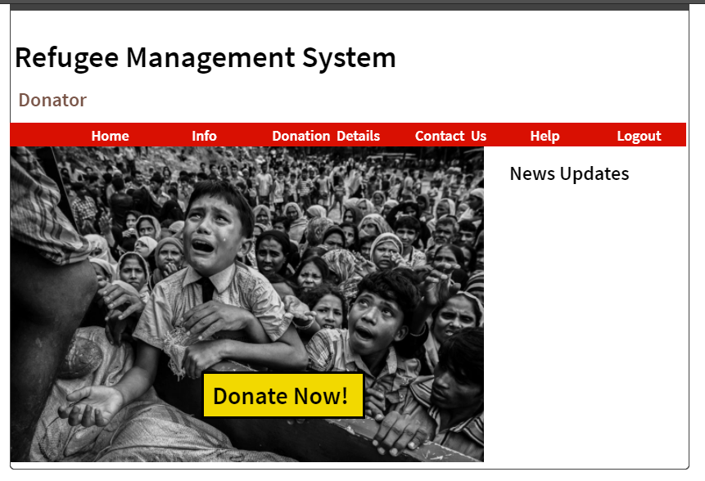

**3.1.4.1 Donation**

Donors from worldwide will be able to donate money, food, cloths, medicine to the refugee camps and participate in helping them via internet by connecting to our helping desk

**3.1.5 Doctor**

* **Info**
* **Contact Us**
* **Logout**

## 3.2 Hardware Interfaces

The minimum hardware requirement is 500 Megahertz CPU and 128 megabytes of RAM.

## 3.3 Software Interfaces

This requires Java to be installed on the system, more specifically Java version 7 or 8 for its latest release. Additional information can be found on section 2.7 of this document. It can be connected with a SQLite database to import data starting from admin data to refugee data.

**Operating system:** We have chosen Windows operating system for its best support and user-friendliness.

**Database:** To record information regarding the refugees, volunteers, donors we have chosen SQL Plus database.

## 3.4 Communications Interfaces

## This project supports all types of web browsers. We are using simple forms for information storage of the refugee, volunteering activities to help the refugees, collecting donations worldwide etc.

# 4. System Features

## 4.1 Registration

**4.1.1 Description and Priority**

This is the most important task of our software where the data of the refugees moving to the camps are stored in the database via this software. All the data of the refugees starting from their name, age, blood group, gender are stored.

**4.1.2 Stimulus/Response Sequences**

* Registration of the refugees, volunteers, donors
* Acquiring the general information for emergency purpose

**4.1.3 Functional Requirements**

**REQ-1:**  It shall register the refugees by taking the appropriate information

**REQ-2:**  It shall notify once the registration is complete

## 4.2 Information retrieval

**4.2.1 Description and Priority**

The motive of this software is to acquire the detailed information of the refugees and the service provided to them so that we can trace how many refugees have entered our country and could estimate what could be the upcoming problems and take measures accordingly.

**4.2.2 Stimulus/Response Sequences**

* Information retrieval of the refugees for future use purpose
* Acquiring the services received by the refugees
* Anticipating the future problems that may arrive

**4.2.3 Functional Requirements**

**REQ-1:**  It shall return the appropriate information

**REQ-2:**  It shall calculate and return a statistic report

## 4.2 Receive donation

**.2.1 Description and Priority**

The motive of this software is to view the detailed information of the refugees and the service provided to them so that people can know and come forward to donate for the refugees and hence it becomes easier for the camps to serve them.

**4.2.2 Stimulus/Response Sequences**

* Some specified types of donation are received
* Donor has to register first
* Admin verifies the donor

**4.2.3 Functional Requirements**

**REQ-1:**  It shall receive the donationand should include in the database

**REQ-2:**  It shall notify the admin once the donation is received

**REQ-3:** It shall notify the donor once the donation is received