|  |  |
| --- | --- |
| **Name** | **Kainath, MD Tazul Islam** |
| **ID** | **19-39341-1** |
| **COURSE** | **Computer Networks** |
| **SECTION** | **F** |
| **ASSIGNMENT** | **Final-Term** |

Y = OSPF ( ODD)

X=4 = R3 (DHCP)

Z-1 = 0 (Switch 0 VTP server)

ID: ST-UVWXY-Z

ID: 19-39341-1

|  |
| --- |
| S=1, T=9, U=3, V=9, W=3, X=4, Y=1, Z=1 |

IP block: 1YX.UV.0.0/16 114.39.0.0/16

**Table 1(VLSM)**

|  |  |  |  |  |  |
| --- | --- | --- | --- | --- | --- |
| Private Ip Block 172.16.0.0/12Subnet | IP Requirement | Num of allocated Ips | Host/N. Bits | Subnet Mask | Allocated Ip Range |
| P | YX=14 | 24=16 | Host Bits:4  Network Bits:28 | 255.255.255.240 | 172.16.0.0/28  To 172.16.0.15/28 |
| Q | XW=43 | 26=64 | Host Bits:6  Network Bits:26 | 255.255.255.192 | 114.39.0.0/26  To 114.39.0.63/26 |
| Between  R1 & R2 | 3 | 23=8 | Host Bits:3  Network Bits:29 | 255.255.255.248 | 114.39.0.64/29  To 114.39.0.72/29 |
| Between  R2 & R3 | 3 | 23=8 | Host Bits:3  Network Bits:29 | 255.255.255.248 | 114.39.0.73/29  To 114.39.0.80/29 |
| VLAN with the LastName Web Server Connected | TX=94 | 27=128 | Host Bits:7  Network Bits:25 | 255.255.255.128 | 114.39.0.81/25  To 114.39.0.208/25 |
| VLAN 10 | YWV=139 | 29=512 | Host Bits:9  Network Bits:23 | 255.255.254.0 | 114.39.0.209/23  To 114.39.2.208/23 |
| VLAN 15 | ZZS=111 | 27=128 | Host Bits:7  Network Bits:25 | 255.255.255.128 | 114.39.2.209/25  To 114.39.3.80/25 |
| NAT IP Pool | 6 | 23=8 | Host Bits:3  Network Bits:29 | 255.255.255.248 | 114.39.3.81/29  To 114.39.3.88/29 |

**Table 2 (Router 1)**

|  |  |
| --- | --- |
| Router>enable  Router#config terminal  Enter configuration commands, one per line. End with CNTL/Z.  Router(config)#int se0/2/0  Router(config-if)#ip address 114.39.0.150 255.255.255.128  % 114.39.0.128 overlaps with FastEthernet0/0  Router(config-if)#ip address 114.39.0.65 255.255.255.248  Router(config-if)#no shut  Router(config-if)#exit  Router(config)#int fa0/0  Router(config-if)#ip address 114.39.0.150 255.255.255.128  Router(config-if)#no shut  Router(config-if)#exit  Router(config)#router ospf 12  Router(config-router)#network 114.39.0.16 0.0.0.7 area 0  Router(config-router)#  00:25:38: %OSPF-5-ADJCHG: Process 12, Nbr 172.16.0.1 on Serial0/2/0 from LOADING to FULL, Loading Done  Router(config-router)#network 114.39.0.32 0.0.0.127 area 0  Router(config-router)#exit  Router(config)#interface fa 0/0.10  Router(config-subif)#ip helper-address 114.39.0.29  R1(config-subif)#int fa0/0.15  R1(config-subif)#encapsulation dot1q 15  R1(config-subif)# ip address 114.39.0.15 255.255.255.128 | Interface selection  Gateways interfaces Setting  OSPF creation  Networks Selection  Ip helper to get Ip from DHCP server  ROAS - Vlans can be connected outside the network selection |

**Table 3 (Router 2)**

|  |  |
| --- | --- |
| Router>enable  Router#config terminal  Enter configuration commands, one per line. End with CNTL/Z.  Router(config)#int fa0/0  Router(config-if)#ip address 172.16.0.1 255.255.255.240  Router(config-if)#no shut  Router(config)#int se0/2/0  Router(config-if)#ip address 114.39.0.70  % Incomplete command.  Router(config-if)#ip address 114.39.0.70 255.255.255.248  Router(config-if)#  00:08:53: %OSPF-5-ADJCHG: Process 12, Nbr 114.39.0.150 on Serial0/2/0 from FULL to DOWN, Neighbor Down: Interface down or detached  Router(config-if)#no shut  Router(config-if)#int se0/2/1  Router(config-if)#ip address 114.39.0.75 255.255.255.248  Router(config-if)#  00:09:15: %OSPF-5-ADJCHG: Process 12, Nbr 114.39.0.29 on Serial0/2/1 from FULL to DOWN, Neighbor Down: Interface down or detached  Router(config-if)#no shut  Router(config-if)#exit  --------------------------------------------------  Router(config)#int se0/2/0  Router(config-if)#ip nat outside  Router(config-if)#exit  Router(config)#int se0/2/1  Router(config-if)#ip nat outside  Router(config-if)#exit  Router(config)#int fa0/0  Router(config-if)#ip nat inside  Router(config-if)#access-list 1 permit 172.16.0.1 0.0.0.14  Router(config)#ip nat pool NAT 114.39.3.33 114.39.3.38 netmask 255.255.255.248  Router(config)#ip nat inside source list 1 pool NAT  Router(config)#exit  Router(config)#router ospf 12  Router(config-router)#network 172.16.0.0 0.0.0.15 area 0  Router(config-router)#network 114.39.0.16 0.0.0.7 area 0  Router(config-router)#network 114.39.0.24 0.0.0.7 area 0  Router(config-router)#exit  Router(config)# | Router Enabling  The Interface  Setting Gateways to the interfaces selection  The Interface Setting Gateways to the interfaces  --------------------------------------  Nat for ip translation Enabling  Permission for the private addresses  Nat pool addresses which will be used for public addresses  OSPF Creation  Networks Selection |

**Table 4(Router 3)**

|  |  |
| --- | --- |
| Router>enable  Router#config terminal  Enter configuration commands, one per line. End with CNTL/Z.  Router(config)#int se0/2/0  Router(config-if)#ip address 114.39.0.24 255.255.255.248  Bad mask /29 for address 114.39.0.24  Router(config-if)#ip address 114.39.0.29 255.255.255.248  Router(config-if)#no shut  Router(config-if)#  %LINK-5-CHANGED: Interface Serial0/2/0, changed state to up  Router(config-if)#int fa0/1  Router(config-if)#  %LINEPROTO-5-UPDOWN: Line protocol on Interface Serial0/2/0, changed state to up  Router(config-if)#ip address 114.39.0.2 255.255.255.240  Router(config-if)#no shut  Router(config-if)#  %LINK-5-CHANGED: Interface FastEthernet0/1, changed state to up  %LINEPROTO-5-UPDOWN: Line protocol on Interface FastEthernet0/1, changed state to up  Router(config-if)#exit  ---------------------------------------------------------------  Router(config)#router ospf 12  Router(config-router)#network 114.39.0.24 0.0.0.7 area 0  Router(config-router)#  00:34:34: %OSPF-5-ADJCHG: Process 12, Nbr 172.16.0.1 on Serial0/2/0 from LOADING to FULL, Loading Done  Router(config-router)#network 114.39.0.0 0.0.0.15 area 0  Router(config-router)#exit  Router>enable  Router#config terminal  Enter configuration commands, one per line. End with CNTL/Z.  Router(config)#ip dhcp pool vlan15  Router(dhcp-config)#network 114.39.0.160 255.255.254.0  Router(dhcp-config)#dns-server 114.39.0.4  Router(dhcp-config)#default-router 114.39.0.150  Router(dhcp-config)#exit | Interface  Setting Gateways to the interfaces selection  Interface Setting Gateways to the interface  Interface Setting Gateways to the interfaces selection  OSPF creation  Networks Selection  DHCP pool address for Vlan 15 creation |

**Table 5 (Switch 0)**

|  |  |
| --- | --- |
| Switch>enable  Switch#config terminal  Enter configuration commands, one per line. End with CNTL/Z.  Switch(config)#vlan 10  Switch(config-vlan)#name TAZUL  Switch(config-vlan)#exit  Switch(config)#vlan 15  Switch(config-vlan)#name KAINATH  Switch(config-vlan)#EXIT  Switch(config)#end  Switch(config)#interface rang fa0/5-6  Switch(config-if-range)#switchport mode access  Switch(config-if-range)#switchport access vlan 10  Switch(config-if-range)#exit  Switch(config)#interface rang fa0/3-4  Switch(config-if-range)#switchport mode access  Switch(config-if-range)#switchport access vlan 15  Switch(config-if-range)#exit  Switch(config)#int fa0/2  Switch(config-if)#switchport mode trunk  Switch(config-if)#  %LINEPROTO-5-UPDOWN: Line protocol on Interface FastEthernet0/2, changed state to down  %LINEPROTO-5-UPDOWN: Line protocol on Interface FastEthernet0/2, changed state to up  Switch(config-if)#exit  Switch(config)#int fa0/1  Switch(config-if)#switchport mode trunk  Switch(config-if)#exit  Switch(config)#end  Switch>enable  Switch#configure terminal  Enter configuration commands, one per line. End with CNTL/Z.  Switch(config)#vtp mode server  Device mode already VTP SERVER.  Switch(config)#vtp domain KAINATH  Changing VTP domain name from NULL to KAINATH  Switch(config)#vtp password 123 | Vlan  Names formate  Giving interface access  Giving interface access  Interface as trunk port making  Creating VTP and Switch 0 as server |

**Table 6 (Switch 1)**

|  |  |
| --- | --- |
| Switch>enable  Switch#configure terminal  Switch(config)#interface range fa0/1-2  Switch(config-if-range)#switchport mode trunk  Switch(config-if-range)#exit  Switch>enable  Switch#configure terminal  Enter configuration commands, one per line. End with CNTL/Z.  Switch(config)#vtp mode client  Setting device to VTP CLIENT mode.  Switch(config)#vtp password 123 | Selecting interface and making it trunk port  Setting VTP and Switch 1 as clients |

**Table 7 (Switch 2)**

|  |  |
| --- | --- |
| Switch>enable  Switch#configure terminal  Enter configuration commands, one per line. End with CNTL/Z.  Switch(config)#vlan 15  Switch(config-vlan)#name KAINATH  Switch(config-vlan)#interface range fa0/2-3  Switch(config-if-range)#switchport mode access  Switch(config-if-range)#switchport access vlan 15  Switch(config-if-range)#exit  Switch(config)#int fa0/1  Switch(config-if)#switchport mode trunk  Switch(config-if)#exit  Switch>enable  Switch#configure terminal  Enter configuration commands, one per line. End with CNTL/Z.  Switch(config)#vtp mode client  Setting device to VTP CLIENT mode  Switch(config)#vtp password 123 | Interfaces and creating Vlans and giving access to the Vlans selection  Setting VTP and Switch 1 as clients |

**Screenshots**

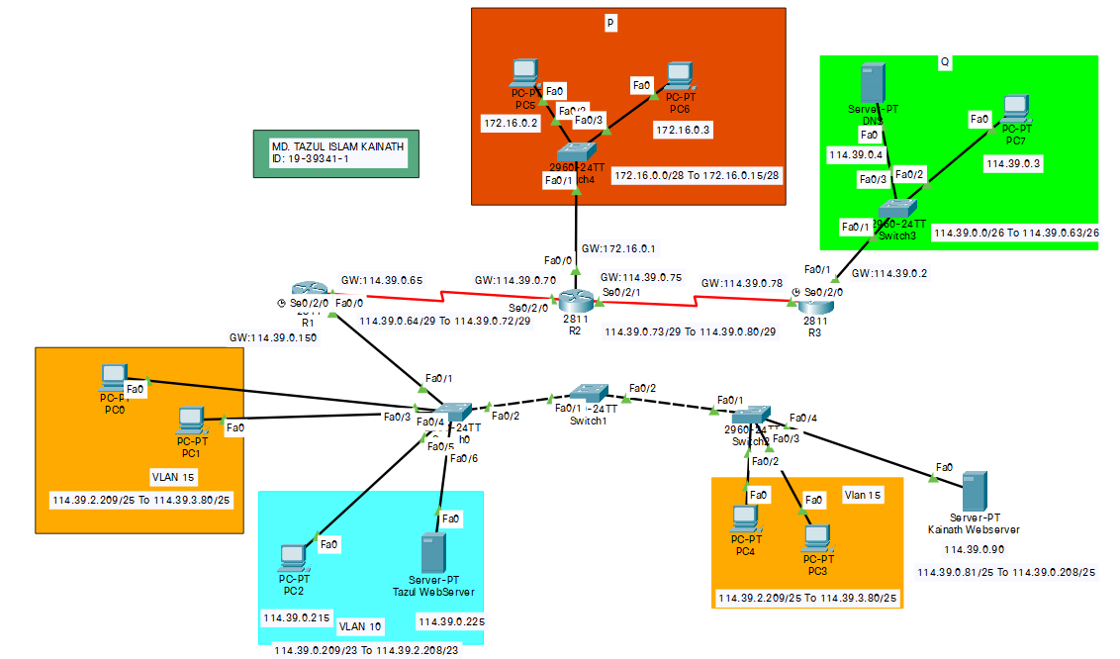

Design with labeling Of Network

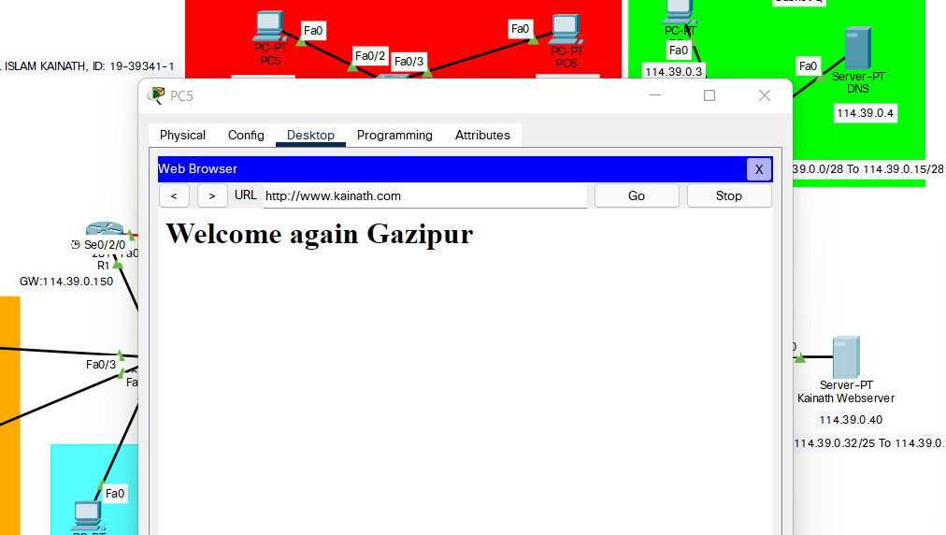

last name web server from pc5 Accessing

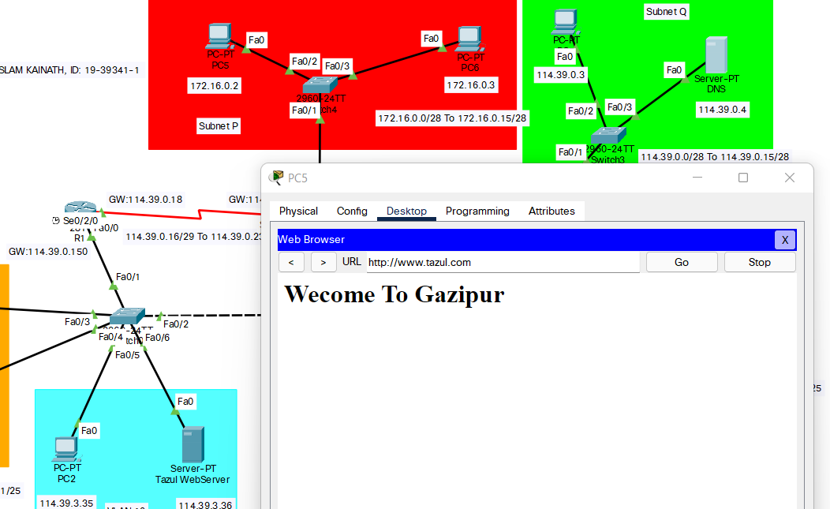

First name web server from pc 5

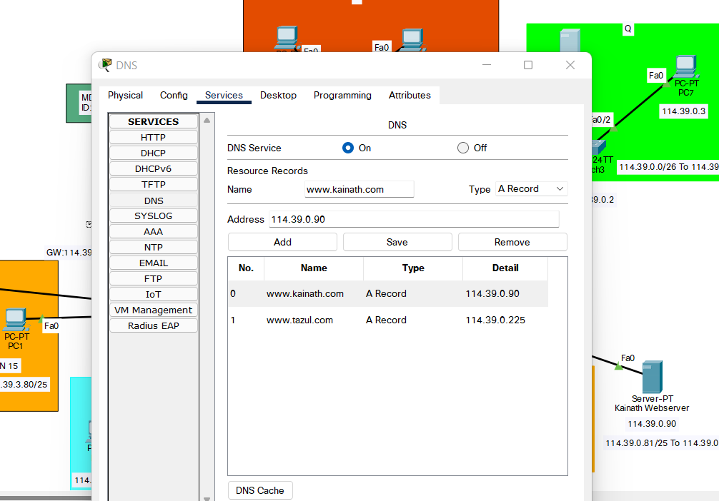

DNS server configuration