

American International University-Bangladesh (AIUB)  
**Department of Computer Science  
Faculty of Science & Technology (FST)  
Spring 20-21**

**Section: C  
Group No: 7**

**Parental Security**

A software Engineering project submitted

By

|  |  |  |
| --- | --- | --- |
| Serial No. | Student Name | Student ID |
| 5 | Suparan Sharma | 18-37275-1 |
| 19 | Md. Tazul Islam Kainath | 19-39341-1 |
| 14 | Md. Zunayed Hossain Saafin | 19-39304-1 |
| 17 | Sadia Islam | 19-39338-1 |

The project will be Evaluated for the following Course Outcomes

|  |  |
| --- | --- |
| Requirements Analysis (functional, quality, and project requirements) [5Marks] | **Total Marks** |
| System Design (UML, UI/UX design) [5Marks] |  |
| Test and Project Management Planning [5Marks] |
| Submission, Completeness, Spelling, Grammar and Organization [5Marks] |

**1.PRODUCT AND PROJECT DESCRIPTION**

* 1. **System Features**

**1.Registration**

**Functional Requirements**

1.1 The software has registration option .The registration procedure is for child user in this system. The child will sign in to the software by doing registration. It will take personal information such as name, email address, Country.

1.2 A verification code will be sent to the email for verification.

1.3 If the verification is not successful , the verification code will be provided again.

**Priority level:** High.

**Precondition:** A valid email address.

**Cross-reference:** N/A

**2.Create Profile**

**Functional Requirements**

2.1After signing in, child user will create two profiles. One is child user profile & another is parents user profile.

* 1. In both profile, name ,mobile number, valid nid number, age ,location is needed.
  2. After creating the profiles, both profiles will be connected.

**Priority level:** High.

**Precondition:** Registration & sign in.

**Cross-reference:** N/A

**3.Schedule**

**Functional Requirements**

3.1 After creating the profile child will create parent's schedule.

3.2 In schedule section there will be many options of routine like , parents mealtime ,medicine, exercise time, any kinds of advise, & other important information.

**Priority level:** High

**Precondition:** Create profile .

**Cross-reference:** N/A

**4.Notification**

**Functional Requirements**

4.1 Following the schedule, a notification alarm will be ringed to parents device by the softeware.it will be reminder for them to do their needed activities .

4.2 If they don’t response then automatically a notification will be shown to child profile .Then they will aware of it.

**Priority level:** High

**Precondition:** Schedule

**Cross-reference:** N/A

**5.Update schedule & Information**

**Functional Requirements**

5.1 User will be able to update or change schedule anytime.

5.2 User can also update other informations like email, phone number etc.

**Priority level:** High

**Precondition:** Registration & schedule .

**Cross-reference:** N/A

**6.1 Settings & Background Options**

**Functional Requirements**

6.1 There will be a settings menu to change many aspects of the software like language, theme (Dark and light mode) etc.

**Priority level:** Low

**Precondition:** Registration & schedule .

**Cross-reference:** N/A

* 1. **System Quality Attributes**

Non-Functional attributes

**Usability** :

The system shall be usable by the senior citizens. The system must be user-friendly

.**Priority level:** High.

**Flexibility** :

Flexibility is used as an attribute of various types of system .users can easily access and adapt the software so frequently to utilize their needs. The software is organized according to user demand and user easily understands the change.

**Priority level:** High.

**Integrity** :

Whenever a change is made to software or any activity from user will recorded in a secure storage and update the activity system through secure connection.

**Priority level:** High.

**Efficiency :**

If the system is using all the available resources then the user will get degraded performance failing the system for efficiency. If the system is not efficient then it can’t be used in real-time applications. As the software will be mostly used by the senior citizen ,it  is organized in small size so that it will be more efficient.

**Priority level:** High.

**Performance :**

Performance of software depends on software optimization. System management sector shall provide better quality database server, transaction and usage storage. They will keep the system out of unnecessary load.

**Priority level:** High.

**Reusability** :

System development should be in good sequence so that reuse of the software will be a good cost-efficient. Software implementation should be in different code library classes to use easily in different application modules. Dividing the application into different modules so that modules can be reused across the application.

**Priority level:** High.

**Portability** :

The System should be so simple transform one medium to another.

**Priority level:** Medium

**Testability :**

The system should be easy to test and find error. The system will be organized in a sequence to divide into different modules for testing.

**Priority level:** High.

**Maintainability** :

The system will be well documented and it will be designed to be easier maintenance. The system shall not be shut down for maintenance more than once in 24 hours. Maintenance should be cost-effective and easy.

**Priority level:** High.

**Interface** :

All aspects of the system will have a simple point and click interface using text field, buttons, all other components of the system with graphical user interface. This interface will be designed to be consistent. The inter face will designed to help accommodate user with disabilities such as color blindness. The system will also have clear and understandable message for every steps and activities.

**Priority level:** High

* 1. **Project Requirements**

**1.3.1 Resources**:

01. Computer

02. Visual studio

03. Adobe illustrator

04. Photoshop

05. Microprocessor

06. Internet

07. Power Backup

08. Smart Voter ID card and number

09. Backup Storage

10. Presiding Administrator Display

11 Database Management

1.3.2 **Operating Environment** :

The server should have Java installed on the machine, along with Java’s cryptographic packages. The server should have minimal support for cookies and encrypted transactions.

1.3.3 **Performance**:

The software shall have a maximum user efficiency at least 95% so that everyone can use the software without issue. Maintaining performance in software development is tough, but important to satisfy users. The software is user-friendly, so requirements contributed by users are the lead users.

1.3.4 **Quality :**

As part of the quality system, software quality is important as it defines and measures the adequacy of the software process, providing evidence that establishes confidence to produce products of suitable quality for their intended purposes. The software maintained the part properly.

1.3.5 **Features :**

Features of the system should be updated with the time.

1.3.6 **Assembling/ Setup Time :**

The whole system will take 12to 24 hours for being assembled and the system will work 12 hours properly with its backup power and storage.

1.3.7 **Resources :**

Resources are strongly connected to the project cost. The amount that’s available for achieving the desired outcome will restrict the use and acquisition of resources, which creates a separate constraint. Resources of project should be high utilized.

1.3.8 **Budget** :

The system will cost less than 150000-200000 taka according to today’s market price. Moreover, the system will more environment friendly.

**2.SYSTEM DESIGN SPECIFICATION**

* 1. **System Design**

**Use case diagram :**

The system that shows the relationship between the user and the different use cases. After the registration user will automatically login to the system. Login is by default process. User will create two profile & also can set schedule of regular routine. the senior citizen will aware of the schedule. There are three actors in the following diagram.

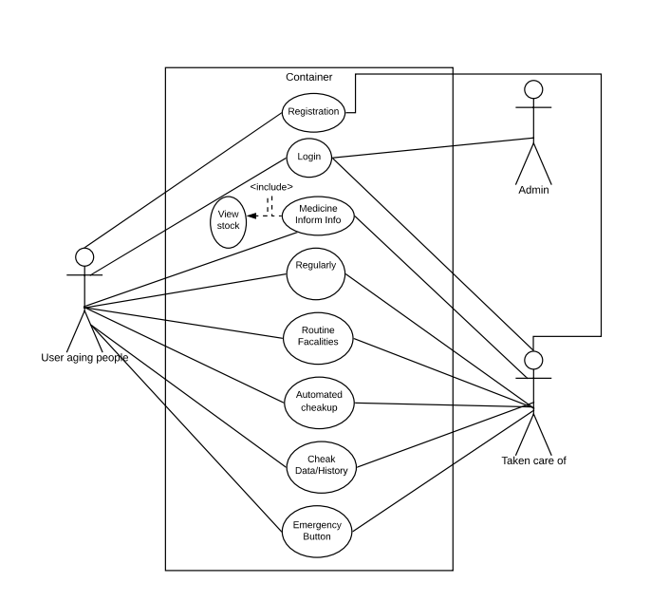

Figure : Activity diagramfor the System

**Class diagram :**

There are classes name of TCO, user, Meal, Routine, medicine The candidates register to the Administrator. After registration and scheduling all information the parents will get notification on scheduled time. The software is connected to the database so that scheduled time can verify the information which was inserted.

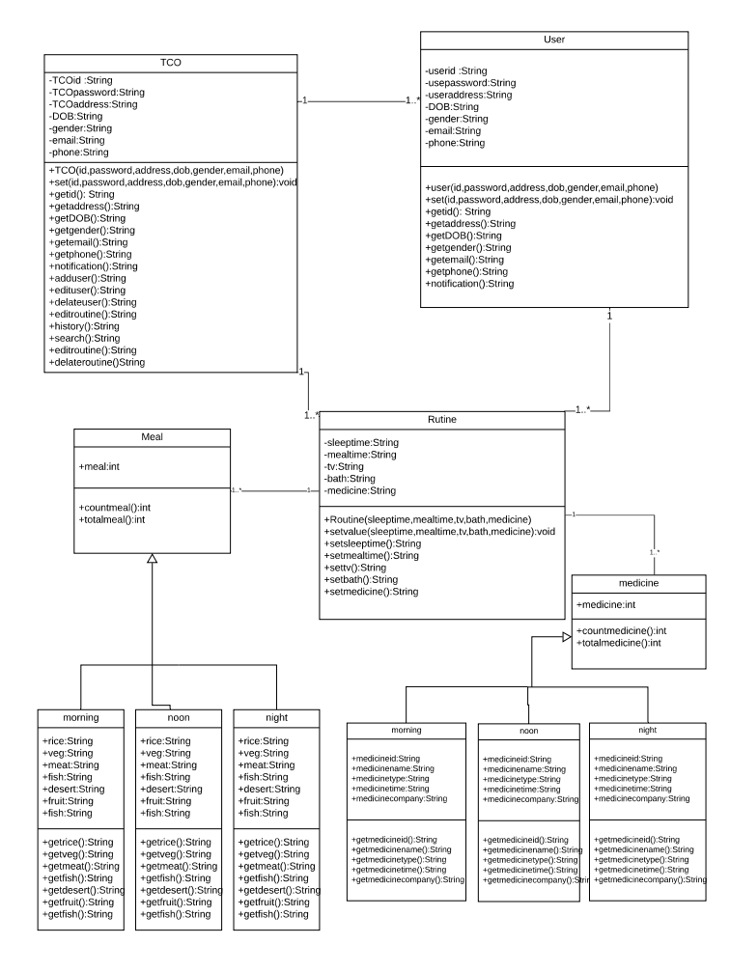

Figure : Class diagramfor the System

**Sequence diagram :**

In this software the user can verify his identity and confirms his information by registration. The diagram shows what order a group of objects works together. The system will verify this with the help of database. The user can perform following actions.

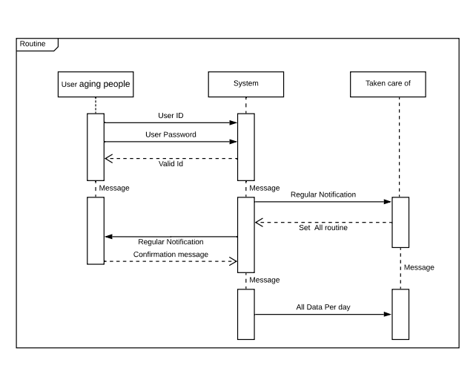

Figure: Sequence Diagram for the System

**Activity Diagram :**

In the process the voter has to follow some step. The diagram is graphical representations of workflows of stepwise activities and actions with support for choice, iteration and concurrency. After automatically sign-in system will focus on the routine activity ,which is organized in the schedule section .

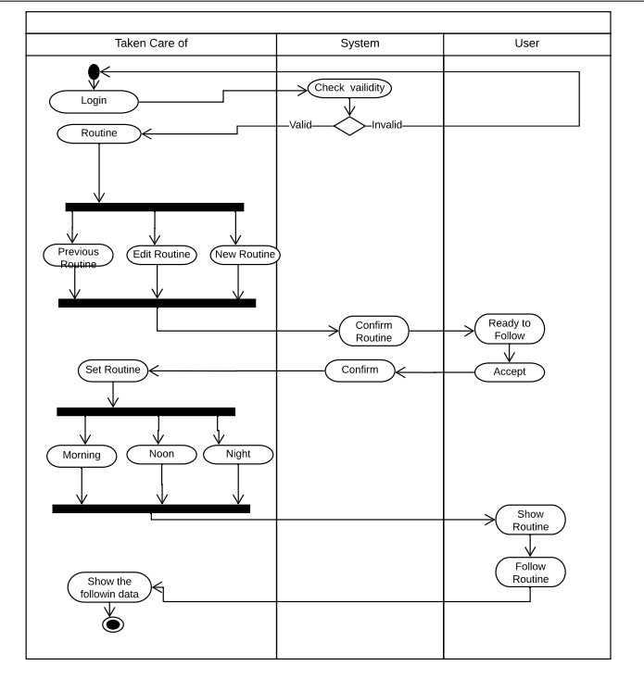

Figure: Activity Diagram for the System

**Entity-Relationship (E-R) Diagram :**

This ER diagram describes entities and attributes. Primary key, derived and multivalued attributes are marked.

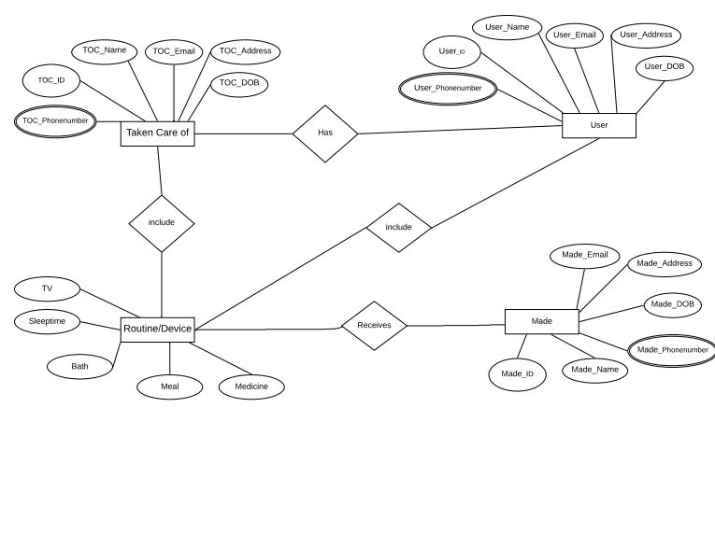

Figure: (E-R) Diagram for the System

* 1. **UI/UX Design**

This is the prototype design of our Parental Security system. The goal of our user interface design is to make the user's interaction as simple and efficient as possible. Therefore users of various levels of skills can use the system without any intervention. Graphic design and typography are utilized to support its usability, influencing how the user performs certain interactions and improving the aesthetic appeal of the design. We have designed following interfaces for this system:

1. Registration page

2. Verification interface

3. Home page

4. Schedule management

5. Alarm interface

6. Settings menu

7. Notification interface

**Interface:** User will start the process from here.

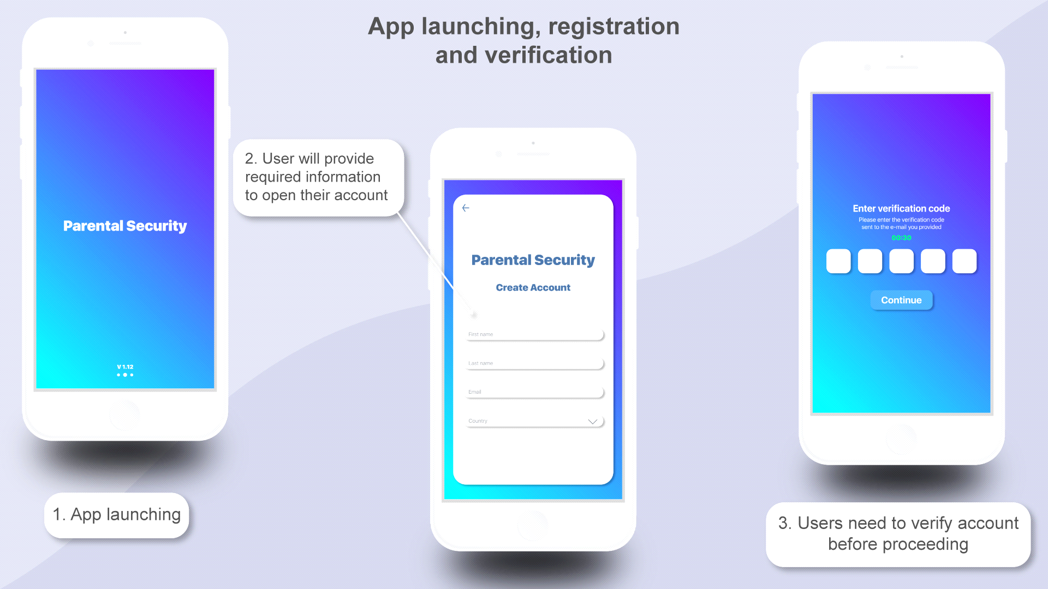

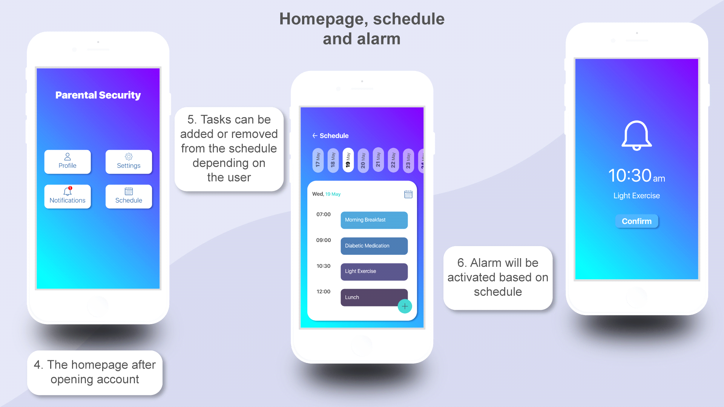

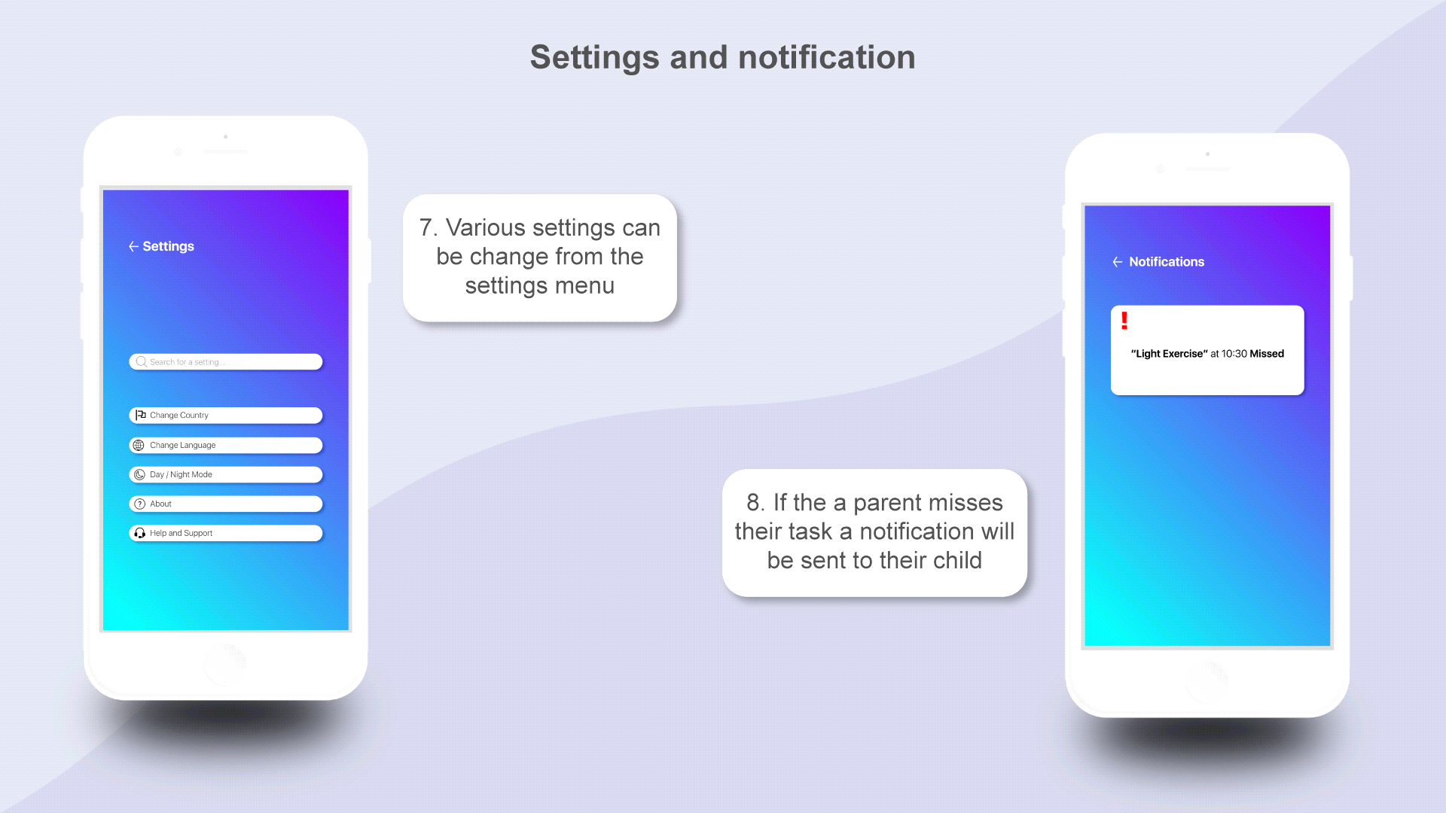

**3.SYSTEM TEST PLAN**

**Objective:** Perform various techniques for testing using the testing tool: Unit testing, Object oriented testing.

**Tools/ Apparatus:** Manual.

**Procedure:**

1. Select a particular system.

2. Identified various modules of the system so that they can be tested stand alone.

3. Prepared test cases of testing the selected elements of the identified software.

4. Performed the test according to our generated test case and produce a bug report which will helpful for the system developer to modify the system for improve system’s quality.

**Project Test Planning**

|  |  |  |  |  |  |
| --- | --- | --- | --- | --- | --- |
| Project Name: Parental Security | | | Test Designed by: Tazul Islam | | |
| Test Case ID: AN0001 | | | Test Designed date:16-04-2021 | | |
| Test Priority: High | | | Test Executed by: | | |
| Module Name: Registration | | | Test Execution date | | |
| Test Title: Registration Verification | | |  | | |
| Description: Security code and verify the email id. | | |
| Precondition (If any): 1. If the email id is valid. | | | | | |
| Test Steps | Test Data | Expected Results | | Actual  Results | Status  (Pass/Fail) |
| 1.Verify Id by code | Email id :  Voters name: Tazul Islam | Give confirmation | |  |  |
| Post Condition: The system will allow for further step. | | | | | |

|  |  |  |  |  |  |
| --- | --- | --- | --- | --- | --- |
| Project Name : Parental Security | | | Test Designed by: Tazul Islam | | |
| Test Case ID: AR00200 | | | Test Designed date: 16-04-2021 | | |
| Test Priority: High | | | Test Executed by: | | |
| Module Name: Schedule | | | Test Execution date: | | |
| Test Title: Check the selected schedule | | |  | | |
| Description: Verify the users routine. | | |
| Precondition (If any): Schedule must be organized. | | | | | |
| Test Steps | Test Data | Expected Results | | Actual  Results | Status  (Pass/Fail) |
| * See all schedule * Select preferable routine | Schedule :  Morning medicine |  | |  |  |
| Post Condition: The system will allow for further step. | | | | | |

|  |  |  |  |  |  |
| --- | --- | --- | --- | --- | --- |
| Project Name: Parental Security | | | Test Designed by: Tazul Islam | | |
| Test Case ID: AR00201 | | | Test Designed date: 16-04-2021 | | |
| Test Priority: High | | | Test Executed by: | | |
| Module Name: Notification Alarm | | | Test Execution date: | | |
| Test Title: Verification of Timely Notification | | |  | | |
| Description: Check that does the notification follow the routine . | | |  | | |
| Precondition (If any): Routine time must be organized. | | | | | |
| Test Steps | Test Data | Expected Results | | Actual  Results | Status  (Pass/Fail) |
| 1.Verify Child profile notification  2.Verify Parent  Profile notification | Schedule Data:  23289240923 | Notification alarm  must give alerts. | |  |  |
| Post Condition: Show the notification | | | | | |