

American International University- Bangladesh

Software Requirement Specifications

Project Title: Online Educational Forum [ StudyBuddy ]

Table of Contents

Introduction: 2

2.0 An overview of the system: 3

3.0 Justification: 4

3.0 Stakeholder analysis: 5

3.1 Stakeholders (Developing organization) 5

3.2 Stakeholders (Clients) 5

4.0 Product Vision and Scopes: 5

5.0 Classes for the system: 6

6.0 Component/Modules of the system: 7

7.0 Functional Requirement: 7

8.0 None Functional Requirements: 8

9. 0 System’s Requirements: 8

10. Prototype: 9

11. Manpower Requirement: 11

12. Budget: 12

13. Constraints: 12

14. Conclusion: 13

# Introduction:

The benefits of using online discussion forums and peer to peer learning for enhancing student learning are well known. Other than in full online courses, their adoption in traditional learning environments complementing face-to-face teaching is increasing and has now become a common educational strategy in higher education. In fact, interest in using online discussion forum as an indicator of students’ performance is increasing. Online discussion forums are expected to enable flexible and independent learning and knowledge construction and develop critical thinking skills. There are, however, some problems such as lack of learners’ focus and inadequate reflection, students not responding to the ideas of others, and surface level discussions. Though there are many advantages of its use, students use of the online discussion forums in the context of their study and the characteristics of an effective online discussion environment that facilitate effective learning need to be investigated.

# 2.0 An overview of the system:

This project is going to be built with the idea that it is going to be an ultimate helping tool for students who are stuck in some academic problems. There will be users who are proficient in some area may come to this platform and other users who are facing problems and looking for solutions. And in return a user who solves a problem for another user may accept a fee as a reward.

Using this service is going to be extremely simple and user friendly. In order to use this system, A user first need to register their identity on this system with Email, phone number, User Name and a strong password.

After the registration is completed, the user will be directed to the login page where the user is required to log in to the system with their registered credentials. Once a user is logged in, the user will be taken to the problem dashboard the where the user can view problems posted by other users.

Even though a user is logged in and able to view the problems dashboard, they users are only one step away from solving or posting a problem. Which is, they are required to add a payment method which will be a transaction account.

The transaction account provided by the users will be responsible for all transactions between users as a user solves a problem for other users. When a transaction will happen, the fee which a user transfer to other user, will first be deposited to the systems account where StudyBuddy will hold the right to accept 10% fee for every transaction that will be done between the users.

StudyBuddy will be very clear to their clients about their business requirements to the users before they register to their system.

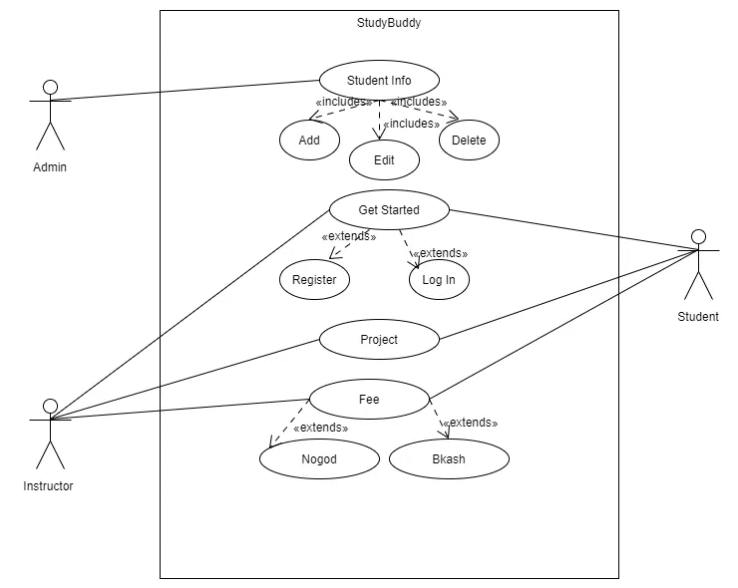

# 3.0 Justification:

The main purpose for developing this system is to simplify the tedious task of Students by providing this service in a user-friendly environment. The main purpose of StudyBuddy is to help students in their most difficult times during studies. It is a platform where Students can find 24/7 homework help and online tutoring. On the other hand, other users (instructors) who are expert in such area can help Students with their knowledge.

Helping students succeed extends beyond enhancing their academic experience. We

aim to make an impact in multiple areas of their lives and in their communities. Our mission is to help every student achieve their best, in school and beyond.

# 3.0 Stakeholder analysis:

## 3.1 Stakeholders (Developing organization)

Internal: Project developer, Product Manager , Testing Engineer , Project Manager

External: Legal Staff, Certifier

Consultant: requirement engineer, Business planner, Sponsor, Usability sponsor

Vendors: Material suppliers

## 3.2 Stakeholders (Clients)

Internal: Company Owner

Secondary (Customer who procure but not use directly): Administration, Developer

Primary Stakeholders (end users): Students, General public, Admin, Subscribers

# 4.0 Product Vision and Scopes:

The E-learning technologies aim to enhance the target of learning outcome in the Education thorough the effective uses of the e-learning technology tools and empower the innovative learning. In the current era E-learning in the computer science playing an effective role to develop the students technical, design and development skills

The Internet has undeniably changed the way we learn today. The recent pandemic has also democratized education making online learning an affordable and preferred mode of education. Students can study from the comfort of their homes without worrying about the pandemic. Moving beyond the four walls of a classroom, online education creatively blends videos, audios, images, and graphics to make learning more engaging for learners across borders. Undeniably, online learning is nothing short of a revolution in the education sector. The demand for online learning solutions shows no sign of fading, and we can say that online learning is the future of education at a global level.

StudyBuddy has the vision to be one of Bangladesh's leading platforms for students to build a large community among each other and together grow a powerful nation with highly educated leaders.

# 5.0 Classes for the system:

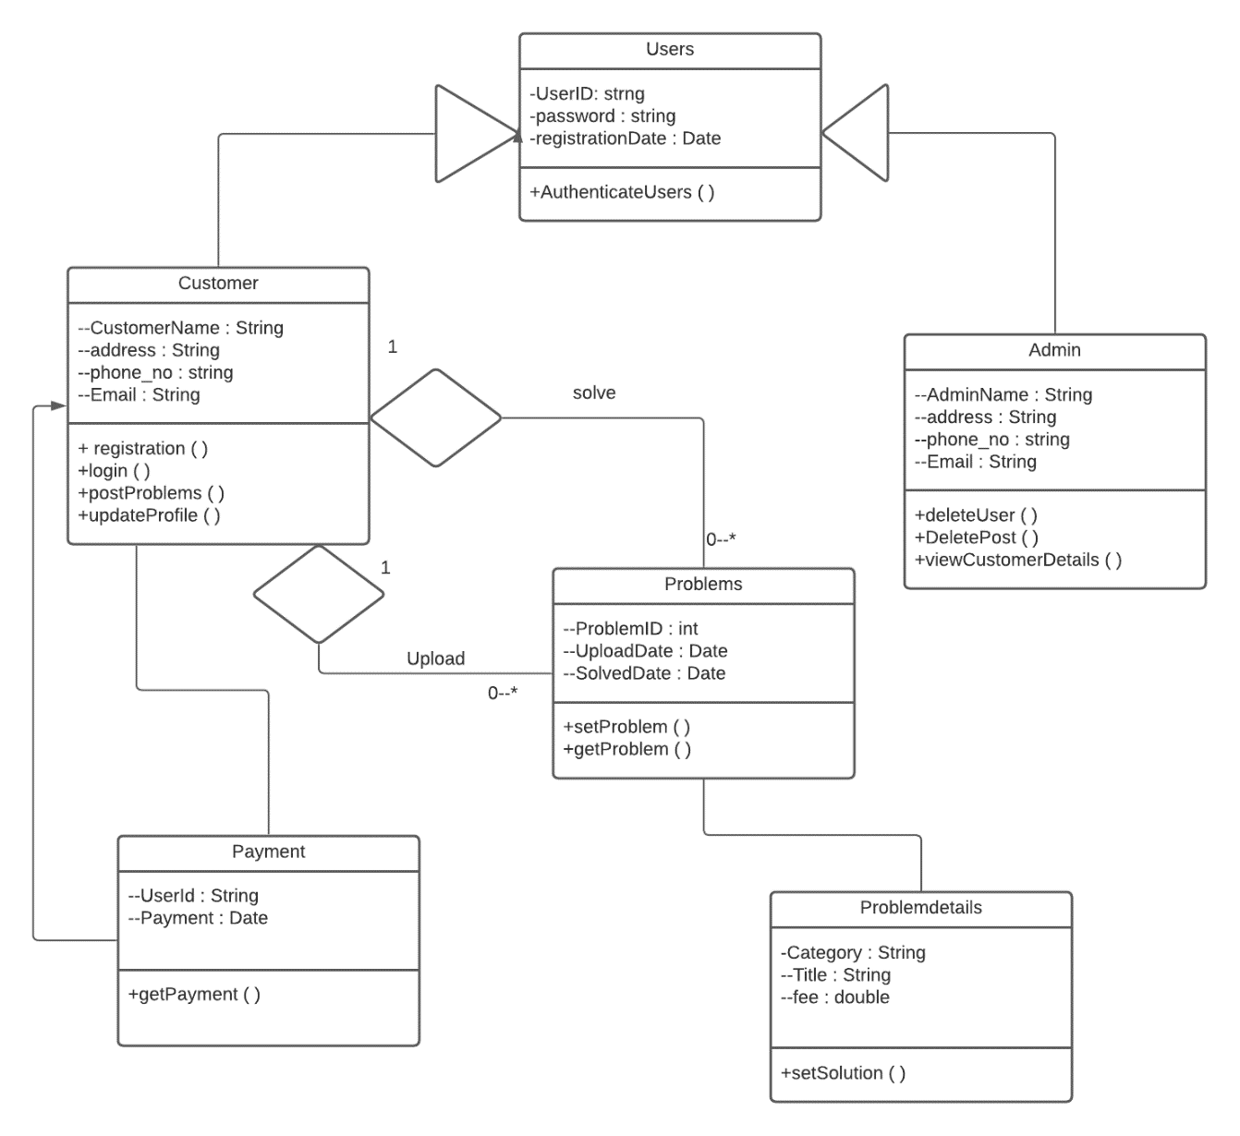

# 6.0 Component/Modules of the system:

• User Authentication

• Registration

• Accounts

• User Info

• Problem Dashboard

# 7.0 Functional Requirement:

|  |  |  |  |  |  |
| --- | --- | --- | --- | --- | --- |
| **Requirement ID** | **Date** | **Requirement**  **Description** | **Dependencies** | **Originator** | **Testing Criteria** |
| FR1 | 06.12.21 | Registers new user and stores their credentials in the database. | User need have valid email ID, Phone Number. | Senior Developer | Unit Testing |
| FR2 | 10.12.21 | authenticate valid users of the system and logs them in. | Must be a registered user. | Senior Developer | Load Testing |
| FR3 | 11.12.21 | Updates user information in the database. | Must be a registered user. | Senior Developer | Functional Testing |
| FR4 | 15.12.21 | Takes user posts as parameter and stores them in the database | Must be a valid post. | Junior Developer | Integration Testing |
| FR5 | 15.12.21 | Display all problems in the dashboard. | Database | Junior Developer | Functional Testing |
| FR6 | 15.12.21 | Admins can delete users, delete posts, block users. | Database | Junior Developer | Functional Testing |

# 8.0 None Functional Requirements:

|  |  |  |  |  |  |
| --- | --- | --- | --- | --- | --- |
| **Requirement ID** | **Date** | **Requirement**  **Description** | **Dependencies** | **Originator** | **Testing Criteria** |
| NFR1 | 18.12.21 | Security | Program | Senior Developer | Unit Testing |
| NFR2 | 18.12.21 | Usability | Program | Junior Developer | Load Testing |
| NFR3 | 22.12.21 | Maintainability | Program | Junior Developer | Functional Testing |
| NFR4 | 24.12.21 | Scalability | Program | Junior Developer | Integration Testing |
| NFR5 | 25.12.21 | Performance | Program | Junior Developer | Acceptance Testing |
| NFR6 | 29.12.21 | Reliability | Program | Senior Developer | End to End Testing |

# 9. 0 System’s Requirements:

* Internet connection
* Web accessible devices
* Web-Server
* Domain

# 10. Prototype:

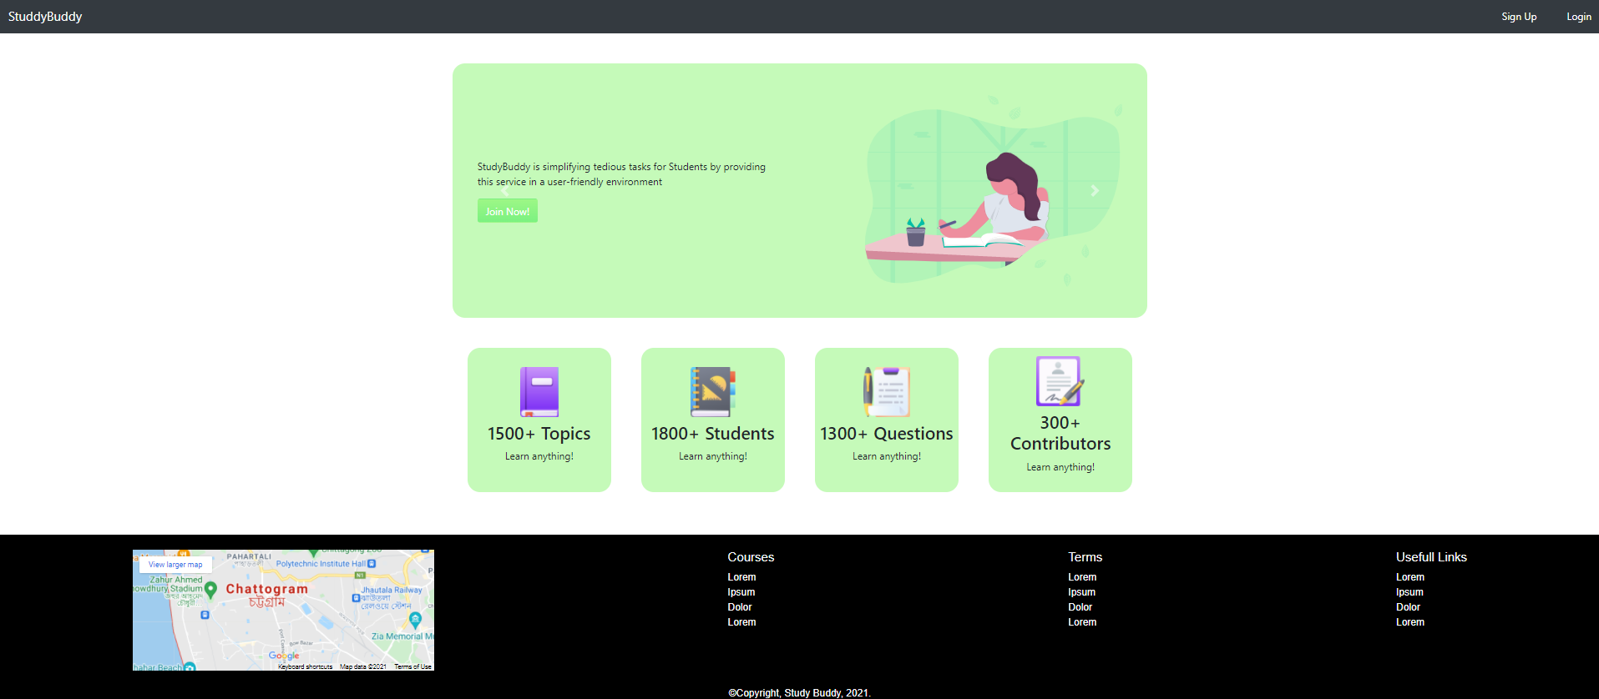

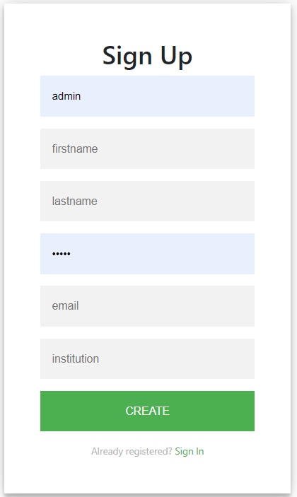 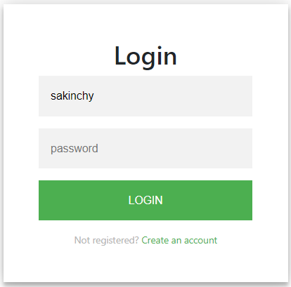

Main Dashboard

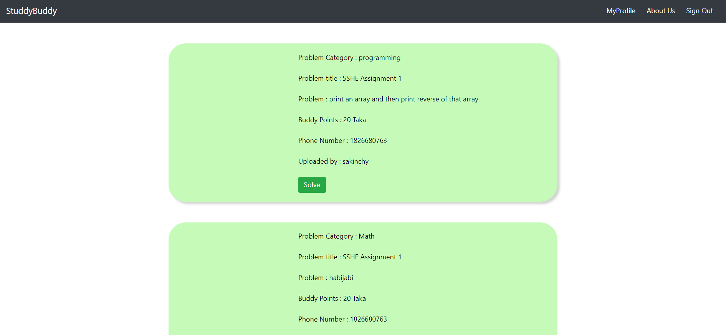

User Profile

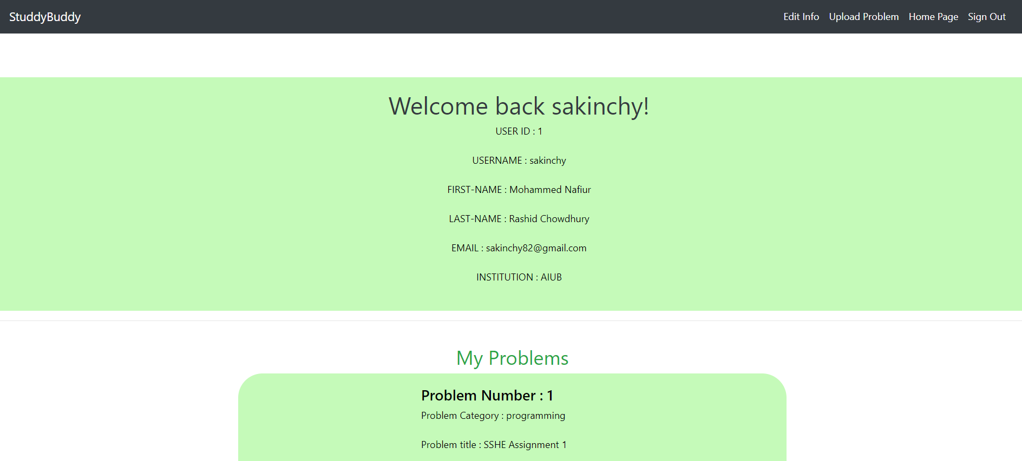

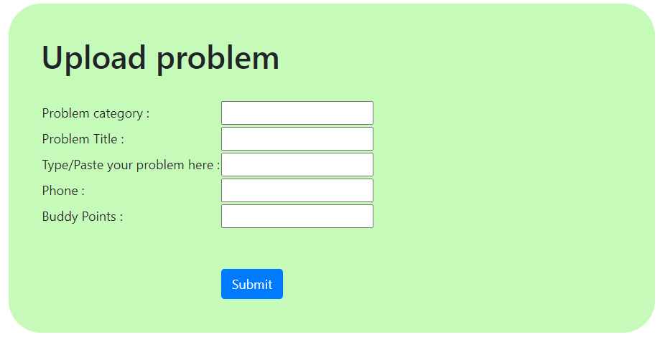

# 11. Manpower Requirement:

|  |  |  |  |
| --- | --- | --- | --- |
| Role | No. of Vacancy | Experience | Responsibility |
| Project Manager | 1 | Minimum ten years of experience related to this field | Leading and guiding, and evaluating project team performance |
| Project Engineer | 1 | Five years of experience in project handling and execution | Resource planning and development schedules.  Monitoring and Reporting progress |
| Back-end Web Developer | 2 | Three years of experience as a database analyst | Update, delete and analyze the user data. |
| UI/UX designer | 1 | Two years | Provide a beautiful and user-friendly device for Front-end Developers |
| Front-end Web developer | 2 | Five years of experience in project handling and execution | Implement the design provided UI/UX designer. |
| Tester | 1 | Three years of experience as a database analyst | conduct both manual and automated tests of software products. |

# 12. Budget:

* Total Development Time: 6 months.
* Total Working Hours needed: 24×(31+31+30+31+30+31) = 24×184 = 4416.
* 2,921 Hours for development
* 1,095 hours for Testing & Debugging
* 2 weeks for revision
* Cost: 1,50,000 BDT
* Resources

Accessories = 80,000 BDT

Domain = 10,000 BDT/ month

*Total Estimated Budget = (1,50,000 + 10,000 +80,000) BDT = 240000 BDT*

# 13. Constraints:

* Control functions
* Higher-order language requirements
* Signal handshake protocols
* Parallel operation
* Audit functions
* Criticality of the application
* Safety and security considerations
* Regulatory policies
* Hardware limitations
* Reliability requirements
* Interface to other applications

# 14. Conclusion:

The above full content is basically is focused on the e-learning medium and technologies. The term content plays a key role in e-learning, but this is not a easy process to have e-learning in all the fields of Computer Science. It needs knowledge of experts in their fields and have different opinion for creating the necessary objects that are useful for making up the quality. Ability and sense of expert is required for developing courseware and necessary structure of the topic. So, we can say that e-learning technology is dynamic way for getting knowledge and interaction with the system. If we have distance education different study programs applied on Computer Science may have several problems and issues, if compared with face-to-face education.