Project Documentation
Data / Tech Job Listings Pipeline


Submitted: 12/12/2025
Team: Ben, Marcus, Michelle

Documentation Outline

- Introduction
  - Overview
  - Problem Statement

- Data Sources
  - What is the data chosen

- Methodology / Approach
  - Tech stack/tools
  - ETL (incl data preparation)
  - Architecture diagram
  - Database schema/ERD diagram
  - Data validation

- Data Transformation
  - Cleaning Raw Data
  - Standardizing & Validating Data
  - Salary Parsing
  - Preparing Fact and Dimension Tables
  - Error Handling and Logging

- Database Structure and Data Loading
  - Data Dictionary
  - Entity Relationship Diagram
  - Data Loading Process

- Analysis / Visualization
- Challenges

- Next Steps / Conclusion

- Appendix

- Introduction

  - Overview
This project develops an end-to-end data engineering pipeline to collect, process, store, and analyze job postings from multiple online sources. The objective is to build a centralized and structured job market database, focused initially on Data / Tech roles, which will support downstream analytics, dashboards, and future automation.

  - Problem Statement
The requesting department needs consolidated, reliable data about job postings to understand in-demand skills, top companies, job availability across countries, and salary variations. However, obtaining this information is challenging due to API limits, web scraping restrictions, and fragmented datasets. This project solves these challenges by designing a robust ETL pipeline and unified data storage.

- Data Sources

  - Data Types Chosen
Web APIs: 2 functional API endpoints found
https://developer.adzuna.com
https://jobicy.com/jobs-rss-feed
Kaggle Dataset: Supplementary dataset to enrich data volume.
https://www.kaggle.com/datasets/andrewmvd/data-engineer-jobs

- Methodology / Approach
  - Technology Stack
The project leverages a modern, scalable technology stack comprising Python for data processing, PostgreSQL hosted on Aiven for relational data storage, and GitHub for version control and collaboration. Python enables efficient ETL operations and data analysis, while PostgreSQL ensures robust storage, indexing, and query capabilities.
  - ETL Pipeline
A structured Extract–Transform–Load (ETL) workflow is implemented to ensure clean and reliable data.
- Extract: Data is collected from multiple sources, including APIs and public dataset.
- Transform: Data undergoes normalization, cleaning, deduplication, and validation to ensure consistency. For example, country codes are standardized, and salary ranges are validated.
- Load: Processed data is loaded into PostgreSQL tables with established relationships to maintain referential integrity.

  - Architecture Overview
The pipeline architecture is designed for efficiency and maintainability:
Sources Extraction → Python ETL → PostgreSQL Loading → Analysis & Visualize
Data flows seamlessly from extraction to storage and finally to the analysis layer, enabling downstream tasks such as querying, visualization, and reporting.
  - Database Schema / ERD Diagram
- fact_jobs: Stores job listings with references to companies and related details.
- dim_companies: Stores company information linked to their respective countries.
- dim_countries: Stores country details, providing a reference for company locations.
Primary and foreign key constraints ensure referential integrity across the tables.
  - Data Validation
- Foreign-Key Validation: Ensures that all relationships between jobs, companies, and countries are consistent.
- Domain-Specific Checks: Maps country data to standard ISO country codes.
This comprehensive approach guarantees reliable and actionable insights from the data.

- DATA TRANSFORMATION
  - Cleaning Raw Data

- Remove HTML tags from job descriptions.
- Trim leading/trailing whitespace.
- Standardize text casing (e.g., title case for job titles, proper case for countries).
- Remove duplicates (e.g., duplicate job postings from multiple sources).
- Normalize symbols and special characters.

  - Standardizing & Validating Data
- Job IDs: Generate a consistent final job ID: <SOURCE>-<raw_id>.
- Country Mapping:
  - Standardize raw country names to ISO country codes.
  - If a country is not recognized, log to source_failed_country.csv and skip insertion for further manual processing.
- Company Validation:
  - Clean company names (strip, remove punctuation, normalize spacing, title-case, removal of company suffix).
  - Lookup existing company_id in dim_companies or insert new record and retrieve ID.
  - Salary Parsing
- Extract numeric values from raw salary text for salary_min and salary_max.
- Manage missing or inconsistent salary formats.
  - Preparing Fact & Dimension Tables
- Map cleaned and validated data into:
  - Dimension Tables: dim_countries, dim_companies (with foreign key reference to countries)
  - Fact Table: fact_jobs (with foreign key references to companies)
- Ensure referential integrity through foreign keys.

  - Error Handling & Logging
- Failed insertions (e.g., due to missing required fields or foreign-key violations) are logged into source_failed_job.csv.
- Invalid or unmapped data is logged for review before reprocessing.

- Database Structure and Data Loading
  - Data Dictionary
    - DIMENSION TABLES
Table: dim_countries
Stores standardized country master list used for validation and foreign-key mapping.
Field Name | Data Type | Description | Constraints
country_code | VARCHAR(2) | ISO country code | Primary Key
country_name | VARCHAR(50) | Full country name | UNIQUE

Table: dim_companies
Stores unique standardized company names.
Field Name | Data Type | Description | Constraints
company_id | SERIAL/INT | Auto-generated company identifier | Primary Key
company_name | VARCHAR(100) | Standardized company name | UNIQUE
country_code | VARCHAR(2) | Company country (if available) | Foreign Key -> dim_countries.country_code
company_id | SERIAL/INT | Auto-generated company identifier | Primary Key

    - FACT TABLE
Table: fact_jobs
Stores cleaned and verified job listings.
Field Name | Data Type | Description | Constraints
joblisting_id | VARCHAR(15) | Final job ID prefixed with source code | PK
company_id | INT | Reference to dim_companies | FK -> dim_companies.company_id
job_title | VARCHAR(150) | Cleaned job title | NOT NULL
description | TEXT | Full job text | NULLABLE
salary_min | INT | Minimum salary | NULLABLE
salary_max | INT | Maximum salary | NULLABLE

  - ERD Diagram
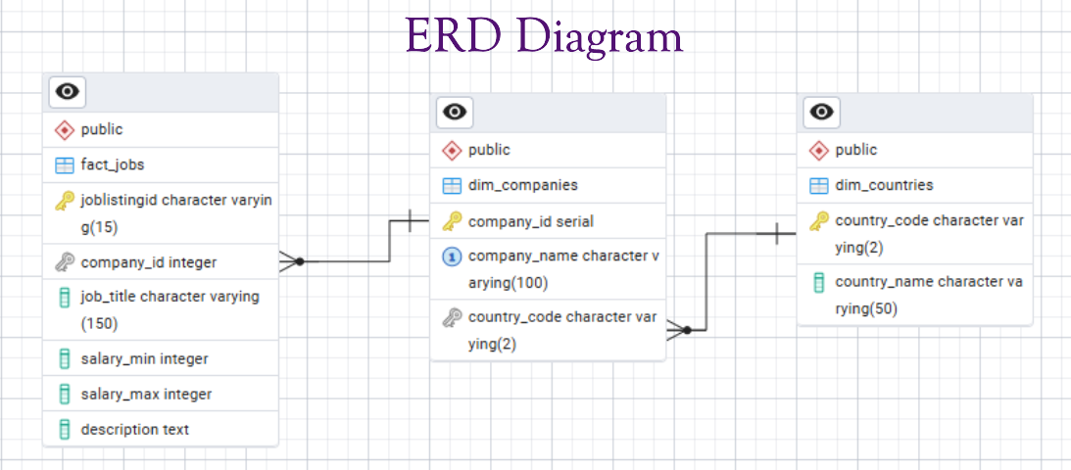
  - Data Loading process
The diagram illustrates the job listing database insertion process. First, cleaned job listing data is checked against the dim_countries table to validate the country code. If the country does not exist, the job listing is saved to a CSV for manual processing. Next, the company name is checked in dim_companies; if it doesn’t exist, a new company record is inserted. Once the company ID is retrieved, the pipeline checks whether the job ID already exists in fact_jobs. If it does not exist, the job listing is inserted into fact_jobs; otherwise, the process is skipped. The workflow ensures that only validated and non-duplicate job listings are stored in the fact table.
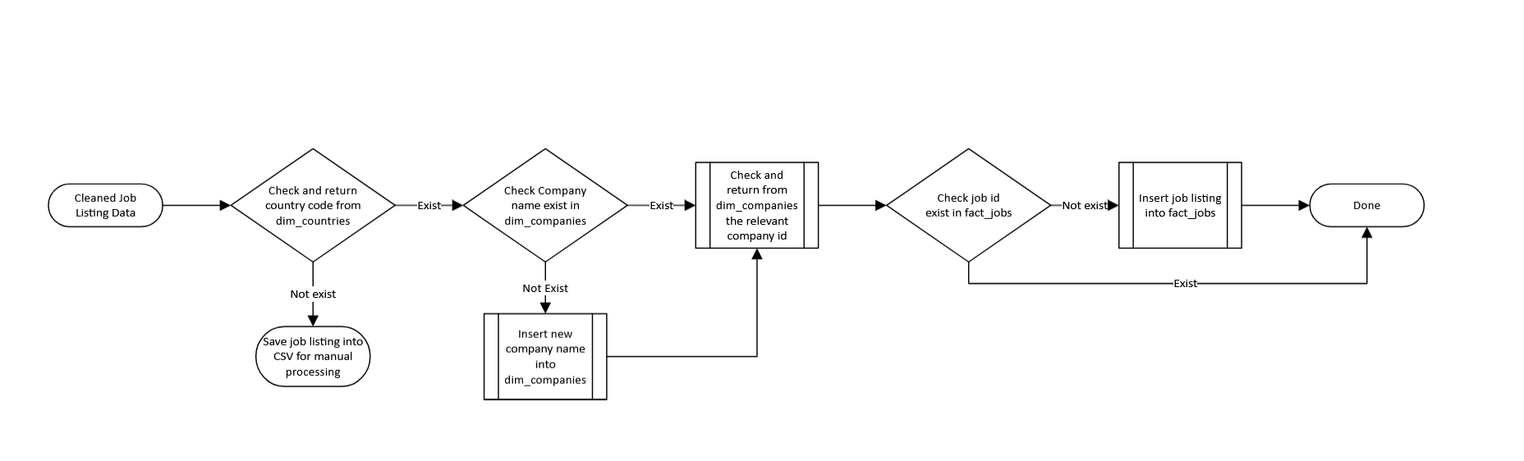

- Analysis / Visualization
- In-demand skills: Python, SQL, ETL, Cloud, Spark.
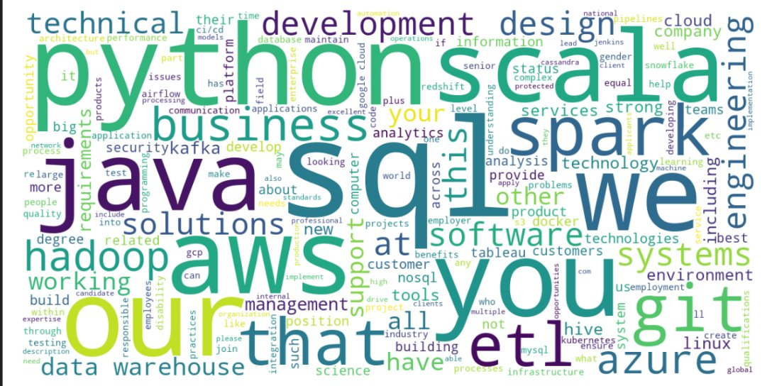
- Top Companies by average salary
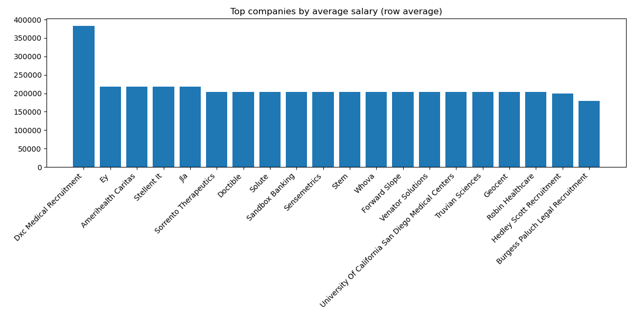
- Salary variation among different countries
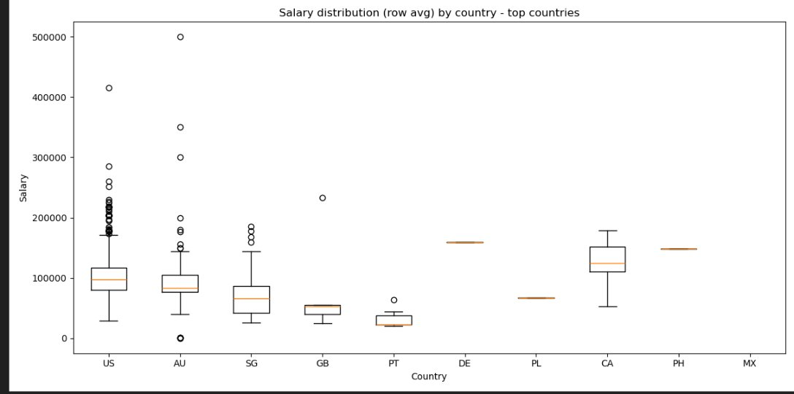

- Challenges
- API limits → Supplement with Kaggle
The APIs we used provided only partial job listings due to request limits and restricted data fields, which made it difficult to build a comprehensive dataset. To address this, we supplemented the pipeline with Kaggle datasets to increase data volume and ensure a more complete foundation for transformation and analysis.

- Scraping blocked → Use API-friendly sources
Attempts to crawl job portals were blocked by anti-bot protections, limiting the accessibility of raw data from multiple job sites. As a workaround, we shifted to sources that support structured data access—such as Adzuna /Jobicy for API-friendly platforms—to ensure stable and compliant data ingestion.

- Inconsistent names → Regex normalization
The raw data contained inconsistent naming patterns across companies and job titles, causing duplicates and lookup failures during transformation. We resolved this by applying regex-based normalization rules to standardize casing, spacing, and symbols across all text fields.

- Python errors → Debugged with structured prompting
During development, the team encountered various Python logic and data-handling errors that slowed progress and affected processing accuracy. These issues were resolved by breaking problems into smaller components, applying structured AI-assisted prompting, and iteratively debugging the code to ensure clean execution.

- Next Steps / Conclusion
  - Enhance data-quality checks
Strengthening data-quality checks will allow the team to detect issues such as missing values, inconsistent formatting, and potential bias more effectively. Implementing automated validation rules during ingestion and transformation will ensure that upstream errors are caught early. This will improve overall dataset reliability and support better analytics outcomes.
  - Load cleaned data into BI & analytics tools
Once the dataset is stabilized, exporting the cleaned data to tools like Power BI or Tableau will enable deeper visual exploration and insights. These platforms allow interactive dashboards, real-time filtering, and advanced trend analysis that can elevate stakeholder decision-making. Connecting the pipeline to BI tools also supports easier reporting and regular updates.
  - Implement automated, scheduled data ingestion with Airflow
Integrating Apache Airflow will allow the entire pipeline—from extraction to loading—to run automatically on a schedule. This reduces manual intervention and ensures new job listings are consistently ingested and processed. With DAG-based orchestration, the team can also monitor task failures and set retry mechanisms for more resilient operations.
  - Expand data sources and enrich datasets
Increasing the number of job APIs or external datasets (e.g., salary surveys, skills taxonomies, company financials) will broaden the analytical scope. A richer dataset allows more accurate trend detection and more meaningful insights into job market dynamics. This also strengthens the database’s ability to support downstream use cases like forecasting or skills-gap analysis.
  - Add monitoring, logging, and pipeline health tracking
Introducing structured monitoring and logging will help identify issues such as failed API calls, slow transformations, or schema mismatches early. Tracking pipeline performance over time will also highlight bottlenecks and improve long-term reliability. These monitoring enhancements form the foundation of a production-grade ETL system.

- Appendix
Files Included
  - BMM_Data_Plumber.pptx
  - Python Notebooks
    - DB_Tables_creation_script.ipynb
    - Extraction_Adzuna_script.ipynb
    - Extraction_Jobicy_script.ipynb
    - Extraction_Kaggle_script.ipynb
    - Visualization_script.ipynb

