**Job Market Analysis Website**

**Team Members**: Maggie Wishart, Francis Lenard Samonte, Tyler Barthel, Matt Zephir, Tim Bresnan

**Project Description:** Creating a job scraping product that can pull from multiple sources and analyze intelligently based on many key details such as job title, radius, pay grade, and companies. This website will serve primarily to display insights and data about job market trends (job position openings), i.e, % of companies that have ‘python’ on their job listing or ranking companies based on highest average starting pay.

**Client Base:**

The targeted clients would be recent graduates that are looking for entry-level job opportunities within the Computer Science, Cyber Security and Data Science Fields.

**Project Details:**

1. Web Scraper
   1. A web scraper that is capable of scraping select job sites and pulling data from the website to our service in order to accurately represent trends in the current job market
2. Realtime databasing and analysis
   1. To be competitive in the job market listing you need up-to-date and real time job data in order to offer relevant insights and up to date information
3. Filtering capabilities
   1. Ability to filter by pay grade, keywords, and companies
4. User interface
   1. Tiles that contain job title, description, and a link to the website where the listing was pulled from
5. Search queries
   1. Ability to query by the users desired keywords and job titles
6. Program language analysis
   1. Scrape the listing and display statistics (i.e. popularity) on the current program languages and tools needed to get a entry level job
7. Scalability and expansion
   1. Storing data for the potential fields to grow into
   2. Potential addition of other career fields in the future
8. Pay Grade analysis
   1. Help the user find job insights into the pay scale of companies and grading which companies have the best starting wages
9. Adaptable Scraping Time Frame
   1. Able to change the time frame from which we will pull the data from other websites.
10. Monetization for revenue
    1. User can watch one ad a day (like bibme) instead of paying a fee to use the product
11. User profiles
    1. Users can create a personal account for saving their job search results, etc.

**Why our project?**

There are many websites today that collect and show job position openings through many companies. Rather than making another website like those, we would instead make this for graduates who are looking for positions so that they can see where and what companies are creating openings. Our website could also be used by current students who are looking to find a major they desire where they could look at our website and see how many job openings are available for these majors.

**Our Team:**

Tyler Barthel, Tyler Powell, Matthew Zephir, Francis Lenard Samonte, John Hargenrader, Andrew Ku, John Lage, Timothy Bresnan, Maggie Wishart

**Roles:**

Software Engineer:

Andrew Ku- 4436570038

Test engineer: Tyler Barthel

Phone: 443-508-1223

Project Manager: Matt Zephir

Phone: 410-208-8421

Data engineer: Francis Lenard Samonte

Phone - 202-809-6706

Email - fsamonte99@gmail.com / [f.l.samonte@email.msmary.edu](mailto:f.l.samonte@email.msmary.edu)

Margaret Wishart (Maggie)

7329080740

Software engineer: John Lage

Phone: 469-203-5007

Email: lagejohn25@gmail.com

Deployment Engineer:Tyler Powell

Phone - 4253461598

Email - powelltc99@gmail.com

Application Programmer: JH(Front-end) TWB MW

Requirements Analyst:JH , Tim Bresnan

Phone (Tim) - (443)-952-0368

Email (Tim) - twolfy@comcast.net/t.w.bresnan@email.msmary.edu

Phone (John H)- 571-388-6353

Email(John H)-j.t.hargenrader@email.msmary.edu

**Concept Documentation**

**Description of User Base**

* The primary users would be people that are searching for jobs and tools they can use to make themselves better applicants. The secondary user base would be employers who want to know what technologies and new tools are trending

**High Level Requirements**

* Collect, store, and process job listing information from a variety of sources
* Ability to create visualizations and raw data analysis
* Present users with clear and unambiguous information on job trends
* Continuous 24/7 uptime of web elements
* Users can create an account so they can save their job search results for future use

**Front End Requirements:**

* Easy to navigate UI
* Infographics showing information of job openings
  + For all companies to compare the different filters
* Different job filters to pick from
* Personal account dashboard

**Adaptability requirements:**

* Maintain strict data format standards so new roles, insights, and jobs can be added and displayed with minimal additional work
* Implement robust and versatile scraping and storage techniques to enable easy use by all aspects of the system

**Maintainable requirements:**

* Create data specification frames that include variables needed for specific graphics or tables. (then used to verify data, improve efficiency in producing new outputs with constantly new data)
* Filter switches produce correct image for user specification

**High Level Design:**

* Internal actors:
  + Job site scraper
  + Database
* External actors:
  + Entry-level job seekers (e.g. college students/fresh graduates)
* Major processes:
  + Glassdoor / indeed API

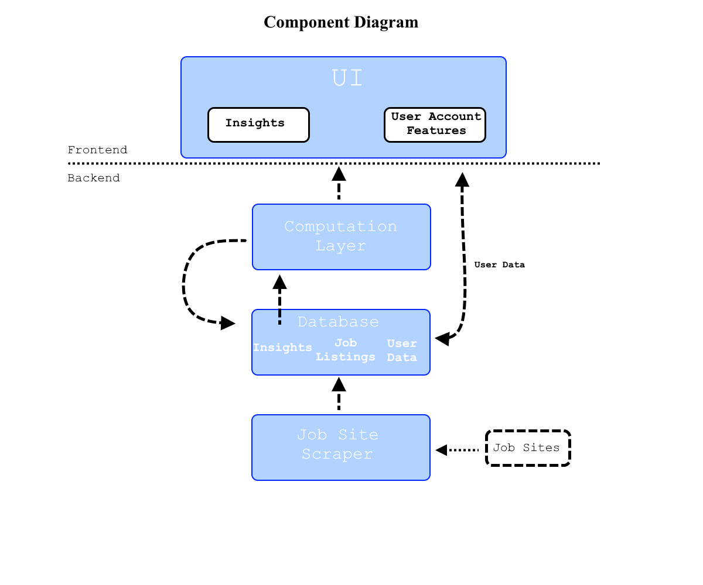

* Actor Use Cases:
  + Entry-level job seekers:
    - When the user enters the URL, they would be directed to the Home Page, which contains the main job search functionalities with the appropriate filters, as well as a Login button. User decides to not Login and just use the job search engine. They
  + Web scraper:
    - After the user enters job filters and clicks “Search”, web scraper begins to scrape data from job listing sites that meet the user’s filters. It then shows the gathered data to our site’s Search Result Page.
* Checklist
  + Data structure design chart
  + Back end design chart

1. **High level description of the project;**
   * Why should the stakeholder invest money in this project?
     + - While being a simple website, it holds many impactful components that would allow in-school students, graduated students, and investors or other companies to see entry level job openings. While also looking at these job openings, information about the job including payscale, job title, and more will be able to be viewed with a link to the website to the job openings where it can be found. This allows for users to have a simple and easy way of looking for job openings and what is included with the position.
   * What about this application will make the current user environment better?
     + - While a large number of sites hosting job listings already exist, corporate recruitment (particularly in the IT sector) can still be extremely confusing and intimidating to job seekers of all experience levels. Our project intends to eliminate a lot of the ambiguity regarding what employers are looking for, what they’re offering, and what the field as a whole looks like through up-to-date metrics on jobs, companies, and industry trends.
   * Who are the primary and secondary users?
     + - Primary- job seekers, graduated students, in-school students
       - Secondary- investors and companies
   * What are the major capabilities they will need? Capabilities are not requirements; capabilities are 10,000 foot high level expectations users might have for the system.
     + - Scrape and store job data from one or more listing sites
       - Compute and present insights using job data in clear and accessible graphs/tables
       - Allow searching/sorting of insights by field, company, location, etc.
       - Support creation and storage of (optional) user accounts
       - Allow registered users to save insights to a dedicated dashboard for future review/reference
2. **Listing of individuals on the team along with their assigned roles**
3. **REAM requirements that your team has identified. Be sure these are requirements that specify *what* not design that specifies *how***
   * Reliable - The web application will be able to respond to user actions that will allow the user to search what they want from different companies through the available functions given from the application. The application will also be up 24/7 (with small downtimes for updating) allowing all users to access the website at any point and give accurate statistics among the search fields they request.
   * Effective - The web application will be simple enough while also providing many usable functions that will benefit any user of the application. With the actions provided to the user, they will be able to find job openings at the entry level while also having the ability to look at companies, payscales, job titles, and more.
   * Adaptable - Our web application will need to have the ability to update as company data and information changes and based on what the current real world experience is of working for these companies. We will need to be able to adapt our current data to the data of the real world.
   * Maintainable - The modular design of our application, along with the usage of version-control (i.e., git) and different branches will enable the development of different/additional features without breaking the main production/working branch. For example, during the development of our application, teams can create branches off the main branch when adding new features, and creating pull requests or performing code reviews before implementing back onto the main branch of the application.
4. **Other requirement categories such as implementation, non-functional that your team has identified at this point**
5. **Screen prototypes created**

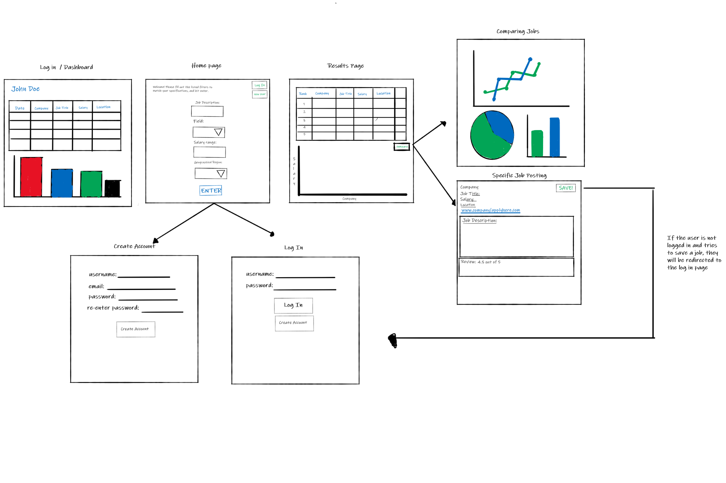

1. **High level architecture use case**

4. Reporting System Performance - System performance that can be monitored: health checks, latency reports, traffic reports, and overall availability of the system should be monitored.

Fresh concept document: https://docs.google.com/document/d/1eGOrNKxj_DG1al3GzkG4ZU0lH2R_AoCposjgXQPfjWo/edit?usp=sharing