Tyler Berry
Stacy Brook PH. D
ECP 3006
22 September 2025

RA3: Revenue
2a. Regression Results:
regress totalrevenue laggedtotalrevenue
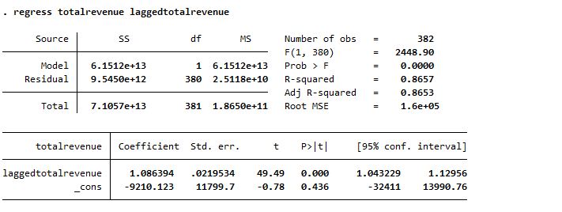
regress totalrevenue laggedtotalrevenue winpct
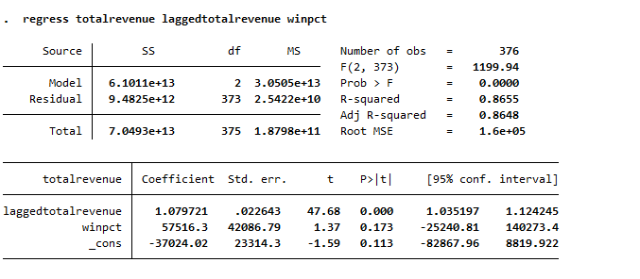
regress totalrevenue laggedtotalrevenue winpct attendance
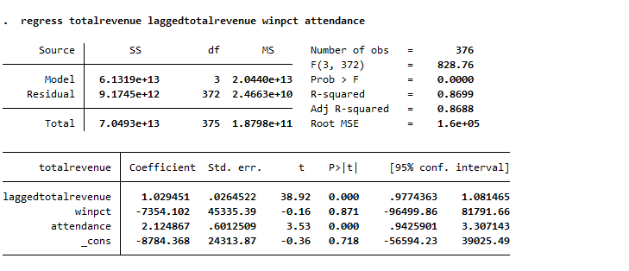
regress totalrevenue laggedtotalrevenue winpct attendance population
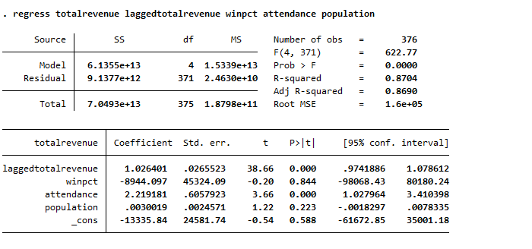

regress totalrevenue laggedtotalrevenue winpct attendance population pci
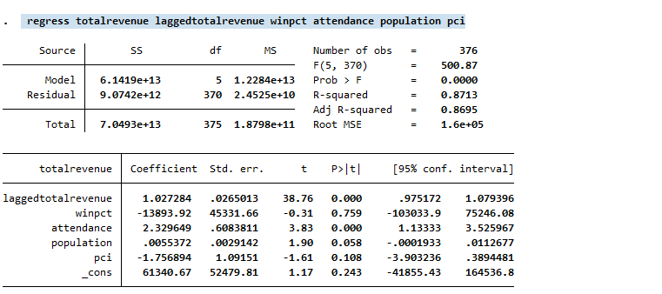

regress totalrevenue laggedtotalrevenue winpct attendance population pci stadiumcapacity
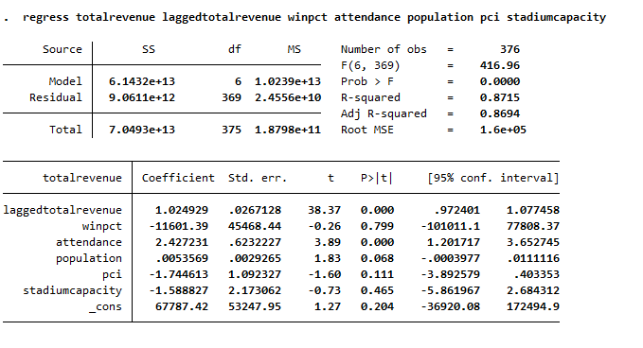

2b. Regression Interpretation:
Regression 1 starts off pretty good. To start off with the Coefficient and the standard error. The coefficient was 1.086394 and the standard error was 0.0219345. The coefficient shows that for every $1 increase in previous revenue there is about a $1 increase in current revenue. This would show a 1:1 relationship between both the variables. The standard deviation is low for what it is in relation to the coefficient. Onto the T and P variable. The T variable is 49, which is greater than 2, which shows that it is statistically significant. The p value is 0, which is less than 0.05 which means we reject the null hypothesis and the variable is still statistically significant which shows a good fit for this model. The confidence interval of {.043229 1.12956} holds our coefficient within in and does not cross 0, which would also make it statistically significant. Onto the R squared and Adjusted R Squared, The R-squared is 0.8657 and the Adjusted R-squared is 0.8653 which would show a high fit for this model meaning that roughly 87% of the variation in total revenue is explained by lag total revenue. The adjusted R-squared is slightly lower but it is still high. The F-stat is very high at 2448.9 which shows an overall statistical significance for this model. In conclusion this regress shows a very strong and statistically significant linear relationship between total revenue and lagged total revenue. The model explains a large amount of the variation in current revenue.
Regression 2 follows along with how regression 1 went with a still statistically significant model overall with some interesting results from winning percentage. To start with, the coefficients and standard error are as follows, 1.079721 for lagged total revenue and 57516.3 for winning percentage. Overall, for lagged total revenue it remains pretty much the same as before with a slight decrease, but This means that for winning percentage there is a nearly $57516 increase in total revenue for every point increase in win percentage which would make sense except for when we look at the standard error. The standard error for Lagged winning percentage is nearly the same as before at 0.022643 which is low in relation to the coefficient but for winning percentage it is a staggering 42806.2 which is extremely high in relation to the coefficient. This would show a low statistical significance for winning percentage. Onto the T and P values, The T value for Lagged total revenue is still above 2 at 47.68 but the T value for win percentage is 1.37 which would show that it is not statically significant. The P value for win percentage is also 0.173 which would show that we fail to reject the null hypothesis meaning it is not statistically significant in relation to the model whilst the P value for Lagged total revenue is still 0. The Confidence intervals are as follows, [1.035197, 1.124245] for lagged total revenue and [-25240.81, 140273.4] for winning percentage. The interval for Lagged total revenue is fine just like before but the interval for winning percentage would show that since the interval crosses 0, we cannot say that it is statistically significant, and variable is not a good fit for the model. Onto the R-squared and the adjusted R-squared, The R-squared is 0.8655 which is higher than before and the adjusted R-squared is 0.8648 which is lower than before. The R-squared being higher shows a good fit for this model but the adjusted R-squared being lower suggests that winning percentage is not a good variable for this model. The F statistics are still very high at 1199.94 suggesting that there is a high fit for this model. In conclusion, Lagged total revenue is still a powerful and consistent predictor of current revenue and winning percentage does not appear to significantly improve the model or predict revenue. The model overall is still statistically significant.

Regression 3 starts to show more statistically significant variables for this model. To start off, the coefficients are as follows 1.0295 for lagged total revenue, -7354.10 for win percentage, and 2.1249 for attendance. Looking at the new variable it is statistically significant, and the variable means that for every 1 extra person in attendance there is a roughly $2 dollar increase in revenue. The lagged total revenue is roughly the same as before, but the win percentage is not negative. Not quite sure why this is but the variable is not significant so we will not worry for now. The standard errors are as follows, 0.0265 for lagged total revenue, 45335.4 for winning percentage which is extraordinarily high in relation to the coefficient suggesting a low statical significance, and 0.6013 which is low for the coefficient suggesting statistical significance. Now onto the T and P values. The T-value for lagged total revenue is 38.92 which suggests high statical significance, -.16 for winning percentage meaning the variable is statistically insignificant, and 3.53 for attendance, which is barely above 2 but nonetheless meaning it is statistically significant. The P-values are as follows: 0 for attendance and lagged total revenue meaning we reject the null hypothesis and 0.871 for winning percentage meaning we fail to reject the null hypothesis. The confidence intervals are all within their needed ranges except for winning percentage but those being [0.9775, 1.0815] for total revenue, [-96499.9, 81791.7] for winning percentage, and [0.943, 3.307] for attendance; all these values except for winning percentage suggest statistical significance based on individual results. Now, onto the R-squared and adjusted R-squared, the R-squared is 0.8699 which is still high even though there is a statistically insignificant variable in this regression, and the adjusted R-squared is 0.8688 which is higher than the previous regression meaning that the additional variable of attendance is a good fit for this model. The F statistics are still high at 828.76 but not as high as before, still suggesting statical significance of this model. In conclusion, the addition of attendance on this model improves it and shows a strong fit for attendance to be included, showing it has a strong impact on revenue. The winning percentage continues to be statistically insignificant in all models, and the lagged revenue has remained a consistent variable and powerful predictor.
Regression 4 follows as the previous ones did but adds a insignificant variable. To start the coefficients are as follows, 1.0264 for the lagged total revenue which is similar to the previous regression, -8940.10 for the winning percentage which is similar to the previous regression but is higher, 2.2192 for attendance which is higher than the previous regression and still statically significant, now for the new variable the coefficient is 0.0030 which is very low meaning for every 1 unit increase in population there is a 0.0030 increase in total revenue which is barley observable. The standard errors follow a similar trend with lagged total revenue and attendance both having fairly normal standard errors of 0.0266 and 0.6058 respectively, but winning percentage and population have very large standard errors relative to their coefficients of 45324.09 and 0.0025 respectively. This would suggest that winning percentage and population are not good fits for our model and that both are not good predictors of revenue. Onto the T and P values. The T-statistics are as follows, 38.66 for lagged total revenue (High and statically significant), -0.20 for winning percentage (low and statistically insignificant), 3.66 for attendance (low and statistically significant), and finally population with 1.22(low and statistically insignificant). This would mean that lagged total revenue and attendance are still both statically significant and that winning percentage and population are both statistically insignificant. The P values for Lagged total revenue and attendance are both 0 showing statistical significance while the P-values for win percentage and population are both above 0.05 at .844 and .233 respectively, with this we fail to reject the null hypothesis suggesting that statical insignificance. The confidence intervals are still mixed like before being, [0.9742, 1.0786] for lagged total revenue, [-98,068.43, 80,180.24] for winning percentage, [1.0279, 3.4104] for attendance, and [-0.0018, 0.0078] for population. Lagged total revenue and attendance are fine but winning percentage and population both have intervals that cross 0 meaning there that the variables are both statically insignificant. The R-squared and adjusted R-squared are still high at 0.8704 and 0.8690 which would show a higher values for the adjusted R-squared meaning population made the model better but I believe this to be false and that attendance and total revenue just became stronger with more variables to show variance, but both those values show a high fit for this model. The F-stat is lower than before at 622.77, which shows that the overall regression model is statistically significant. In conclusion, lagged total revenue is the strongest predictor still along with attendance being a large variable. Winning percentage is now joined by population as insignificant variables but overall, the model is still a good fit.
Regression 5 is nearly the same, but it adds another insignificant variable. To start with coefficients, lagged total revenue is 1.0273, winning percentage is -13,3893.92, attendance is 2.3295, population is 0.0055, and now PCI or per capita income is -1.7596 which means for every 1 unit increase in PCI there is a -1.7596 decrease in total revenue. These values would suggest that the only 2 significant variables are lagged total revenue and attendance, the other 3 are all insignificant. The standard errors are all similar results to their coefficients, either being normal or extremely high. The standard errors are as follows: .026(lagged total revenue), 45331.66(winning percentage), .6083811(attendance), 0.0029(population), and 1.091(PCI). Winning percentage, population and PCI all have extremely high standard deviations suggesting statically insignificant variables. Onto the T and P values. The T values are as follows, 38.76 for lagged total revenue (High and statically significant), -0.31 for winning percentage (low and statistically insignificant), 3.83 for attendance (low and statistically significant), 1.9 for population (low and statistically insignificant), and finally -1.61 for PCI (low and statistically insignificant). Only Lagged total revenue and Attendance are the only significant variables with population being extremely close to being significant, the rest are insignificant. The P values are 0 for lagged total revenue and attendance whilst for win percentage, population and now Pci are as follows: 0.759, 0.058, and 0.108. This means that all 3 of those variables have P values higher than 0.05 which means we fail to reject the Null hypothesis. All the confidence intervals are as follows: [0.9752, 1.0794] for lagged total revenue, [-103,033.9, 75,246.08] for winning percentage, [1.1334, 3.5260] for attendance, [-0.00019, 0.01127] for population, and [-3.9032, 0.3894] for PCI. Lagged total revenue and attendance are fine as before, but with PCI being negative there is another statically insignificant figure in the model. The R-squared and Adjusted R-squared are as follows 0.8713 and 0.8695 both of which are higher than the previous model which still suggests strong fit for the model even though the addition of another statistically insignificant variable. Finally, the F stat is 500.87 which is smaller than before but still shows the overall model fits. In conclusion, lagged total revenue and attendance are still significantly impacting total revenue and the addition of PCI did not change that. Winning percentage continues to be a weird variable, switching from positive to negative when it was added to the model and the confidence interval growing as well. The addition of PCI did not add much to the model since it is statistically insignificant, and population is almost a significant variable.
Finally, regression 6 adds another insignificant variable being stadium capacity. To start with the coefficients, they go as follows: 1.0249 for lagged total revenu8e, -11,601.39 for winning percentage, 2.4272 for attendance, 0.0054 for population, -1.7446 for PCI, and finally -1.5888 for stadium capacity. These are split 50/50 on positive and negative influences on total revenue but overall, all the coefficients have shrunk except for winning percentage, which grew. Onto the standard errors they are like before both in value and in interpretation they are follows in order before: 0.267, 45468.44, .62322, 0.0029, 1.09, and finally 2.17. Stadium capacity has a huge standard error suggesting statistical significance. Onto the T and P values, 38.37 for lagged total revenue (High and statically significant), -0.26 for winning percentage (low and statistically insignificant), 3.89 for attendance (low and statistically significant), 1.83 for population (low and statistically insignificant), -1.60 for PCI (low and statistically insignificant). And finally -0.73 for stadium capacity (low and statistically insignificant). Lagged total revenue and attendance are both as high as before. Population and PCI are both on the cusp of being statistically significant, and winning percentage and stadium capacity are both statistically insignificant. The P values for lagged total revenue and attendance are both 0, meaning they are statistically significant, population and PCI are lower at 0.068 and 0.111 meaning they are close to being statically significant, and stadium capacity and win percentage are high at .799 and .465 respectively showing insignificance. The confidence intervals are as follows: [0.9724, 1.0775] for lagged total revenue, [-101,011.1, 77,808.37] for winning percentage, [1.2012, 3.6525] for attendance, [-0.0004, 0.0111] for population, [-3.8928, 0.4034] for PCI, and [-5.8617, 2.6843] for stadium capacity, just like before lagged attendance and attendance are normal, population and PCI are on the cusp of being significant. Finally, winning percentage and stadium capacity are both statistically insignificant. From here the R-squared and adjusted are 0.8751 and 0.8694 showing a high fit for the variation in the model and the adjusted R-squared is essentially unchanged. Finally, the F-statistics are 416.96, which is even lower than before but still overall statistically significant. In conclusion, lagged total revenue and attendance are significant drives of total revenue, population and Pci have borderline no effect and win percentage and stadium capacity have no significance at all. The R-squared is .87 across all models and adding variables doesn’t really improve explanatory power.
2C. Economic Interpretation: The main issue when it comes to winning percentage is that it is negative and statistically insignificant. This would make sense if it was significant knowing that by the law of demand the demand must slope downward and winning percentage is a demand side variable, but the issue is that it is not statistically significant and is not truly independent.
2d. Economic Explanation: The main Driver make sense economically is the coefficient on winning percentage being negative and statically insignificant. This suggests that winning more games does not independently increase the team’s revenue once other factors are controlled for. This result makes economic sense because the effect of winning is more of a impact on the attendance and not the revenue. Attendance is more of a driver for revenue as we see in this model so there is a sounder explanation of why this is. Moreover, team revenues are highly persistent over time reflecting long term contracts as well as media rights and other issues. These are not necessarily dependent on short term winning percentage. If the Chicago bears go 0-14 their fans will still be at the stadium to watch the game, and the game will still be broadcasted. So, in this context winning percentage makes sense to be economically and statistically insignificant because it is not a driver of revenue but rather attendance.
2e. Included Variable: One variable that was included that should not have been included is stadium capacity. This is because stadium capacity is largely not needed when it comes to sports. The owners and GM’s do not control the stadium capacity and that shows in the regression. It is arguably the least statistically significant behind winning percentage and that’s because it is a supply side variable. People attending games are not thinking about the stadium capacity when they buy tickets and that’s the main issue, stadium capacity has nothing to do with revenue its attendance that is the driver so that means stadium capacity is not an independent variable and is influenced by attendance largely.
2f. Omitted Variable: One variable that was omitted from the original regression is if the game will be broadcasted locally or nationally. This would be set up like a dummy variable of 1 and 0 depending on if it is local or national broadcast. I believe this to be important because when we look at revenue, especially in sports at a high level like D1 NCAA college athletics, a relatively large driver is if the game is televised since the television allows those not in attendance to be there. When looking at broadcast we can see that if a consumer is watching the game from across the country that would be a driver to the revenue of the game if more people are watching it. Unlike win percentage and stadium capacity which are dependent on attendance this would be an independent variable making it so that there is some influence on revenue.
2h. Heteroskedasticity Regression Results and Interpretation:
estat hettest
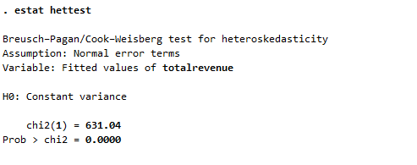
Since the probability of chi2 is less than 0.05 we reject the null hypothesis and conclude that the regression has heteroskedasticity. These results would suggest that there is some unusual scatter in the regression model primarily because of dependence on other variables.
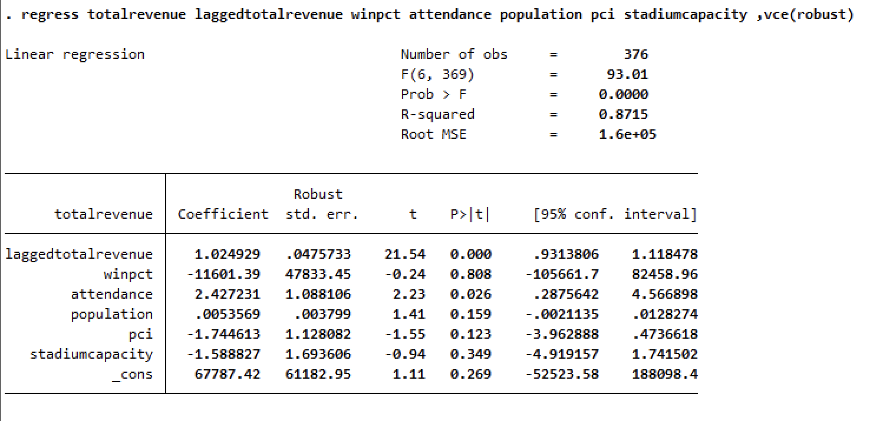
This regression to start is based on regression 6, we see there is some change in the data. To start off with the coefficients and the standard errors, the coefficients are as follows: 1.024929 (Lagged total revenue), -11601.39 (winning percentage), 2.247231 (attendance), .0053569 (population), -1.744613(PCI), and -1.588827 (stadium capacity). With these we can see some groups appear of population, PCI, attendance, and lagged total revenue having positive impacts and win percentage and stadium capacity having negative impacts with winning percentage being a very large number. Onto the new robust standard errors, we can see that they have in general decreased over the prior regression being as follows, .0475 for lagged total revenue, 47833.45 for winning percentage, 1.0881 for attendance, .003799 for population, 1.1281 for PCI, and 1.6936 for stadium capacity. With this we can see more groups of Lagged total revenue and Attendance being relatively low in relation to their coefficients, but the standard errors increased. Population and PCI both decreased making them closer to being significant but still too high to be and finally winning percentage and stadium capacity have unbelievably high standard errors even with the robust standard errors making them insignificant. Onto the T and P values, the T values are as follows: 21.54 for lagged total revenue, -0.24 for winning percentage, 2.23 for attendance, 1.41 for population, -1.55 for PCI, and -0.94 for stadium capacity. When looking at the absolute value of these we see Lagged total revenue and attendance are both statistically significant, population and PCI are on the cusp of being so, and winning percentage and stadium capacity are both statistically insignificant. When looking at the P values we see some interesting results, only lagged total revenue and attendance are signifying at the 95% confidence level the rest are statistically insignificant. The confidence intervals are like the last as wellbeing only lagged total revenue and attendance having realistic confidence intervals. The F-stat is still high and the probability of it are 0 making the model significant and finally the adjusted R-squared is 0.8751 making the model overall statistically significant. When looking at this through the lens of heteroskedastic we can see that there is some present since the chi 2 is less than 0.05 so we can conclude that there is heteroskedastic effects on the data.

