Tyler Berry
Stacy Brook PH. D
ECP 3006
23 November 2025
Final

2A. Literature Review:
Article 1:
Popescu​‍​‌‍​‍‌​‍​‌‍​‍‌ and Crama (2016) explore how a broadcaster can maximize advertising revenue in live-events situations where the lengths of commercial breaks are stochastic. They study the dynamic scheduling problem and conclude that in a simplified setting with only 15- and 30-second ads, the optimal policy is a look-ahead rule, and knowing the future break durations in advance is of no use. For complex, real-world situations (multiple ad lengths, diversity constraints), the simple greedy scheduling heuristic is surprisingly effective, especially under linear pricing, while look-ahead heuristics become more significant if short ads are given a premium. The main managerial implication of the paper is that the best tool of a broadcaster is a proactive sales strategy: by adding a larger share of short-duration ads to their flexible ad portfolio and choosing the best overbooking level, as the flexibility of short ads will be more valuable for risk reduction than complex, reactive scheduling adjustments, they should strategically create a flexible ad portfolio. Here we can observe the result of advertisements on the variable revenue, and this clarifies some of the results we see in the ad revenue in both regressions. This means that an increase in ad revenue can be both good and bad depending on the manner in which it is ​‍​‌‍​‍‌​‍​‌‍​‍‌utilized.

Article 2:
Gil​‍​‌‍​‍‌​‍​‌‍​‍‌ and Hartman (2007) analyzes the determinants of concession sales in the Spanish movie exhibition industry through the use of proprietary weekly data from a major exhibitor from 2003 to 2005, to fill a gap in the empirical research of this high-margin revenue stream. The authors discover that the ticket purchase channel has a very strong impact on the concession revenues and that customers buying through the Internet and automated kiosks are those who spend the most on concessions as compared to the ones who use traditional box office windows. Besides, the study points out that there is a positive correlation between the size of the transaction and the amount of money spent on the concession, thus suggesting that the composition of the audience, such as bigger groups or families, leads to higher consumption per capita, even though the sharing is still possible. In the end, the paper asserts that film exhibitors are able to increase their profit not only through attendance, but also by strategically encouraging the nontraditional sales channels and considering local market features that uplift the secondary revenue. ​‍​‌‍​‍‌​‍​‌‍​‍‌We can see here that they find, while on a smaller scale, that attendance has the same effect on concessions, being that concessions are increased by attendance at the given event.

2B. Regression Results & Interpretation I:
regress realtotalconcession realtotaladrev realtotaladexp totalattendance FY
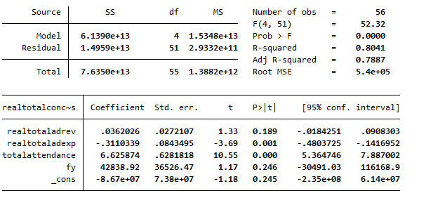
Regression 1 starts mildly strong with a strong fit for the model. To start with, the coefficients are as follows: 0.0362026 for real total ad revenue and a standard error of 0.0272107. This means that for every 1 unit increase in total ad revenue, we see a 0.0362026 increase in real total concession sales. This makes sense, being that ad revenue would lead to an increase in sales, but we will evaluate this further later. Next is −0.3110399 in real total ad expense and a standard error of 0.0843495. This means for every 1-dollar expense in real total ad expense, there is a −0.3110399 increase in real total concessions. Onto total attendance, we see a variable of 6.625874 and a standard error of 0.6281188. This means that for every 1 unit increase in total attendance, there is a 6.625874 unit increase in total concessions. This also makes sense logically. Finally for fiscal year we see a coefficient of 42838.92 and a standard error and a standard error of 36526.47. This means that for every 1 unit increase in fiscal year (when you move a year up), there is a 42838.92 unit increase in total concessions. Onto the T and P values, they are as follows: 1.33 (T) and 0.189(P) for real ad revenue. This means that real variable revenue is an insignificant predictor of real total concessions. -3.69(T) and 0.001(P) for real total ad expense. This makes it significant and makes it a mildly strong predictor of real total concessions. 10.55(T) and 0.000(P) for total attendance. This makes it a strong predictor of total concessions. Finally, 1.17(T) and 0.246(P) for the fiscal year. This means that the fiscal year is insignificant and not a predictor of real total concessions. The confidence intervals are as follows: [-0.0184251, 0.0908303] for real total ad revenue, which crosses 0, making the variable still insignificant. [-0.4803725, –0.1416952] For real total ad expense, yielding a statistically significant result. [5.364746, 7.887002] For the total attendance, this is fine like before, and really doesn’t have anything wrong with it, so it is still statistically significant. Finally, [−30491.03, 116168.9] for the fiscal year, this is incredibly large and crosses 0, yielding a statistically insignificant result. The other stats are as follows: The F stat is 52.32 and has a probability of less than 0.001, which means the model is significant. The R-Squared is 0.8041, which means that about 63% of the variation in real total concessions. The adjusted R-Squared is 0.7887, which follows as before but is slightly lower than the regular R-Squared when accounting for the number of variables. Overall, the model is good and has two strong predictors of real total concessions.

2C. Regression Results & Interpretation 2: |X|
regress realconcessions realadrev realadexp attendance sex fy
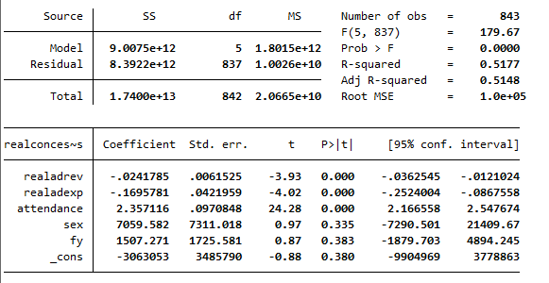
Regression 2 follows as before, with it being a strong model. To start with, the coefficients are as follows: -0.0241785 for real ad revenue and a standard error of 0.00615125. This means that for every 1 unit increase in ad revenue, we see a -0.0241785 decrease in real concession sales. Next is -0.1695781 in real total ad expense and a standard error of 0.0421599. This means for every 1-dollar expense in real ad expense; there is a -0.1695781 increase in real concessions. Onto attendance, we see a variable of 2.357116 and a standard error of 0.0970848. This means that for every 1 unit increase in total attendance, there is a 2.357116 unit increase in total concessions. This also makes sense logically. Next, we see a 7059.582 for sex and a standard error of 7311.018. For fiscal year we see a coefficient of 1507.271 and a standard error and a standard error of 1725.581. This means that for every 1 unit increase in fiscal year (when you move a year up), there is a 1507.003 unit increase in total concessions. When we look at the sport individually, we see some interesting results, like ad revenue now being negative and both sexes and the fiscal year being significantly smaller than before. Onto the T and P values, they are as follows: -3.93 (T) and 0(P) for ad revenue. This means that real variable revenue is a significant predictor of real concessions. -4.02(T) and 0(P) for real ad expense. This makes it significant and makes it a mildly strong predictor of real concessions, much like before. 24.28(T) and 0.000(P) for attendance. This makes it a strong predictor of total concessions. 0.96(T) and 0.338(P) for sex. This makes it insignificant, and we fail to reject the null hypothesis, similar to fiscal year like before with values of 0.87(T) and 0.383(P). The confidence intervals are as follows: [-0.0362545, -0.0121024] for real ad revenue, which makes it significant. [-0.2524004, -0.0867558] For real ad expense, yielding a statistically significant result. [2.166558, 2.547675] For the attendance, this is fine like before and really doesn’t have anything wrong with it, so it is still statistically significant. [-7290.501, 21409.67] for sex and [-1879.703, 4884.245] for fiscal year. Both of these are statistically insignificant and cross 0. The other statistics are as follows: The F-stat is 179.67 and has a probability of less than 0.001, which means the model is significant. The R-Squared is 0.5177, which means that about 52% of the variation in real total concessions. The adjusted R-Squared is 0.5148, which follows as before but is slightly lower than the regular R-Squared when accounting for the number of variables. Overall, this model was a good fit, and we had three predictors of real concessions.
2D. Omitted Variable:
An omitted Variable that should be included is metropolitan or micropolitan area size. The size of the metropolitan or micropolitan area where the school is located is a very important variable that is missing in the model. This variable basically denotes the population of the area around the institution, and it is directly linked to the possible number of people who could attend games and buy concessions. The model at present has attendance, but this is just the number of people who showed up at a particular game or games. It does not represent the total size of the market or the possible fan base for the athletics program. On top of that, the metropolitan or micropolitan area size would help the model to adjust for differences in the population around the areas, which impacts both attendance and sales of concessions. Normally, schools in big metropolitan areas have a larger pool of potential attendees than schools in small towns, even if their actual attendance numbers are almost the same. The model might be attributing differences in concession revenues to variables such as sex or fiscal year incorrectly if it does not consider the size of the population around the area. Moreover, it is not hard to collect data for this variable. In previous research tasks, we have already used geofib. Adding this to the existing dataset can be achieved through a simple merger or VLOOKUP function, just like we have done before.
2E. Conclusions:
Beyond just increasing attendance, we saw no other variable be significant and positive in the second regression on the sport level, but on the university level, we see different results. To start with, regression 2, because that is where we see the strangest results. The negative effect of the two ad-related variables suggests that schools generating more advertising revenue may be relying on alternative revenue sources rather than concession sales, or that the types of events or advertising partnerships generating revenue are not associated with increased concession purchases. So, due to both of these factors being negative, the AD should target marketing that increases in-stadium attendance, since attendance has a large positive effect on concession revenue. We can see in this that only attendance is positive and highly significant, so we should focus on attendance at the games first and foremost. Onto Regression 1, we see similar results. Advertising revenue has a positive but statistically insignificant relationship with total concession sales. This suggests that again, the revenue is not a significant driver of concession performance. Advertising expenses have a large, statistically significant negative effect on concession sales. This suggests that the universities' advertising spending is not producing higher attendance or concession purchases. In fact, it may be pulling resources away from more effective revenue-generating activities or being spent on campaigns unrelated to actual game-day turnout. Attendance has a strong, positive, and statistically significant effect on concession sales, which is the same as before. The Athletic Director, considering all these effects, focuses resources on increasing attendance. Attendance is the most powerful driver of concession revenue. Strategic fan-engagement, promotions, and student incentives are likely to generate far greater returns than spending more on advertising. Next, reevaluate advertising expenditures. We see a negative effect, so there must be an effect that is falling flat, potentially misallocations of funds, or ineffective campaigns that are not increasing game day turnout. So overall, the athletic director should take attendance at the games with utmost importance for increasing total and individual concession sales.

Reference:
Popescu, Dana G., and Pascale Crama. “Ad Revenue Optimization in Live Broadcasting.” Management Science, vol. 62, no. 4, Institute for Operations Research and the Management Sciences (INFORMS), Apr. 2016, pp. 1145–64, https://doi.org/10.1287/mnsc.2015.2185. Accessed 28 Nov. 2025.

Gil, Ricard, and Wesley R. Hartmann. “The Role and Determinants of Concession Sales in Movie Theaters: Evidence from the Spanish Exhibition Industry.” Review of Industrial Organization, vol. 30, no. 4, Springer, 2007, pp. 325–47, https://doi.org/10.2307/41799338. JSTOR.

