Tyler Berry
Stacy Brook PH. D
ECP 3006
5 October 2025

RA4: Economic Impact
2A. Regression Results:
regress countrytaxgrowthrate numberofhomegames statetaxgowthrate countyunemploymentrate
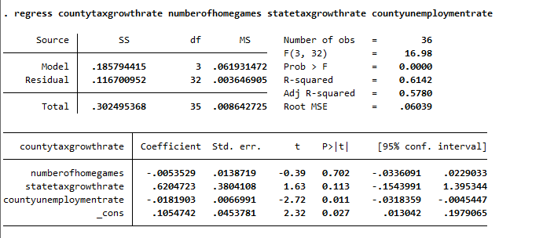

regress countrytaxgrowthrate homeattendance statetaxgowthrate countyunemploymentrate
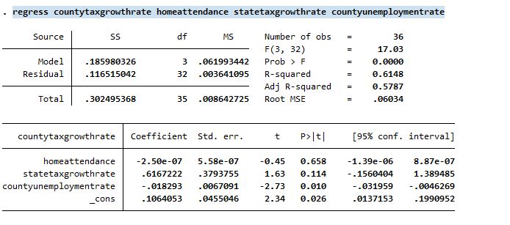
2B. Regression Results:
Regression 1 starts off weak, with 1 of the variables being significant. To start with the coefficients, the number of home games has a negative coefficient of -0.0053529 and a standard error of 0.0138719. This means that for every 1 unit increase in county tax growth rate, there is a -0.0053529 in the number of home games, which makes 0 sense realistically. The standard error is also unbelievably high. Regarding the country's unemployment rate, the coefficient is -0.0181903, and the standard error is 0.0066991. Neither of these shows us anything really other than that they are negative and significant. Finally, on the state tax growth rate, the coefficient is 0.6204723 and the standard error is 0.3804108. With this, it follows the variable of home games, and there is nothing significant here. When looking at the T values and P values of the variables, all the T values are less than the absolute value of 2, except for the county unemployment rate, which has a T-stat of 2.73, meaning it is significant, meaning that all the variables are statistically insignificant. The P values tell a similar story, all being higher than 0.05, meaning that we fail to reject the null hypothesis, resulting in the variables being statistically insignificant. Onto the Confidence intervals, they are as follows: -0.0336091, 0.0229033} for the number of home games, {-0.0318359, -0.0045447} for the county unemployment rate, and finally -0.1543991, 1.395344} for the state tax growth rate. All these values cross into the negatives, meaning that all of them are statistically insignificant. Finally, the R-squared and adjusted R-squared the R-squared is 0.6142 and the adjusted R-squared is 0.5780. This means that the regression overall does not fit the variance in the data, and the variables are likely not related to the dependent variable. Finally, the F is low, but the prob of F is 0, meaning that there is some significance in this regression. In conclusion, it is highly unlikely that home attendance, state tax growth rate, and county unemployment rate have any influence on county tax growth rate.

Regression 2 continues weak, with 1 of the variables again being significant. To begin with the coefficients, the home attendance coefficient is -2.50e-07 with a standard error of 5.58e-07. This means that for every 1 unit increase in county tax growth rate, there is -2.50e-07 in the home attendance, which continues to make 0 sense realistically just like before, and it has a super low impact on the variable, being almost 0. The standard error is still unbelievably high. Regarding the country's unemployment rate, the coefficient is -0.018293, and the standard error is 0.0067091. Neither of these shows us anything really other than that they are negative and significant, just like the previous regression. Finally, onto the state tax growth rate, the coefficient is 0.6167222, and the standard error is 0.3793755. With this, it follows the previous 2 variables, and there is nothing significant here. When looking at the T values and P values of the variables, all the T values are less than the absolute value of 2, except for the county unemployment rate, which is still 2.73, meaning it is statistically significant, meaning that all the variables are statistically insignificant. The P values tell a similar story, all being higher than 0.05, meaning that we fail to reject the null hypothesis, resulting in the variables being statistically insignificant. Onto the Confidence intervals, they are as follows: {-1.39e-06, 8.87e-07} for home attendance, {-0.031959, -0.0046269 } for the county unemployment rate, and finally {-0.1566044, 1.389485} for the state tax growth rate. All these values cross into the negatives except for home attendance, meaning that all of them are statistically insignificant. Finally, the R-squared and adjusted R-squared are 0.0220 and the adjusted R-squared is -0.0691. This means that the regression overall does not fit the variance in the data, and the variables are likely not related to the dependent variable. Finally, the F is low at 0.24, and the probability of F is high at 0.8682, meaning that the overall regression is statistically insignificant. In conclusion, it is highly unlikely that home attendance, state tax growth rate, and county unemployment rate have any influence on county tax growth rate.

2C. Event Analysis:
No, college football is not a significant driver of the growth rate in Taxable Sales in Watauga County. We can observe this through the fact that when we run the regression comparing the growth rate to the number of both home attendance and home games, it shows a statistically significant influence on the county tax growth rate. This could be because there is no real way to see a difference between when there is football and not. This would be hard to see with the 12-month differential, knowing that college football only plays 6 games at home over any given season, meaning attendance and home games would not have any impact, especially not when it comes to any individual school against the state.
2D. Comparison:
When looking at the results of these regressions, we see very similar results to those of Baade, Baumann & Matheson's 2011 paper on the economic impact of college football at the University of Florida and Florida State. We can see that there is no real correlation between the growth of the county tax rate and either home attendance or the number of home games yields a significant effect on the In Baade, Baumann, and Matheson’s paper, they conclude that there is no real economic Impact from college football or basketball on the state or county in which they are. This is similar to the results gained in my regressions due to the fact that there is no significance to the attendance or the number of home games, meaning there is no real impact on the economy, and we can even see that the results in smaller schools and bigger schools (Appalachian State vs Florida State) have no economic impact on their respective counties.
2E. Omitted Variable:
Stated Variable: One variable that was omitted should not have been the ticket revenue from these schools. This would be like attendance, but give us a more monetary way to view the economic impact of college football.
Explanation: The reason that the revenue of the school's athletic programs or more growth in revenue would reflect on the county's tax growth rate. We could see if the football team really has an impact on the county's respective tax growth rate or if there is no real effect. When we see the variables such as attendance and the number of home games, there is no real way to see how that would affect the growth rate, especially since the number of home games is just 1, 2, or 3 at most. This would certainly drag down the data because the values are small and really have no impact on the economic impact. If there is a home game, for example, but the year is 2020, and there is no people at the game but it is still classified a home game there is no way to see that in the regression. This is the issue that is fixed with revenue. We can see how much money the schools pull in over the course of the season and the years and compare that to the growth rate in county taxes to see the true economic impact of the sports program on the state.

