Tyler Berry
Stacy Brook PH. D
ECP 3006
20 October 2025

RA6: Salary

2A. Missing University and FY’s PDF file and Missing Sport:
- Portland State FY 2018 total revenue
- Portland State FY 2022 Assistant coach salary
- Portland state FY 2019-2023 Concessions
- Maryland, Baltimore County FY 2017-2023 Concessions
- North Carolina Wilmington FY 2017-2023 Concessions
- California FY 2021 Guarantee
2B. Regression Results:
regress realheadcoachsalary realvariablerevenue assistantcoachsalaryfte winningpercentage
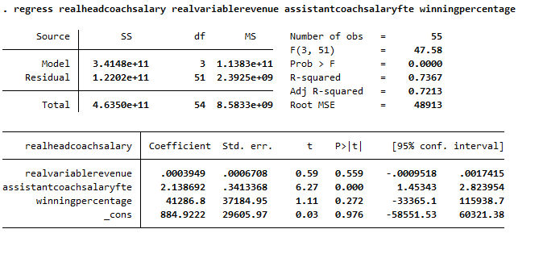

regress realheadcoachsalary realvariablerevenue assistantcoachsalarypositions winningpercentage
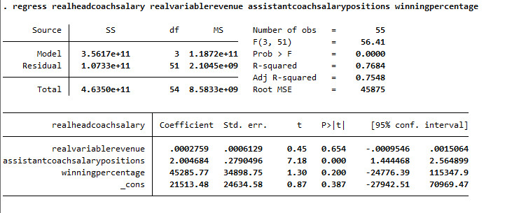

regress lnrealheadcoachsalary realvariablerevenue assistantcoachsalaryfte winningpercentage\
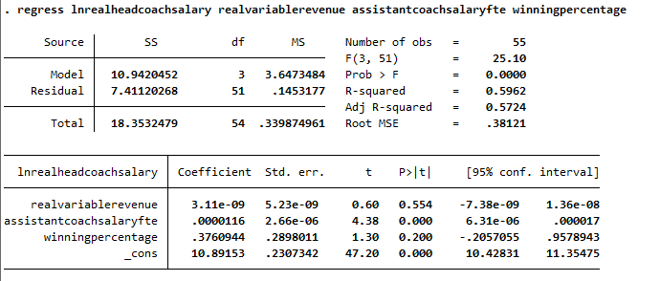

regress lnrealheadcoachsalary realvariablerevenue assistantcoachsalarypositions winningpercentage

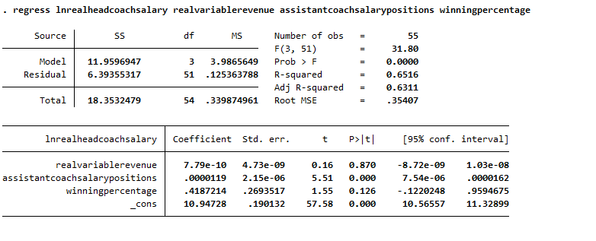

2C. Regression Results:
Regression 1 starts mildly strong with a strong fit for the model. To start, the coefficients are as follows: real variable revenue has a coefficient of 0.0003949 and a standard error of 0.0006708. This means that for every 1 dollar increase in real variable revenue, we can see a 0.0003949 real head coach salary. This is standard since the real variable revenue refers to the entire school and not just the volleyball program. The assistant head coach salary, divided by FTE, has a coefficient of 2.138692 and a standard error of 0.3413368, with this we can see that for every 1 unit increase in assistant head coach salary divided by FTE we can see a 2.138692 in head coach salary which overall makes sense since there is a better chance the head coach gets paid more or always close to double what the assistant coach gets paid. Finally winning percentage has a coefficient of 41,286.8 and a standard error of 41,286.8; both are extremely high, which would suggest that the coach's pay is determined by the winning percentage, but we will reevaluate this later. Onto the T and P values they are as follows: real variable revenue has a T and P value of 0.59(T) and 0.559(P), neither of these are significant since the T value is less than the absolute value of 2 and the P value is higher than the confidence value of 95% which means we fail to reject the null hypothesis leading to a non-statistically significant variable. The assistant head coach's salary divided by FTE has a T and P value of 6.27(T) and 0(P). Both are significant and are good predictors of the Real head coach's salary. Winning percentage has a T and P value of 1.11(T) and 0.272(P), which are both insignificant and a bad predictor of the real head coach salary. The confidence intervals are as follows: (-0.0009518, 0.0017415) for real variable revenue, which crosses 0, meaning it is not statistically significant. (1.45343, 2.823954) For the assistant head coach's salary divided by the FTE, this follows as before and is fine and statistically significant. (-33,365.1, 115,938.7) For the winning percentage, this is incredibly large and crosses 0, yielding a statistically insignificant result. On the rest of the statistics, the F is 47.58 and has a probability of less than 0.001, which is good and shows a strong fit for the model. The R-squared is 0.7367, which means that about 73.7% of the variation in head coach salary is explained by the three predictors. The adjusted R-squared is 0.7213, which means that after adjusting for the number of predictors, about 72.1% of the variance is still explained, indicating a strong fit. In conclusion, only the assistant head coach's salary divided by the FTE is the only real predictor here.
Onto regression 2, it starts stronger. To start, the coefficients are as follows: real variable revenue has a coefficient of 0.0002759 and a standard error of 0.0006129. This means that for every 1 dollar increase in real variable revenue, we can see a 0.0002759 real head coach salary. The assistant head coach salary, divided by positions, has a coefficient of 2.004684 and a standard error of 0.2790496, with this we can see that for every 1 unit increase in assistant head coach salary divided by FTE we can see a 2.004684 in head coach salary which overall makes sense since there is a better chance the head coach gets paid more or always close to double what the assistant coach gets paid and especially by how many assistants there are. Finally winning percentage has a coefficient of 45,285.77and a standard error of 34,898.75; both are extremely high, which would suggest that the coach's pay is determined by the winning percentage, but we will reevaluate this later. Onto the T and P values they are as follows: real variable revenue has a T and P value of 0.45(T) and 0.654(P), neither of these are significant since the T value is less than the absolute value of 2 and the P value is higher than the confidence value of 95% which means we fail to reject the null hypothesis leading to a non-statistically significant variable. The assistant head coach's salary divided by postion has a T and P value of 7.78(T) and 0(P). Both are significant and are good predictors of the Real head coach's salary. Winning percentage has a T and P value of 1.30(T) and 0.200(P), which are both insignificant and a bad predictor of the real head coach salary. Winning percentage did get stronger as a variable, but it is still not statistically significant. The confidence intervals are as follows: (-0.0009546, 0.0015064) for the real variable revenue, which crosses 0, meaning it is not statistically significant. (1.444468, 2.564899) For the assistant head coach's salary divided by the Position, this follows as before and is fine and statistically significant. (-24,776.39, 115,347.9) For the winning percentage, this is incredibly large and crosses 0, yielding a statistically insignificant result. Both variable revenue and winning percentage became less insignificant but are still a good bit away from being the prior. On the rest of the statistics, the F is 56.41 and has a probability of less than 0.001, which is good and shows a strong fit for the model. The R-squared is 0.7684, which means that about 76.8% of the variation in head coach salary is explained by the three predictors. The adjusted R-squared is 0.7548, which means that after adjusting for the number of predictors, about 75.5% of the variance is still explained, indicating a strong fit. In conclusion, only the assistant head coach's salary divided by the position is the only real predictor here. The other two variables do get more significant in this model but are still both insignificant.
After log-transforming head coach salary regression 3 is weaker than the other two. To start, the coefficients are as follows: real variable revenue has a coefficient of 3.11e-09 and a standard error of 5.23e-09. This means that for every 1 dollar increase in real variable revenue, we can see a 3.11e-09 real head coach salary. This is standard as before, since the real variable revenue refers to the entire school and not just the volleyball program. The assistant head coach salary, divided by FTE, has a coefficient of 0.0000116 and a standard error of 0.00000266, with this we can see that for every 1 unit increase in assistant head coach salary divided by FTE we can see a 0.0000116 in head coach salary which overall makes sense since there is a better chance the head coach gets paid more or always close to double what the assistant coach gets paid. Finally winning percentage has a coefficient of 0.3760994 and a standard error of 0.2898011; both are extremely high in relation to the variables expected when using the natural log in a regression, which would suggest that the coach's pay is determined by the winning percentage, but we will reevaluate this later. Onto the T and P values they are as follows: real variable revenue has a T and P value of 0.60(T) and 0.554(P), neither of these are significant since the T value is less than the absolute value of 2 and the P value is higher than the confidence value of 95% which means we fail to reject the null hypothesis leading to a non-statistically significant variable. The assistant head coach's salary divided by FTE has a T and P value of 4.38(T) and 0(P). Both are significant and are good predictors of the Real head coach's salary. Winning percentage has a T and P value of 1.30(T) and 0.200(P), which are both insignificant and a bad predictor of the real head coach salary. Both variable revenue and winning percentage continue to get more significant as the assistant head coach's salary divided by the FTE gets less significant. The confidence intervals are as follows: (-7.38e-09, 1.36e-08) for the real-valued revenue variable, which crosses 0, indicating it is not statistically significant. (6.31e-06, 0.000017) For the assistant head coach's salary divided by the FTE, this follows as before and is fine and statistically significant. (-0.2057, 0.9579) For the winning percentage, this is large and crosses 0, yielding a statistically insignificant result. For the remaining statistics, the F is 25.10 and has a probability of less than 0.001, which is good and indicates a strong fit for the model. The R-squared is 0.5962, which means that about 59.6% of the variation in head coach salary is explained by the three predictors. The adjusted R-squared is 0.5724, which means that after adjusting for the number of predictors, about 57.2% of the variance is still explained, still quite good, but lower than your previous two unlogged models (which were around 0.72–0.75). In conclusion, only the assistant head coach's salary divided by the FTE is the only real predictor here, as same as it was before.
Regression 4 follows regression 3 in a similar vein. To start, the coefficients are as follows: real variable revenue has a coefficient of 7.79e-10 and a standard error of 4.73e-09. This means that for every 1 dollar increase in real variable revenue, we can see a 7.79e-10 real head coach salary. This is standard as before, since the real variable revenue refers to the entire school and not just the volleyball program. The assistant head coach salary, divided by FTE, has a coefficient of 0.0000119 and a standard error of 0.00000215, with this we can see that for every 1 unit increase in assistant head coach salary divided by Position we can see a 0.0000119 in head coach salary which overall makes sense since there is a better chance the head coach gets paid more or always close to double what the assistant coach gets paid. Finally winning percentage has a coefficient of 0.4187214 and a standard error of 0.2693517; both are extremely high in relation to the variables expected when using the natural log in a regression, which would suggest that the coach's pay is determined by the winning percentage, but we will reevaluate this later. Onto the T and P values they are as follows: real variable revenue has a T and P value of 0.16(T) and 0.870(P), neither of these are significant since the T value is less than the absolute value of 2 and the P value is higher than the confidence value of 95% which means we fail to reject the null hypothesis leading to a non-statistically significant variable. The assistant head coach's salary divided by positions has a T and P value of 5.51(T) and 0(P). Both are significant and are good predictors of the Real head coach's salary. Winning percentage has a T and P value of 1.55(T) and 0.126 (P), which are both insignificant and a bad predictor of the real head coach salary. Winning percentage did get stronger as a variable, but it is still not statistically significant. The confidence intervals are as follows: (-8.72e-09, 1.03e-08) for the real variable revenue, which crosses 0, meaning it is not statistically significant. (7.54e-06, 1.03e-05) For the assistant head coach's salary divided by the position, this follows as before and is fine and statistically significant. (-0.1220, 0.9595) For the winning percentage, this is incredibly large and crosses 0, yielding a statistically insignificant result. Both variable revenue and winning percentage became less insignificant but are still a good bit away from being the prior. For the remaining statistics, the F is 31.80 and has a probability of less than 0.001, which is good and indicates a strong fit for the model. The R-squared is 0.6516, which means that about 65.2% of the variation in head coach salary is explained by the three predictors. The adjusted R-squared is 0.6311, which means that after adjusting for the number of predictors, about 63.1% of the variance is still explained, still quite good, but lower than your previous two unlogged models (which were around 0.72–0.75). In conclusion, only the assistant head coach's salary divided by the position is the only real predictor here, the same as it was before.
2D. Comparison:
When we look at the two real variable head coaches we see some serious similarities, to start with the coefficients for real variable cost they are very similar being, 0.0003949(1) and of 0.0002759(2), there is almost no discernable difference in these variables which makes sense because they are the same variable along both. When we look at winning percentage we see the same results, 41,286.8(1) and 45,285.77(2), in this we can see the same thing as before being neither of this change. Onto positions vs FTE we can see more similarities, those coefficients are, 2.138692(1) and 2.004684(2), On this we can see that there really is no difference between positions and FTE when it comes to the effect of assistant head coach pay divided by variable x but this makes sense because in most cases the FTE and the number of positions are the exact same being 2 in most cases. The T and P values follow suit with the prior coeffects, and they are as follows, 0.59(T) and 0.559(P) yields from real variable revenue in regression 1 and 0.45(T) and 0.654(P) from regression 2, these are almost the exact same and are both statistically insignificant. 6.27(T) and 0(P) for FTE In regression 1 and 7.78(T) and 0(P) for positions in regression 2, Positions is slightly more significant, but both are statically significant, so it does not matter that much. Finally, onto the winning percenter they are as followed, 1.11(T) and 0.272(P) for regression 1 and 1.30(T) and 0.200(P) for regression 2, they are both statistically insignificant and not discernably different. Now onto the other variables for the two real head coach salary’s we can see similarity’s here. First the F stats are as follows 47.58 and has a probability of less than 0.001(1) and the F is 56.41 and has a probability of less than 0.001(2) both are very similar, and both show a strong fit for the model. Now the R-squared we can see them as follows, 0.7367(1) and 0.7684 (2), in this we can see a similar fit for the model and there is not much of a difference. Finally, onto the adjusted R squared we can see them as follows, 0.7213(1) and 0.7548(2), this would suggest that the assistant head coach divided by the positions fits the model just a bit better than the prior.
Now onto the Natural Log variables, to start with the coefficients for real variable cost they are very similar being, 3.11e-09 (3) and of 7.79e-10 (4), Now we can see some difference with FTE having a larger coefficient than positions but they are so close to being trivial, onto winning percentage we see a similar results to the prior results of 0.3760994(3) and 0.4187214 (4), in this we can see the same thing as before being neither of this change. Onto positions vs FTE we can see more similarities, those coefficients are, 0.0000116 (3) and 0.0000119 (4), Now both of these are exactly the same and have no real difference. The T and P values follow suit with the prior coeffects, and they are as follows, 0.60(T) and 0.554(P) yields from real variable revenue in regression 3 and 0.16(T) and 0.870(P) from regression 4, these are now very different making regression 3 have a better fit than regression 4. onto the positions vs FTE for assistant head coach salary, they are as followed 4.38(T) and 0(P) for FTE In regression 3 and 5.51(T) and 0(P) for positions in regression 4, Positions is slightly more significant, but both are statically significant, so it does not matter that much. Finally, onto the winning percenter they are as followed, 1.30(T) and 0.200(P) for regression 3 and 1.55(T) and 0.126 (P) for regression 4, they are both statistically insignificant and not discernably different. Onto the other statistics the F stats are as follows. First for variable revenue, 25.10 and has a probability of less than 0.001(3) and 31.80 and has a probability of less than 0.001(4), Both of these are similar and show a good fit for the model. Onto the R-squared and adjusted R-squared are as follows. the R-squared we can see them as follows, 0.5962 (3) and 0.6516 (4), in this we can see a similar fit for the model and there is not much of a difference. Finally, onto the adjusted R squared we can see them as follows, 0.5724 (3) and 0.6311 (4), These are all very similar and show a common result on both sides.
2E. Limitation 1: The biggest limitation on this model is that it does not consider contract length or the ability to re-negotiate contracts. Brook shows that head coaches who sign new contracts and those who sign modified contracts capture different mixes of variable and fixed program revenues when salaries are set. This means that pooling together these teams and the seasons leaves an estimator bias due to there being no accounting for the negotiation of contracts.
2D. Limitation 2: Two variables that I think should be included in the regression model are length of contract and lagged win lagged win percentage. First on length of contract, this accounts for what was stated in limitation 1 allowing for there to be some views on if there is negotiation allowed in the contracts. This would give some ways to see the mixes of fixed and variable revenues for the data. Onto lagged win percentage it follows the previous research assignments because it does not make sense for the coach’s salary of any given year to be decided by those years winning percentage. Instead, it would make sense for the winning percentages to be lagged to see the previous year so that we can see actual performance, maybe even using an average so we can see winning percentage over there entire contract.

