Tyler Berry
Stacy Brook PH. D
ECP 3006
20 October 2025

RA5: Production
2A. Regression Results 1:
regress r single doub trip hr sb hbp sf nbb gidpcs outs, vce(robust)
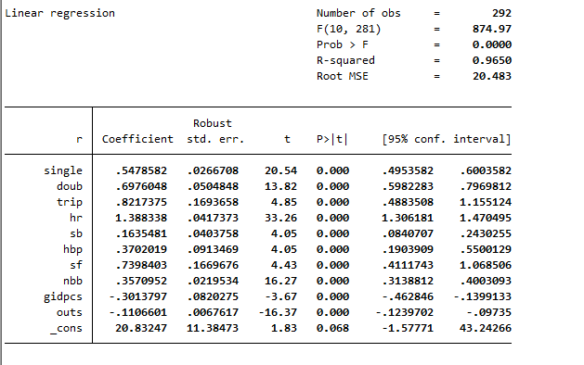

2B. Regression Interpretation:
Regression 1 begins strongly, with all variables being significant. To start, the coefficients are as follows: singles are .5478582, which means that for every run there is a .5478582 in singles. Doubles have a coefficient of .6976048, which means that same as before, for every run, there is a .6976048 increase in doubles. Triples have a similar value in .8217375. We can see an upward trend, meaning that for every run, there is an upward trend from singles to triples. Home runs are where we see a real change, being 1.388338, which means for every run there is a 1.388338 in home runs, which makes sense in the statistical sense. Stolen bases have a coefficient of .1635481. Hit by pitch has a coefficient of .7398403. Sacrifice flies have a coefficient of .7398403. Grounded into double plays by opposing batter has a coefficient of -.3013797, which is the first negative we see, meaning that for every run there is a -0.3 decrease in grounded into double plays. Nbb has a coefficient of .3570952, which is common to the rest of them. Finally, the coefficient for outs is -.1106601, which is another negative coefficient. Onto robust standard errors, all of them are low in relation to their coefficients and they are as follows: .0266708 for singles, .0504848 for doubles, .1693658 for triples, .0417373 for home runs, .0403758 for stolen bases, .0913469 for hit by pitch, .1669676 for sacrifice flies, .0219534 for nbb, .0820275 for grounded into doubles plays, and finally .0067617 for outs. All of these standard errors are low and show no unusual variance in the data. Onto the T and P values, all the P values are 0, meaning we reject the null hypothesis, showing that the data is statistically significant. The T values are as follows: 20.54 for singles, 13.82 for doubles, 4.85 for triples, 33.26 for homeruns, 4.05 for stolen bases, 4.05 for hit by pitch, 4.43 for sacrifice flies, 16.27 for nbb, -3.67 for grounded into double plays, and finally -16.37 for outs. We can see that the strongest statistical significance is singles, doubles, home runs, nbb, and outs. With that being said, all of the variables are statistically significant. The confidence intervals are as follows: [0.4953582, 0.6003582] for singles, [0.5982283, 0.7969812] for doubles, [0.4883508, 1.155124] for triples, [1.306181, 1.470495] for home runs, [0.0840707, 0.2430255] for stolen bases, [0.1903909, 0.5536129] for hit by pitches, [0.4111743, 1.068435] for sacrifice flies, [0.3138812, 0.4003093] for nbb, [-0.462846, -0.1399133] for grounded into doubles plays, and [-0.1239702, -0.09735] for outs. All of these intervals are within their needed ranges to be statistically significant. Onto the R-squared, which is 0.9650, which means that we can explain 97 percent of the variation in the data with this regression, which shows very strong statistical significance. The F is 874.97, and the probability of F is 0, which also shows strong statistical significance. In conclusion, we can see a strong statistical significance in this data, and there are no real outliers in the data. We can see that there is a strong fit for this model.

2C. Regression Results 2:
regress r single doub trip hr sb hbp sf nbb gidpcs outs
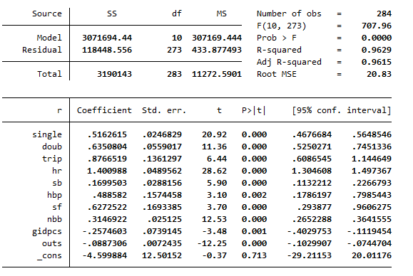

2D. Comparison with Blass:
When we compare the seasons of 1994 to 2003 with Blass’s regression of the seasons from 1976-1978, we can see some similarities in the data, to start with the coefficients they are as follows, singles are .5478582. Doubles have a coefficient of .6976048. Triples have a similar value in .8217375. Home runs have a coefficient of 1.388338. Stolen bases have a coefficient of .1635481. Hit by pitch has a coefficient of .7398403. Sacrifice flies have a coefficient of .7398403. Grounded into double plays by opposing batter has a coefficient of -.3013797. Nbb has a coefficient of .3570952, Finally, the coefficient for outs is -.1106601. When we look at Blass the coefficients are similar with, singles being 0.518, doubles being 0.625, triples being 0.849, home runs being 1.375, non-intentional walks being 0.320, hit by pitch being 0.495, stolen bases being 0.173, grounded into double plays and caught stealing being -0.206, and finally outs being -0.086. With this we can see all the similar coefficients being close to each other and even having the same signs with gidpcs and outs both being negative, home runs is still above 1. Stolen bases and sacrifice flies are slightly higher but still near each other. The standard deviations follow the same story as coefficients being as followed for the 1994 to 2003: .0266708 for singles, .0504848 for doubles, .1693658 for triples, .0417373 for home runs, .0403758 for stolen bases, .0913469 for hit by pitch, .1669676 for sacrifice flies, .0219534 for nbb, .0820275 for grounded into doubles plays, and finally .0067617 for outs. Onto Blass they are as followed, 0.025 for singles, 0.056 for doubles, 0.137 for triples, 0.026 for non-intentional walks, 0.156 for hit by pitch, 0.029 for stolen bases, 0.074 for grounded into double plays and caught stealing, 0.169 for sacrifice flies, and 0.006 for outs. All of these much like coefficients are similar with the 1994-2003 seasons. When we look at the R-squared we can see in 1994-2003 seasons the R-squared is 0.9650 which means that 96.5% of the variation in the data is explained by the regression. This shows a great statical significance. When we look at Blass we can see a R-squared of 0.946 which means that 94.6% of the variation in the data with this regression. Even though 1994-2003 fits the regression better we can see a similar result in Blass showing a similar result. In conclusion, both models are almost identical to each other suggesting production is common throughout baseball seasons and we can see similar results through the history of the MLB. We can see a pretty interesting increase slightly which could continue but would back up Goulds hypothesis on biomechanics in baseball showing that humans progressively get better at whatever sport they are playing-especially pitchers, but that is a insert and is not terribly important. Overall, they are similar when we compare them.

