Class Exercise 10: Demographic Tables

Instructions: Providing tables in your research paper is a great way to summarize statistical information for your reader.

Practice generating APA-formatted Tables. Report the demographic, descriptive statistics from our experimental dataset and then summarize the data in created tables. Follow your instructor’s demonstration for how to format APA Tables.

Requirements: To successfully complete this exercise, you are required to:
- Report the demographic statistics of our experiment
  - Hint: In Jamovi, go to “Exploration/Descriptive”
- Review the APA_Table_Figure_7ed.pdf file in Canvas
- Create two (2) Tables in APA format
  - focus on formatting table components (table number, title, headings, body, note)

Please create up to two (2) Tables for this exercise. For your final paper, you must include at least two (2) Tables, but you can certainly make more if they better summarize your demographic information.

Please use a word processing program (such as MS Word) to complete this exercise.

- - - - - - - - - - - - -

Participants by Condition (count = number of participants in each condition)
Unforgiveness – IH: 21
Unforgiveness – Control: 30
Forgiveness – IH: 22
Forgiveness – Control: 38

Participants’ Gender Identity: % (n = x)
Man: 38.1
Woman: 54.9
Non-Binary/Third gender: 0.9
Gender: Unspecified: 6.2

Participants’ Race: % (n = x)
Asian or Asian American: 11.3
Black or African American: 6.6
Latino/a/x: 3.8
White: 70.8
Other: 0.9
Mixed race/ethnicity: 5.7
Native Hawaiian or Other Pacific Islander: 0.9

Other Demographic Information

Age
Mean (Average) Age, Standard deviation Age:
(M_{age} = 35.18 , SD = 16.10)

Education Level
Less than a high school diploma = 2
High school diploma or GED = 37
Some college, no degree = 12
Associate’s Degree (AA, AS) = 4
Bachelor’s Degree (BA, BS, BBA) = 25
Master’s Degree = 18
Professional Degree (for example, MD, DDS, JD) = 6
Doctorate (PhD, EdD) = 3
Prefer not to say = 0

Median Education Level:
Median_{Education} = Associates

Let’s First Create an APA table of the sample sizes per condition

Recreate the table above:
Table 1
Sample Size Per Condition
Post-Transgression Response | Intellectual Humility Condition
 | Intellectual Humility | Control | Total
Unforgiving | 21 | 30 | 51
Forgiving | 22 | 38 | 60
Total | 43 | 68 | 111

Now, recreate the table below and report the demographic data:

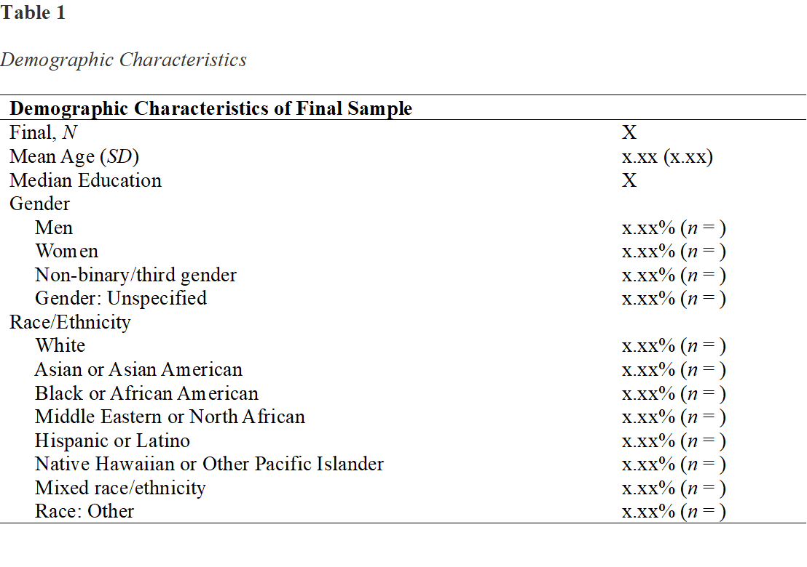

Table 1
Demographic Characteristics
Demographic Characteristics of Sample
Total, N | 113
Final, N | 108
Mean Age (SD) | 35.18
Median Education | Associates
Gender
Men | 38.05% (n = 43)
Women | 54.87% (n = 62)
Non-binary/third gender | 0.88% (n = 1)
Gender: Unspecified | 6.19% (n = 7)
Race/Ethnicity
White | 70.75% (n = 75)
Asian or Asian American | 11.32% (n = 12)
Black or African American | 6.60% (n = 7)
Middle Eastern or North African | 0.00% (n = 0)
Hispanic or Latino | 3.77% (n = 4)
Native Hawaiian or Other Pacific Islander | 0.94% (n = 1)
Mixed race/ethnicity | 5.70% (n = 6)
Race: Other | 0.94% (n = 1)

Note: The percentages are based on the total sample

