Class Exercise 11: Data Analysis & Graphing

Instructions: Report the statistical results of our study and Graph your results

Requirements: To successfully complete this exercise, you are required to:
- Identify and report statical information from your Jamovi analysis output
- create visual representations of the data result pattern(s)

Please use a word processing program (such as MS Word) to complete this exercise.

- - - - - - - - - - - - -
Preliminary Results - analyzed via Pearson’s r Correlation
Let’s start with testing whether there is an association between IH and apology quality. Fill out the following information and then describe the statistical results. This data will be used for your Paper Results’ section.
- Statistical test conducted: Pearson’s r correlation
- r(104) = 0.37, p < .001
*Notes: If p very small, you can just put p < .001. Otherwise, put the exact p-value (p = .xxx) and round to 3 decimals. Round r to 2 decimals
The number in parentheses is the degrees of freedom. The number after the = sign is the correlation coefficient, and the reported p-value indicates whether the correlation coefficient is statistically significant.
Primary Results - analyzed via ANOVA
Let’s finish our results prep with what we want to report in our paper. Fill out the following information and then describe the statistical results. This data will be used for your Paper Results’ section. M refers to the Mean or Average, SD refers to the Standard Deviation, and SE refers to the Standard Error (you will only need the SE for graphing purposes)
- IV 1: Intellectual Humility (IH vs. Control)
- IV 2: Post-Transgression Response (Unforgiving vs. Forgiving)
- DV: Apology Quality
- Statistical test performed = 2 x 2 between-subjects ANOVA
  - Main effect of Intellectual Humility
    - IH
      - M = 5.08
      - SD = 0.94
      - SE = 0.15
    - Control
      - M = 4.93
      - SD = 1.11
      - SE = 0.14
    - Inferential Stats: F(1, 103) = 0.52, p = .473
  - Post-Transgression Response
    - Unforgiving
      - M = 5.04
      - SD = 1.18
    - Forgiving
      - M = 4.95
      - SD = 0.92
    - Inferential Stats: F(1, 103) = 0.22, p = .644
  - Interaction effect
    - Unforgiving
      - IH: M =5.16 , SD = 0.89
        - SE = 0.20
      - Control: M =4.96 , SD = 1.36
        - SE = 0.25
    - Forgiving
      - IH: M =5.01 , SD = 1.01
        - SE = 0.22
      - Control: M = 4.91, SD = 0.87
        - SE = 0.15
    - Inferential Stats: F(1, 103) = 0.06, p = .815

*We will hold onto this statistical information and work to put this information in paragraph format (i.e. results paragraphs) in the next CEs
- - - - - - - - - - - - -

Below is example output from different data, but there’s additional information about the other statistics in our output if you want to take a deeper dive.

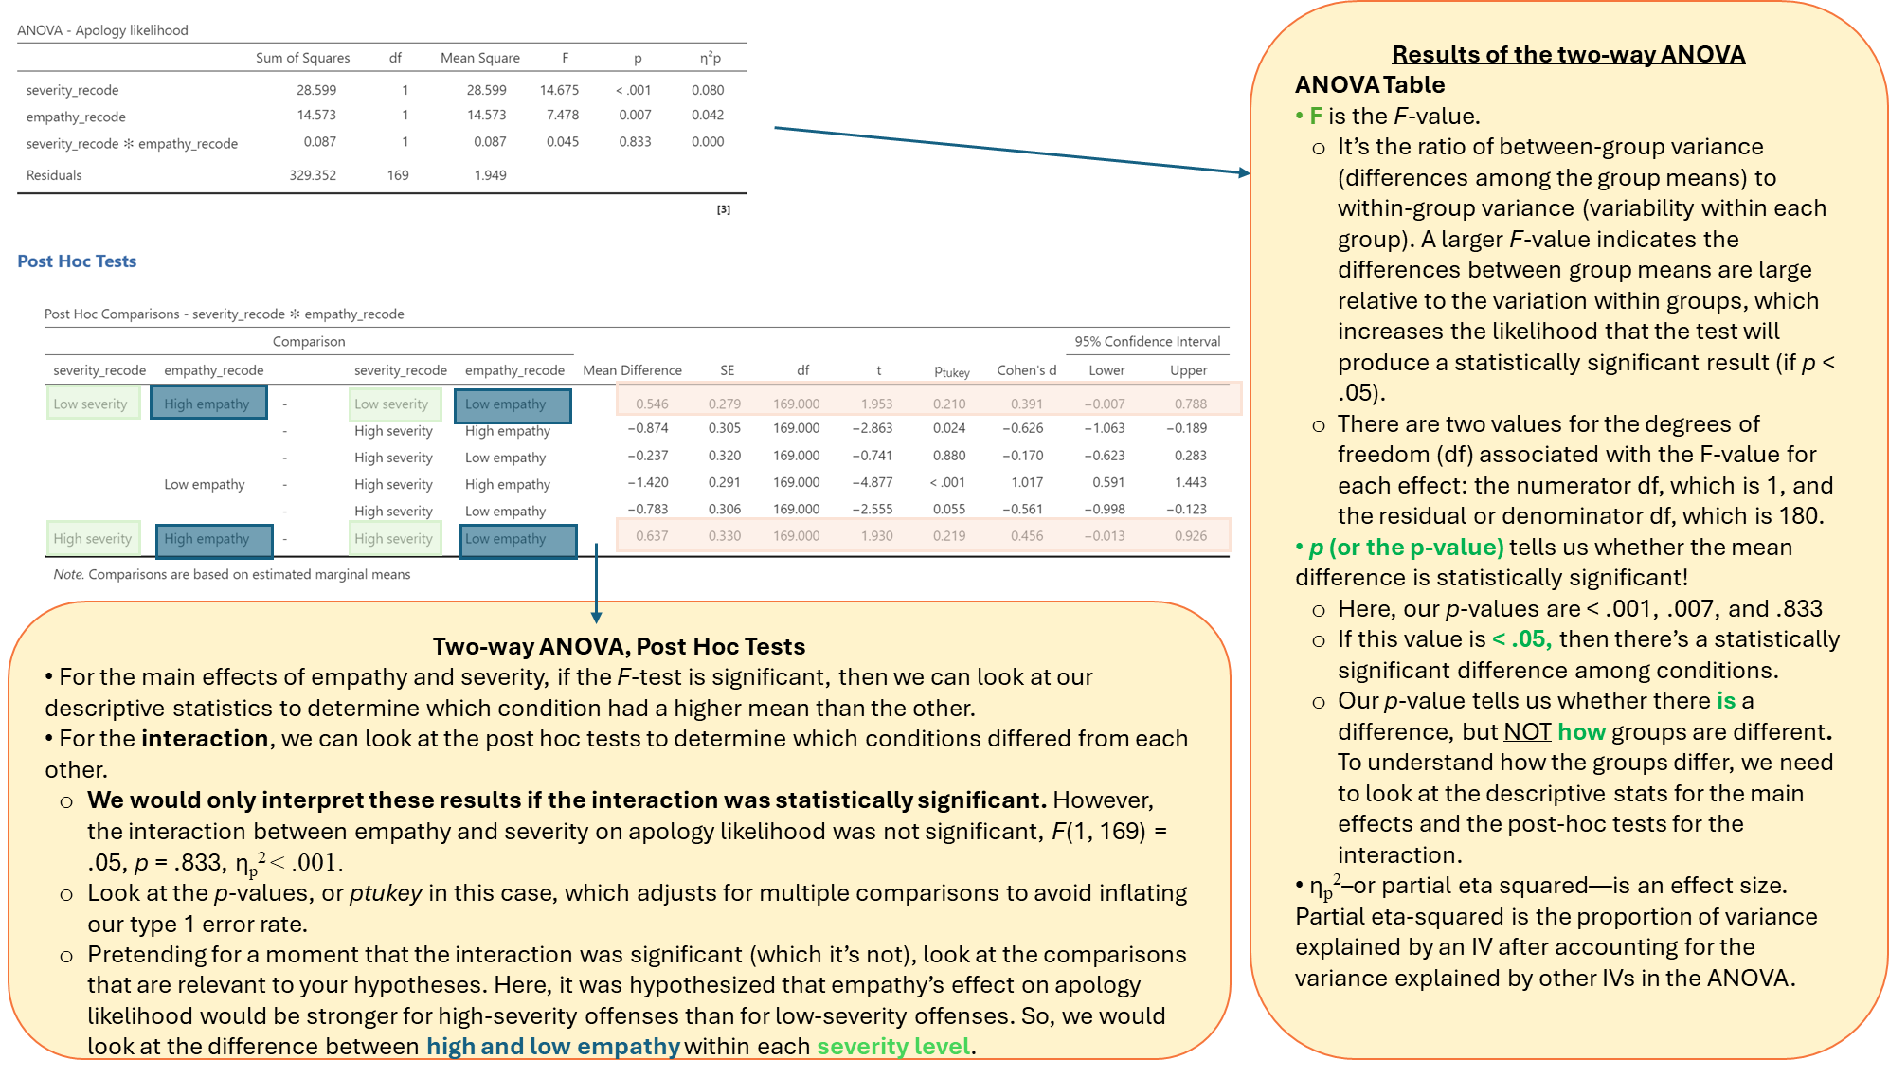

Graphing:

Paste your 3 graphs here: Interaction, main effect of IH, and main effect of post-transgression response

APA Checklist & Tips!
- Use colors that are easy to read.
- Ensure all text in the graph is in Times New Roman, 12pt font.
- Add x-axis and y-axis lines, ensuring the y-axis reflects the scale range for the dependent variable (DV).
- Add labels to the x-axis and y-axis.
- Include data labels on the outside end of each bar to display the means.
- Make all text and lines black for consistency.
- The background lines may be removed, but it's okay to keep them if necessary.
- Include a note at the bottom stating that the error bars represent standard errors.
- Ensure the figure # and title are in APA format (see example below)

