Class Exercise 12: Statistical Reporting & Graphing Figure

Instructions: Report the statistical results of our study and create a visual graph to represent the average mean results.

Requirements: To successfully complete this exercise, you are required to:
- draft you’re the primary findings of your results section using the results you reported in CE 11.
- create 3 visual representations of the data result pattern(s) in Excel

Please use a word processing program (such as MS Word) to complete this exercise.

- - - - - - - - - - - - -

Below is the example from the PPT that you can use as a template
Primary Analysis: The Effect of Commission vs. Omission and Apology vs. No Apology on Forgiveness
Next, I examined differences in forgiveness between the commission and omission transgression, and whether apologies functioned differently for the commission and omission transgression. To test this, I conducted a 2 (offense type: commission vs. omission) x 2 (apology condition: apology vs. no apology) between-subjects ANOVA. Consistent with hypothesis 2, there was a statistically significant main effect of offense type on forgiveness, F(1, 591) = 23.75, p < .001, η2 < .039 (see Figure 1). Participants in the commission condition (M = 3.79, SD = 1.38) reported lower levels of forgiveness compared to participants in the omission condition (M = 4.30, SD = 1.36). Additionally, consistent with hypothesis 2, there was a statistically significant main effect of apology condition on forgiveness, F(1, 591) =10.48, p = .001, η2 = .017, F(1, 58) = 12.22, p < .001, η_{p}² = .041 (see Figure 2). Participants who received an apology (M = 4.22, SD = 1.38) than participants who did not receive an apology (M = 3.88, SD = 1.36). Lastly, contrary to hypothesis 3, there was not a statistically significant interaction between offense type and apology condition on forgiveness, F(1, 591) = 1.14, p = 2.87, η_{p}² = .002 (see Figure 3). This suggests that apologies promoted forgiveness to a similar extent for both commissions and omissions.

Write a rough draft of your primary results below:

Next, I examined differences in forgiveness between post-transgressional responses, and whether apologies functioned differently for levels of intellectual humility. To test this, I conducted a 2 (offense type: high intellectual humility vs. low intellectual humility) x 2 (post-transgressional response: forgiving vs. not forgiving) between-subjects ANOVA. Inconsistent with my hypothesis , there was no statistically significant main effect of intellectual humility on apology quality, F(1,103) = 0.61, p = .815. Participants in the intellectual humility condition (M = 5.081, SD = 0.942) reported no difference in levels of apology quality compared to participants in the control condition (M = 4.931, SD = 1.107). Additionally, inconsistent with our second hypothesis, there was no statistically significant main effect of post-transgressional response on apology quality, F(1,103) = 0.22, p =.644. Participants who received a forgiving post-transgressional response (M = 4.94, SD = 0.918) than participants who did not receive a forgiving response (M = 5.039, SD = 1.181). Lastly, contrary to our third hypothesis, there was not a statistically significant interaction between intellectual humility and post-transgressional response on apology quality (F(1,103) = 0.61, p =.815). This suggests that both intellectual humility and post-transgressional response are not statistically significantly related to apology quality both independently and when measured together.

Create Figures
Please follow along in class to create a figure for the main effect of message framing. Next, create a graph for the main effect of recall type. Lastly, create a graph for the interaction – try creating one on your own, or follow the steps below:
- Create a 2x2 table of the means like the one we did in CE 7 (interactions)
  - Highlight 2x2 Mean results
  - While highlighted: click “insert” tab
  - Select the 2D Column
- Add your Standard Error bars (SE) to the Figure
    - First, add the SEs anywhere in the Excel spreadsheet, as long as they follow the same 2X2 format. For example…

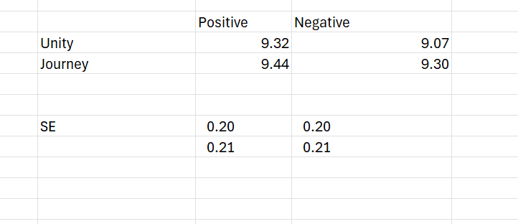

    - Highlight the first color bars (only one bar)
      - Chart Design -> Add Chart Element -> Error Bars -> More Error Bar Options
        - Direction (both, End Style (Cap), Error Amount (Custom/Specify Value)
        - Positive error value: (highlight your SE values for IV 1 levels OR type in the value)
        - Negative error value: highlight your SE values for IV 1 levels OR type in the value (same values as the positive)

***If you highlighted two conditions (the same color but across two conditions, you can tell Excel to include both error bars by adding a comma “,” in between the values

Example: in the positive error value, highlight the SE value for IV 1 level across the one condition of IV 2, add comma, then highlight the SE value for IV 1 level for the second condition of IV 2
[0.03,0.04]

    - Highlight the second color bars (only one bar)
      - Chart Design -> Add Chart Element -> Error Bars -> More Error Bar Options
        - Click the statistical illustration (i.e., the bars)
          - Direction: click Both,
          - End Style: click Cap
          - Error Amount: click Custom, then Specify Value
        - Positive error value: highlight your SE values for the second color bar OR type in value
        - Negative error value: highlight your SE values for the second color bar OR type in value (same values as the positive)
- Y-axis Title:
  - Click “Chart Design”
    - Add Chart Element -> Axis Titles -> Primary Vertical
    - Write in your Y-axis title (Dependent Variable)
- Y-axis Values:
  - Double click Y-axis values
    - Click “Text Options” in the Format Axis options
    - Edit the units, minimum & maximum bounds to your desire (roughly 6 values to illustrate the Y-axis values is the norm)
- Adjust Figure font sizes and colors to your preference
- Finally, copy and paste your Figure to this document

APA Checklist & Tips!
- Use colors that are easy to read.
- Ensure all text in the graph is in Times New Roman, 12pt font.
- Add x-axis and y-axis lines, ensuring the y-axis reflects the scale range for the dependent variable (DV).
- Add labels to the x-axis and y-axis.
- Include data labels on the outside end of each bar to display the means.
- Make all text and lines black for consistency.
- The background lines may be removed, but it's okay to keep them if necessary.
- Include a note at the bottom stating that the error bars represent standard errors.
- Ensure the figure # and title are in APA format (see example below)

Example Figure
