Participants:
A total of 113 participants were recruited. Convenience sampling was used to recruit 73 participants by having students distribute a Qualtrics survey link. An additional 40 participants were recruited via Prolific and compensated $1.40 for their participation. Five of the total 113 participants did not fully complete the survey and were therefor excluded. Out of the total sample, 62 were women, 43 were women, seven were unspecified, and one was non-binary or a third gender (M_{age} = 35.18, SD = 16.10; Median_{education} = 2-year degree). The distribution of race was 70.75% White, 6.60% Black/African American, 5.67% mixed race/ethnicity, 11.32% Asian and Native Hawaiian/Pacific Islander, 3.77% Latinx, .94% Native American, and .9.4% other race/ethnicity (see Table 1).
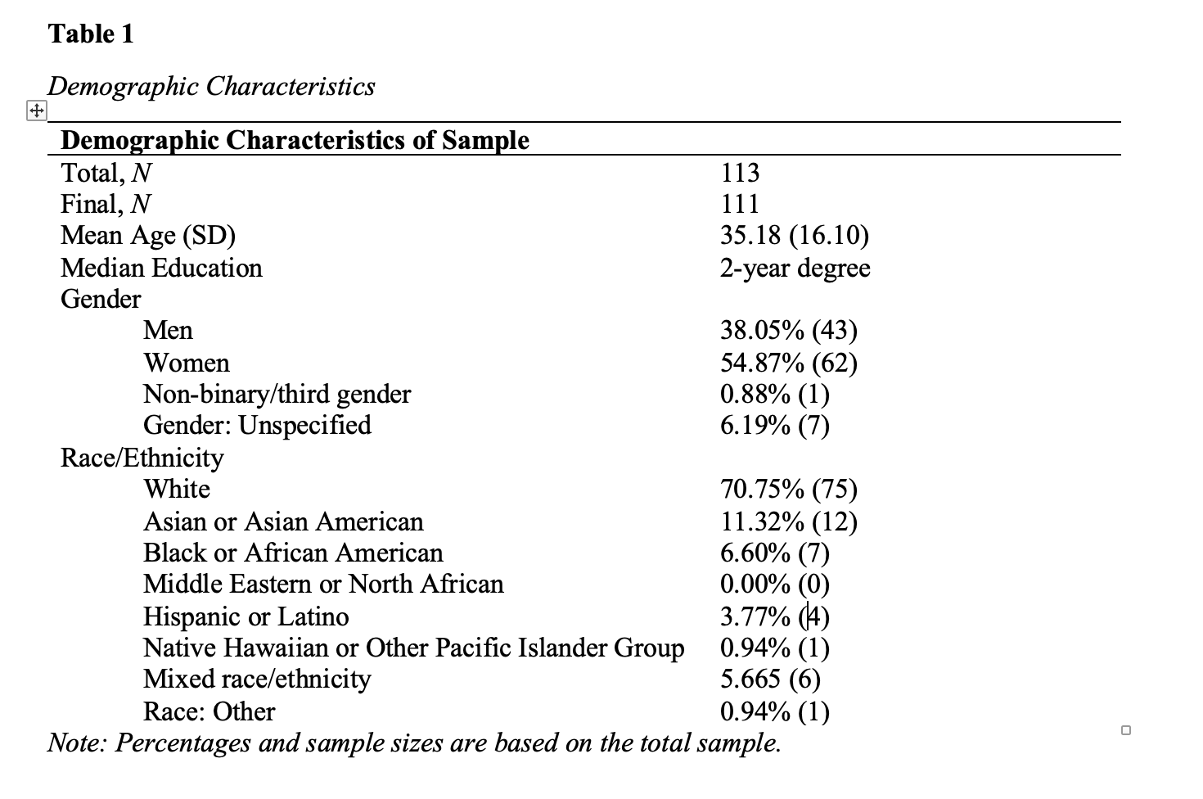

Materials and Procedures:
Intellectual Humility
Participants were randomly assigned to one of two conditions. For the first independent variable, the intellectual humility condition, participants had to think of a time they acted with type of humility. Then, they are instructed to write about this instance, specifically for a few minutes. The aim of this is to temporarily increase their level of intellectual humility. Participants that were not assigned to the prior condition were instead given a control condition. This required them to write about a time they had a day off from school or work, as well as the emotions they experienced. Similarly, they were also instructed to write for a few minutes. This condition acts as a control because it does not attempt to temporarily raise the participant's level of intellectual humility.
Post-transgressional Response
Once participants complete the first question, they are then instructed to imagine themselves in a situation (see Appendix A for the full scenario). For the second independent variable, post transgressional response, there were two conditions: forgiving and unforgiving. The situation is the same for both conditions, but the victim’s response in each situation is changed. In the forgiving condition, the victim’s post transgression response is forgiving of the transgressor. In unforgiving conditions, the victim’s post-transgression response is not forgiving. This allows us to see if the way a victim’s responds has any impact on the apology behavior of the transgressor.
Apology Quality
The dependent variable was measured by having the participants fill out a series of multiple choice questions after reading through the situation. The multiple choice questions asked how likely the participant would respond to the partner in the scenario, prompting them with different responses. These responses measured the participants level of guilt, defensiveness, avoidance, acceptance of responsibility and dismissiveness (Ludwig et al., 2022). Examples of the questions asked were “You do not say anything to [the victim] about submitting the incorrect answer.” And "I want to make it up to you. Maybe we can study together for the exam." With the option to select between “not at all likely” (1) to “extremely likely” (7). See Appendix B for the full list of questions.
Appendix:
Appendix A – Post-transgressional Response Forgiving and Unforgiving Scenario
Forgiving condition
Imagine that you are a student in a psychology class. Your professor has the class play a game of psychology Jeopardy in preparation for the next exam, which takes place the following week. The game is intended to create an engaging review session to boost student grades. Your professor also incentivizes the class to prepare for the review session by awarding bonus
points to the top 3 teams. There are 20 students in the class and your professor assigns each student to work in pairs, for a total of 10 teams. Your professor pairs you up with another student in the class named Taylor. You don’t know Taylor very well, but you remember disagreeing with Taylor’s comments during a number of class discussions throughout the semester. Be that as it may, both you and Taylor studied for the review session and feel prepared. Taylor is hoping to get at least 3rd place because the bonus points could boost Taylor’s grade from a C+ to a B-. You have a better grade in the course, so the extra credit won’t really impact your grade. Throughout the Jeopardy game, you and Taylor first work on your answers independently and then compare your answers. When you agree, you submit that answer. When you disagree, you work with each other to arrive at the best answer. You end up working well with Taylor, collaborating on each question to come up with many correct answers. You are now tied for 3rd place with another team and just need to win a tie-breaking round to secure 3rd place and receive the bonus points. Your professor asks a difficult question, and both you and Taylor write your response on your respective answer sheets. But when you and Taylor compare your answers, they are not the same. You want to make a quick decision to ensure that your team answers before the other team, and you have a gut feeling that your answer is the right one. So rather than talk through it, you hit the buzzer and submit your answer. However, your professor indicates that you are incorrect. The next team reveals the correct answer, which, to your surprise, matches the answer that Taylor came up with. Your team unfortunately misses out on the bonus points because you went with your answer instead of Taylor’s answer. Afterwards, Taylor seems bummed about the outcome and upset with you because your team was so close to getting the bonus points. Taylor says, "Oh well, no worries. It could happen to anyone.”
Unforgiving condition
Imagine that you are a student in a psychology class. Your professor has the class play a game of psychology Jeopardy in preparation for the next exam, which takes place the following week. The game is intended to create an engaging review session to boost student grades. Your professor also incentivizes the class to prepare for the review session by awarding bonus points to the top 3 teams. There are 20 students in the class and your professor assigns each student to work in pairs, for a total of 10 teams. Your professor pairs you up with another student in the class named Taylor. You don’t know Taylor very well, but you remember disagreeing with Taylor’s comments during a number of class discussions throughout the semester. Be that as it may, both you and Taylor studied for the review session and feel prepared. Taylor is hoping to get at least 3rd place because the bonus points could boost Taylor’s grade from a C+ to a B-. You have a better grade in the course, so the extra credit won’t really impact your grade. Throughout the Jeopardy game, you and Taylor first work on your answers independently and then compare your answers. When you agree, you submit that answer. When you disagree, you work with each other to arrive at the best answer. You end up working well with Taylor, collaborating on each question to come up with many correct answers. You are now tied for 3rd place with another team and just need to win a tie-breaking round to secure 3rd place and receive the bonus points. Your professor asks a difficult question, and both you and Taylor write your response on your respective answer sheets. But when you and Taylor compare your answers, they are not the same. You want to make a quick decision to ensure that your team answers before the other team, and you have a gut feeling that your answer is the right one. So rather than talk through it, you hit the buzzer and submit your answer. However, your professor indicates that you are incorrect. The next team reveals the correct answer, which, to your surprise, matches the answer that Taylor came up with. Your team unfortunately misses out on the bonus points because you went with your answer instead of Taylor’s answer. Afterwards, Taylor seems bummed about the outcome and upset with you because your team was so close to getting the bonus points. Taylor then says, "This will be a tough one to let go of”.
Appendix B: Full List of Apology Quality and Intellectual Humility Questions
