CE 19/20: Presentation Proposal
Instructions: Propose a new experiment that examines the effects of intellectual humility within a new research context.

First, this class exercise provides new contexts to investigate the effects of intellectual humility. Use the example articles below to kickstart brainstorming for your proposal.

If you’d like to propose a context not included in this list (option #1), please seek preapproval from your instructor.

Requirements: To successfully complete this exercise, you are required to:
- choose a context from the list provided (or propose your own)
- brainstorm your proposal design by completing the worksheet
  - each proposal will include intellectual humility as IV #1.
  - identify an additional factor for your IV #2 (a variable of interest within your chosen context that may impact your DV). Your design should also consider how intellectual humility influences your DV depending on your second variable (i.e., the interaction between IH and your second IV).
  - identify an interesting outcome variable or DV.
- Attend class. This class exercise requires you to collaborate with your instructor on generating testable research questions and an appropriate study design. To receive full credit on this assignment (8pts) you must attend class.
- Assignment Due Date: End of class on 4/16
- - - - - - - - - - - - -

New Contexts

Read through the following studies and choose which one you would like to base your research proposal. Please search for these articles on the Pitt Library or Google Scholar.

- Idea from your future directions in your discussion section, or a propose a new study idea that’s not based on the list of articles below:
  - As long as it fits a 2x2 between-subjects study design
- This option requires preapproval from your instructor!

- Ludwig, J. M., Schumann, K., & Porter, T. (2022). Humble and apologetic? Predicting apology quality with intellectual and general humility. Personality and Individual Differences, 188, Article 111477. https://doi.org/10.1016/j.paid.2021.111477
  - IV #1 Intellectual Humility. Use or improve our intellectual humility manipulation.
  - IV #2: A new variable with 2 levels: Besides the victim’s post-transgression response, what would be another interesting IV to examine? For example, another situational, offense, or a relationship variable. Try to make this a True IV, but we can discuss theoretically meaningful participant-variable options.
  - DV: This can be a different measure of apologies or a new DV that’s relevant to your research context. For example, what are other methods we could use to measure apology behavior? What other conflict behaviors would be important to measure?

- Henderson, P. R., Evans, N. D., Baker, C. D., & Fetterman, A. K. (2026). The reputational impact of Wrongness Admission by a Politician Depending on Their Party Affiliation and participant ideology. Journal of Applied Social Psychology, 56, 218–232. https://doi-org.pitt.idm.oclc.org/10.1111/jasp.70047.
  - IV #1 (True IV): You could experimentally manipulate wrongness admission (i.e., how IH manifests behaviorally)
  - IV #2: Examine a new IV. Try to make this a True IV, but we can discuss theoretically meaningful participant-variable options.
  - DV: Same or different DV

*Note that you can use a similar IV of wrong admission, but in a completely different context. For example, you can examine the effects of imagining a romantic partner’s wrongness admission/IH or another person’s IH [e.g., a scientist's IH (see example below), a religious/spiritual leader’s IH, an instructor’s IH] on people's thoughts, feelings, and behaviors.

- Koetke, J., Schumann, K., Bowes, S. M., & Vaupotič, N. (2025). The effect of seeing scientists as intellectually humble on trust in scientists and their research. Nature Human Behaviour, 9(2), 331–344. https://doi.org/10.1038/s41562-024-02060-x
  - IV #1 (True IV): You can utilize a similar IV for intellectual humility
  - IV #2: Examine a new IV. We can discuss theoretically meaningful participant-variable options.
  - DV: Same or different DV

- Porter, T., & Schumann, K. (2018). Intellectual humility and openness to the opposing view. Self and Identity, 17(2), 139–162. https://doi.org/10.1080/15298868.2017.1361861
  - IV #1 (True IV): You can use their experimental manipulation of IH
  - IV #2: True IV, or we can discuss theoretically meaningful participant-variable options
  - DV: Same or different DV

Research Proposal Worksheet

Please brainstorm ideas within your research proposal by completing the following guiding prompts.

Motivation, Research Question:
Draft your research question (RQ).
Does modeling intellectual humility influence admission of wrong doing in individuals with antisocial personality disorder.

What is the motivation for your RQ (i.e., why is it important to study this topic)? How will examining your RQ advance knowledge within the field (e.g., the specific contribution your proposed research can make)?
If we find that modeling pro-social behaviors such as intellectual humility results in behavioral change, it has implication for the future of antisocial personality treatment.

Study Design
Operationally define your IVs and their levels. Note that for your presentation, you need to generate and show the materials you would use to manipulate your IV—similar to how you might show the phrases used to prime unity vs. journey.

IV #1: Intellectual Humility

level 1 = Manipulated positive
level 2 = Control

Operational definition of IV #1: The participant observes confederates demonstrating intellectual humility prior to participating in the activity

IV #2: Antisocial Personality Disorder

Operational definition of IV #2: Current diagnosis of antisocial personality disorder

What is your DV of interest? Write out your DV operational definition(s) (provide a reference for an existing measure or create your own). Note that for your presentation, you need to show how you will measure your DV; for example, if you are using a self-reported scale, you need to show the items that will be used to measure your DV.
DV: Admission of wrong doing.
Operational definition: Participants will complete a five item self-report after failing at the rigged cognitive test. The items are as follows:
- How did you perform in accordance with your expectations?
- How challenging did you find the task?
- How satisfied were you with your own performance?
- How satisfied were you with your partner’s performance?

If you successfully completed the task:
Who do you think contributed more to the completion of the task? (me/my partner)

If you failed to complete the task:
Who do you think contributed more to the failure of the task? (me/my partner)

After completing the five item self-report, participants will complete the same IH scale we used in our class’s study.

Is your experimental design between-subjects, within-subjects, or a mixed design?
Between-subjects

Methods:
Participants
What is your target population? (e.g., students, general population, sampling an even number of democrats and republicans or men and women, etc.)
People diagnosed with anti-social personality disorder, Ages 18-50

Materials
Make a list of the materials required for your proposal.
Camera, room, microphone, false cognitive test, self-reported admission of wrong-doing, 3 confederates (two for modeling, one for participating), post-test intellectual humility assessment

Procedure
What is the procedure for your proposal? Draw a diagram/flowchart below.
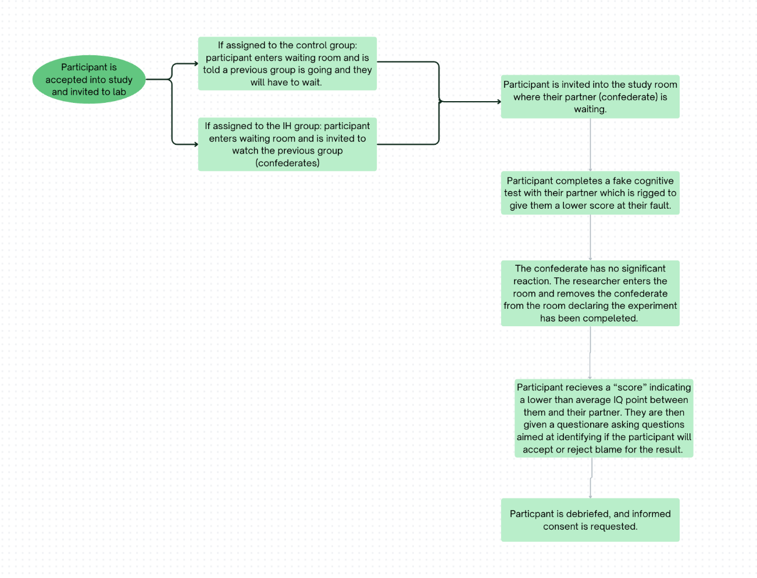

Expected Results:
Fill out the chart below to connect your hypotheses and expected results. Write out your hypotheses for each main effect and interaction in the left column. And then visualize your expected results for each hypothesis by either drawing or describing the pattern of results in the right column.
Hypotheses Expected Results
Main effect #1:  Participants exposed to modeled IH will show greater admission of wrongdoing than those in the control condition. | The mean admission of wrongdoing will be greater in the IH condition than in the control condition
Main effect #2:  Participants diagnosed with antisocial personality disorder will be less likely to admit to wrongdoing than participants without ASPD. | The mean admission of wrongdoing for people diagnosed with ASPD will be less than the mean admission of wrongdoing for participants without APSD
Interaction effect:  The effect of IH manipulation on admission of wrongdoing will differ depending on the participants diagnosis of ASPD | The positive manipulation of intellectual humility will be stronger for participants without ASPD

