Implications of Intellectual Humility and Post-Transgression Response on Apology Quality

Jacob L. Bayer and Thomas M. Bixler
University of Pittsburgh

Abstract
Apologies are vital for conflict resolution, and previous research has made clear that intellectual humility (IH) levels in the transgressor are associated with higher quality apologies. Our research aims to build on this finding by identifying how the victim’s post-transgression response can influence apology quality in individuals with heightened intellectual humility. In the current experiment (N = 108), participants were randomly assigned to an intellectual humility condition or a control condition. In the IH condition, participants’ intellectual humility was temporarily increased by explaining what IH is and then asking them to reflect on a time they acted with it. Participants then read a vignette in which they imagined themselves as a transgressor toward a victim who responded with either forgiveness or non-forgiveness. Apology quality was then measured by having participants rate a series of responses to the victim. Our results showed that participants in the intellectual humility condition did not report higher quality apologies compared to participants in the control condition. Moreover, apologies from participants who received a forgiving post-transgression response did not significantly differ from participants who did not receive a forgiving response, and there was not a statistically significant interaction between intellectual humility and post-transgression response on apology quality. However, we did find a positive correlation between intellectual humility and apology quality, reflecting previous research. While our correlational findings between intellectual humility and apology quality align with prior research, our results also suggest that experimentally inducing IH may require a stronger manipulation to influence apology behavior.
Keywords: intellectual humility, apology, post-transgression response, forgiveness, conflict resolution

Implications of Intellectual Humility and Post-Transgression Response on Apology Quality
Conflict is an undeniable staple of human interaction that shapes our connections to one another. The offender, or transgressor’s, ability to apologize to the victim after an interpersonal offense occurs can influence the relationship between the two people (Ludwig et al., 2022). Specifically, apologizing and seeking forgiveness leads to higher feelings of closeness in relationships (Schumann, 2014). A useful term when measuring conflict resolution interactions is preemptive forgiveness, which is the process of forgiving the transgressor before an apology is given (Struthers et al., 2008). Despite this, there is still limited knowledge of what predicts whether transgressors offer a high-quality apology. Another important characteristic is intellectual humility, which involves an individual’s ability to identify gaps in their own beliefs and admit to wrongdoing (Ludwig et al., 2022). However, there is limited experimental work that manipulates intellectual humility and examines whether its effect on apologies depends on the victim’s reaction to the offense (i.e., preemptive forgiveness or unforgiveness). In the current research, if we can successfully increase intellectual humility, it may have significant applications such as increasing the likelihood of apology behavior and/or the quality of a given apology. This study therefore aims to answer the following three questions. First, does intellectual humility promote higher quality apologies? Second, does preemptive forgiveness change the response of the transgressor to provide a higher quality apology? Lastly, does intellectual humility interact with preemptive forgiveness to provide a higher quality apology?
Conflict can emerge from a multitude of situations. Specifically, we will be looking at conflict that stems from wrongdoing. This involves a transgressor invoking negative emotions within a victim through an action or offense that goes against the victims’ beliefs. Apologies seek to resolve conflict by inducing forgiveness in the victim. Ultimately, apologizing to a victim leads to feelings of validation, reduced anger, and forgiveness of the transgressor (Schumann, 2014). It is also important that there is sincerity built into an apology, so the victim knows that the transgressor values them (Ludwig et al., 2022). They are not only beneficial to quickly resolving a conflict but can also create lasting effects that positively impact relationships (Koetke et al., 2024). Thus, it is important that we understand what characteristics influences these apologies.
Intellectual humility is the perfect balance between confidence in your own beliefs and the openness to being wrong, and fluctuating between the two as a situation requires (Porter et al., 2022). Transgressors with higher levels of intellectual humility should therefore be more likely to apologize because they are more likely to realize their wrong and to take accountability as a result. Psychologically targeting a transgressor can have significant implications, as affirmations can lead transgressors to be less defensive and have more comprehensive apologies (Schumann, 2014). In support of this, Ludwig et al. (2022) found that apology behavior was positively associated with intellectual humility. Specifically, researchers found that when participants had their intellectual humility manipulated by imaging an event where they wronged a close friend, that there was a positive effect on the apology comprehensiveness and a negative effect on defensiveness. Clearly, there is sufficient reasoning to investigate the relationship between intellectual humility and high-quality apologies.
In addition to prior research on apology quality and intellectual humility, there has also been evidence that a victim’s post-transgression response influences apology behavior. Apologies are multifaceted, and the victim’s response can influence apology just as much as a transgressor’s cognitive skills. For instance, Struthers et al. (2008) conducted a study on undergraduate students with the goal of determining how preemptive forgiveness can increase distress in the transgressor, which may lead them to feel guilty. In Study 1, participants were told to be tutors and unknowingly provided a virtual student with incorrect information, causing that student to fail a task. The victim (the virtual student) then responded by either implying forgiveness or a grudge. Results showed that transgressors who received implied forgiveness viewed the victim more positively and demonstrated a greater desire to reconcile compared to those who received the grudge response. Implied forgiveness signals acceptance to the transgressor, reducing defensiveness and instead eliciting guilt, which motivates pro-relational behavior like apologizing. This feeling of guilt usually motivates a person to apologize. These findings will be extremely useful to tie into the results of our own experiment because if a post-transgressional response elicits guilt, it is more likely to result in an apology.
Additionally, a paper published identifying the effects of post-transgression responses on apology, Guilfoyle (2015), examined the relationship between post-transgressional response and preemptive forgiveness. Specifically, it looked not only at the transgressors’ willingness to apologize, but also at their level of self-control and their level of social pain. They found that when forgiveness is unearned, transgressors experience interpersonal conflict that leads them to apologize. Together, these findings suggest that victim responses shape conditions under which transgressors are most motivated to apologize. Our second research question aims to determine whether a similar effect emerges in our own experiment. These variables are also related to intellectual humility and can give us more insight into what creates an effective apology and what prevents specific social effects to lead someone not to seek reconciliation.
The effect of preemptive forgiveness on apology behavior may also depend on a transgressor's level of intellectual humility (IH). When a victim responds with a grudge or the social situation is more ambiguous the transgressor must consider if they were truly wrong and how to respond. In this context, IH may play a particularly important role as a transgressor who is open to recognizing their own limitations would be better equipped to sit with that discomfort and respond with an apology over defensiveness. In fact, IH may matter most when the social feedback from the victim is ambiguous or unforgiving, because those situations demand more cognitive openness and self-scrutiny to motivate reconciliation.
In the current study, we examined whether intellectual humility influences apology quality when a transgressor is pre-emptively forgiven or not. Using random assignment, we invoked a higher level of intellectual humility in some participants, while others were put in a control condition. After they are primed, we have them read a story where they are the transgressors in a conflict. Participants are then either preemptively forgiven or not by the victim. Participants then rated how likely they would be to say apology statements to the victim that represent a higher quality apology. First, we hypothesized that participants randomly assigned to the intellectual humility condition will offer higher quality apologies than participants in the control group. Second, we hypothesized that participants assigned to the forgiveness condition will have higher quality apologies than those in the unforgiving condition. Finally, we hypothesized that within the forgiving condition the intellectual humility group would deliver the higher quality apologies. Additionally, in the unforgiving condition we also believe the intellectual humility group would deliver the higher quality apologies. However, we believe the difference between the IH and control group will be more significant in the unforgiving group than the forgiving group.
Method
Participants
A total of 113 participants were recruited. These participants had to be at least 18 years of age. Convenience sampling was used to recruit 73 participants by having students in Research Methods Lab distribute a Qualtrics survey link to friends, family, and acquaintances. An additional 40 participants were recruited via Prolific, who were compensated $1.40 for their participation. Five of the total 113 participants did not fully complete the survey and were therefore excluded from data analysis. Out of the total sample, 62 were women, 43 were men, seven were unspecified, and one was non-binary or a third gender (M_{age} = 35.18, SD = 16.10; Median_{education} = 2-year degree). The distribution of race was 70.75% White, 11.32% Asian and 0.94% Native Hawaiian/Pacific Islander, 6.60% Black/African American, 5.70% mixed race/ethnicity, 3.77% Latinx, and 0.94% other race/ethnicity (see Table 1).
Materials and Procedures
Intellectual Humility
Participants were randomly assigned to one of two conditions: Intellectual humility or control. In the intellectual humility condition, participants were given the definition of IH and instructed to write about a time that they acted in accordance with the definition. Specifically, they were instructed to “Describe a time when you acted with intellectual humility. Do not describe an event in which you felt humiliated or shameful; rather, describe when you acted with intellectual humility or a situation where you had a mindset consistent with the characteristics of intellectual humility described above. Spend a few minutes writing about that situation and the emotions that you experienced.” The aim of this instruction is to temporarily increase the participants’ level of intellectual humility. In the control condition, participants wrote about a time they had a day off from school or work, as well as the emotions they experienced. Similarly, they were also instructed to write for a few minutes. This condition acts as a control because it does not attempt to temporarily raise the participants’ level of intellectual humility.
Post-transgression Response
Once participants completed the first question, they were then instructed to imagine themselves in a transgressional situation (see Appendix A for the full scenario). Participants imagined themselves as a student playing a Jeopardy with a partner in preparation for an exam. For the last question, the student decides to answer quickly and avoids talking through the answer with their partner. The answer ends up being incorrect, costing both the student and partner to miss out on bonus points. For the second independent variable, post transgression response, participants were randomly assigned to a forgiving or unforgiving condition. The situation is the same for both conditions, but the victim’s response in each one was manipulated. In the first condition, the victim’s post transgression response is forgiving of the transgressor, where they state that “Oh well, no worries. It could happen to anyone.” In the second condition, the victim’s post transgression response is unforgiving, where they state that “This will be a tough one to let go of.” This allows us to see if the way a victim responds has any impact on the apology behavior of the transgressor.
Apology Quality
The dependent variable was measured by having the participants rate the extent to which they would say apology statements to the victim (1 = Not at all likely, 7 = Extremely likely) (Ludwig et al., 2022). The questions asked how likely the participant would respond to the partner in the scenario, prompting them with different responses. Each item addressed a specific element of apology comprehensiveness, including remorse (“I’m very sorry.”), acceptance of responsibility (“It’s my fault.”), acknowledgment of harm (“You must be really frustrated that you didn’t get the bonus points.”), explanation (“I got a little flustered because of the pressure.”), reparation (“I want to make it up to you. Maybe we can study together for the exam.”), commitment to change (“If we ever have the chance to work together again, I will fully consider your input.”), and a request for forgiveness (“I hope you’ll accept my apology.”). These items were averaged to create an apology quality score. Furthermore, participants also completed an item measuring avoidance (“You do not say anything to Taylor about submitting the incorrect answer.”) and defensiveness (“I didn’t do anything wrong.”). See Appendix B for the full list of questions
Self-Reported Intellectual Humility
Our manipulation of intellectual humility was checked using a self-reported IH scale, where participants ranked certain statements on a 7-point scale (1 = Not at all likely, 7 = Extremely likely) (Ludwig et al., 2022). The manipulation check specifically stated “Please answer these questions based on how you think or feel about yourself right this moment.” These items were averaged to create an intellectual humility score.
Demographics
Participants were asked to report their demographic information including race, gender, age, and highest level of education. See table 1 for the demographic statistics.
Results
Preliminary Analyses
To determine the possible association between intellectual humility and apology quality, a
Pearson’s r correlation was conducted. The results found a statistically significant, moderate positive correlation r(104) = .37, p <.001. This means that higher intellectual humility was associated with higher apology quality.
Primary Analyses
Next, we examined the effects of intellectual humility and post-transgression response on
apology quality. To test this, we conducted a 2 (intellectual humility vs. control) x 2 (post-transgression response: forgiving vs. not forgiving) between-subjects ANOVA. Inconsistent with our hypothesis, there was no statistically significant main effect of intellectual humility on apology quality (F(1, 103) = 0.52, p = 0.473) (see figure 1). Participants in the intellectual humility condition (M = 5.08, SD = 0.94) did not report higher quality apologies compared to participants in the control condition (M = 4.93, SD = 1.11). Additionally, inconsistent with our second hypothesis, there was no statistically significant main effect of post-transgression response on apology quality (F(1, 103) = 0.22, p = .644) (see figure 2). Apologies from participants who did receive a forgiving post-transgressional response (M = 4.94, SD = 0.92) did not significantly differ from participants who did not receive a forgiving response (M = 5.04, SD = 1.18). Lastly, contrary to our third hypothesis, there was not a statistically significant interaction between intellectual humility and post-transgressional response on apology quality (F(1, 103) = 0.06, p = 0.815) (see figure 3). Our results found that there was not a statistically significant difference in apology quality when intellectual humility was manipulated or when post-transgressional response was manipulated. Moreover, our findings also found that the effect of intellectual humility did not depend on the victim’s post transgression response.
Discussion
The current study aimed to examine whether intellectual humility and the victim’s post-transgression response impact apology quality. In accordance with our preliminary analysis, we did find a positive correlation between intellectual humility and apology quality. However, our primary analyses did not support our hypotheses. We found there was no significant effect of intellectual humility on apology quality. Furthermore, apology quality was unaffected by a victim’s post-transgressional response. Finally, the interaction between intellectual humility and post-transgressional responses also did not affect apology quality. These findings do not undermine the strength of our study, which utilizes experimental design. This goes beyond the limitations of only using a correlational design.
Our study found a positive correlation between intellectual humility and apology quality. Ludwig et al. (2022) also found there to be a statistically significant relationship between intellectual humility and apology comprehensiveness. Transgressors who are higher in intellectual humility are more likely to be aware of their own limits and admit when they are wrong, leading to a higher chance of apologizing in a genuine way. These characteristics, in turn, are associated with variables like empathetic effort and self-protection (Ludwig et al., 2022). Increases in empathetic effort and self-protection show higher quality apologies from transgressors. Combining these findings, because both experiments found a positive association, there is a strengthened likelihood that the two variables are in fact related. This consistency increases our confidence in the relationship between the variables. Additionally, these results confirm our belief that the vignettes used in both studies were temporarily influencing intellectual humility as intended.
Next, in the current study, we experimentally manipulated intellectual humility to examine whether it promoted higher quality apologies. Our study aimed to heighten one’s intellectual humility by having them imagine a scenario where they acted in accordance with the definition of intellectual humility. However, this manipulation of intellectual humility did not have a statistically significant effect on apology quality. The present results are consistent with Koetke et al.’s (2023) work, which deals with the effect of intellectual humility on investigative behavior. Their manipulation of intellectual humility, using the fallibility salience test, successfully increased participants’ levels of intellectual humility, like our study. However, their study did not find a direct effect between intellectual humility and investigative behavior. This was explained because of the minimal manipulation of the fallibility salience test. Similarly, our method of manipulation suffered a similar challenge, where although we were able to successfully manipulate intellectual humility, it was not enough to produce a direct effect with apology quality. Perhaps, using a stronger manipulation test in our study would have led to statistically significant results for this main effect. An example of this could potentially be conducting the study under experimental conditions where the manipulation was done with other real participants or confederates. For example, if we had manipulated intellectual humility in a more intense way, such as in person modeling or purposely putting individuals in a situation where they were objectively wrong and had to recognize it, we could have more effectively increased intellectual humility.
Additionally, we found there to be no statistically significant effect of post-transgression response on apologies. Struthers and colleagues (2008) also examined the effect of a victim’s post-transgression response on a transgressor’s repentance using a laboratory experiment. Participants in this experiment acted as a tutor who provided answers to a student. The study was rigged by having the participants give answers that were incorrect to the student. This induced a transgression, causing the student to not complete his assignment. After this manipulation, the student responded in one of four ways: In the grudge condition “Now the computer shows that I was unable to answer the questions correctly and it has logged me out of the test program and it won't let me enter it again// YOU SHOULD HAVE BEEN MORE CAREFUL // The prof should have used a more knowledgeable TA”, the control condition “Now the computer shows that I was unable to answer the questions correctly and it has logged me out of the test program and it won't let me enter it again”, the explicit forgiveness condition “Now the computer shows that I was unable to answer the questions correctly and it has logged me out of the test program and it won't let me enter it again // ohhh well, that's okay, I forgive you. That's it I guess, good luck with your courses” and the implied forgiveness condition “Now the computer shows that I was unable to answer the questions correctly and it has logged me out of the test program and it won't let me enter it again // ohhh well, that's okay I appreciated your help. That's it I guess, good luck with your courses.”.
Results showed that the grudge response provided the lowest prosocial conduct, while implied forgiveness provided the highest. This is a stark contrast compared to our study but there are a couple explanations that can explain these differences. Struthers and colleagues (2008) had students respond in four different ways, while we only had two forgiveness conditions. Furthermore, their method included two additional surveys where the participants addressed the victim’s post-transgression response, whereas we only had participants rank how they themselves would respond back to the victim. Perhaps an even greater explanation, Struthers and colleagues (2008) had participants interact with a real person. Our study had participants imagine themselves in a scenario that they read, with no actual interactions. Additionally, the victim’s response was more overly negative or extreme than ours, which could have also influenced the results. Overall, these differences paint a clear picture of why we may not have found a significant main effect of post-transgression response on apology quality. In summary, we did not do as effective a job at simulating a real transgression with pre-emptive apology (or lack thereof) as Struthers and colleagues.
Finally, we delved into the interaction between intellectual humility and post transgression response on apology quality. Again, we found a non-significant interaction between these two variables. This means regardless of the post-transgression response of the victim, when placed in the intellectual humility condition, there was no significant effect on their apology quality. A possible explanation for this finding is that participants may have over- or under-reacted compared to how they would have reacted in the specific scenario we had them imagine themselves in. This helps us understand why we did not find any significant relationships between intellectual humility and post-transgression response on apology quality.
Two primary limitations were identified in our method. First, in terms of sampling, a convenience sampling method was used, which does not provide a representative sample of the general population. Thus, the results we found may not be applicable to other groups and so we are unable to draw a broader conclusion based on these results. We could address this limitation by using a representative sample in the future.
Secondly, our measure of the dependent variable was heavily reliant on self-report measures and, while hypothetical scenarios can be controlled against all participants to minimize confounding variables, they lack ecological validity. These self-report measures are subject to social desirability and self-enhancement. These limitations could be addressed by conducting a future study in a lab environment to increase ecological validity, where participants’ apology behavior is observed and measured.
In future research, we would like to investigate the relationship between intellectual humility and admission of guilt. Although our research did not show a direct relationship between intellectual humility and apology quality, previous research has demonstrated there to be a link between intellectual humility and wrongdoing admission. It would be interesting to identify if this relationship transitions into a courtroom simulation.
Additionally, looking at how demographic differences between the transgressor and the victim could produce interesting results. For example, does post-transgressional response and/or apology quality change when the victim and transgressor are of different sex, age, or race? We hypothesize that social psychology factors, such as social identity theory, may result in decreased intellectual humility and/or apology quality toward members of different groups than within groups.

References
Guilfoyle, J. R. (2015). The effects of post-transgression responses on apology. YorkSpace Library. https://yorkspace.library.yorku.ca/server/api/core/bitstreams/29f15e37-c096-40f8-8e31-c6ec0c6cf11d/content
Koetke, J., Schumann, K., Porter, T., & Smilo-Morgan, I. (2023). Fallibility salience increases intellectual humility: Implications for people's willingness to investigate political misinformation. Personality & Social Psychology Bulletin, 49(5), 806–820. https://doi.org/10.1177/01461672221080979
Koetke, J., Schumann, K., Welker, K., & Coleman, P. T. (2024). Intellectual humility is reliably associated with constructive responses to conflict. PLoS ONE, 19(9), 12. https://doi.org/10.1371/journal.pone.0309848
Ludwig, J. M., Schumann, K., & Porter, T. (2022). Humble and apologetic? Predicting apology quality with intellectual and general humility. Personality and Individual Differences, 188, 111477. https://doi.org/10.1016/j.paid.2021.111477
Porter, T., Elnakouri, A., Meyers, E. A., Shibayama, T., Jayawickreme, E., & Grossmann, I.
(2022). Predictors and consequences of intellectual humility. Nature Reviews
Psychology, 1(9), 524-536. https://doi.org/10.1038/s44159-022-00081-9
Schumann, K. (2014). An affirmed self and a better apology: The effect of self-affirmation on transgressors' responses to victims. Journal of Experimental Social Psychology, 54, 89-96. https://doi.org/10.1016/j.jesp.2014.04.013
Struthers, C. W., Eaton, J., Shirvani, N., Georghiou, M., & Edell, E. (2008). The effect of preemptive forgiveness and a transgressor’s responsibility on shame, Motivation to Reconcile, and Repentance. Basic and Applied Social Psychology, 30(2), 130–141. https://doi.org/10.1080/01973530802209178

Appendix A – Post-transgressional Response Forgiving and Unforgiving Scenario
Forgiving condition
Imagine that you are a student in a psychology class. Your professor has the class play a game of psychology Jeopardy in preparation for the next exam, which takes place the following week. The game is intended to create an engaging review session to boost student grades. Your professor also incentivizes the class to prepare for the review session by awarding bonus
points to the top 3 teams. There are 20 students in the class and your professor assigns each student to work in pairs, for a total of 10 teams. Your professor pairs you up with another student in the class named Taylor. You don’t know Taylor very well, but you remember disagreeing with Taylor’s comments during a number of class discussions throughout the semester. Be that as it may, both you and Taylor studied for the review session and feel prepared. Taylor is hoping to get at least 3rd place because the bonus points could boost Taylor’s grade from a C+ to a B-. You have a better grade in the course, so the extra credit won’t really impact your grade. Throughout the Jeopardy game, you and Taylor first work on your answers independently and then compare your answers. When you agree, you submit that answer. When you disagree, you work with each other to arrive at the best answer. You end up working well with Taylor, collaborating on each question to come up with many correct answers. You are now tied for 3rd place with another team and just need to win a tie-breaking round to secure 3rd place and receive the bonus points. Your professor asks a difficult question, and both you and Taylor write your response on your respective answer sheets. But when you and Taylor compare your answers, they are not the same. You want to make a quick decision to ensure that your team answers before the other team, and you have a gut feeling that your answer is the right one. So rather than talk through it, you hit the buzzer and submit your answer. However, your professor indicates that you are incorrect. The next team reveals the correct answer, which, to your surprise, matches the answer that Taylor came up with. Your team unfortunately misses out on the bonus points because you went with your answer instead of Taylor’s answer. Afterwards, Taylor seems bummed about the outcome and upset with you because your team was so close to getting the bonus points. Taylor says, "Oh well, no worries. It could happen to anyone.”
Unforgiving condition
Imagine that you are a student in a psychology class. Your professor has the class play a game of psychology Jeopardy in preparation for the next exam, which takes place the following week. The game is intended to create an engaging review session to boost student grades. Your professor also incentivizes the class to prepare for the review session by awarding bonus points to the top 3 teams. There are 20 students in the class and your professor assigns each student to work in pairs, for a total of 10 teams. Your professor pairs you up with another student in the class named Taylor. You don’t know Taylor very well, but you remember disagreeing with Taylor’s comments during a number of class discussions throughout the semester. Be that as it may, both you and Taylor studied for the review session and feel prepared. Taylor is hoping to get at least 3rd place because the bonus points could boost Taylor’s grade from a C+ to a B-. You have a better grade in the course, so the extra credit won’t really impact your grade. Throughout the Jeopardy game, you and Taylor first work on your answers independently and then compare your answers. When you agree, you submit that answer. When you disagree, you work with each other to arrive at the best answer. You end up working well with Taylor, collaborating on each question to come up with many correct answers. You are now tied for 3rd place with another team and just need to win a tie-breaking round to secure 3rd place and receive the bonus points. Your professor asks a difficult question, and both you and Taylor write your response on your respective answer sheets. But when you and Taylor compare your answers, they are not the same. You want to make a quick decision to ensure that your team answers before the other team, and you have a gut feeling that your answer is the right one. So rather than talk through it, you hit the buzzer and submit your answer. However, your professor indicates that you are incorrect. The next team reveals the correct answer, which, to your surprise, matches the answer that Taylor came up with. Your team unfortunately misses out on the bonus points because you went with your answer instead of Taylor’s answer. Afterwards, Taylor seems bummed about the outcome and upset with you because your team was so close to getting the bonus points. Taylor then says, "This will be a tough one to let go of”.
Appendix B: Full List of Apology Quality and Intellectual Humility Questions
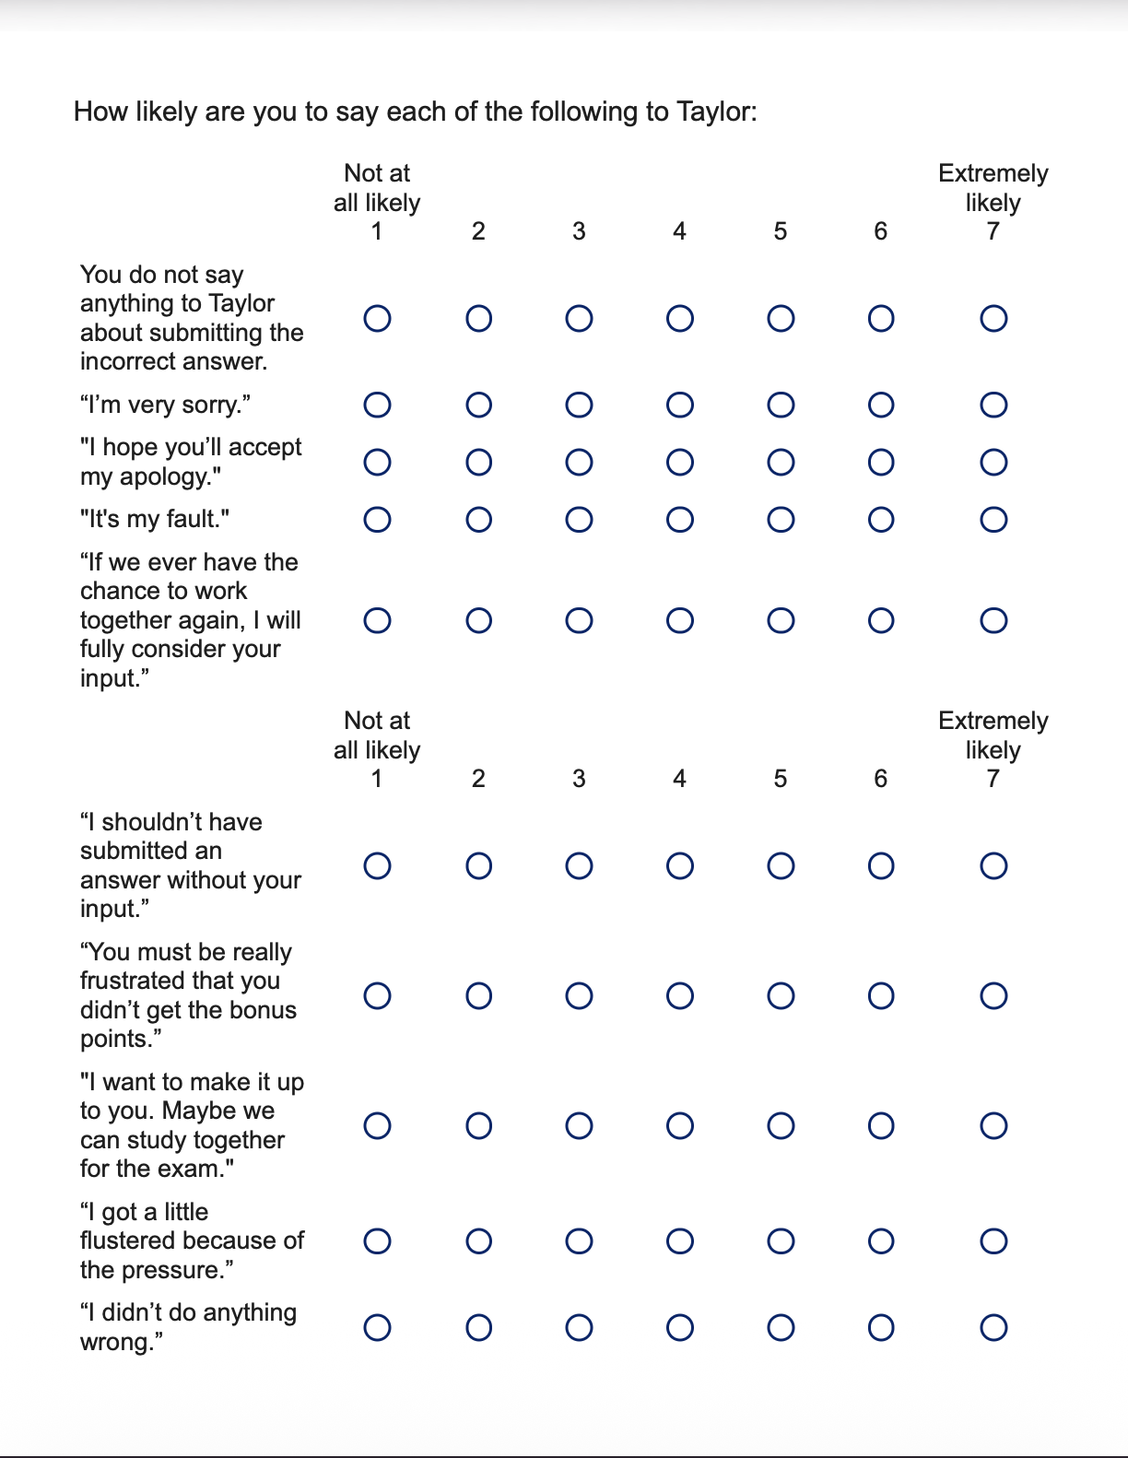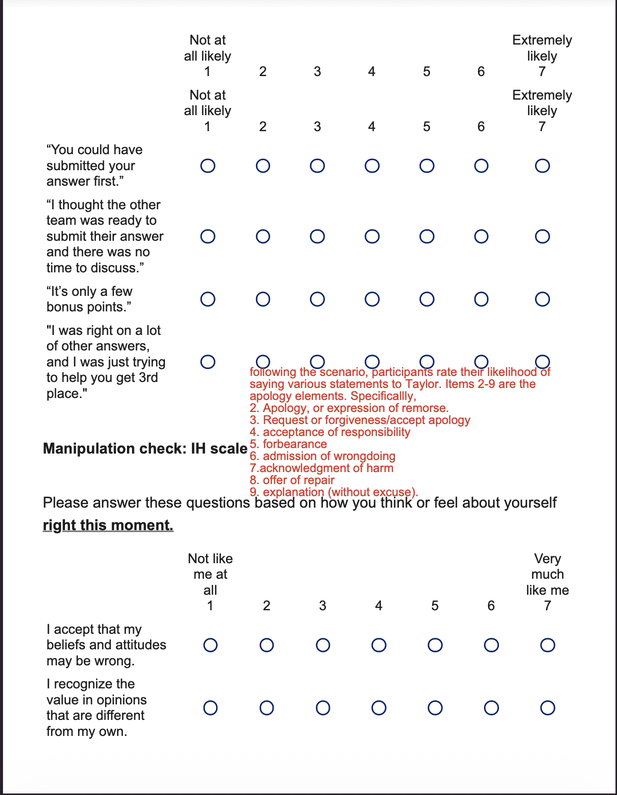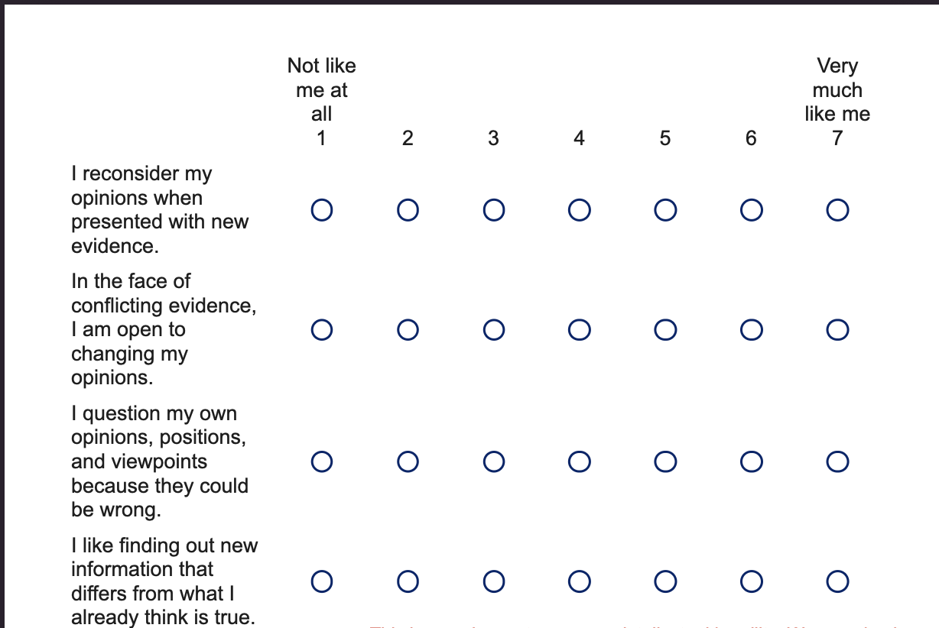

Table 1
Demographic Characteristics
Demographic Characteristics of Sample
Total, N | 113
Final, N | 108
Mean Age (SD) | 35.18 (16.10)
Median Education | Associates
Gender
Men | 38.05% (n = 43)
Women | 54.87% (n = 62)
Non-binary/third gender | 0.88% (n = 1)
Gender: Unspecified | 6.19% (n = 7)
Race/Ethnicity
White | 70.75% (n = 75)
Asian or Asian American | 11.32% (n = 12)
Black or African American | 6.60% (n = 7)
Middle Eastern or North African | 0.00% (n = 0)
Hispanic or Latino | 3.77% (n = 4)
Native Hawaiian or Other Pacific Islander | 0.94% (n = 1)
Mixed race/ethnicity | 5.70% (n = 6)
Race: Other | 0.94% (n = 1)

Note: The percentages are based on the total sample

Figure 1
The Effect of Intellectual Humility on Apology Quality

Figure 2
The Effect of Post-Transgression response on Apology Quality

Figure 3
The Interaction Effect of Intellectual Humility and Post-Transgression Response on Apology Quality

