Thomas Jackson

Abstract:

This report will be about a basic representation of stellar formation within a system. The three major parts of any stellar system are the mass of the Atomic cloud, Molecular cloud, and the mass of the active stars. The atomic cloud is a cloud of ionized hydrogen and due to this ionization, stars cannot form within these clouds of gas. This cloud makes a transition into what is called molecular gas, a mix of dust and hydrogen, but the gas and dust are not ionized and therefore can collapse into new stellar bodies. The behavior of these systems is dominated by the rate in which the atomic cloud makes the transition into a non-ionized state. Stars have a very similar trend line to that of the Molecular gas within a system. These systems can be split into two stable but different categories, one being the systems that converge to a constant fractional mass and the others that cycle between periods dominated by atomic gas, molecular gas and then to large amounts of stellar mass. While the behavior of the convergent systems is fairly similar across the board, the oscillating systems follow a trend of increasing frequency and decreasing amplitude as the rate of molecular gas formation increases. Also with the increasing molecular gas formation, rate convergent series have different places of convergence. All of this revolves around equations describing the formation of large and hot blue stars.

Mathematical statement of the problems:

This is the first set of equations. These equations become more useful when you eliminate S.

M: The fraction of total mass that is molecular gas

A: The fraction of total mass that is Atomic gas

S: The fraction of total mass that is stellar mass

n: Any number between 1 and 3.5

dA /dt = K1S + K2S + K3AM2

dM/dt = K3AM2 – K4SMn

dS/dt = K4SMn –K1S –K2S

These are the second set of equations. These are more useful and easier to validate and run.

T: Total mass of the system (I presume this to equal 1)

T= A+M+S

a = A / T

m = M / T

s = S / T

x = (K1+K2)t

a+m+s=1

k1 = K3T2/(K1+K2)

k2 = K3T2/(K1+K2)

da/dx = 1 - a – m - k1 m2 a

dm/dx = k1 m2 a + k2 mn (a -1+m)

s =1-m-a

Numerical method:

A fourth order Runge-Kutta method was used to approximate with good accuracy the behavior of this system. This numerical method is being used to solve a single differential equation. The code below represents one time step forward for a single value within the system.

SA = A + ( del_t / 2) * f1(A, M,S);

SSA = A + (del_t / 2) * f1(SA , SM ,S );

SSSA = A + del_t *f1(SSA , SSM , S );

AP=A +(( del_t /6)*(f1(A , M ,S )+2*f1(SA , SM ,S )+ 2*f1(SSA , SSM ,S )+f1(SSSA , SSSM ,S )));

Technical specifications:

Cpu 2.7 GHz Intel Core i5

Memory: 16 GB 1867 MHz DDR3

hw.ncpu: 4

hw.byteorder: 1234

hw.memsize: 17179869184

hw.activecpu: 4

hw.targettype:

hw.physicalcpu: 2

hw.physicalcpu_max: 2

hw.logicalcpu: 4

hw.logicalcpu_max: 4

hw.cputype: 7

hw.cpusubtype: 8

hw.cpu64bit_capable: 1

hw.cpufamily: 1479463068

hw.cacheconfig: 4 2 2 4 0 0 0 0 0 0

hw.cachesize: 17179869184 32768 262144 3145728 0 0 0 0 0 0

hw.pagesize: 4096

hw.pagesize32: 4096

hw.busfrequency: 100000000

hw.busfrequency_min: 100000000

hw.busfrequency_max: 100000000

hw.cpufrequency: 2700000000

hw.cpufrequency_min: 2700000000

hw.cpufrequency_max: 2700000000

hw.cachelinesize: 64

hw.l1icachesize: 32768

hw.l1dcachesize: 32768

hw.l2cachesize: 262144

hw.l3cachesize: 3145728

hw.tbfrequency: 1000000000

hw.packages: 1

hw.optional.floatingpoint: 1

hw.optional.mmx: 1

hw.optional.sse: 1

hw.optional.sse2: 1

hw.optional.sse3: 1

hw.optional.supplementalsse3: 1

hw.optional.sse4_1: 1

hw.optional.sse4_2: 1

hw.optional.x86_64: 1

hw.optional.aes: 1

hw.optional.avx1_0: 1

hw.optional.rdrand: 1

hw.optional.f16c: 1

hw.optional.enfstrg: 1

hw.optional.fma: 1

hw.optional.avx2_0: 1

hw.optional.bmi1: 1

hw.optional.bmi2: 1

hw.optional.rtm: 0

hw.optional.hle: 0

hw.optional.adx: 1

hw.optional.mpx: 0

hw.optional.sgx: 0

hw.optional.avx512f: 0

hw.optional.avx512cd: 0

hw.optional.avx512dq: 0

hw.optional.avx512bw: 0

hw.optional.avx512ifma: 0

hw.optional.avx512vbmi: 0

hw.cputhreadtype: 1

Results:

This first example is within the convergent type systems. The parameters are:

N= 1.79

k1 = 8 k2=15

S_active = .3 M_cloud= .3 A_cloud=.4

delta_t=.01

Phase diagrams:

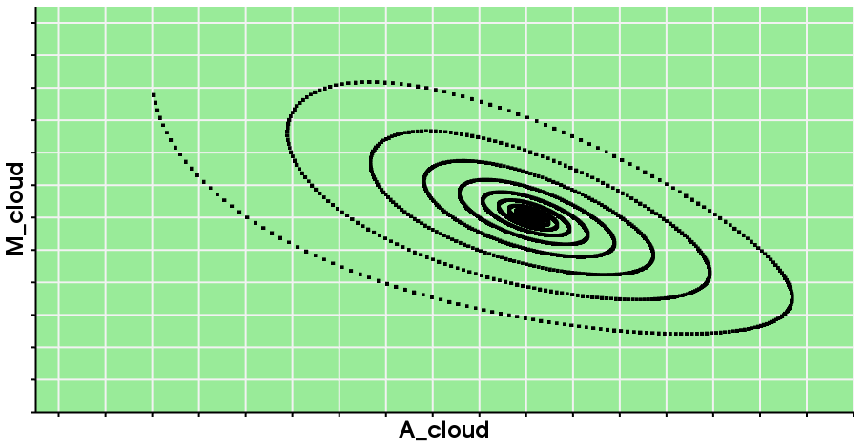 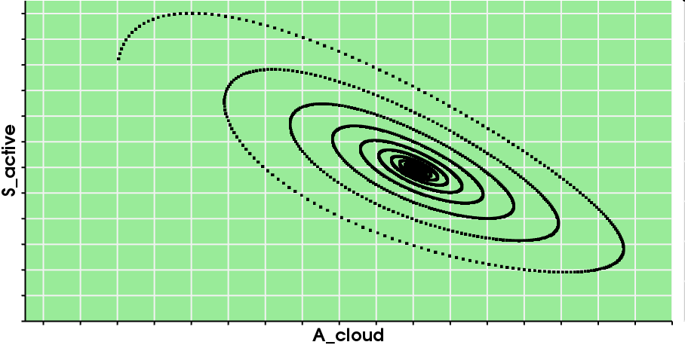

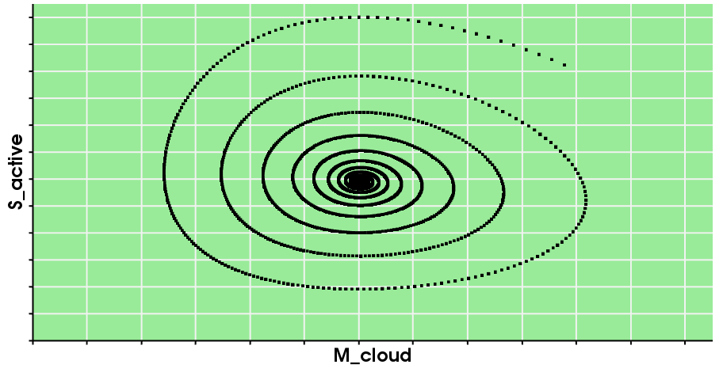

These phase diagrams spiral inwards and shows how this system converges towards a single value for the fraction of the total mass of the system.

Graphs of behavior over time: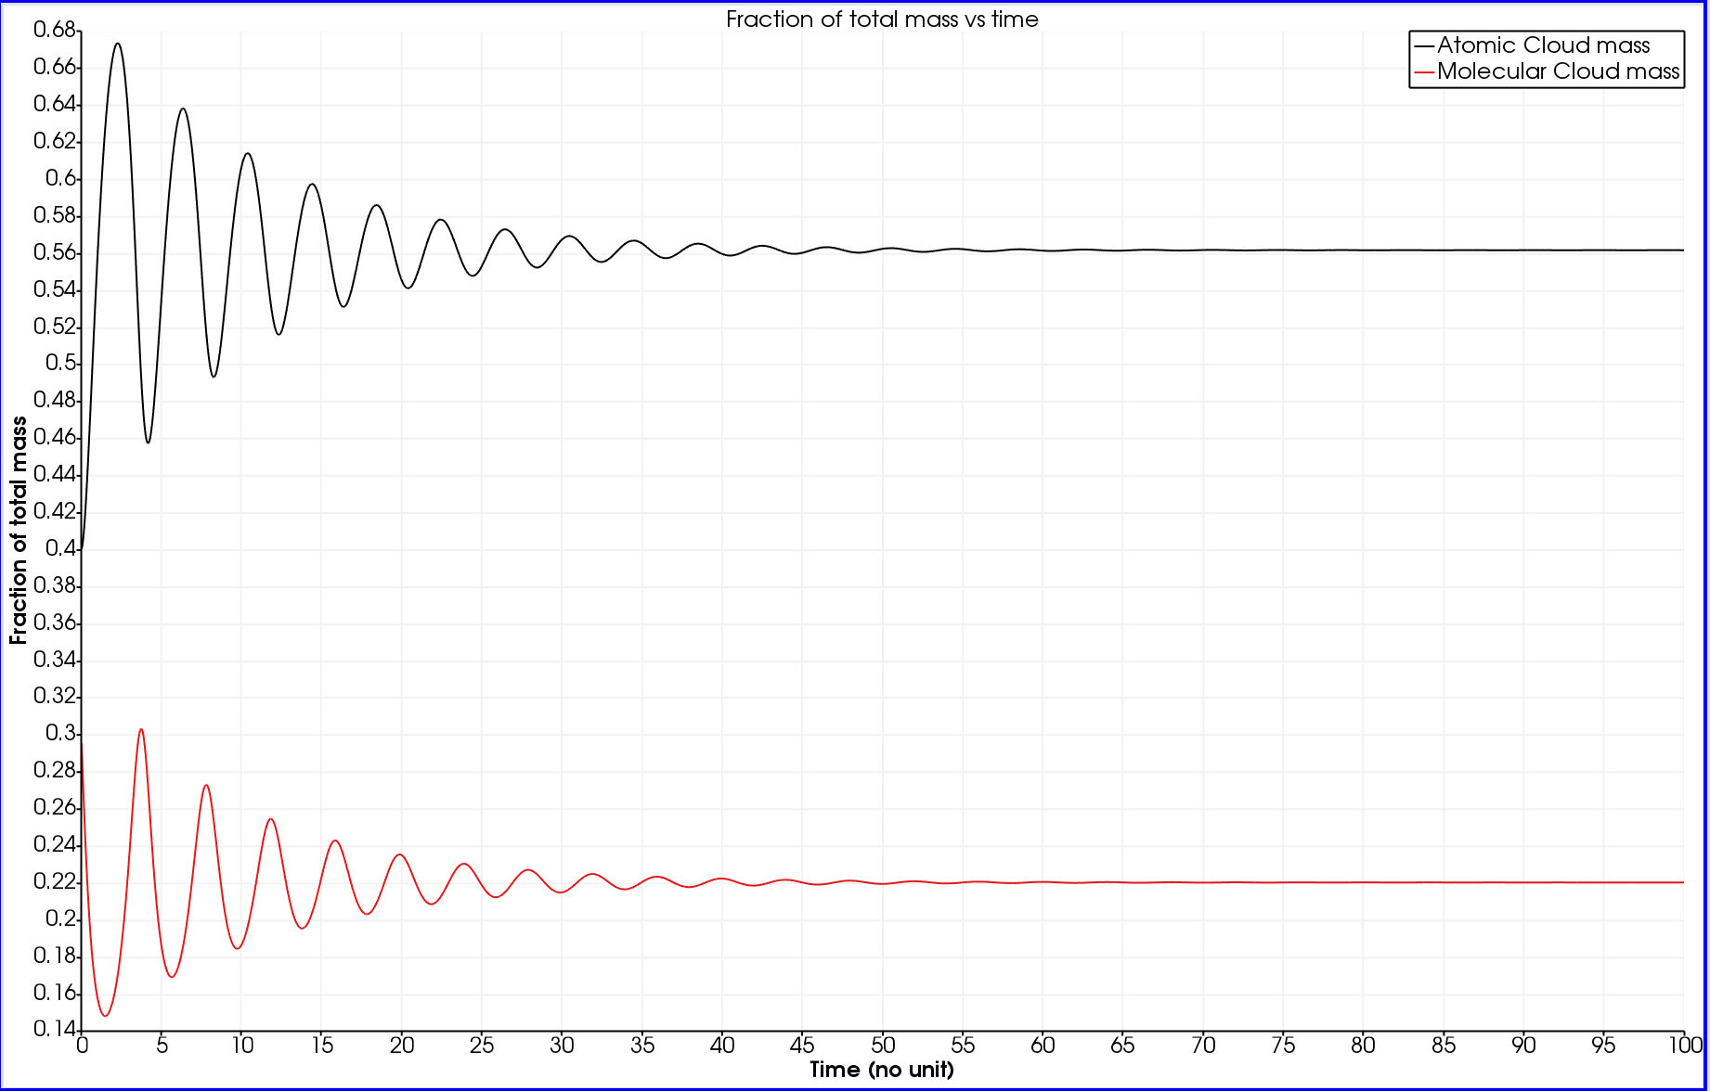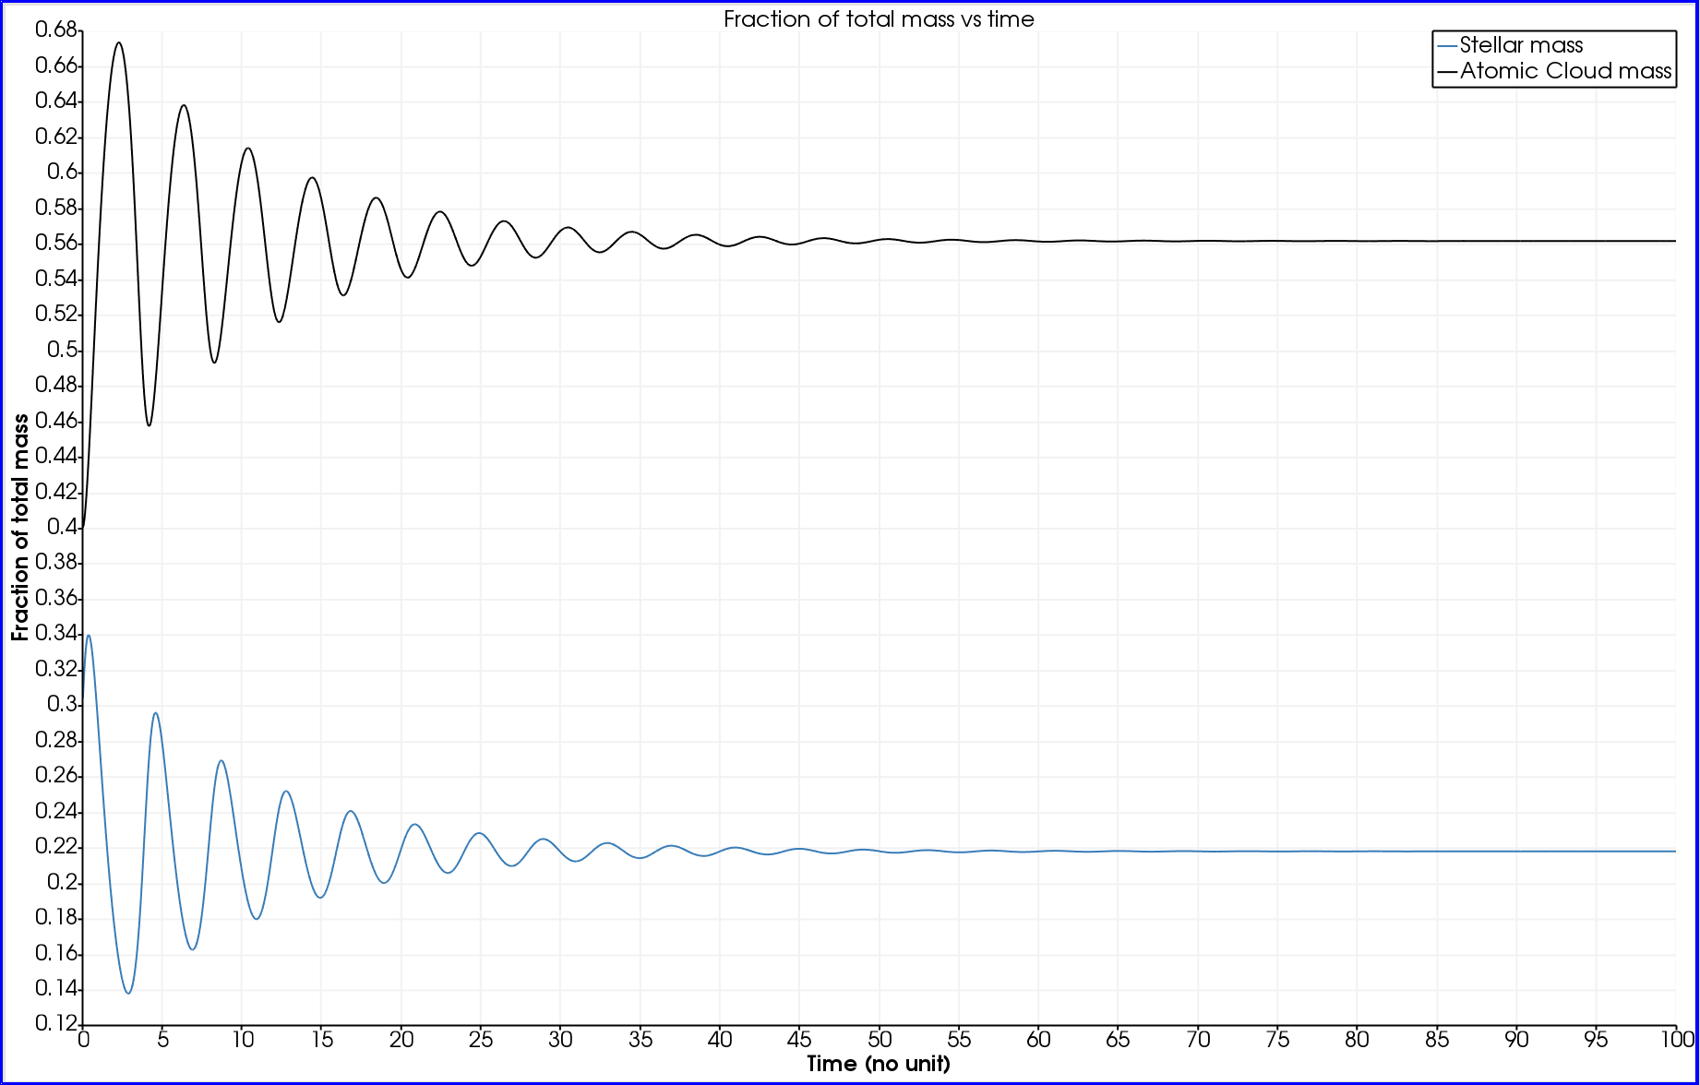

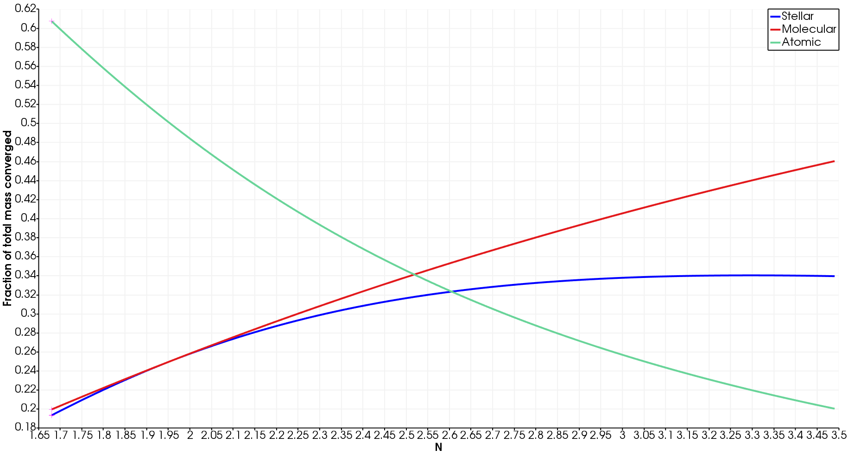With the graphs above a dampened oscillation appears to have the fractions each approach a different value. This behavior is fairly common among different values of n. When you plot what each graph converges to when they converge and you plot it against the exponent n you get the graph below.

When you plot each function’s converging fractions against n the trend brings the Atomic mass down and thus allows the constant number of stars to increase. But the fraction does not exactly follow the trend the molecular gas does because of the mass loss of the stars. Increasing the value of n allows molecular gas to form much quicker.

The next system is part of the oscillating systems. The parameters are:

N= 1.48

k1 = 8 k2=15

S_active = .3 M_cloud= .3 A_cloud=.4

delta_t=.01

These are the phase diagrams. Notice how these diagrams do not spiral inwards and instead form a loop.

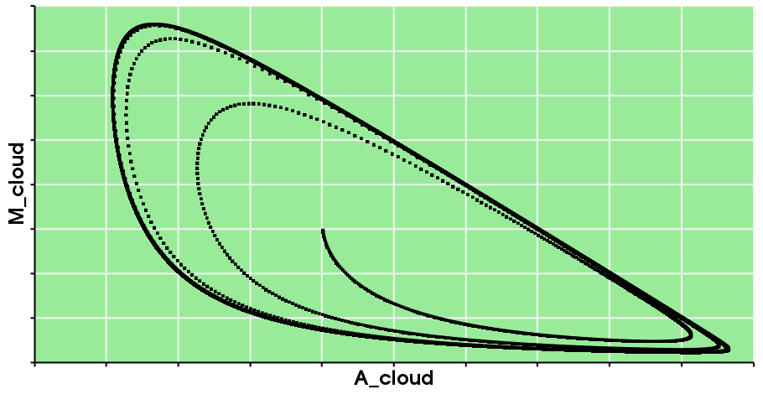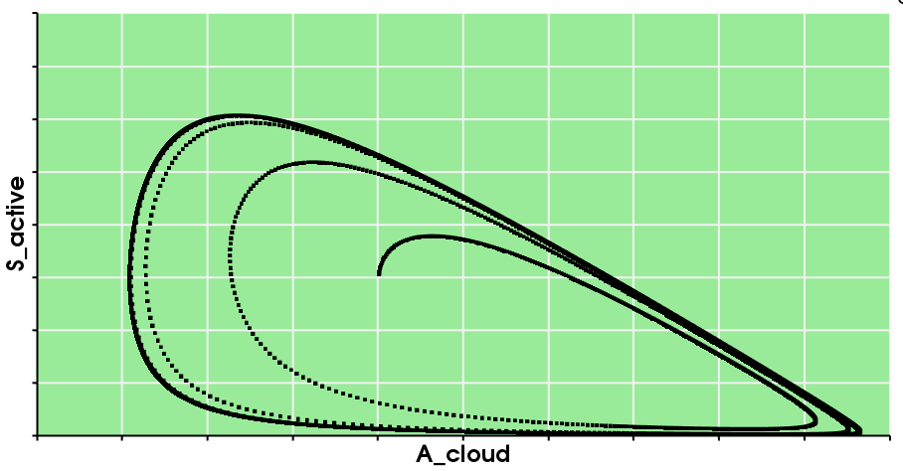

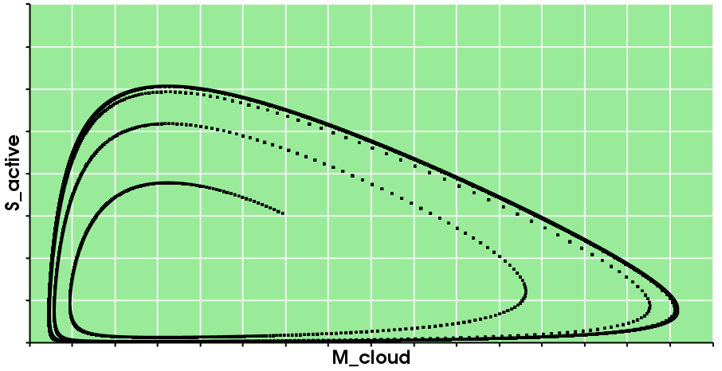

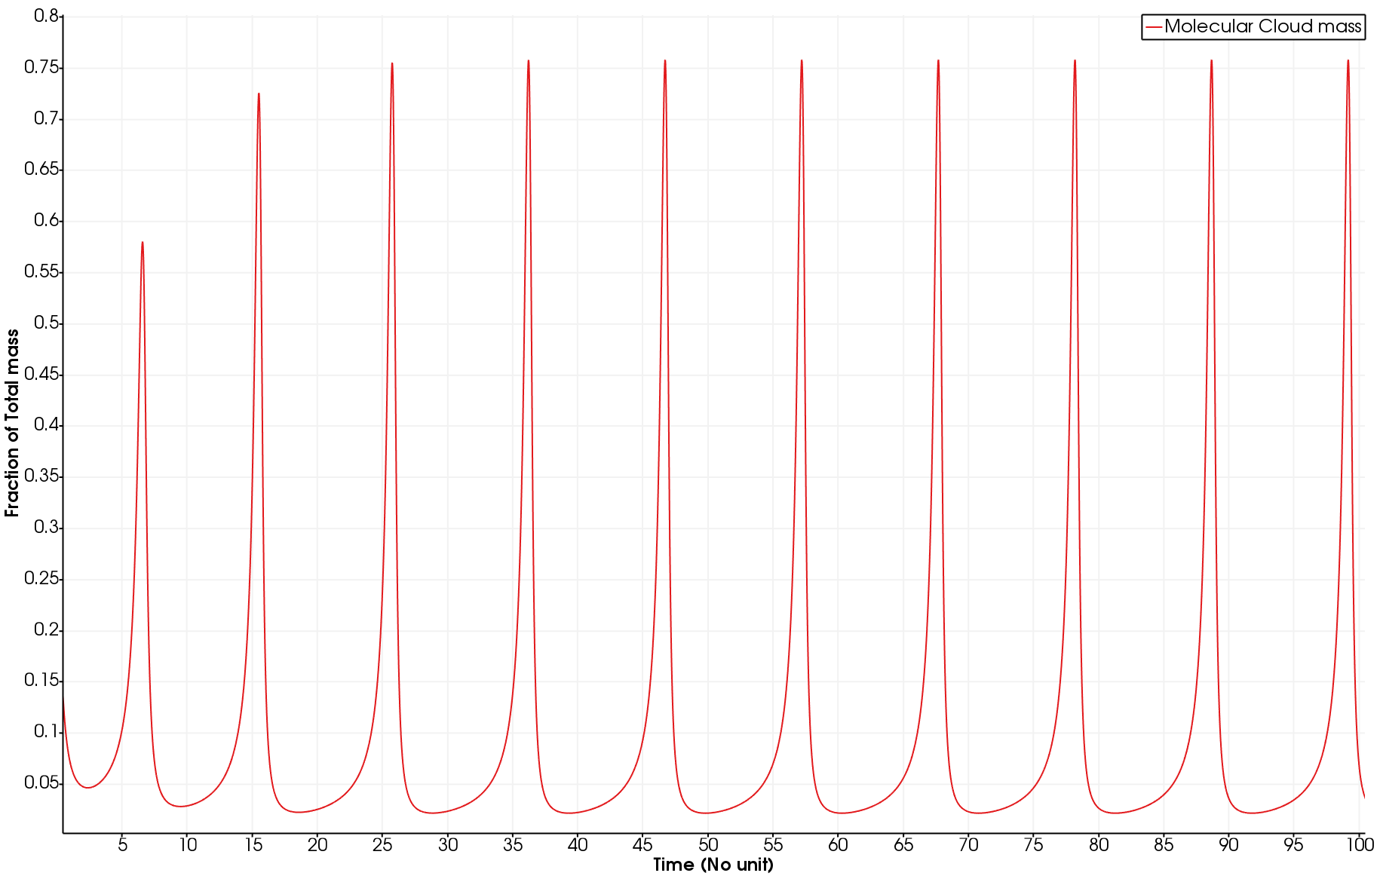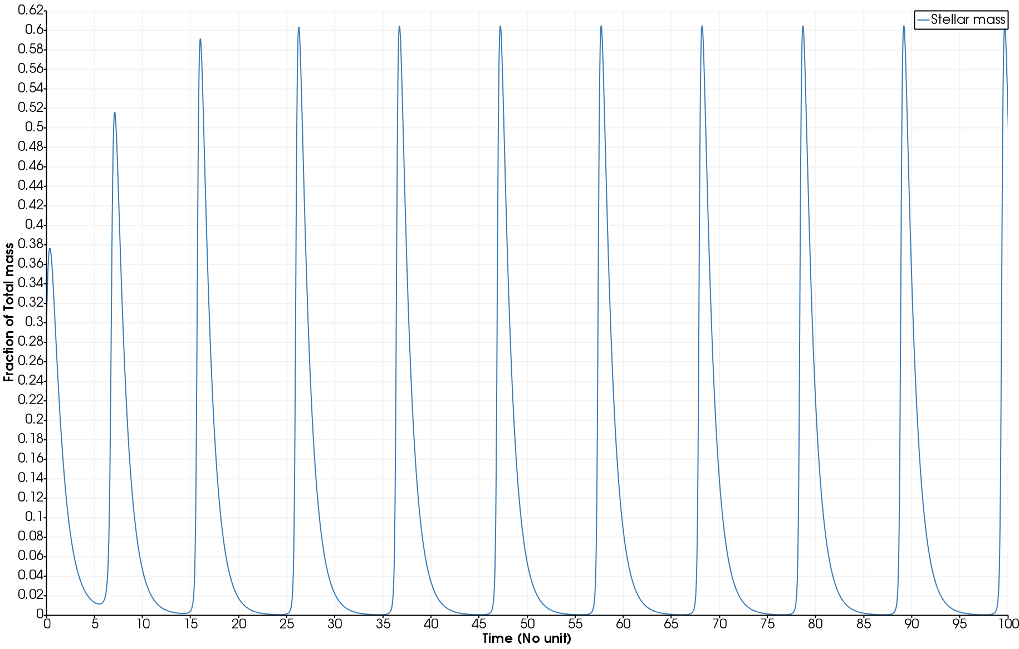Graphs of behavior over time:

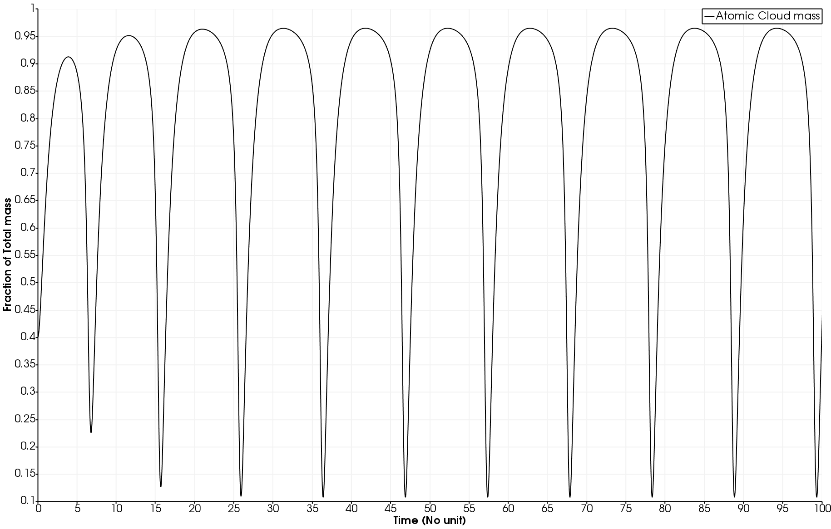

These graphs showcase how certain periods of time were dominated by different parts of the total mass of the system. It also shows the periodic nature of these types of systems.

Each one of these systems has a specific frequency and amplitude of oscillation and when plotted against n it yields the following graphs:

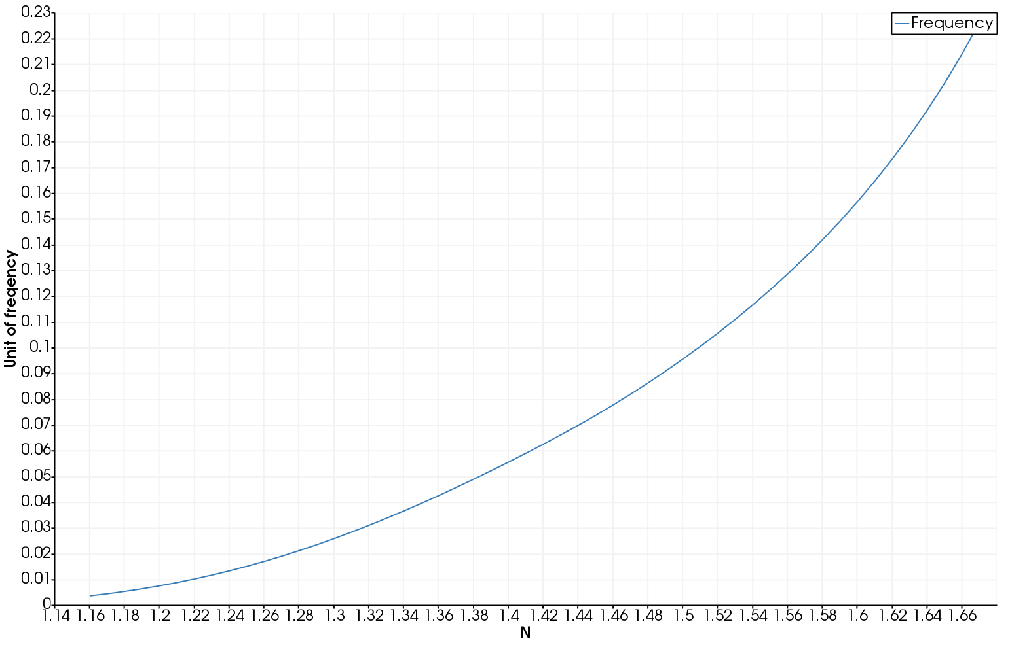

This graph shows quadratic relationship between that of the frequency of these oscillating systems and n. This relationship can be found due to n’s role in the transfer of molecular gas into stellar mass. When n gets bigger the rate of transfer increases thus increasing the frequency of this oscillation because the stellar wind has a more drastic increase if the stars form very quickly.

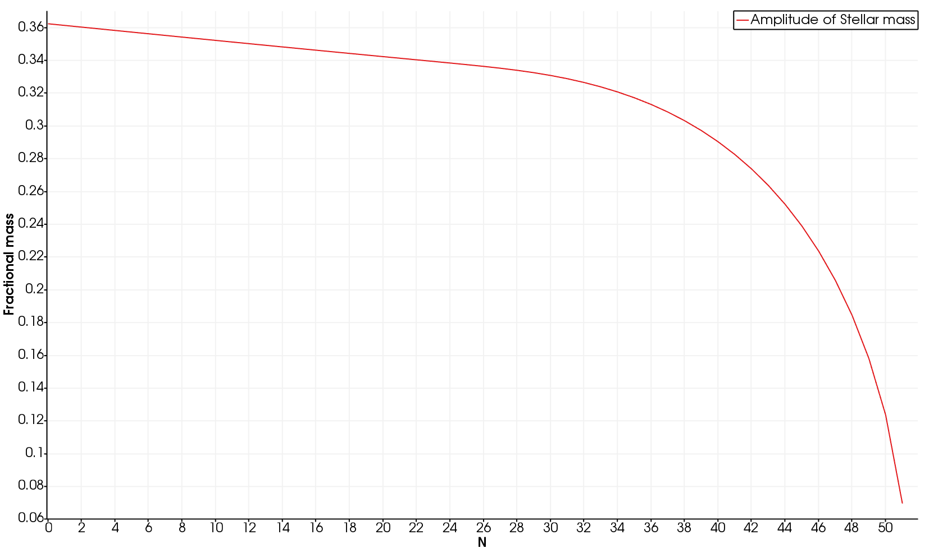

The amplitude of oscillation of these systems is also affected by the n selected for each system.

Another thing to keep in mind is that as the frequency increases the level of precision needed also increases. When the frequency of the system gets to large for the system you end up with a graph that appears as such.

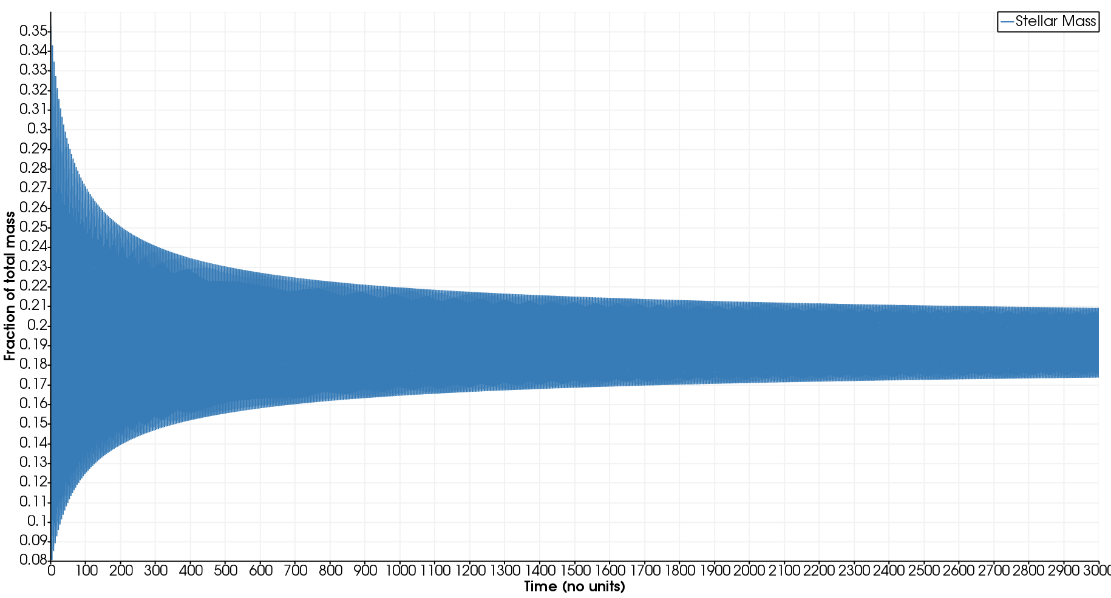

This tapered appearance follows a similar convergence scheme as the convergence seen in the other types of systems. Therefor it can be determined that the error introduced if to great adds dampening effects to the oscillation.

These equations do not have an exact solution available but there are some graphs in the paper this report is based on. When compared to my graphs they follow very similar trends and they line up very well giving similar results.