The “How to” guide on how to set up an automation for the emails attachments download in Outlook:

1. Enable Macros in Outlook.

<https://www.extendoffice.com/documents/outlook/1368-outlook-enable-disable-macros.html>

1. Add the option “Run a Script” in the “Rules and Alerts“  wizard in Outlook (by default it is disabled, but it might not be the case for all the people).

<https://answers.microsoft.com/en-us/msoffice/forum/msoffice_outlook-mso_win10/the-option-to-run-a-scritp-has-disappeared-from/d289e698-47fa-497a-80fa-633067a0de37#ThreadAnswers>

* Here, you would have to download and apply the registry key setting which you can find by checking the following link:

<https://onedrive.live.com/?id=6117FC33D161D286%2189288&cid=6117FC33D161D286>

1. Follow the steps from the bellow [tutorial](https://www.extendoffice.com/documents/outlook/3747-outlook-auto-download-save-attachments-to-folder.html):

**1**. Press **Alt** + **F11** keys to open the Microsoft Visual Basic for Applications window.

**2**. Click **Insert** > **Module**, and then paste below VBA script into the new opening Module window.

**VBA: Auto Save Outlook Attachments into a certain folder**

Public Sub SaveAttachmentsToDisk(MItem As Outlook.MailItem)

Dim oAttachment As Outlook.Attachment

Dim sSaveFolder As String

sSaveFolder = "C:\Users\DT168\Documents\outlook-attachments\"

For Each oAttachment In MItem.Attachments

oAttachment.SaveAsFile sSaveFolder & oAttachment.DisplayName

Next

End Sub

**Note**: Please find out *sSaveFolder  ->*Replace the destination folder’s path as you need.

**3**. Save the VBA Script and close the Microsoft Visual Basic for Applications window.

**4**. Go to the **Mail** view, and click **Home** > **Rules** > **Manage Rules & Alerts**. See screenshot:  
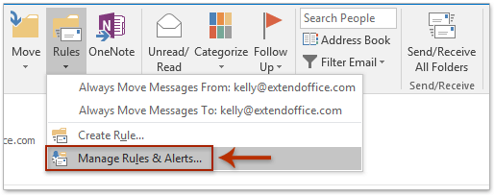

**5**. In the opening Rules and Alerts dialog box, please click the **New Rule** button on the **E-mail Rules** tab. See screenshot:  
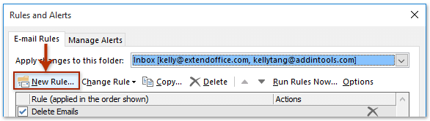

**6**. Now in the Rules Wizard dialog box, please click to select the **Apply rule on messages I receive** option, and click the **Next** button.  
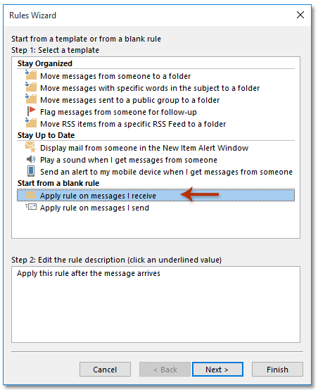

**7**. In the Rules Wizard (which condition(s) do you want to check?) dialog box, please uncheck any option, and click the **Next** button. And then click the **Yes** button in the popping up Microsoft Outlook dialog box. See screenshot:  
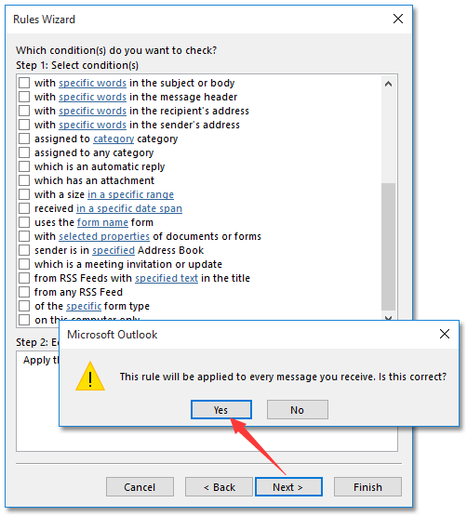

**8**. Now in the Rules Wizard (what do you want to do with the message?) dialog box, please: *(1)* Check the **run a script** option; *(2)* Click the text of *a script* to open the Select Script dialog box, select the script we added in Step 2 and click the **OK** button; *(3)* Click the **Next** button.  
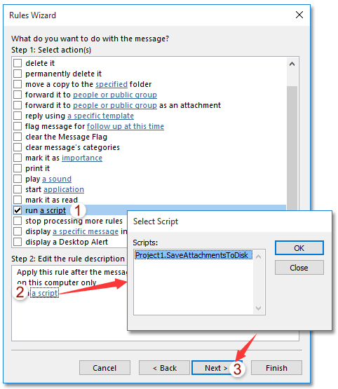

**9**. In the Rules Wizard (Are there any exceptions?) dialog box, please click the **Next** button directly.

**10**. Now in the last Rules Wizard dialog box, please name the rule in the **Step 1** box, check options as you need in the **Step 2** section, and click the **Finish** button.  
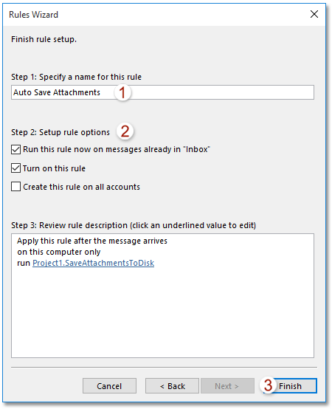

**11**. Close the Rules and Alerts dialog box.

And now all attachments are downloaded from your email account and saved into the specified destination folder. And all attachments of incoming emails will be automatically downloaded and saved into the specified folder too.