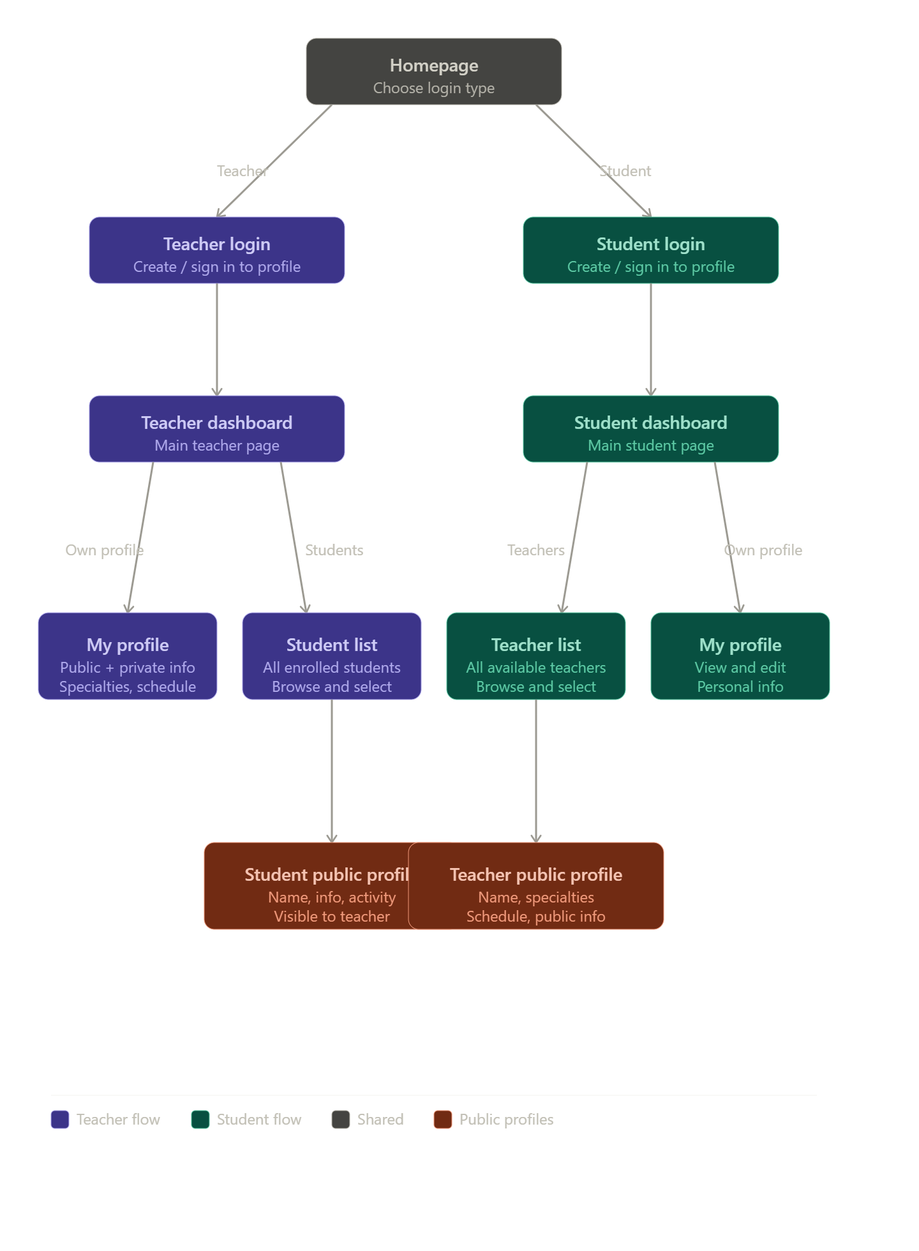
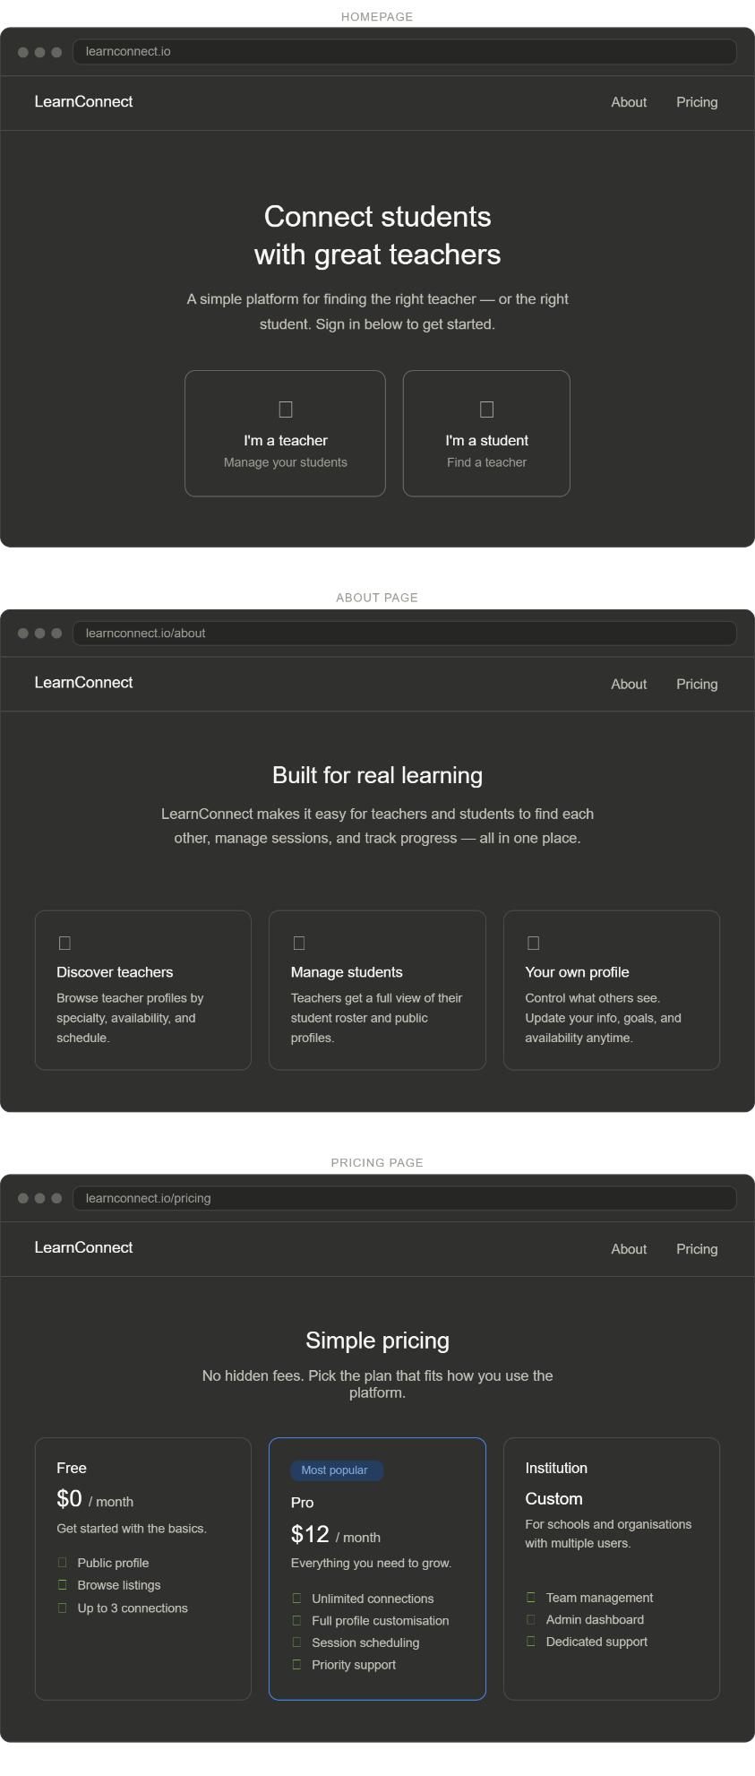
Homepage has simple layout which allows you to select how to login and check the about and find pricing. Can add more feature but keeping it simple for now. Homepage accessed with top left home button

About section just explains the topic in simple terms

Pricing shows different pricing plans.

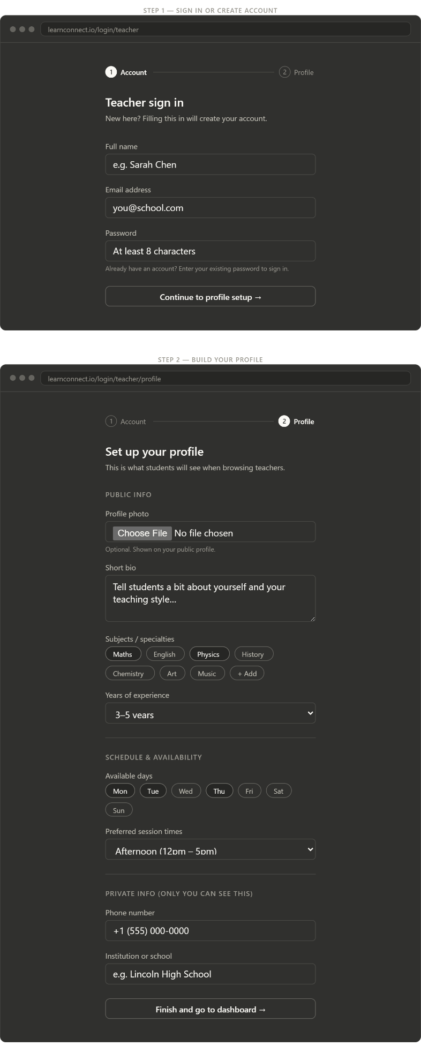
Teacher login will let them first initialize an account which immediately adds them to the database.

Then teachers will get to set up their profile by adding a picture, a bio of their experience and credibility where they can add links to their linkedin and such. Then a bubble selection where they add their skills and specialties (can be more specific). Adding a schedule for their availability which is able to be seen by everyone in a weekly calendar format.

Once profile is created, they will be prompted to wait for a background check which means the account will be locked until the background check is completed so they can’t do anything until their confirmation.

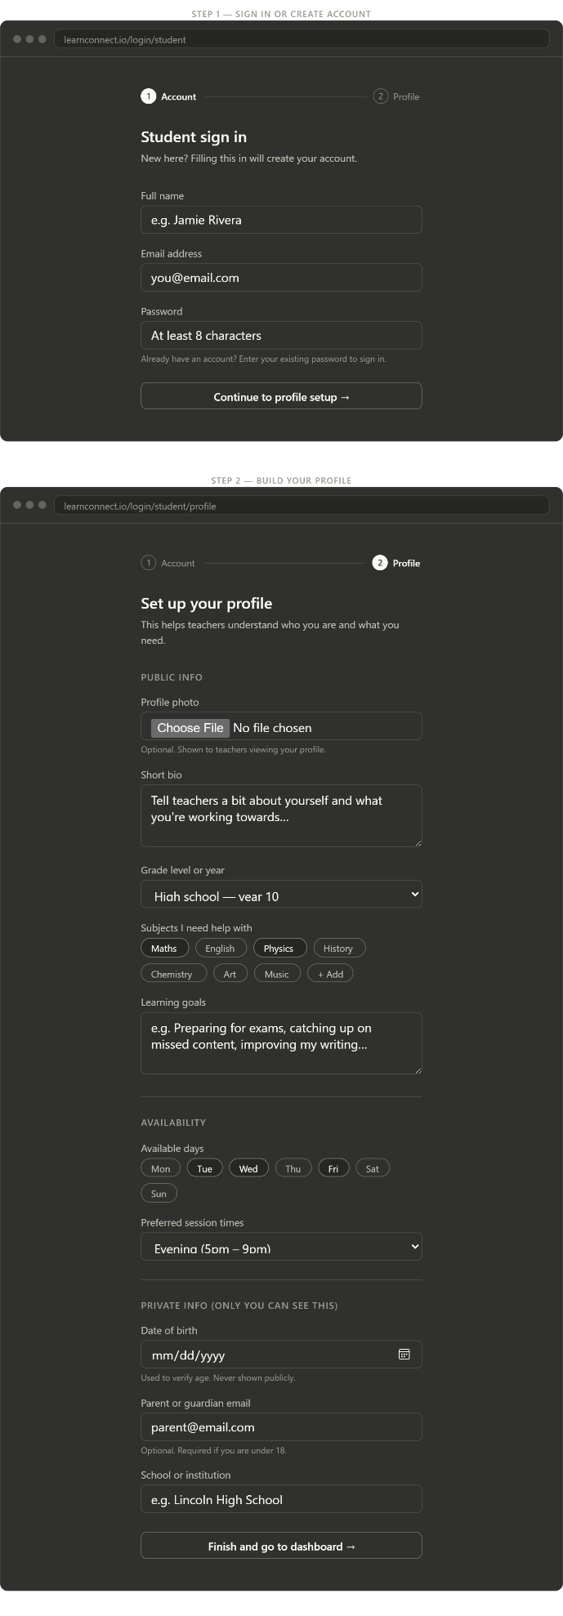
Student login will let them first initialize an account which immediately adds them to the database.

Students follow similar profile creation with a profile picture, bio which what they are struggling with and explaining their grade level and what subjects they need help with. Additional specific learning goals or topics they want emphasized with an option to include example exams or homework. They also make a calendar which will be available with everyone.

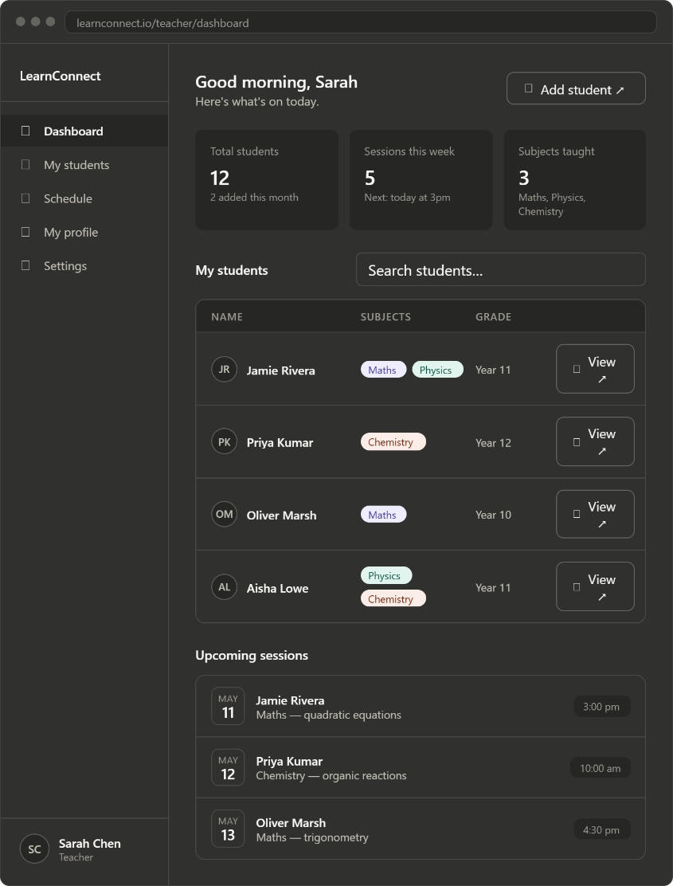
The teacher profile shows their own dashboard and some information they would want to see. They can access their students, schedule, public profile, and settings all from this page and clicking on the students name will take you to their public profile.

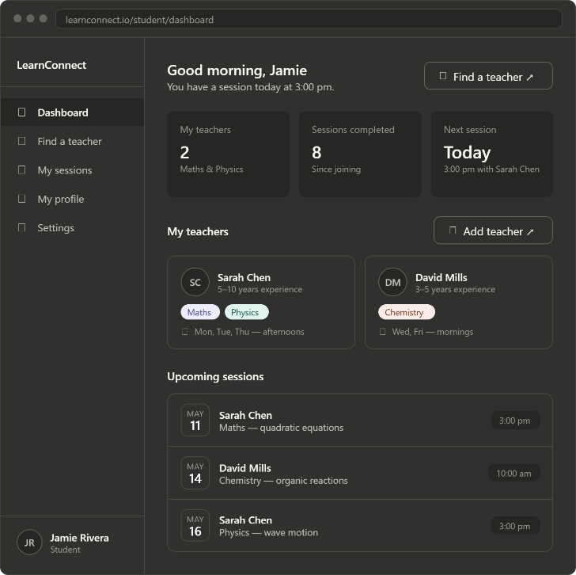
The student dashboard looks similar with their important information being displayed with them being able to click on a teacher to find their public profile.

