Лабораторная_регулярные выражения

Есть фрагмент файла LOG.txt, который содержит записи событий при работе некоторой системы. Найдите по варианту адреса, распечатайте их без повторов.

**Варианты**

1. адреса неавторизованных юзеров
2. адреса несанкционированных пользователей
3. адреса, с которых были попытки залогиниться после 24:00 (до 07:00 утра)
4. адреса, с которых пытался залогиниться пользователь patrick
5. адреса, с которых были попытки повторно залогиниться
6. адреса, с которых пытался залогиниться пользователь user
7. адреса, с которых были попытки залогиниться 18 октября
8. адреса, с которых пытался залогиниться администратор
9. адреса, с которых не логинился пользователь patrick
10. адреса, с которых больше N попыток подключения?
11. с какого адреса зафиксировано больше всего попыток подключиться?
12. адреса, с которых были попытки залогиниться не 18 октября
13. адреса, с которых были попытки залогиниться в рабочее время
14. с какого адреса зафиксирована более 10 подключений?
15. вывести все различные адреса
16. с какого адреса логинился юзер с самым длинным ником?

Пример регулярного выражения с использованием спецсимволов в шаблоне для выделения адресов в текстовом файле LOG.txt

Найдём первый адрес в лог-файле. Используем для адреса шаблон

r'\d+\.+\d+\.+\d+\.+\d'

Используем метод re.search - поиск заданного шаблона в строке, метод возвращает результат при первом совпадении.

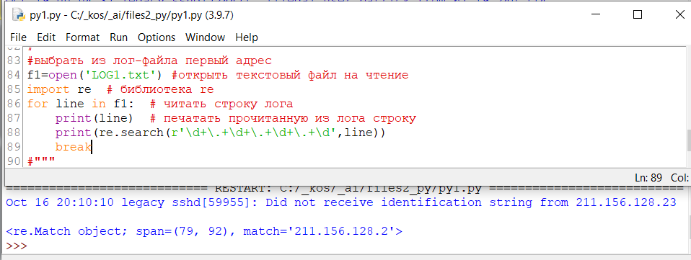

Фрагмент LOG-файла

Oct 16 20:10:10 legacy sshd[59955]: Did not receive identification string from 211.156.128.23

Oct 16 20:19:43 legacy sshd[59961]: Illegal user patrick from 211.156.128.23

Oct 16 20:19:53 legacy sshd[59966]: Illegal user patrick from 211.156.128.23

Oct 16 20:20:22 legacy sshd[59981]: Illegal user rolo from 211.156.128.23

Oct 16 20:20:28 legacy sshd[59983]: Illegal user iceuser from 211.156.128.23

Oct 16 20:20:34 legacy sshd[59985]: Illegal user horde from 211.156.128.23

Oct 16 20:20:38 legacy sshd[59987]: Illegal user cyrus from 211.156.128.23

Oct 16 20:20:48 legacy sshd[59991]: Illegal user wwwrun from 211.156.128.23

Oct 16 20:20:58 legacy sshd[59993]: Illegal user matt from 211.156.128.23

Oct 17 01:29:25 legacy sshd[60366]: Illegal user test from 218.237.4.57

Oct 17 01:29:28 legacy sshd[60368]: Illegal user guest from 218.237.4.57

Oct 17 01:29:32 legacy sshd[60370]: Illegal user admin from 218.237.4.57

Oct 17 01:29:35 legacy sshd[60374]: Illegal user admin from 218.237.4.57

Oct 17 01:29:38 legacy sshd[60376]: Illegal user user from 218.237.4.57

Oct 17 01:29:51 legacy sshd[60387]: Illegal user test from 218.237.4.57

Oct 17 23:29:11 legacy sshd[64098]: Did not receive identification string from 147.46.76.225

Oct 17 23:37:18 legacy sshd[64139]: Illegal user patrick from 147.46.76.225

Oct 17 23:37:22 legacy sshd[64141]: Illegal user patrick from 147.46.76.225

Oct 17 23:39:35 legacy sshd[64151]: fatal: Timeout before authentication for 147.46.76.225

Oct 18 00:09:42 legacy sshd[64320]: Illegal user test from 211.174.181.158

Oct 18 00:09:45 legacy sshd[64322]: Illegal user guest from 211.174.181.158

Oct 18 00:10:18 legacy sshd[64330]: Illegal user test from 211.34.197.3

Oct 18 00:10:22 legacy sshd[64332]: Illegal user guest from 211.34.197.3

Oct 18 00:10:25 legacy sshd[64334]: Illegal user admin from 211.34.197.3

Oct 18 00:10:29 legacy sshd[64336]: Illegal user admin from 211.34.197.3

Oct 18 00:10:32 legacy sshd[64338]: Illegal user user from 211.34.197.3

Oct 18 00:10:44 legacy sshd[64347]: Illegal user test from 211.34.197.3

Oct 18 22:47:31 legacy sshd[72101]: Did not receive identification string from 83.64.18.219

Oct 18 23:02:01 legacy sshd[72124]: Illegal user patrick from 83.64.18.219

Oct 18 23:02:02 legacy sshd[72126]: Illegal user patrick from 83.64.18.219

Oct 18 23:02:15 legacy sshd[72138]: Illegal user rolo from 83.64.18.219

Oct 18 23:02:17 legacy sshd[72140]: Illegal user iceuser from 83.64.18.219

Oct 18 23:02:18 legacy sshd[72142]: Illegal user horde from 83.64.18.219

Oct 18 23:02:20 legacy sshd[72144]: Illegal user cyrus from 83.64.18.219

Oct 18 23:02:22 legacy sshd[72148]: Illegal user wwwrun from 83.64.18.219

Oct 18 23:02:24 legacy sshd[72150]: Illegal user matt from 83.64.18.219

Oct 18 23:02:25 legacy sshd[72152]: Illegal user test from 83.64.18.219

Oct 18 23:02:31 legacy sshd[72154]: Illegal user test from 83.64.18.219

Oct 18 23:02:33 legacy sshd[72156]: Illegal user test from 83.64.18.219

Oct 18 23:02:34 legacy sshd[72158]: Illegal user test from 83.64.18.219

Oct 18 23:02:35 legacy sshd[72160]: Illegal user www-data from 83.64.18.219

Oct 18 23:02:37 legacy sshd[72162]: Illegal user mysql from 83.64.18.219

Oct 18 23:02:40 legacy sshd[72166]: Illegal user adm from 83.64.18.219

Oct 18 23:02:41 legacy sshd[72168]: Illegal user apache from 83.64.18.219

Oct 18 23:02:43 legacy sshd[72170]: Illegal user irc from 83.64.18.219

Oct 18 23:02:44 legacy sshd[72172]: Illegal user irc from 83.64.18.219

Oct 18 23:02:46 legacy sshd[72174]: Illegal user adm from 83.64.18.219

Oct 18 23:02:51 legacy sshd[72182]: Illegal user jane from 83.64.18.219

Oct 18 23:02:53 legacy sshd[72184]: Illegal user pamela from 83.64.18.219

Oct 18 23:03:00 legacy sshd[72196]: Illegal user cosmin from 83.64.18.219

Oct 18 23:03:56 legacy sshd[72270]: Illegal user cip52 from 83.64.18.219

Oct 18 23:03:57 legacy sshd[72272]: Illegal user cip51 from 83.64.18.219

Oct 18 23:04:05 legacy sshd[72276]: Illegal user noc from 83.64.18.219

Oct 18 23:04:12 legacy sshd[72287]: Illegal user webmaster from 83.64.18.219

Oct 18 23:04:18 legacy sshd[72297]: Illegal user data from 83.64.18.219

Oct 18 23:04:20 legacy sshd[72299]: Illegal user user from 83.64.18.219

Oct 18 23:04:26 legacy sshd[72301]: Illegal user user from 83.64.18.219

Oct 18 23:04:27 legacy sshd[72303]: Illegal user user from 83.64.18.219

Oct 18 23:04:29 legacy sshd[72305]: Illegal user web from 83.64.18.219

Oct 18 23:04:30 legacy sshd[72307]: Illegal user web from 83.64.18.219

Oct 18 23:04:32 legacy sshd[72309]: Illegal user oracle from 83.64.18.219

Oct 18 23:04:33 legacy sshd[72311]: Illegal user sybase from 83.64.18.219

Oct 18 23:04:34 legacy sshd[72313]: Illegal user master from 83.64.18.219

Oct 18 23:04:36 legacy sshd[72315]: Illegal user account from 83.64.18.219

Oct 18 23:04:38 legacy sshd[72317]: Illegal user backup from 83.64.18.219

Oct 18 23:04:39 legacy sshd[72319]: Illegal user server from 83.64.18.219

Oct 18 23:04:41 legacy sshd[72321]: Illegal user adam from 83.64.18.219

Oct 18 23:04:42 legacy sshd[72323]: Illegal user alan from 83.64.18.219

Oct 18 23:04:44 legacy sshd[72325]: Illegal user frank from 83.64.18.219

Oct 18 23:04:46 legacy sshd[72327]: Illegal user george from 83.64.18.219

Oct 18 23:04:47 legacy sshd[72329]: Illegal user henry from 83.64.18.219

Oct 18 23:04:49 legacy sshd[72331]: Illegal user john from 83.64.18.219

Oct 18 23:04:58 legacy sshd[72343]: Illegal user test from 83.64.18.219

Oct 18 23:47:19 legacy sshd[72387]: Did not receive identification string from 67.19.240.114

Oct 19 00:04:37 legacy sshd[72447]: Illegal user patrick from 67.19.240.114

Oct 19 00:04:38 legacy sshd[72449]: Illegal user patrick from 67.19.240.114