main

neuralNet

cifar10testdata.mat

CNNparameters.mat

debuggingTest.mat

i < num of images

normalize

convolve

ReLU

maxpool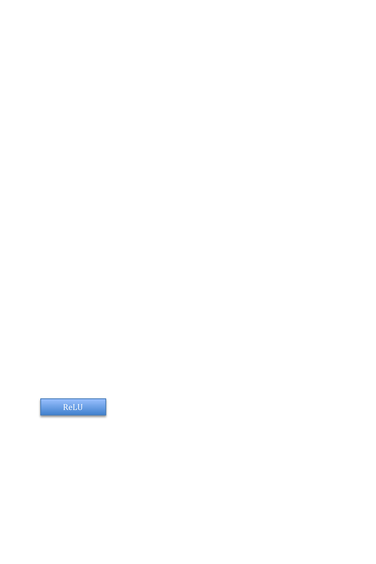

convolve

convolve

ReLU

ReLU

convolve

ReLU

maxpool

convolve

ReLU

maxpool

full connect

soft max

surf ( )

convolve

ReLU

true

false out(2)

3D shaded surface plot

10x10 Matrix of classification

Probabilities

numImages x10 Matrix of probability vectors

false out(1)

top k

plot of top k

percentages