**Top-k Classification Results:**

|  |  |
| --- | --- |
| K | Accuracy |
| 1 | 0.4371 |
| 2 | 0.6591 |
| 3 | 0.7864 |
| 4 | 0.8626 |
| 5 | 0.9135 |
| 6 | 0.9496 |
| 7 | 0.971 |
| 8 | 0.9847 |
| 9 | 0.9942 |
| 10 | 1 |

**Discuss:**

We were very surprised to see the top-k classification plot follow an exponential distribution. This demonstrates that the probability estimations provided by the CNN are accurate. We expected the probability estimations to be an arbitrary metric, but looking at the logarithmic nature of the plot it is clear that the probabilities are very accurate.

**Confusion Matrix:**

|  |  |  |  |  |  |  |  |  |  |  |  |
| --- | --- | --- | --- | --- | --- | --- | --- | --- | --- | --- | --- |
|  | CNN Estimated Classification | 1 | 2 | 3 | 4 | 5 | 6 | 7 | 8 | 9 | 10 |
| True Classification |  |  |  |  |  |  |  |  |  |  |  |
| 1 |  | 531 | 41 | 65 | 37 | 10 | 8 | 18 | 38 | 210 | 42 |
| 2 |  | 40 | 519 | 9 | 26 | 10 | 7 | 19 | 29 | 111 | 230 |
| 3 |  | 87 | 8 | 386 | 117 | 97 | 70 | 104 | 88 | 25 | 18 |
| 4 |  | 39 | 18 | 127 | 325 | 45 | 136 | 186 | 89 | 13 | 22 |
| 5 |  | 53 | 6 | 270 | 69 | 259 | 38 | 162 | 114 | 22 | 7 |
| 6 |  | 19 | 7 | 151 | 222 | 49 | 281 | 111 | 125 | 20 | 15 |
| 7 |  | 10 | 7 | 120 | 125 | 93 | 23 | 557 | 33 | 9 | 23 |
| 8 |  | 32 | 7 | 73 | 98 | 77 | 94 | 54 | 533 | 13 | 19 |
| 9 |  | 192 | 84 | 35 | 44 | 7 | 8 | 10 | 16 | 542 | 62 |
| 10 |  | 69 | 191 | 23 | 41 | 4 | 9 | 30 | 68 | 127 | 438 |

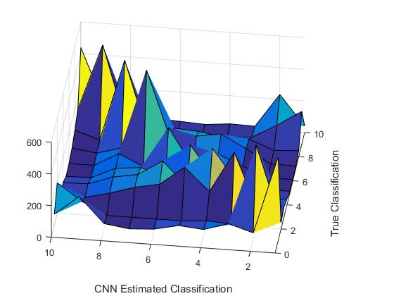

**Discuss:**

The surface plot above demonstrates how well the CNN classifies images. There is a very strong response on the diagonal which represents the correct classifications. What is interesting is that this matrix is somewhat diagonal. This demonstrates images from class C1 and class C2 are frequency confused for one another. A lot of this confusion is entirely logical; for example, trucks and automobiles are frequently confused for each other. Another great example of confusion are cats and dogs are frequently confused for one another. We are again very impressed with how well the CNN because we’re sure there has been more than a few times when we have confused one of these classes with another class.