ECC AutoCAD Electrical Drawing Standards



Trenton Cathcart

Gregory DuBuque

10.04.2024



Contents

1. DRAWING SET-UP 5

1.1 – AutoCAD Electrical Software Setup 5

1.2 – ACADE Project Set-up and Start 19

The project setup documentation can be found by clicking here. 19

1.3 – ACADE Page Numbering Details 19

1.4 Schematic Standard 20

1.5 - Floor Plan Standards 28

1.6 29

1.7 - Drawing Scale 29

1.8 - Key Plans 29

1.9 - Match Lines 29

1.10 - Text Sizing 29

1.11 - Text Styles 30

1.12 - Layer Creation / Naming 30

1.13 - System Layer Colors 31

1.14 - ECC Standard Layers 31

2. MODEL AND PAPER SPACE CONSIDERATIONS 32

2.1 - Model Space 32

2.2 - Paper Space 32

3. LEGENDS / DETAILS / BLOCKS / NOTES 32

3.1 - Device Legend 32

3.2 - Cable Legend 32

3.3 - Details 32

3.4 - Standard Block Structure 32

4. VIEWPORTS / SHEET SIZES 33

4.1 - Types of Viewports (Regular Vs Polygonal) 33

4.2 - Scaling A Viewport 33

4.3 - Multiple Viewports – Key Plan Layout 33

4.4 - Standard Sheet Sizes 33

5. POST-ENGINEERING REVIEW 33

5.1 - Drafter Check (Detail Size, Layout Changes, Etc.) 33

5.2 - Saving to Q360 33

5.3 - Uploading to Fieldwire 34

6. REVISIONS 34

6.1 - Drawing Changes 34

6.2 - Revision Annotation 34

6.3 - Saving to Q360 34

6.4 - Uploading to Fieldwire 34

7. XREFS 35

7.1 - When to Create XREF 35

7.2 - Project XREF 35

7.3 - XREF Considerations 35

7.4 - Changes to Existing XREF 35

8. AS-BUILTS 35

8.1 - Drawing Changes 35

8.2 - As-Built Standard Practices 1

8.3 - Saving to Q360 1

9. FOLDER ORGANIZATION 1

9.1 - Project Folder Structure & Naming 1

10. ABBREVIATIONS 2

11. LISP DEFINITIONS / COMMANDS 4

12. APPENDIX DRAWINGS 7

# DRAWING SET-UP

## – AutoCAD Electrical Software Setup

1. AutoCAD Electrical software settings
   1. In the Options Menu:
      1. Open and Save tab
         1. Save as: AutoCAD 2018 drawing (*.dwg)
         2. Uncheck the “Show Proxy Information Dialog Box”

* + 1. Plot and Publish tab
       1. Add your default printer.
       2. Uncheck “Use OLE Application”

* + 1. System tab
       1. Uncheck “Display OLE Text Size Dialog”

* + 1. Drafting tab
       1. Uncheck “Display Auto Snap Tool tip”
       2. Uncheck all “Auto Track Settings.”

* + 1. 3d Modeling tab
       1. Uncheck “2D Wireframe Visual Style”
       2. Uncheck “All other Visual Styles.”
       3. Uncheck “Display the Viewport Controls”
       4. Open View Cube

* + - 1. Uncheck “Show UCS Menu.”

* + 1. Selection tab
       1. Uncheck “Object Grouping”

* 1. Command Line Settings
     1. FILEDIA – set to 1.

* + 1. AEEMXDATAUPDATEMODE – set to 1.

* 1. Snap to Drawing Grid Settings
     1. Snap X Spacing – 0.125
     2. Snap Y Spacing - 0.125
     3. Grid X Spacing - 0.25
     4. Grid Y Spacing – 0.25
     5. Major Line Every - 2

1. Default Project Properties
   1. Components tab
      1. Tag format - %F%N
      2. Click Suffix Setup

* + 1. Select top set-up option.

* 1. Wire numbers tab
     1. Format - %N
     2. Select “Above Wire”
     3. Select “Centered”
     4. Click Suffix Set-up

* + 1. Select 3rd option.

* 1. Cross References tab
     1. Same Drawing and Between Drawings - %N

* 1. Drawing Format tab
     1. Spacing – 1.0
     2. Width – 11
     3. Multi-wire spacing – 0.5
     4. Select Reference numbers
     5. Click Set-up

* + 1. Select “Numbers only”

## – ACADE Project Set-up and Start

## The project setup documentation can be found by clicking [here](https://tcathcart33.github.io/AutoCad-Electrical-Setup/AUTOCAD_ELECTRICAL_PROJECT_CREATION_DIRECTIONS.pdf).

## – ACADE Page Numbering Details

1. **Reference (000)** serves as the foundational category, containing critical information such as the list of page numbers and the project name, providing a reference point for the entire documentation set.
2. **Floor Plan (Pages 100-199)** encompasses detailed layout plans, utilizing ECC component designations to pinpoint exact locations, wire runs, and other essential elements. These components utilized are door locks and contacts, intercoms, cameras, access control and special details.
3. **Network (Pages 200-299)** is dedicated to one-line layouts of network devices, such as encoders, decoders, computers, PLCS, and other control devices connected by standard Cat6 cables. This outlines the structure of the network, detailing how various devices communicate and control different operations within the system.
4. **Intercom (Pages 300-399)** focuses on one-line diagrams that map out all intercom connections, both new installations and existing systems. This category ensures that all communication lines are clearly documented, facilitating easy troubleshooting and future expansions.
5. **Video (Pages 400-499)** is reserved for one-line diagrams of video interface systems, including both new installations and existing setups. This category details the connections and configurations necessary for the video systems to operate seamlessly.
6. **Panel/Rack Layouts (Pages 500-599)** offers a detailed depiction of all jobs rack and panel layouts as well as their locations in the given building. These racks include
   1. Main Jail Control Rack (JCR-1) – Network, Intercom, and Video devices housing.
   2. Main Jail Control Enclosure (JCE-1) – Door and Utility control PLC panels
   3. All remote racks or enclosures
7. **Terminal Block Details (Pages 600-699)** provides an intricate description of how wires are routed between components, and wire routings from panels to the field devices.
8. **AC Distribution (Pages 700-799)** involves schematic diagrams that depict the distribution of AC power to various components and wires. These diagrams may include details on the existing power supplies or new, typically ranging from 120V to 240V.
9. **DC Distribution (Pages 800-899)** like the AC Distribution, focuses on schematic diagrams but for DC power components. This often includes the stepping down of voltage to 24V, detailing how DC power is distributed throughout the system.
10. **PLC (Pages 900-999)** covers the schematics and descriptions of devices controlled by a Programmable Logic Controller (PLC). This category includes detailed labeling of inputs and outputs for each device, providing a comprehensive overview of the control systems in place.

## Schematic Standard

## Component Displays

## **Component Tag:** Marked in blue text, this tag identifies the component using an abbreviation, along with the page and rung number it corresponds to. For example, a control relay might be labeled as ***"CR 901 43.”*** These tags will always follow the format “Abbreviation-Page Number-Rung number”

* 1. **Descriptions 1-3:** Displayed in orange text, these fields provide various details about the component.
  2. **Rating:** Shown in red text, this field specifies the component’s relevant ratings that are critical to the system's performance.
  3. **Location:** Presented in gray text, this field indicates where the component is located within the job, such as its position on floor plans, panels, or in specific rooms.
  4. **Manufacturer and Part Number:** Displayed in black text, this field provides the manufacturer's name and part number for the component.
  5. **Terms:** These are displayed in a teal text, and denote possible wire connections for any given component.
  6. **Rung Numbers:** Rung numbers are displayed in purple and run vertically along all schematic pages that specify and link components to its page number and rung number.

A control relay schematic symbol with its corresponding attributes can be observed below in ***Figure 1.***

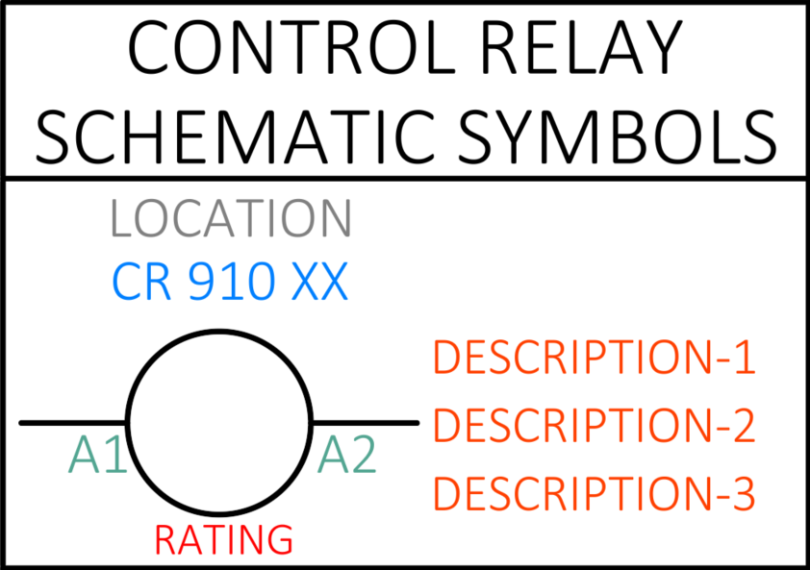

***Figure 1: Control Relay Schematic Symbol***

## Wiring

## **Wire Numbers:** Each connection is assigned a unique wire number that follows the format of the page number and rung number. If two wires are on the same rung number, the wire further to the right-hand side of the page receives a lettered subscript. For example, two wires found on page 710 at rung number 20 would be designated as 710 20 and 710 20A, as shown in **Figure 2** below. All wire numbers are displayed in lime green color, either attached by a leader or placed directly on top of the wire.

## **PLC I/O’s:** Each PLC connection is assigned a unique identifier, such as I:00.01/00 for an input or O:00.01/00 for an output. These identifiers sequence based on the number of connections for a given PLC and the number of PLCs in a drawing. The first letter indicates whether it's an input (I) or an output (O). The second part identifies the PLC number, the next specifies the card number in the PLC, and the final two digits represent the specific connection. For example, for the second output PLC that is the third card in the PLC and the fifth connection on that card, the identifier would be O:02.03/05. These identifiers are displayed in the same color as wire numbers. Terminal blocks within a drawing can adopt these wire numbers and PLC I/O identifiers. The general format is I or O: PLC#. PLC Card/Connection.

## **Wire Types:** Each wire in a schematic is assigned a wire type label, displayed with a leader that points directly to the wire. The wires are also color-coded according to the general color scheme within the document and denote its associated wire size and insulation color. A solid line denotes a wire that is internally wired within the panel, a dashed line details field wires that will run from the panel to a specified location for a given job.

## These standards can be observed below within **Figures 2 & 3.**

## 

***Figure 2: Wire Number Conventions***

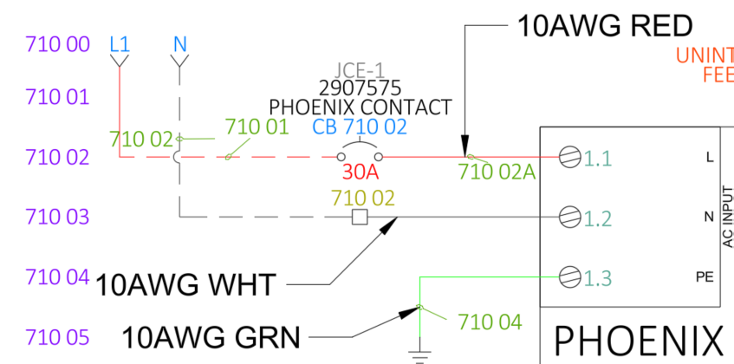

***Figure 3: Wire Type Labels***

1. Power Schematics
   1. 3-Phase AC system inputs (700 series pages) are denoted on rung 00 and denoted by source arrows labeled Line Neutral and Ground.
   2. The AC system input supplies power to devices such as circuit breakers, terminal blocks, UPSs, power supplies, distribution blocks, and surge protectors, which are located on rung 02 of the respective pages.
   3. All subsequent devices related to AC power distribution will be evenly spaced to prevent cluttering.
   4. Grounds are represented by the universal ground symbol and indicate a termination to a grounding mechanism within the panel, such as a ground bar or grounding terminals.

These standards are depicted within **Figure 4** Below.

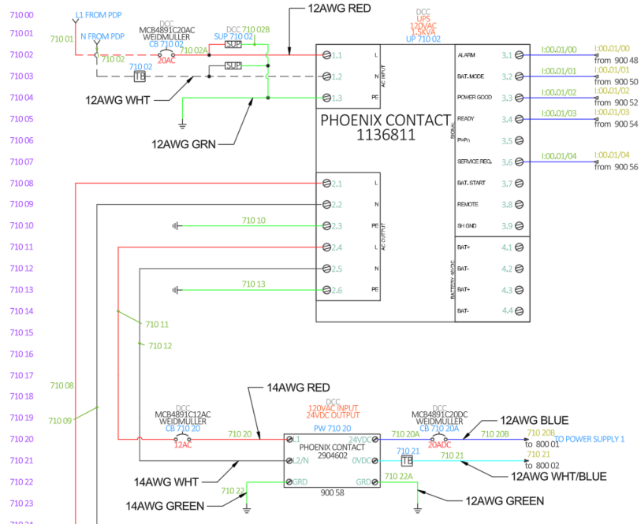

***Figure 4: Power Schematic Set-up***

## Control Power Schematics

## All control source inputs for the 800 series pages are indicated by destination arrows, usually originating from the power schematic 700 series pages. These inputs are located on rung 00, and any subsequent source or negative connections appear on the next index lines, such as 800 00, 800 01, 800 02, and so on.

## Major devices in the control circuit, such as power supplies or redundancy modules, are centered on the rungs and display their various connections below the device.

## All control lines, both positive and negative, should be located on the same rung—with positive feeds on the left and negatives on the right. The negative lines will include source arrows to indicate individual branch destinations. All overcurrent protection devices or connections should be placed in line with these branches. Lines not terminated by a terminal block or other specific devices are implied to be connected together using rated connection jumpers.

## A diagram example for control power can be observed below within Figure 5.

## 

***Figure 5: Control Power Schematic Set-up***

## PLC Schematics

## All PLC schematics begin on the 900 series pages. Each set of rungs should house no more than three individual PLC logic controllers, PLC distribution devices, or PLC cards. Each page contains two rung sets: 00–44 and 45–89. When starting a new PLC, the first logic controller or distribution block should be placed on the left side of rungs 00–44, with the first card located on rung 03. The next two devices can be placed in any order.

## For input and output cards, the first PLC in the first set of rungs should also be located on rung 03. If space permits a second card, it should be placed on rung 23. If I/O cards are in the second rung set, the first card should be on rung 48 and the second on rung 68.

## All I/O cards should be arranged in sequential order—from top to bottom and left to right—starting with I/O 1 for each new card.

## If a new PLC is introduced, the new set of cards should jump to the next base 10 page. For example, if seven I/O cards and a logic controller make up one PLC and are located on pages 900–904, then the next PLC stack will start on page 910, following the same standard setup.

## All card inputs and outputs should be spaced by 0.5 inches to ensure that devices fall on unique rung numbers.

## Input PLC cards will have their terminals and connections facing from right to left, with terminal blocks and components serving as the intersection point. The positive power will run from top to bottom on the left-hand side, and the negative power will run from top to bottom on the right-hand side.

* 1. Output PLC cards will have their terminals and connections facing from left to right, with terminal blocks and components serving as the intersection point. The negative power will run from top to bottom on the left-hand side, and the positive power will run from top to bottom on the right-hand side.

PLC standards example can be observed below within **Figure 6.**

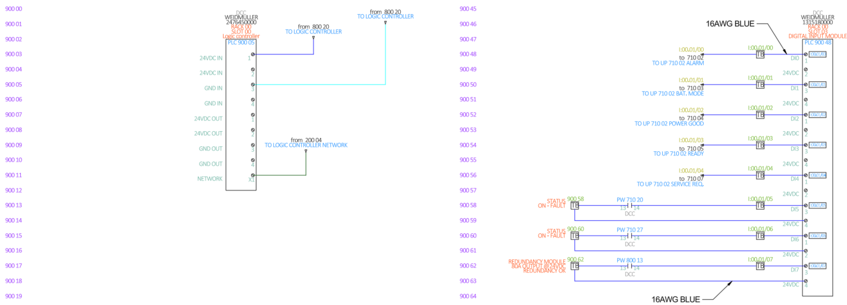

***Figure 6: PLC Schematic Example***

1. Panel Design
   1. Series 500 pages contain job-specific rack constructions and layouts. Each page includes viewports with description blocks beneath them, stating the panel's name, the viewport's scale, the panel and enclosure part numbers, and the floor plan equivalent symbol.
   2. All panel components will be represented using footprints—highly detailed images of the components' physical appearance. These should be dimensioned according to the manufacturer's specifications to ensure an accurate, to-scale panel design.
   3. Within the viewport, all panel footprints linked to individual schematic parent devices should be placed and designed accordingly. They will follow the same attribute constructions as their parent devices. All devices must be accounted for and placed within the viewport to generate an accurate Bill of Materials (BOM). Spacing between sensitive components and separate branches should be closely monitored and arranged according to UL specifications. Wireways should be placed between components that require electrical connections, with larger wireways used in areas with higher wire traffic. A panel layout example can be seen below in **Figure 7.**
   4. The 600 series pages contain the field wiring details relevant to any wiring to be completed by installation teams, ensuring an easy and coherent installation process. Key plans should be used to show a zoomed-in section of the given panel to demonstrate the field wiring details. These details need to be clearly labeled with all relevant components and wires, along with a description bar stating their functions. A Series 700 example detail can be seen below in **Figure 8.**

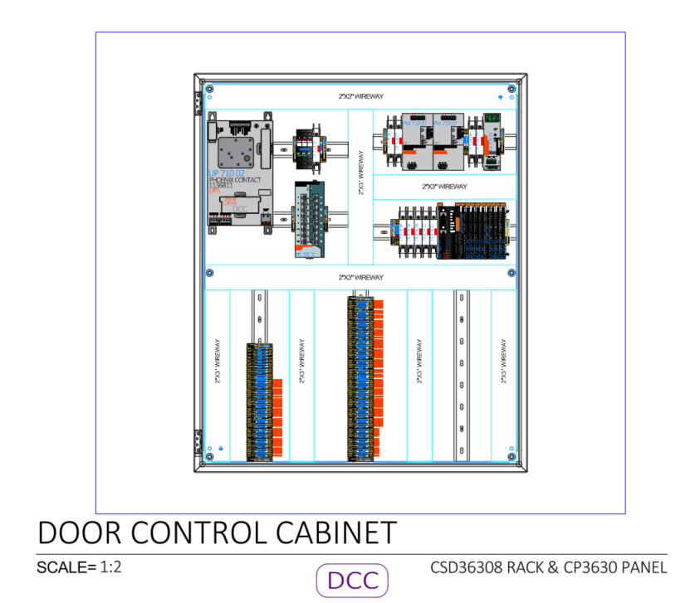

***Figure 7: Panel Layout***

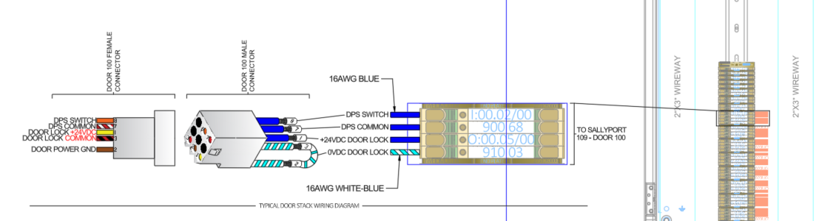

***Figure 8: Field Wire Diagrams***

1. Network One-Lines
   1. Series 200 pages contain all network connections for internet protocol (IP) or TCP communication methods with any given job, this may also include any smaller communication forms like video transmission or universal serial bus (USB). The pages are set up with any network devices such as switches, routers, or hubs located on the right side of the page. All end devices will be located on left half of the page with all relevant ports clearly labeled on each device.
      1. 1 – 64 port network switch per page.
      2. 2 – 32 port network switches per page.
      3. 3 – 16 port network switches per page.
   2. All Pages will have headers located above the devices stating the components’ location in relation to the rest of the system.
   3. For systems that contain control, video, and intercom networks; these networks end devices and their class will be connected to their own individual network switches. For example, Monitors, Controllers, Computers and other such devices would be connected to Switch 1; While intercom processors and Intercoms would be connected to a separate switch 2.
   4. Any device that will have a unique location that’s not specified by its header, will have a floor plan equivalent symbol represented on the top right corner of the device.
   5. 16 port Network switches will have connections spacings of 0.5 inches. 32 and 64 port network switches will have connection spacings of 0.25 inches. All end devices will have connection spacings of 0.5 inches. Viewport scales shall not exceed 1:2 for any network drawing.

A detailed Network drawing can be observed below within **Figure 9.**

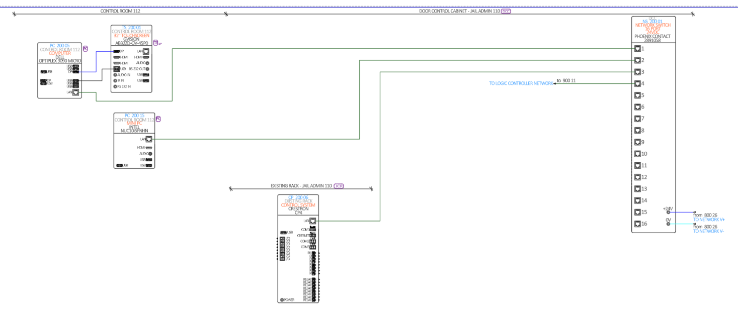

***Figure 9: Typical Network One-Line Diagram***

1. Intercom One-Line Diagrams
   1. The intercom one-line diagrams are located on Series 300 pages. To ensure unique device component tags, place the connectors in these diagrams 0.5 inches apart.
   2. All devices should include a header stating the device's location.
   3. Position the processor or main equipment on rung number 01 to ensure that each speaker or intercom is indexed starting from 1.
2. Video Surveillance One-Line Diagrams
   1. If there isn't enough space to include video surveillance equipment on the network pages, all such equipment should be cross-referenced onto Series 400 pages.
   2. Place network switches on rung number 01 to ensure that each end device is indexed starting from 1.
   3. All rung numbers are to be viewport frozen for these pages.
   4. To prevent overlapping of ports from network pages, any previously used ports or devices from the network pages should be hidden or displayed in different colors.

## - Floor Plan Standards

1. Door controls
   1. All Door locks and contacts on the floor plans will be footprints that link to the parent and child devices from the 900 series schematics.
   2. These devices will be place on a job number JAIL CONTROL Purple layer “102675 JAIL CONTROL”.
   3. Attempt to keep all door control floor plans on page 100-110
2. Intercom
   1. All Intercoms and speakers on the floor plans will be footprints that link to the parent and child devices from the 300 series schematics.
   2. These devices will be place on a job number INTERCOM Blue layer “102675 INTERCOM”.
   3. Attempt to keep all door control floor plans on page 110-120
3. Video Surveillance
   1. All cameras and relevant devices on the floor plans will be footprints that link to the parent and child devices from the 400 series schematics.
   2. These devices will be place on a job number VIDEO SURVEILLANCE Magenta layer “102675 VIDEO SURVEILLANCE”.
   3. Attempt to keep all door control floor plans on page 120-130.

## - Drawing Scale

ECC standard scales for floor plan layouts are:

1/16” = 1’-0”

3/32” = 1’-0”

1/8” = 1’-0”

Ensure graphical scale, title block scale, and viewport scale are the same.

ECC standard scale for details is:

1:8

If floor plans are not shown on sheet, graphical scale will be removed. There may be sheets where a scale is not used at all. Indicate this with NTS in the title block.

## - Key Plans

Key plans are to be used if the entire floor plan is not shown on the page. Show the area of work with a magenta-colored hatch-filled polyline that represents the boundaries of the viewport. When the head-end location is on a different level, outside of the area of work, an additional key plan would be used on the first sheet of the drawing. Show the head-end location(s) with a leader pointing to the specific room. If the floor plans are split into multiple areas and utilize match lines, the match lines shall also be shown on the key plan with 1/8” text identifying the area. When creating a key plan, isolate the floor plan layer and copy entire floor plan to the side. Scale the entire copied floor plan down to .001. Cut and paste the scaled floor plan as a block on the desired sheet. Key plans should not be created by using a viewport.

## - Match Lines

Match lines are used to denote a cut line between two or more areas. Text is placed around the outside edge of the match line to indicate the area to be matched. Match lines are to be on their own layer, using hidden line type, 0.5 thickness, 1/8” paper text height.

## - Text Sizing

Text size is dictated by drawing scale. ECC standard text sizes are 1/16”, 3/32”, and 1/8”. Based on the drawing scale:

|  |  |  |  |  |  |
| --- | --- | --- | --- | --- | --- |
| 1/8” = 1’-0” | | 3/32” = 1’0” | | 1/16” = 1’-0” | |
| Paper | Model | Paper | Model | Paper | Model |
| 1/8” | 12” | 1/8” | 16” | 1/8” | 24” |
| 3/32” | 9” | 3/32” | 12” | 3/32” | 18” |
| 1/16” | 6” | 1/16” | 9” | 1/16” | 12” |

## - Text Styles

ECC uses text style “standard” for all text, excluding: floor plan, detail, and key plan headings which uses “style 1”. These styles are to be used for all text in a given ACADE project to ensure smooth integration with field wires object character recognition.

*Standard = Microsoft Yi Baiti Style 1 = Calibri Light*

## - Layer Creation / Naming

ECC Standard layers are created from the drawing clean-up / TRANS command. Additional standard layers can be brought into the drawing by using the command MYLAYER. Refer to section 2.13 for ECC Standard Layers. Additional layers for symbols, notes, cabling, etc. shall be formatted with the project number followed by the type of system. System type is not to be abbreviated in layer names. (*Ex. 100336 JAIL CONTROL).*

## - System Layer Colors

ECC defined layer colors are to be used when possible. Existing system layer colors shall not be similar to new system layer colors. Existing system device attribute should stay consistent with existing system symbol color. Refer to section 2.13 for ECC Standard Layers.

## - ECC Standard Layers

|  |  |  |
| --- | --- | --- |
| Layer Name | Layer Color and ACI | Notes |
| Jail Control | Purple - 204 |  |
| Area of Work | Magenta - 6 | Hidden line type, 0.5 line weight  If system color is Magenta, use Green - 3 |
| -Audio | Red - 1 |  |
| Audio-Visual | Blue - 5 |  |
| Ceiling | Grey – 9 |  |
| -Control | Purple – 204 |  |
| -Data | Orange Brown - 34 |  |
| Defpoints | Cyan - 5 | Defpoints should **never** be frozen or  turned off |
| DESC | Blue - 150 | Component Tags |
| DESCCHILD | Orange - 20 | Description of Components |
| Door Tag | Dark Brown – 46 | Color can be changed depending on  project situation |
| --Drafting Notes | Magenta - 6 |  |
| Floor Plan | Brown – 23 |  |
| Furniture | Light Brown - 42 |  |
| Intercom | Blue – 5 |  |
| LOC | Grey - 8 | Location Indicator |
| Match line | Black (White) - 7 | Hidden line type, 0.5 line weight |
| Misc | Grey – 253 |  |
| -Network | Green – 96 |  |
| Paging / Public Address | Blue – 5 |  |
| Rev Cloud# | Orange – 30 |  |
| Room Tag | Dark Brown – 46 | 9” typically |
| Rung Numbers | Purple - 190 |  |
| Security | Purple – 204 |  |
| Sheet Notes | Black (White) - 7 |  |
| Sound | Blue – 5 |  |
| -Video | Blue – 5 |  |
| Viewports | Blue – 5 | No Plot |
| Video Surveillance | Magenta - 6 |  |

# MODEL AND PAPER SPACE CONSIDERATIONS

## - Model Space

Floor plans, notes associated with floor plans, one-line diagrams, and plate details should be in model space. Draw a boundary around anything other than the floor plans to ensure these items are easily located. Doing this ensures all pertinent project information is in one place and can be easily copied for future projects.

## - Paper Space

Device/cable legends, details, general/sheet notes, key plan, site plan, title block should be in paper space.

# LEGENDS / DETAILS / BLOCKS / NOTES

## - Device Legend

Utilize tool palette blocks to create the device legend. This includes the top and bottom legend headings. Legends should flow consistently with head-end devices at the top and like symbols grouped together. All device symbols being shown on the floor plans must be shown in the legend. If utilizing an area of work border/outline, only the devices that are inside of the area of work need to be in the legend. Existing re-installed/relocated legend items need to be grouped together below any new equipment utilizing a blank legend box and a re- installed/relocated heading box. Existing legend items use the same format as re-installed/relocated and are the last grouped legend items. Legend blocks should utilize the standard system layers without referencing project numbers.

## - Cable Legend

Utilize tool palette blocks to create the cable legend. This includes the top and bottom legend headings. Cable legends should flow alphabetically based on cable letter designation.

## - Details

ECC utilizes standard details in all drawings when applicable. These standard details are found in the tool palette in AutoCAD. Additional ECC details can be found by using the AWWT program, also found in AutoCAD. Search AWWT to ensure that the most updated details are being used on new drawings. Detail heading text size shall always be 1/8” and style 1 text. When working on a fire alarm project, use lisp command *IB* to pull in details associated with legend blocks. Detail blocks should utilize the standard system layers without referencing project numbers.

## - Standard Block Structure

ECC standard blocks shall be uniform and consistent. The blocks need to have proper connection types shown as well as connection points. Connection points shall be spaced at a minimum of 3/16”. Device model numbers shall be *Style 1* text style utilizing 3/32” text and connection call outs shall be *Standard* text style utilizing 1/16” text.

# VIEWPORTS / SHEET SIZES

## - Types of Viewports (Regular Vs Polygonal)

Viewports are generally rectangular, however in certain situations a polygonal viewport will be required. Polygonal viewports will be useful when floor plans are irregular to utilize sheet space effectively.

## - Scaling A Viewport

Depending on the content in the viewport, the scale will vary. Floor plan viewports must match the identified scale in the title block and the scale bar accordingly. One-line viewports will typically be scaled at 1:1. The scale bar will not be present and the identified scale in the title block shall read NTS. Rack layout viewports and speaker rigging viewports will be scaled at 1:8. The scale of rack viewports or speaker rigging viewports is not indicated in the title block. Plate detail viewports will typically be scaled at 1:1. If the plate detail is too large to fit on a standard sheet with 1:1 scale, the scale can be set at 1:2, but no smaller. The scale bar will not be present and the identified scale in the title block is dictated by content on sheet. Floor plan viewports take precedence in the identified scale in the title block and scale bar, if present.

## - Multiple Viewports – Key Plan Layout

If multiple viewports for a single level are required on a sheet, they must be identified with a key plan. The viewport layer should be changed to 0. A line should also connect the viewport to the hatch of the key plan. If multiple levels are to be shown on the same sheet, each viewport boundary must have a corresponding key plan with indication of level in heading.

## - Standard Sheet Sizes

ECC standard page sizes include:

(Arch B) – 11 x 17

(Arch C) – 18 x 24

(Arch D) – 24 x 36

(Arch E) – 30 x 42

# POST-ENGINEERING REVIEW

## - Drafter Check (Detail Size, Layout Changes, Etc.)

Upon completion of project, the drafter will perform a high-level review to ensure the drawing meets ECC’s CAD standards. Some of the common standards to verify include: text sizes, proper layer usage, complete and accurate legends, consistent line breaks, etc.

## - Saving to Q360

After drafter check of CAD standards, drafter to print drawing to PDF format. PDF should be saved in project’s *DOCUMENTS* folder in Autodesk Docs. PDF should be named in a specific format which identifies the project number, the system abbreviation, followed by drawing. *(Ex. 100456 SR DRAWING).* PDF then must be uploaded to the documents tab of corresponding project in Q360. The category of *Engineering* and sub category of *Drawings* must be selected.

## - Uploading to Fieldwire

Upload the pdf to the corresponding system folder inside the Fieldwire project (To create PDF see 9.2). Once the PDF has been uploaded and processed, select all pages and run the “*Scan number/description*” action under the Actions pull down. Resize the Description and Page Number boxes to ONLY highlight the “Area” and “Sheet Number” information on the page. Be sure to expand the Description box large enough to encompass possible longer “Area” descriptions on the proceeding pages. Confirm Fieldwire has scanned the information correctly. If Tasks are required on the project, please refer to page 9 of the “*Fieldwire Operational Procedures Document*” located in the “*PAGE LAYOUT-HELP DOCS”* Tool palette. Once PDFs are uploaded and/or Tasks are created, go to settings and turn on both Notification settings for “Send email when tasks are created or updated” and “Send email when plans have a new version or markups”.

# REVISIONS

## - Drawing Changes

Revisions are changes to the drawing after initial engineering is complete. These typically happen after a project has been submitted. Drawing revisions ensure that the drawings are as accurate and up to date as possible.

When a revision is issued, the project title block shall indicate the revision number and date completed. The drafting technician and system engineer work collaboratively to issue these drawing changes.

## - Revision Annotation

Creating these drawing changes requires indication of such change. All changes need to be clearly shown within the ACADE title block.

## - Saving to Q360

Drafter to print drawing to PDF format. PDF should be saved in project’s *DOCUMENTS* folder in Autodesk Docs. PDF should be named in a specific format which identifies the project number, the system abbreviation, followed by drawing and REV number*. (Ex. 100456 SR DRAWING – REV.1).* PDF then must be uploaded to the documents tab of corresponding project in Q360. The category of *Engineering* and sub category of *Drawings* must be selected.

## - Uploading to Fieldwire

Upload the pdf to the corresponding system folder inside the Fieldwire project (To create PDF see 10.3). Once the PDF has been uploaded resolve the sheet version conflict to upload the PDF as a new version. If Fieldwire doesn’t recognize the sheet numbers, select all pages and run the “*Scan number/description*” action under the Actions pull down. Resize the Description and Page Number boxes to ONLY highlight the “Area” and “Sheet Number” information on the page. Be sure to expand the Description box large enough to encompass possible longer “Area” descriptions on the proceeding pages. Confirm each page as new version. If the project has Tasks, the engineer will update any device task changes.

# XREFS

## - When to Create XREF

XREFs should be created when multiple system types and/or projects need to be shown on a centralized drawing, or for linking a singular floor plan to the sequential 100 series pages. Creating the XREF simplifies floor plan changes and ensures that once as-builts are complete, system changes are accurately reflected on previous and future projects. ECC utilizes project and site XREFs, thus it is important to determine the correct type needed for each project.

## - Project XREF

Project XREFs are used when a new site has multiple systems being installed at the same time. The project XREF is created during the initial drafting phase. Project XREFs will turn into site XREFs after three or more projects have been added to the site. Using an existing project XREF should only be done if the previous projects have the as-built changes complete.

## - XREF Considerations

When working with XREFs, there are several considerations to keep in mind. Before an XREF is created, it should be verified that an existing XREF for this site does not exist. When creating an XREF from scratch, the drawing needs to be saved with the site name followed by XREF. *(Ex. TERMINAL BUILDING XREF).* Best practice on site XREFs would be to create page layouts that encompass the entire site’s floor plans. These page layouts as well as the title block page number should be named XREF and the page number associated with it. *(Ex. XREF-1, XREF- 2).* There should be no reference to existing device call outs, revision clouds, area of work call outs, etc. in an XREF. These annotations need to be located in their respective drawing.

## - Changes to Existing XREF

When a project requires an existing XREF be utilized, before any changes are made, a copy of the XREF needs to be created and placed into “OLD XREFS” folder. There needs to be a sub folder created within “OLD XREFS” which should be named using the last project number and the date of the copy. *(Ex. 100429 – 09-16-21).* Utilize the layer properties manager to determine the last project number.

# AS-BUILTS

## - Drawing Changes

As-builts from field changes shall be updated on the project drawing. Drafting will scan all marked up as-builts to the project sub-folder on server. This sub-folder will need to be created in the main project folder labeled “SCANNED AS-BUILTS”. Drafting will update drawing per as-built changes. When an as-built is complete, the project title block shall indicate the completion date. System engineer will review drawing changes for accuracy. Once reviewed, if project is a site XREF, bind and insert the XREF into the drawing. Once bound, a 1/8” (sizes C, D, & E) or a 3/32” (size 11x17) note on DEFPOINTS layer shall be placed under the most recent as-built date on the first page. The note shall read “XREF BINDED”

## - As-Built Standard Practices

***Standard practices for as-built process will be forthcoming.

## - Saving to Q360

Drafter to print drawing to PDF format. PDF should be saved in project documents folder on the server. PDF should be named in a specific format which identifies the project number, the system abbreviation, followed by as-built drawing. *(Ex. 100456 SR AS-BUILT DRAWING).* PDF then must be uploaded to the documents tab of corresponding project in Q360. The category of *Engineering* and sub category of *As-Builts* must be selected.

# FOLDER ORGANIZATION

## - Project Folder Structure & Naming

At the onset of a project, the project folder needs to be created utilizing the project number and name. *(Ex. 100889 ENGLEWOOD MEDICAL BUILDING).* If multiple projects are linked to the same site, the project folder will consist of all projects linked. *(Ex. 100781 – 100782 – 100783 BLUE VALLEY NORTHWEST HIGH SCHOOL).* Sub folders are created for project specific files. These folders should only be created when needed and no folders should be left empty. Standard ECC folders consist of *“ADDENDUMS, AE CAD, AE PDF, DOCUMENTS, SCANNED AE PDF, SCANNED AS-BUILTS, AND SPECS”.* The documents sub folder should stay as organized as possible by creating additional folders for items such as site pictures, battery calcs, etc. The relevant CAD file should be the only item left outside of a sub folder.

# ABBREVIATIONS

|  |  |  |  |
| --- | --- | --- | --- |
| Abbreviation | Definition | Abbreviation | Definition |
| AC | Access Control | PE | Professional Engineer |
| ACC | Access Control Cabinet | PM | Project Manager |
| ACI | AutoCAD Color Index | Q360 | Solutions 360 |
| A/E | Architect - Engineer | REV | Revision |
| AFF | Above Finish Floor | RTLS | Real Time Locating System (IR Tracking) |
| AHJ | Authority Having Jurisdiction | SC | Structured Cabling |
| AHU | Air Handling Unit | SDR | Sound Rack |
| ANN | Annunciator | SM | Sound Masking |
| AR | Area of Rescue/Refuge | SOW | Scope of Work |
| AV | Audio Visual | SR | Sound Reinforcement |
| AWWT | And Where Was That?  (CAD Program) | SS | Security |
| BDA | Bi-Directional Antenna | STE | Suite |
| BP | Button Panel | TSM | Technical Service Manager |
| CAC | Cellular Alarm  Communicator | TE | Telephone Entry |
| CB | Code Blue | VS | Video Surveillance |
| CD | Candela | XREF | External Reference |
| CCO | Customer Change Order |  |  |
| CL | Clock |  |  |
| CS | Cable System |  |  |
| DAS | Distributed Antenna System |  |  |
| DE | Door Entry |  |  |
| DOAS | Direct Outside Air Supply |  |  |
| DPS | Door Position Switch |  |  |
| EOL | End of Line / End of Life |  |  |
| ER | ERRCS – Emergency Responder Radio Coverage  System (BDA, DAS) |  |  |
| FA | Fire Alarm |  |  |
| FAA | Fire Alarm Annunciator |  |  |
| FACP | Fire Alarm Control Panel |  |  |
| FM | Fire Marshal |  |  |
| GF | General Foreman |  |  |
| IC | Intercom |  |  |
| ICO | Internal Change Order |  |  |
| IS | Infant Security |  |  |
| JC | Jail Control |  |  |
| KP | Keypad |  |  |
| MUA | Make-up Air Unit |  |  |
| NAC | Notification Appliance  Circuit |  |  |
| NC | Nurse Call |  |  |
| NTS | Not to Scale |  |  |
| PA | Public Address |  |  |
| PB | Push Button |  |  |
| PC | Project Coordinator |  |  |

|  |  |  |  |
| --- | --- | --- | --- |
| Abbreviation | Definition | Abbreviation | Definition |
| **Sales** | | **Project Management** | |
| AJG | Anthony Goana | AB | Andrew Bolin (LN) |
| CSC | Craig Copas | JB | Janna Baker (LN) |
| DL | Dalton Lane | JM | Jason Monroe (LN) |
| DDT | Dan Throener | JMB | Joe Bullock (LN) |
| DSB | Dan Balsinger | TG | Taylor Graham (LN) |
| GJS | Greg Scott | JK | Joseph Keeton (OM) |
| JKA | Jan Aden | LE | Laura Evans (OM) |
| JWJ | Jere Jimerson | MB | Melissa Birkel (OM) |
| JPH | John Hanrahan | TB | Tia Barr (KC) |
| KAL | Katrina Larson | JS | Janet Seacreas (KC) |
| GLH | Logan Hinnant | CB | Craig Betzen (WI) |
| MBA | Mark Allen | LL | Leah Logan (WI) |
| MPE | Michael Eager | DH | Dean Hinnant (SP) |
| NLH | Nick Hutton | SR | Spencer Rotton (SP) |
| SW | Shane Warren |  |  |
| SEL | Scott Lord |  |  |
| SF | Steve Franks |  |  |
| WAT | Wil Toler |  |  |
|  |  |  |  |
| **Estimating** | | **Technical Service Manager (TSM)** | |
| KC ECC | Kansas City House Account | Lincoln | Donna Urbanec |
| LN ECC | Lincoln House Account | Omaha | Joel Stolley |
| OM ECC | Omaha House Account | Kansas City | Greg Pippin |
| SP ECC | Springfield House Account | Springfield | Steven Wood |
| WI ECC | Wichita House Account | Wichita | Craig Betzen |
|  |  |  |  |
| **Engineering** | | **Programming** | |
| AVDL | AV Design Labs | JJ | Justin Jiskra |
| BRO | Brad Oberg | JS | Jeremy Skeels |
| BG | Brett Graverholt | KR | Kyle Robinson |
| CLC | Carrie Chartier | MK | Matt Kubes |
| CMJ | Chase Jacobson | TH | Thomas Huber |
| DB | Darwin Brandt | BS | Benjamin Stalker |
| JBW | Jarrod Workman |  |  |
| RDT | Rory Thelen |  |  |
| RC | Ryan Chab |  |  |
| TCS | Tim Steinhauer |  |  |
| GD | Gregory DuBuque |  |  |
| TC | Trenton Cathcart |  |  |

# LISP DEFINITIONS / COMMANDS

|  |  |
| --- | --- |
| **Layer Commands** | |
| Command | Function |
| ABD | Places selected objects on “AS-BUILT DELETED” layer |
| ASB | Adds the layer “AS-BUILT DELETED” |
| AOW | Adds the layer “AREA OF WORK” |
| AUDIO | Creates all one-line cable layers for audio-visual projects |
| FIRE | Changes all XREF layers associated with fire alarm to the color (5) blue |
| LAYAV | Thaws/turns on all audio-visual layers (including XREF layers) and turns off all other  system layers |
| LAYCL | Thaws/turns on all clock layers (including XREF layers) and turns off all other system  layers |
| LAYF | Thaws/turns on all fire alarm layers (including XREF layers) and turns off all other  system layers |
| LAYIR | Thaws/turns on all IR tracking layers (including XREF layers) and turns off all other  system layers |
| LAYNC | Thaws/turns on all nurse call layers (including XREF layers) and turns off all other  system layers |
| LAYP | Thaws/turns on all paging/intercom layers (including XREF layers) and turns off all  other system layers |
| ML | Adds the layer “MATCH LINE” |
| MYLAYER | Creates all ECC default layers |
| NURSE | Changes all XREF layers associated with nurse call to the color (3) lime green |
| SOUND | Changes all XREF layers associated with sound/intercom/paging to the color (4) cyan |
| THAW | Thaws/turns on all layers (except frozen AE, As-built, or grid line layers) |
| TRANS | Translates AE layers to ECC default layers |
|  |  |
|  |  |
| **Object Layer Commands (typically set up as keyboard macros)** | |
| Command | Function |
| AECLOCK | Changes selected objects to AE CLOCK layer |
| AEFIREALARM | Changes selected objects to AE FIRE ALARM layer |
| AENURSECALL | Changes selected objects to AE NURSE CALL layer |
| AESECURITY | Changes selected objects to AE SECURITY layer |
| AESOUND | Changes selected objects to AE SOUND layer |
| CELING1 | Changes selected objects to CEILING layer |
| CLOCK1 | Changes selected objects to CLOCK layer |
| FLOORPLAN1 | Changes selected objects to FLOOR PLAN layer |
| FURNITURE1 | Changes selected objects to FURNITURE layer |
| MISC1 | Changes selected objects to MISC layer |
| NURSECALL1 | Changes selected objects to NURSE CALL layer |
| REVCLOUD1 | Changes selected objects to REV CLOUD layer |
| ROOMTAG1 | Changes selected objects to ROOM TAG layer |
| ZERO | Changes selected objects to “0” (zero) layer |
|  |  |
|  |  |
|  |  |
|  |  |
|  |  |

|  |  |
| --- | --- |
| **Audio-Visual Specific Object Layer Commands (typically set up as keyboard macros)** | |
| Command | Function |
| AUDIO1 | Changes the selected objects to -AUDIO layer |
| CONTROL1 | Changes the selected objects to the -CONTROL layer |
| DATA1 | Changes the selected objects to the -DATA layer |
| NETWORK1 | Changes the selected objects to the -NETWORK layer |
| VIDEO1 | Changes the selected objects to the -VIDEO layer |
|  |  |
| **Object Edits, Object Creation, Object Property Commands** | |
| Command | Function |
| ATTCOLOR | Changes attributes color by clicking on each attribute |
| BRKLH | Breaks horizontal lines with a 1/16” gap |
| BRKLH6 | Breaks horizontal lines with a 6” gap |
| BRKLH32 | Breaks horizontal lines with a 3/32” gap |
| BRKLV | Breaks vertical lines with a 1/16” gap |
| BRKLV6 | Breaks vertical lines with a 6” gap |
| BRKLV32 | Breaks vertical lines with a 3/32” gap |
| DDCHTEXT | Change attribute properties |
| IB | Insert fire alarm, nurse call, or audio-visual details from a legend block |
| INCATT | Numbers the devices in sequential order using a blocks attribute. Used to address  devices or change cable labels in sequential order |
| R4 | Creates a polyline that will fillet the corners of the lines with a specified radius |
| TEXTMC | Text command that center aligns the text with predefined text height that is specified (STANDARD text style) – Used typically for one-line cables / floor plan cable  labels |
| TEXTMC1 | Text command that center aligns the text with predefined text height that is specified (STYLE1 text style) – Used typically for floor plan / detail headings / and  one-line block headings. |
| TLEN | Calculates the total length of selected polylines. |
| XRR | Reloads XREF(s) and reconciles the layer |
|  |  |
| **Page Layout Commands** | |
| Command | Function |
| GATTE2 | Changes title block attributes by selecting certain page layouts |
| QVLAYOUT | View all page layout tabs at once |
| TABSORT | Re-orders tabs alphabetically |
| VPF | Freezes viewport layers per system |
| ZEA | Zoom extents all page layouts, purges blocks and layers, and saves drawing |
| **Helpful Commands / Tips & Tricks Commands** | |
| Command | Function |
| ATTREQ | Turns off attribute box when inserting a block from the tool palette |
| ATTSYNC | Updates block attributes |
| AUDIT | Fixes drawing errors |
| BATTMAN | Allows user to re-order attributes |
| COMPARE | Compare differences between 2 drawings |
| CTRL + R | Cycles between view ports |
| LAYER | Freeze or thaw a specific layer. Type LAYER (enter) F (for freeze) (enter) *FIRE  ALARM* (layer name) (enter twice) |
| PEDITACCEPT | Removes “Do you want to make a poly line” from PEDIT command |
| TCASE | Changes text objects to be all uppercase, lowercase, title case, or sentence case |
| TEXTALIGN | Aligns different text in a line |

|  |  |
| --- | --- |
| TEXTALLCAPS | Forces CAD to utilize all CAPS (except attribute editor) |
| TJUST | Sets justification of any selected DTEXT or MTEXT without moving text object |
| TORIENT | Makes un-readable text, more readable |
| USCDETECT | Fixes curser jumpiness |
| VPLAYER | Freeze or thaw a specific layer in current or all viewports. Type VPLAYER (enter) F (for  freeze) (enter) *FIRE ALARM*(layer name) C (C for current, A for all) (enter twice) |
|  |  |
|  |  |
| Hold CTRL and double click on an attribute to change that specific attribute | |
| If text mask doesn’t work – ALT+SHIFT+A and then PICKSTYLE=1 | |
| For line types (hidden/dash/etc) to view correctly by scale – change the following variables:  MSLTSCALE=1, PSLTSCALE=1, LTSCALE=1 | |
|  |  |
|  |  |
|  |  |

# APPENDIX DRAWINGS

Appendix drawings will be forthcoming in a future revision.

x„ }w~—|‚qzxƒ|“s€}w~—|‚qzxƒ|{~|t}xtqqr|tqxq|…|¹q|zvqr|r|xvsz{~ˆqˆtsz{qr|{ws}~z qr|‡~‚Ž„s€qr|}w~—|‚qzxƒ|stxw{|wqrxzqr||zqsw|t}x‚|‚rxz{|qr|q|¹qysvqrysqrszqr| xqqws‡ˆq||vsq~w„

‡„ }w~—|‚qxvvw|tt“}w |tt„~ˆ‚xz€szvqr|vvw|ttszº”•Œ„xy~zt„€~w|¹xƒ}|¸tqw||q…x»|zˆ|…‡~ˆ|»xwv…z~wqr…t~ˆqr…|q‚„qr|xvvw|ttƒˆtq

‡|x}rts‚xxvvw|tt„xvvw|tt‚xzz~q‡|stq|vxtx‚w~tttqw||q„

‚„ ‚sq…tqxq|“yr|w|qr|}w~—|‚qst~‚xq|vsz„

v„ ttq|ƒq}|“xyxtq}|~ˆqqr|ttq|ƒ…v~z~qx‡‡w|»sxq|„

|„ xw|x“ˆvƒxq‚rqr|€~~w}xzr|xvsz{~zqr|}x{|~wtqxq|yrxqst‡|sz{tr~yz~z qr|}x{|„stqx€~~w}xzts€ƒˆqs}|xw|tr~yz~zqr|}x{|„stqqr|~y|w|»|€swtqyr|z

stqsz{qr|ƒ„

€„ vwxysz{t‚x|“vwxysz{t‚x|tr~ˆvƒxq‚rqr|t‚x|~€qr|»s|y}~wq„ “s€‚~zq|zqt~zqr|}x{|v~z~qrx»|xt}|‚s€s‚t‚x|…}ˆqzqt„ “s€‚~zq|zqt~zqr|}x{|rx»|ƒˆqs}|»s|y}~wqt‚x|tqrxqxw|vs€€|w|zq…}ˆqxtz~q|v„|x‚r

»s|y}~wqysqr|zz||vq~rx»|xt‚x|stq|vˆzv|w|x‚rr|xvsz{„

{„ vxq|“|zq|wqr|vxq|yr|z|z{sz||wsz{†vwx€qsz{rxt‡||z‚~ƒ}|q|„xyxttr~y vxq|¹¹†¹¹†¹¹¹¹ r„ vwxyz‡“szsqsxt~€qr|vwx€q|wyr~y~wŽ|v~zqr|}w~—|‚q

s„ tx|t“szsqsxt~€qr|tx|t}|wt~zyr~t~vqr|}w~—|‚q

—„ |z{‡“szsqsxt~€qr||z{sz||w~zqr|}w~—|‚q„

Ž„ }w~{‡“szsqsxt~€qr|}w~{wxƒƒ|w~zqr|}w~—|‚q„s€z~}w~{wxƒƒ|wststq|v}ˆqz†x„

„ }ƒ“szsqsxt~€qr|}w~—|‚qƒxzx{|w„ ƒ„ }‚“szsqsxt~€qr|}w~—|‚q‚~~wvszxq~w„

z„ w|»sts~zt“yr|zqr|w|xw|w|»sts~zt~zx}w~—|‚qtqxq|yrs‚rw|»sts~zzˆƒ‡|wsqst€~~y|v‡ qr|vxq|„

~„ }w~—|‚qzˆƒ‡|w“s€ƒ~w|qrxz}w~—|‚qzˆƒ‡|wst~zxvwxysz{tr~y ‡~qr—~‡zˆƒ‡|wtxzv xv—ˆtqqr|q|¹qysvqr„

}„