Here’s the information I’d collect before building the website:
Company Logo
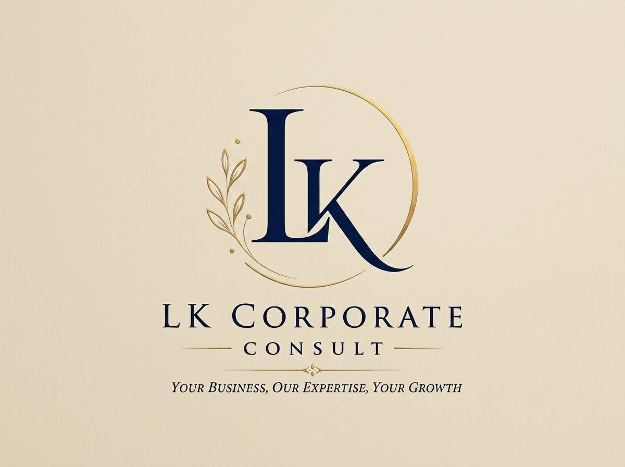
About LK Corporate Consult
LK Corporate Consult is a Nigerian corporate and legal consultancy firm registered with the Corporate Affairs Commission (CAC). Formerly known as Sparkle Legal Consult, the firm has evolved into LK Corporate Consult with a renewed focus on providing professional, efficient and client-focused corporate, legal and business advisory services.
With experience in over 200 business registrations and post-incorporation applications, we assist entrepreneurs, companies, organisations and investors with the legal and regulatory processes required to establish, maintain and grow their businesses in Nigeria.
Our approach is centred on providing practical, reliable and timely solutions. We simplify complex regulatory and corporate processes and guide our clients through each stage with professionalism and attention to detail.
Our Services
1. Registration of Legal Entities
We assist clients with the establishment and registration of various forms of legal entities, including:
- Business Name Registration
- Company Registration
- Non-Governmental Organisation (NGO) Registration
We provide guidance on the appropriate structure for your business and assist with the registration process from commencement to completion.
2. Post-Incorporation Services
Our post-incorporation services help businesses remain properly structured and compliant with their statutory obligations. These include:
- CAC Annual Returns Filing
- Change of Company/Business Name
- Change of Directors
- Change of Shareholders
- Change of Persons with Significant Control (PSC)
- Increase and Reduction of Share Capital
- Transfer of Shares
- Certified True Copies (CTC) of Corporate Documents
- Upgrade from Business Name to Company
- Other CAC post-incorporation applications and amendments
3. Intellectual Property Registration
We assist individuals, businesses and organisations in protecting their intellectual property and proprietary interests through:
- Trademark Registration
- Copyright Registration
- Patent Registration
Our services are designed to help clients protect their brands, creative works, inventions and other intellectual property assets.
4. SCUML Registration
We provide assistance with Special Control Unit Against Money Laundering (SCUML) registration and related compliance requirements for businesses within the applicable regulated sectors.
5. Export Licence Registration
We assist businesses seeking to participate in international trade with the registration and documentation required for applicable export licences and regulatory approvals.
6. Legal Consultation
We provide legal consultation and advisory services to individuals, entrepreneurs, companies and organisations on a range of corporate, commercial and regulatory matters.
Our objective is to help clients understand their legal obligations, manage risks and make informed business decisions.
7. Business Consultation
Beyond legal services, LK Corporate Consult provides business advisory support to entrepreneurs and companies seeking to establish, structure and develop their businesses.
We assist clients in navigating relevant registration, regulatory and operational requirements while providing practical guidance suited to their business objectives.
8. Other Corporate & Business Services
We also provide a range of additional corporate, legal and business support services tailored to the specific needs of our clients.
Why Choose LK Corporate Consult?
At LK Corporate Consult, we understand that starting and running a business involves more than simply registering a company. Businesses must continuously deal with regulatory requirements, corporate changes, documentation and legal obligations.
Our role is to make these processes simpler, clearer and more efficient for our clients.
We are committed to:
- Professionalism
- Integrity
- Efficiency
- Confidentiality
- Attention to Detail
- Client Satisfaction
- Practical and Solution-Driven Advice
With our experience in corporate registrations and post-incorporation matters, we strive to provide services that allow our clients to focus on building and growing their businesses while we handle the relevant corporate and regulatory processes.
Our Mission
To provide accessible, professional and reliable corporate, legal and business advisory services that help individuals and businesses establish, protect, maintain and grow their ventures in Nigeria.
Our Vision
To become a trusted and leading corporate and business consultancy firm recognised for professionalism, efficiency, integrity and client-focused solutions.
Our Commitment
At LK Corporate Consult, every client and business is unique. We therefore take a client-focused approach to every engagement, providing services tailored to the client's specific needs and objectives.
LK Corporate Consult — Simplifying Corporate Compliance. Supporting Business Growth and Creating Business Solutions.
Phone/WhatsApp number: 07034930571
Email address: sparklelegalconsult@gmail.com, lkcorporateconsult@gmail.com
Office address: No 12 Army Post Housing Estate, Kurudu, Abuja, FCT, Nigeria.
Social media links: easyb_withlana (Instagram), http://www.youtube.com/@EasyBitswithLana
Store Link: https://selar.com/m/easybitswithlana
Preferred colours: Navy Blue and Gold

