UNIVERSITY OF RWANDA
COLLEGE OF SCIENCE AND TECHNOLOGY
SCHOOL OF ICT
COMPUTER AND SOFTWARE ENGINEERING DEPARTMENT
NYARUGENGE CAMPUS
MODULE CODE/TITLE: WEB DESIGN
PROJECT TECHNICAL REPORT
WEB TECHNOLOGY TECHNICAL ASSESSMENT 2026
Project: AgriLink — Connecting Farmers with Better Markets

Student Name: | Mumporeze Teta Christa
Registration Number: | 225072339

Table of Contents
Table of Contents 1
Table of Figures 1
List of Abbreviations 1
Chapter 1. Introduction 1
1.1. Historical Background of the Case Study 1
1.2. Problem Statement 1
1.3. Objectives of the Project 1
1.4. Expected Outcomes 1
1.5. Project Rationale (Importance to the Community) 1
Chapter 2. System Analysis and Design 1
2.1. System Analysis 1
2.1.1 Intended Users of the Project 1
2.1.2 Intended System Partners 1
2.2. System Design 1
1. High-Level Architecture 1
2. UI Design (User Flow) and Flowchart 1
3. Database Design with ERD and Relationships 1
Chapter 3. Implementation 1
3.1. Introduction of the Section 1
3.2. Screenshots and Page Discussions 1
Homepage (index.html) 1
About Us Page (about.html) 1
Contact Us Page (contact.html) 1
Join AgriLink Registration Form (form.html) 1
Chapter 4. Conclusion and Recommendation 1
Recommendations 1
To the Lecturer, about technicalities: 1
To the School, about time constraints: 1
To the Partners (owners of the business the app targets), about the app developed: 1
To the User, about training: 1
To the Beneficiaries (customers/farmers), about the new technological tool: 1
Appendix 1

Table of Figures
List of figures appears below. In Word, right-click and choose "Update Field" if figure numbers change after edits.
Figure 1: High-Level System Architecture .......... Chapter 2
Figure 2: User Journey Flowchart .......... Chapter 2
Figure 3: Entity Relationship Diagram (Proposed Database) .......... Chapter 2
Figure 4: AgriLink Homepage .......... Chapter 3
Figure 5: About Us Page .......... Chapter 3
Figure 6: Contact Us Page .......... Chapter 3
Figure 7: Join AgriLink Registration Form .......... Chapter 3

List of Abbreviations
Abbreviation | Meaning
HTML | HyperText Markup Language
CSS | Cascading Style Sheets
JS | JavaScript
UI | User Interface
UX | User Experience
ERD | Entity Relationship Diagram
DOM | Document Object Model
RWF | Rwandan Franc
ICT | Information and Communication Technology

Chapter 1. Introduction

1.1. Historical Background of the Case Study
Agriculture remains one of the most important economic activities in Rwanda, employing a large share of the population and forming the backbone of many rural livelihoods. Traditionally, farmers have relied on informal networks — word of mouth, local markets, and middlemen — to sell their produce. This approach often leaves farmers with limited bargaining power, inconsistent access to buyers, and little visibility into fair market prices.
Meanwhile, buyers such as retailers, restaurants, and agricultural organizations frequently struggle to locate reliable suppliers of fresh produce at consistent quality and volume. The absence of a shared digital platform means both sides of the market operate with incomplete information, leading to inefficiencies, wasted produce, and lost income for farmers.
AgriLink was conceived as a response to this gap: a simple, accessible web platform where farmers, buyers, vendors, and agricultural organizations can connect directly, list products, view indicative market prices, and communicate — without requiring advanced technical knowledge to participate.

1.2. Problem Statement
Farmers in many communities lack a direct, low-cost channel to reach buyers beyond their immediate locality. This results in three recurring problems:
- Limited market reach — farmers depend on local buyers or middlemen, often accepting lower prices.
- Lack of price transparency — there is no easy way to compare current prices for common agricultural products.
- Fragmented communication — buyers and farmers have no shared platform to register interest, browse offerings, or make contact.
AgriLink addresses these problems by providing a single, easy-to-use website where agricultural stakeholders can register, list what they offer or need, view sample market prices, and get in touch.

1.3. Objectives of the Project
The general objective of this project is to design and implement a web-based platform that connects farmers with buyers and other agricultural stakeholders. The specific objectives are to:
- Design a clear, responsive website structure covering a homepage, informational pages, and a registration form.
- Implement a consistent visual identity using HTML5 and CSS3, reflecting an agricultural, trustworthy theme.
- Add client-side JavaScript to validate user input on the registration and contact forms, improving data quality and user experience.
- Present sample agricultural products and market prices in a clear, organized way.
- Lay out a proposed data model (ERD) and system architecture to guide a future backend implementation.

1.4. Expected Outcomes
By the end of this project, the following outcomes are expected:
- A fully navigable multi-page website (Home, About, Contact, Join Us) with a consistent design system.
- A working registration form with client-side validation preventing incomplete submissions.
- A working contact form with real-time feedback for missing or invalid fields.
- A documented system design (architecture, user flow, and proposed database) ready to guide backend development in a future phase.

1.5. Project Rationale (Importance to the Community)
AgriLink is relevant to the wider community because it targets a real and common challenge faced by smallholder farmers and local buyers: limited access to markets and market information. Even as a front-end prototype, the platform demonstrates how a simple, well-designed website can lower the barrier for farmers to be discovered by buyers, and for buyers to discover a wider range of suppliers.
Beyond its immediate use case, the project also serves an educational purpose: it demonstrates the practical application of web design principles responsive layout, accessible forms, and clear information architecture to a socially relevant problem.
Chapter 2. System Analysis and Design

2.1. System Analysis

2.1.1 Intended Users of the Project
- Farmers — list agricultural products and reach buyers directly.
- Buyers — browse listings and market prices, and contact farmers or vendors.
- Retailers — source produce in bulk for resale.
- Vendors — market and sell agricultural products through the platform.
- Agricultural Organizations — support and coordinate farming communities through the platform.
- Transport & Logistics Partners — facilitate the movement of goods between farmers and buyers.

2.1.2 Intended System Partners
- Local agricultural cooperatives, who can help onboard farmer members.
- Transport and logistics providers, for future delivery integration.
- Mobile money / payment providers, for a future secure payments feature.
- Local government agriculture offices, as a source of verified market price data.

2.2. System Design

1. High-Level Architecture
The current implementation is a static front-end system built with HTML5, CSS3, and vanilla JavaScript. The diagram below also shows the planned backend layer (application server and database) for a future phase of the project, which would allow real user accounts, persistent product listings, and order management.
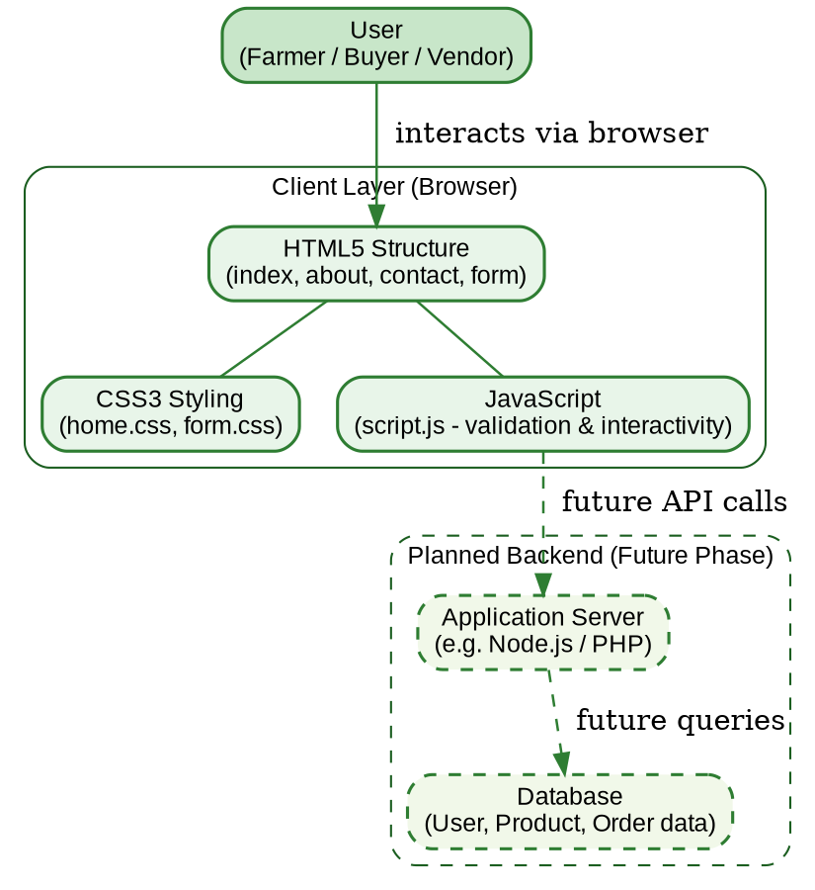
Figure 1: High-Level System Architecture — current client layer and planned backend

2. UI Design (User Flow) and Flowchart
The user interface follows a simple, linear flow: a visitor lands on the homepage, browses available products and prices, and can then explore the About page, reach out through the Contact page, or proceed directly to the Join Us registration form. Client-side JavaScript validation ensures the registration and contact forms are only submitted once required fields are correctly filled in.
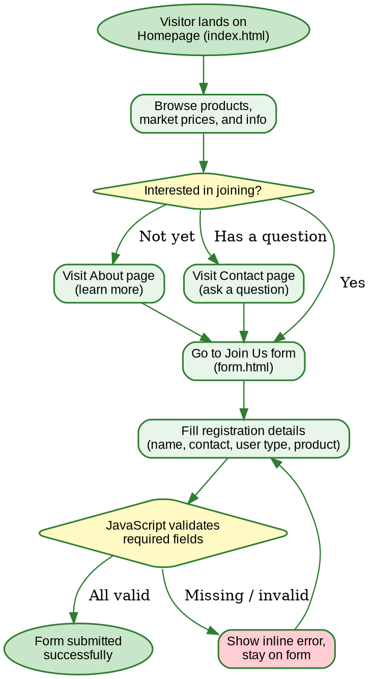
Figure 2: User Journey Flowchart across the AgriLink website

3. Database Design with ERD and Relationships
Although the current version of AgriLink does not yet persist data to a database (the forms currently validate input in the browser only), the project proposes the following data model to support a future backend. It centers on four entities: User, Product, Order, and Message.
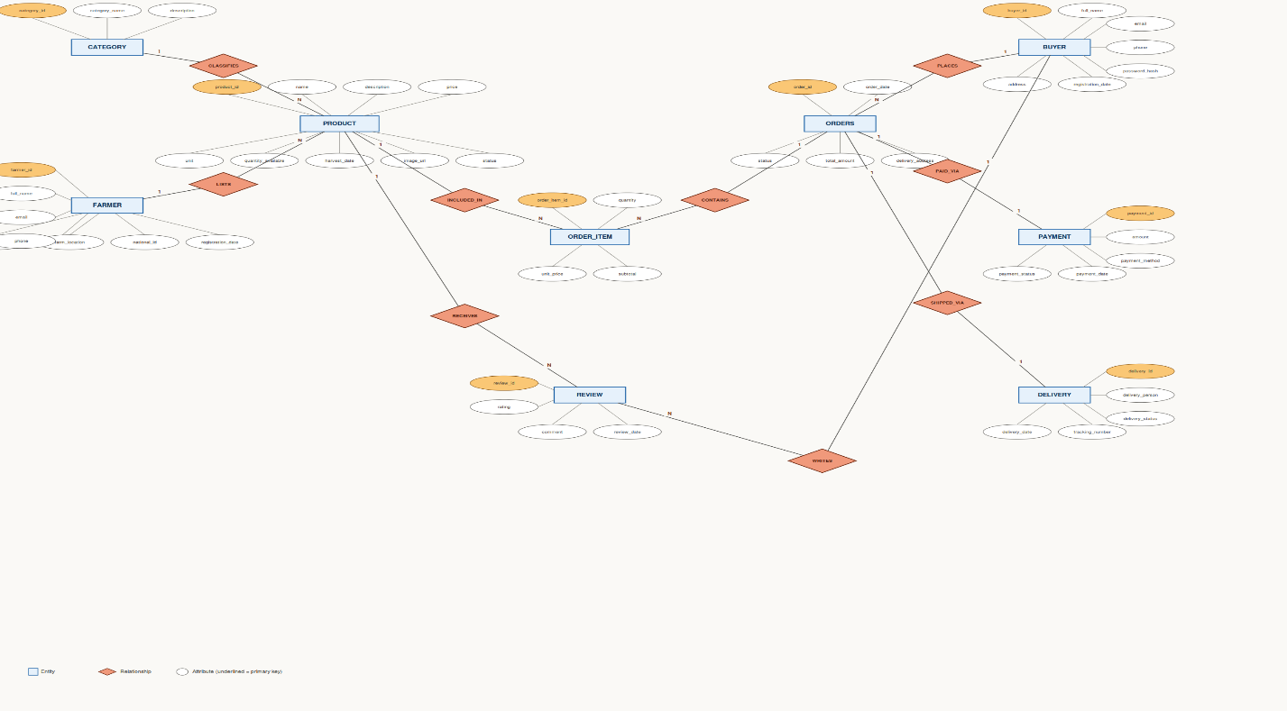
Figure 3: Proposed Entity Relationship Diagram (ERD) for future backend implementation
Relationships: a User (as farmer or vendor) can list many Products (1-to-many). A User (as buyer) can place many Orders, and each Order references one Product (many-to-one). A User can send many Messages through the contact system.

Chapter 3. Implementation

3.1. Introduction of the Section
This section presents the implemented pages of the AgriLink website, with a screenshot and discussion for each. The site was built using semantic HTML5 for structure, CSS3 for styling (a shared stylesheet, home.css, plus form.css for the registration page), and a single JavaScript file (script.js) that handles form validation across the site.

3.2. Screenshots and Page Discussions

Homepage (index.html)
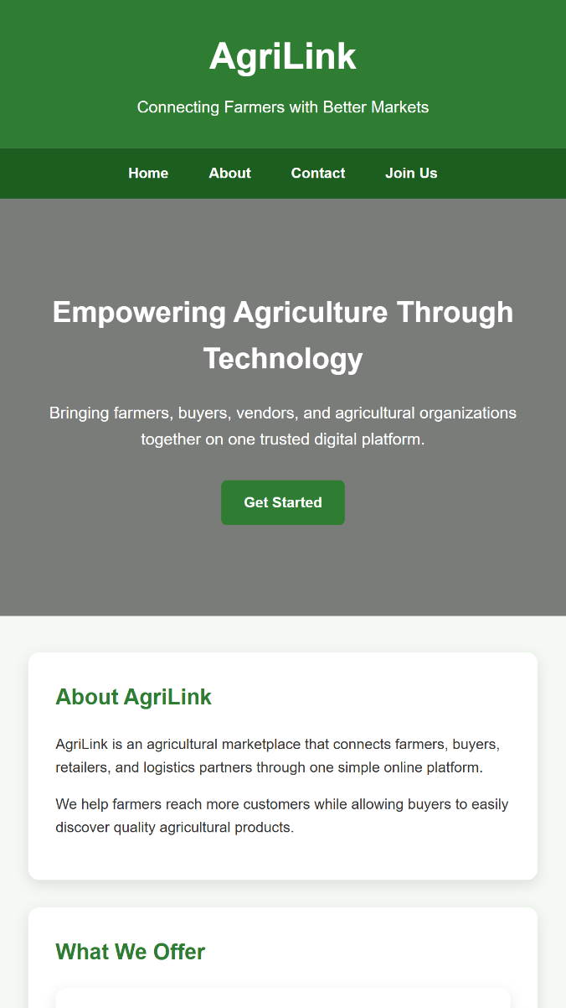
Figure 4: Homepage (index.html)
The homepage introduces AgriLink and its purpose through a hero banner, followed by sections covering the platform's offerings, the available agricultural products (cassava, beans, maize, Irish potatoes, tomatoes, and bananas), a sample market price table, platform statistics, testimonials, and a closing call-to-action. The navigation bar at the top links to every other page, and is present consistently across the site. This page is intentionally content-rich, as it serves as the main entry point for both farmers and buyers to understand what the platform offers before registering.

About Us Page (about.html)
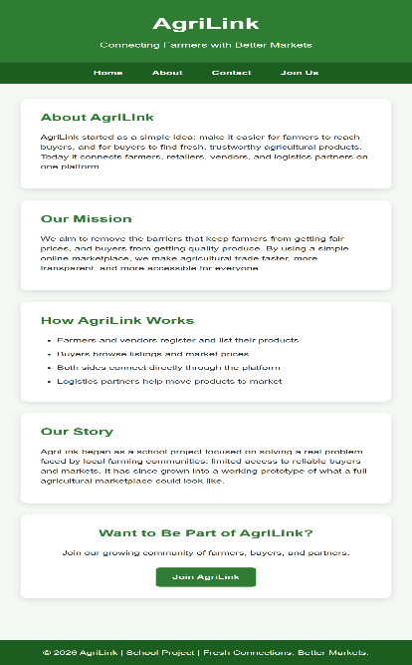
Figure 5: About Us Page (about.html)
The About page expands on AgriLink's mission, explains how the platform works step by step, and shares the motivation behind the project. It reuses the same visual language (colors, card layout, section spacing) as the homepage so that navigating between pages feels seamless. This page ends with the same call-to-action button used elsewhere, encouraging visitors to proceed to registration.

Contact Us Page (contact.html)
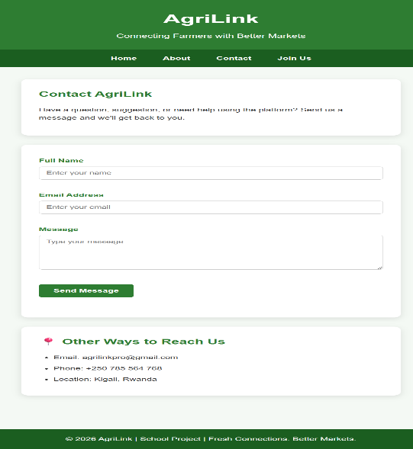
Figure 6: Contact Us Page (contact.html)
The Contact page provides a short form (Full Name, Email Address, Message) alongside alternative contact details (email, phone, location). This form is connected to script.js: on submission, JavaScript checks that the name, email, and message fields are filled in, and that the email address matches a valid pattern, before showing a success message. This prevents empty or malformed submissions and gives the user immediate feedback without needing a server round-trip.

Join AgriLink Registration Form (form.html)
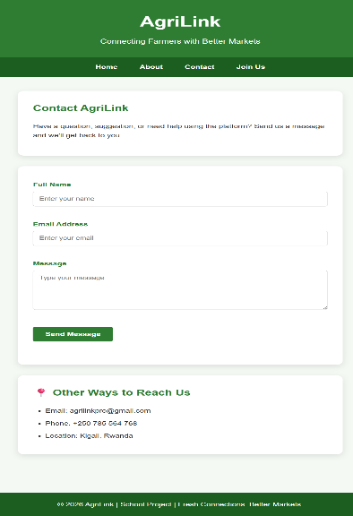
Figure 7: Join AgriLink Registration Form (form.html)
The Join Us page contains the main registration form, collecting personal details (first name, last name, email, phone, password), location (district, sector), and agricultural details (user type, main product, farm size, years of experience). All required fields are marked with the HTML required attribute, and script.js performs a check on submission: if any required field is left empty, the form is prevented from submitting, the empty fields are outlined in red, and the user is alerted to complete them. A "Back to Homepage" link was also added to this page so users can easily return to the main site without using the browser's back button.

Chapter 4. Conclusion and Recommendatiion
The AgriLink project successfully delivers a complete, navigable front-end web platform consisting of four pages (Home, About, Contact, and Join Us), a shared design system, and working client-side form validation. At this stage, an estimated 80% of the project's objectives have been achieved: the site structure, styling, content, and interactivity are complete and functioning as intended. The remaining 20% relates to backend functionality — persisting registrations and messages to a real database, and authenticating users — which was outside the scope of this phase but has been planned for through the system design in Chapter 2.

Recommendations

To the Lecturer, about technicalities:
It would be valuable to receive guidance on connecting a static front-end like this one to a lightweight backend (for example, a simple Node.js/Express API with a database), so that our projects can progress from prototype to a functioning full-stack application within the module's timeframe.

To the School, about time constraints:
Additional lab time dedicated specifically to backend integration and deployment would help students complete end-to-end projects, rather than stopping at a front-end-only prototype.

To the Partners (owners of the business the app targets), about the app developed:
Agricultural cooperatives and buyer organizations considering adoption of a platform like AgriLink should plan for a pilot phase with a small group of farmers and buyers, to validate that the registration flow and product categories match real-world needs before a wider rollout.

To the User, about training:
Basic digital literacy training (how to fill in an online form, why an internet connection is needed, how to check for confirmation messages) would help ensure farmers with limited prior exposure to web platforms can use AgriLink confidently.To the Beneficiaries (customers/farmers), about the new technological tool:
Farmers and buyers are encouraged to provide accurate and complete information when registering, since the usefulness of the platform depends directly on the quality and reliability of the listings and contact details shared.

Appendix
Link to the account and password of the GitHub repository of the deployed project:
https://github.com/Tchristah/AGRILINK-PROJECT/tree/main/agrilink.html

