Names: Jasper O. Tan

Christopher Marajay

Title: Remote Controlled Watering System

1. **Rationale**

The Watering System contains an IR Remote when button is press the IR Receiver will send the data to the Arduino then control the Relay Module and make the Solenoid valve activated to water the plants.

1. **Features**

* LCD Display
* Water Level Alarm
* Automatic Water Refill
* IR Control System

1. **Statement of the problem**

Plants need water on regular basis and sometimes we forgot to water it because we have to many things to do in our home. The student made this project to help people with have a hobby in planting and sometimes they forget to water it just because other thing need to do by using this project you can still water the plant even though your doing something else as long as your within the range of the plant so that your plant is still healthy even though you have little time in managing it.

1. **Block Diagram**
2. 



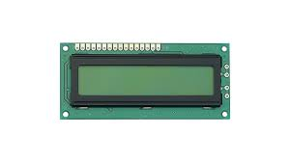

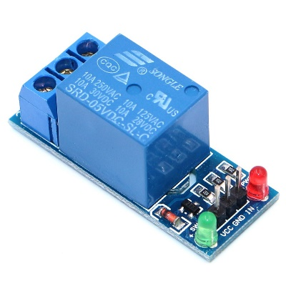

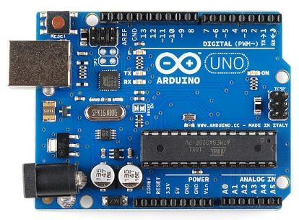

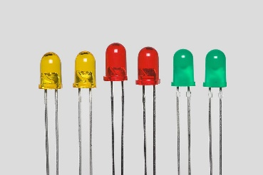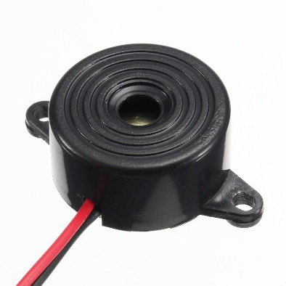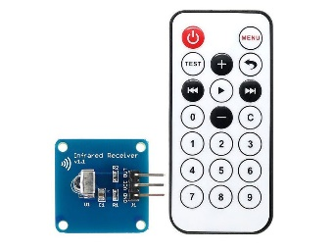

**WATER SENSOR**