Groups 1 & 2:

Sprint 1:
Create a simple web page that every developer on the team can ping.

Execution:
We have created a simple web page that takes in 2 integer inputs, submits the values via an AJAX request to the backend, where the values are added and the sum is returned to the web page that called it. The page does not have to be reloaded in order to display the sum. The goal here was for the group to become familiar with AJAX, Flask and parsing JSON. The web page can be found at 142.93.59.52:8000

→We are using the flask web development framework
→The webpage is HTML, CSS, the Bootstrap framework, and Javascript for updating the webpage with the sum. Screenshots of all are below:

process.py

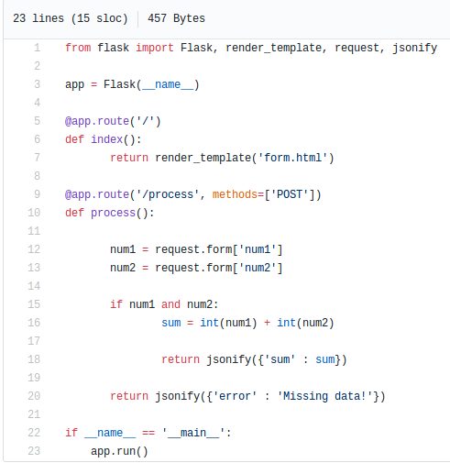

forms.html

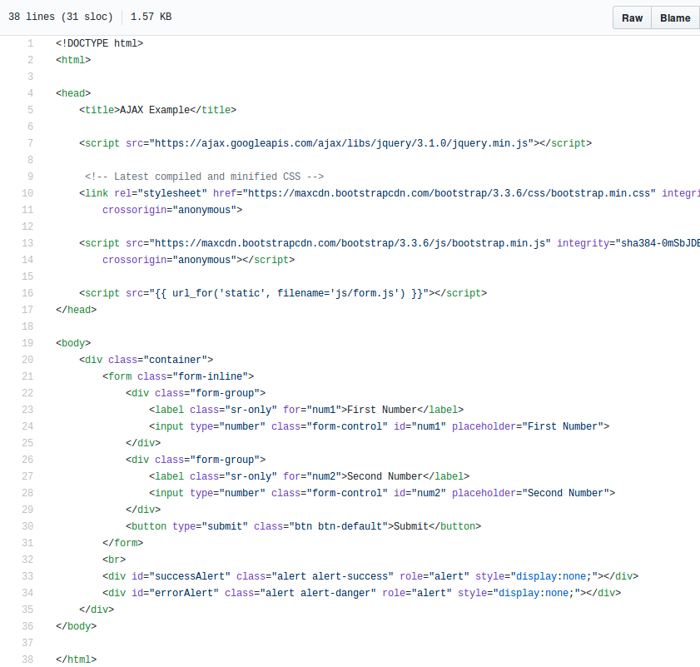

forms.js

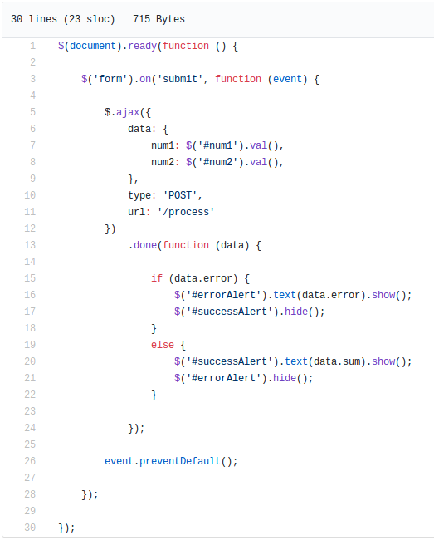

1. 142.93.59.52:8000 at initial load
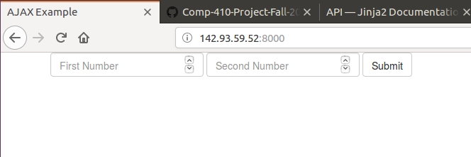
2. The two inputs can take in integer values. Because the form is from the Bootstrap library, the inputs come with built-in validation code as exemplified in Screenshot 3. The submission of the values 5 and 8 should result in the sum 13 being returned to the form.
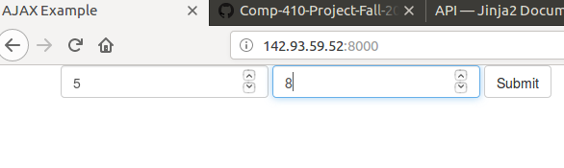

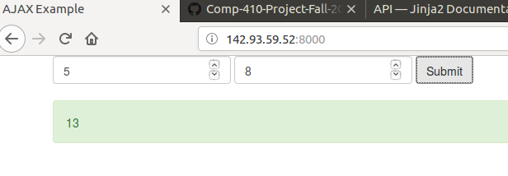
3. When the value is returned to the page, note that the page does not need to reload. The green is simply an indicator that the transmission of data was successful. It does not prove that the sum is correct.

