# Step 1:

Make an account on github.

# Step 2:

Get GitHub Desktop

# Step 3:

Start it up, go to FILE -> clone repositor

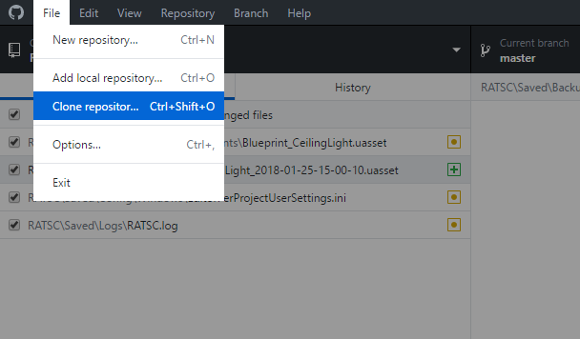

# Step 4:

Go to URL, and type in the following values (replace ADD PATH TO WHERE YOU WANT TO STORE PROJECT with the path where you want to store the project. Then, press clone. This should copy all data to your local computer.

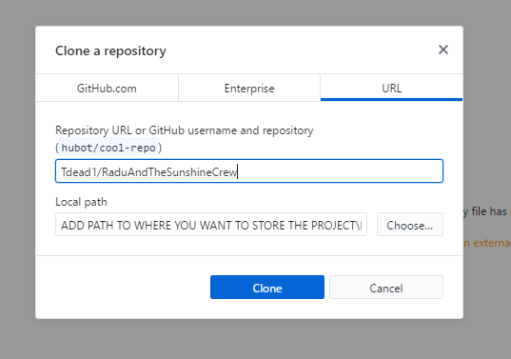

# Step 5:

Make a change, even if it’s just adding your name to the created readme file.

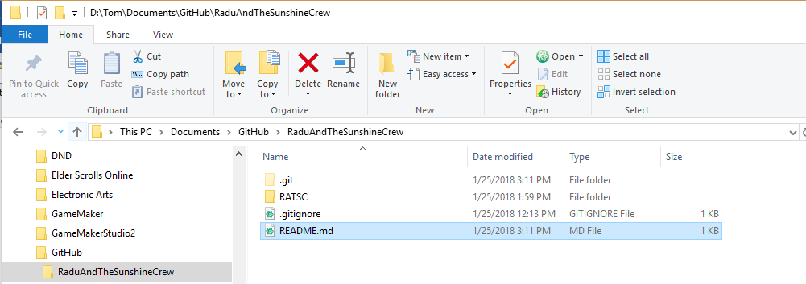

# Step 6:

Go back to GitHub Desktop, and this README.md should have shown up. This is the file you changed.

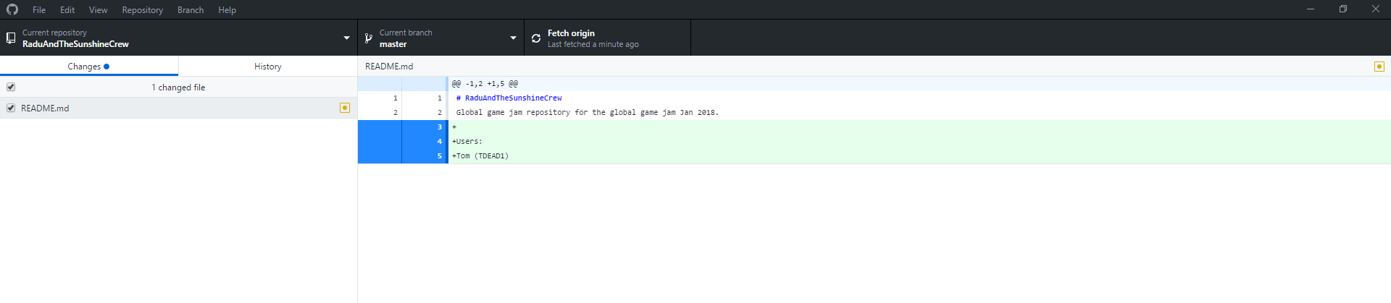

# Step 7:

To commit the readme (send it to github) type in a summary of your change, and a description, and press commit to master.

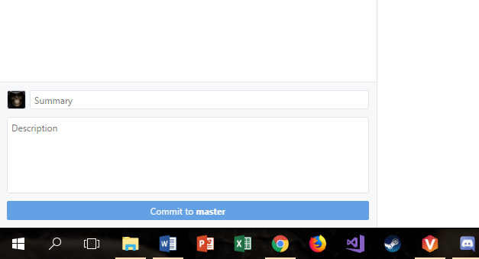

# Step 8:

At the top, fetch origin should now have changed to push origin. Click on it to submit your files to the online repository.

