

Assignment 2 linux
Name: Harsh Shrivastav
Branch and section: B.Tech(AI and ML){D}
ROLL number:2501730265

Submitted to : ms megha

Linux Setup, Shell Commands, and Automation – Assignment Report

Introduction
The purpose of this assignment is to demonstrate a practical understanding of the Linux operating system, which is a cornerstone of modern computer science and IT infrastructure. [Linux is widely used in both academic and industrial environments due to its open-source nature, robust security features, and powerful scripting capabilities.
This report documents the successful installation of the Ubuntu Linux distribution, the execution of essential shell commands for file and system management, and the development of shell scripts to automate routine tasks such as backups and system monitoring. Additionally, this assignment incorporates version control using GitHub, a critical skill for collaborative software development.

Linux Installation Documentation
  - Hardware Configuration
The installation was performed on a system with the following specifications: Host Operating System: Windows 11
Processor (CPU): [Intel Core i9-12400F]
RAM Allocated: [ 4 GB allocated to Virtual Machine] Disk Space Allocated: [ 20 GB]
  - Installation Process
I installed Ubuntu using [Select One: VirtualBox / Windows Subsystem for Linux (WSL)] as per the assignment instructions.
Step 1: Downloaded the Ubuntu ISO image from the official website.
Step 2: Configured the virtual environment, allocating the necessary RAM and storage. Step 3: Followed the installation wizard, setting up the user profile and time zone.
Step 4: The installation was completed successfully, and the system booted into the Linux terminal/GUI.
- Shell Command Implementation
The following table documents the execution of 20 essential shell commands used for file navigation, management, permissions, and monitoring.

Category | Command | Description/Usage | Output Screenshot
File Navigation | pwd | Prints the "Present Working Directory". Used to verify current location. | 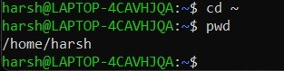
 | ls | Lists files in the current directory. | 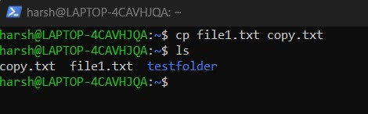
 | cd Desktop | "Change Directory". Moves into the Desktop folder.
 | tree | Displays directory structure in tree like farat | 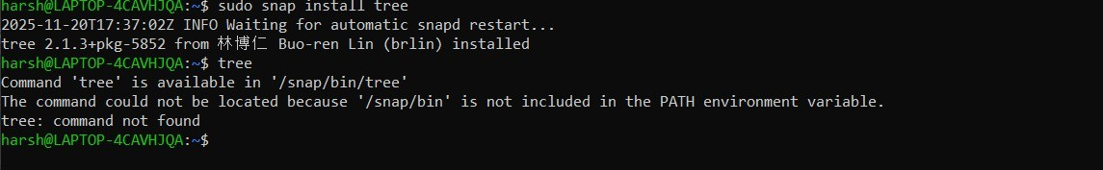
File Mgmt | mkdir my_folder | "Make Directory". Creates a new folder named 'my_folder'. | 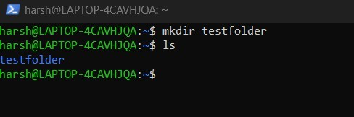
 | touch file.txt | Creates an empty file named 'file.txt'. | 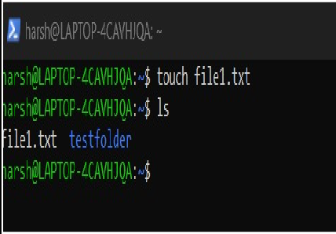

Category | Command | Description/Usage | Output Screenshot
 | cp file.txt backup.txt | Copies 'file.txt' to a new file named 'backup.txt'.
 | mv file.txt new_loc/ | Moves a file to a different directory. | 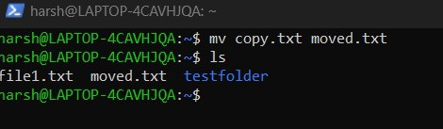
 | rm backup.txt | Removes (deletes) the specified file. | 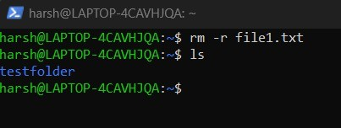
Permissions | ls -l | Shows file permissions (read/write/execute). | 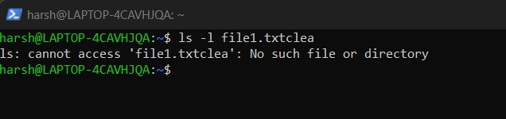
 | chmod 777 file.txt | Changes permissions to give full access to everyone. | 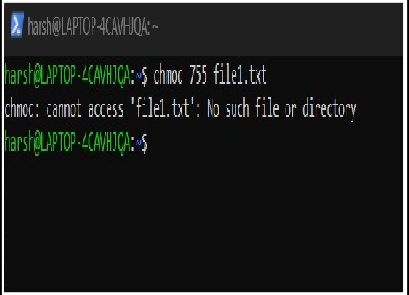

Category | Command | Description/Usage | Output Screenshot
Monitoring | ps | Displays currently running processes. | 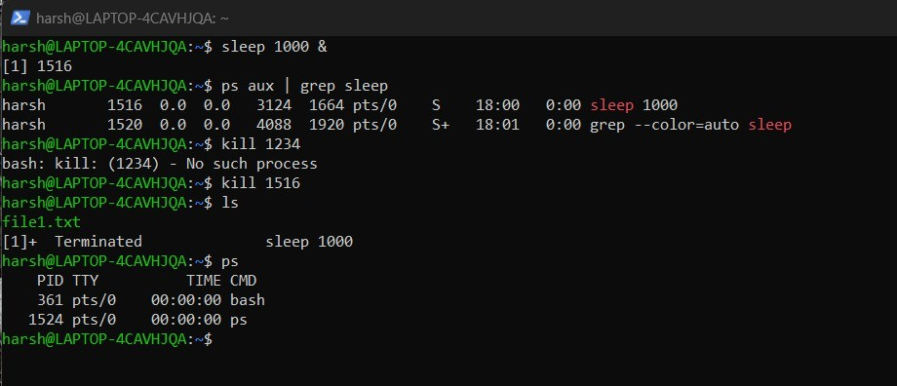
 | top | specific real-time view of system processes (CPU/RAM usage). | 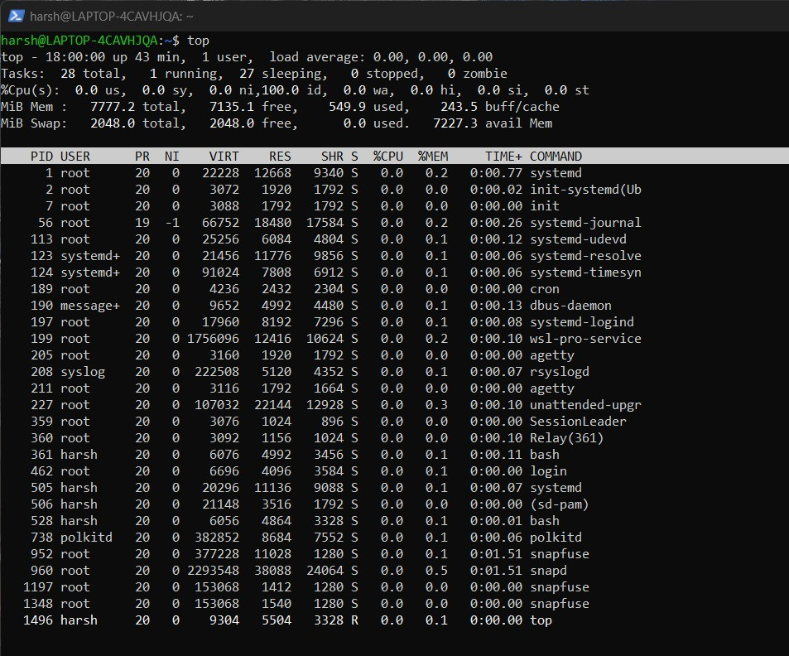
 | free -m | Displays the amount of free and used memory in MB. | 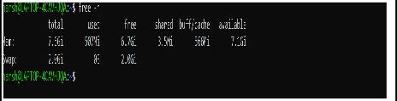

Category | Command | Description/Usage | Output Screenshot
Networking | ifconfig | Displays network interface configuration (IP address). | 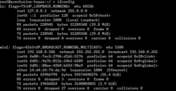
 | ping google.com | Checks connectivity to a server by sending packets. | 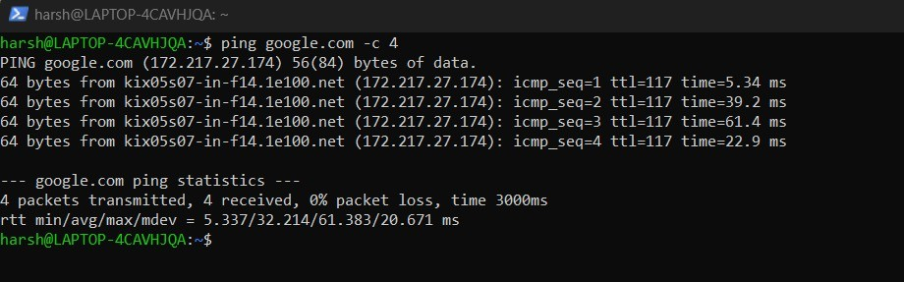

- Shell Script Development

The following scripts were developed to automate specific tasks. Each script includes header comments and variable definitions as required.

Script 1: Backup a Directory

- Purpose: This script creates a backup of a specified directory by copying it to a backup folder with a timestamp appended to the name.
- Code:
  - #!/bin/bash
- # Purpose: Backup a directory with a timestamp
- ​
- SOURCE_DIR="/home/user/documents"
- BACKUP_DIR="/home/user/backup"
- TIMESTAMP=$(date +%Y%m%d_%H%M%S)
- ​
- # Create backup directory if it doesn't exist
- mkdir -p $BACKUP_DIR
- ​
- # Copy the directory
- cp -r $SOURCE_DIR $BACKUP_DIR/backup_$TIMESTAMP
- ​
- echo "Backup completed successfully at $TIMESTAMP"

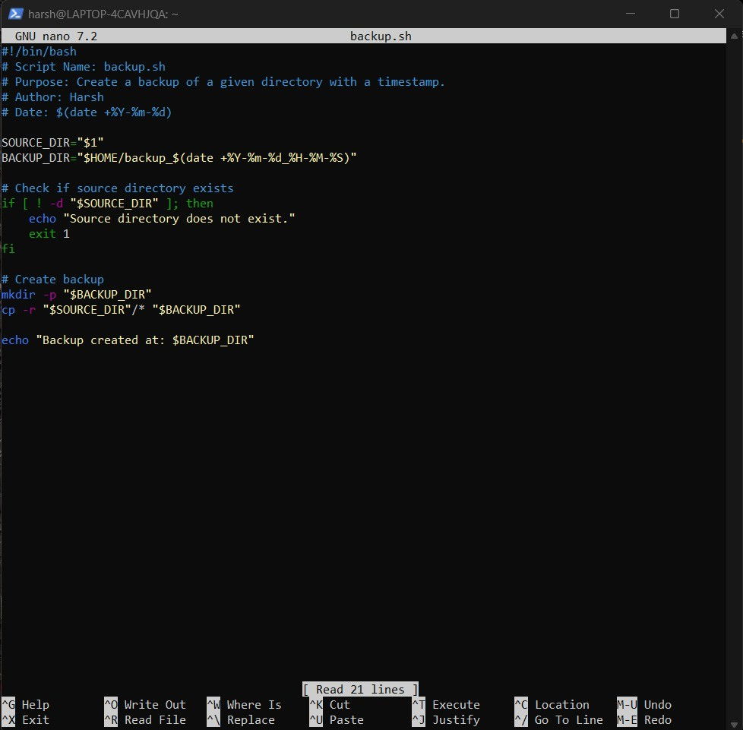

Script 2: CPU/Memory Monitoring

- Purpose: This script logs the current CPU and Memory usage into a text file.
- Code:
  - #!/bin/bash
  - # Author: [harsh]
  - # Purpose: Log CPU and Memory usage
  - ​
  - LOG_FILE="system_monitor.log"
  - ​
  - echo "Monitoring started at $(date)" >> $LOG_FILE
  - ​
  - # Log the top lines of the 'top' command output
  - top -b -n 1 | head -n 5 >> $LOG_FILE
  - ​
  - echo " " >> $LOG_FILE
  - echo "Log updated."

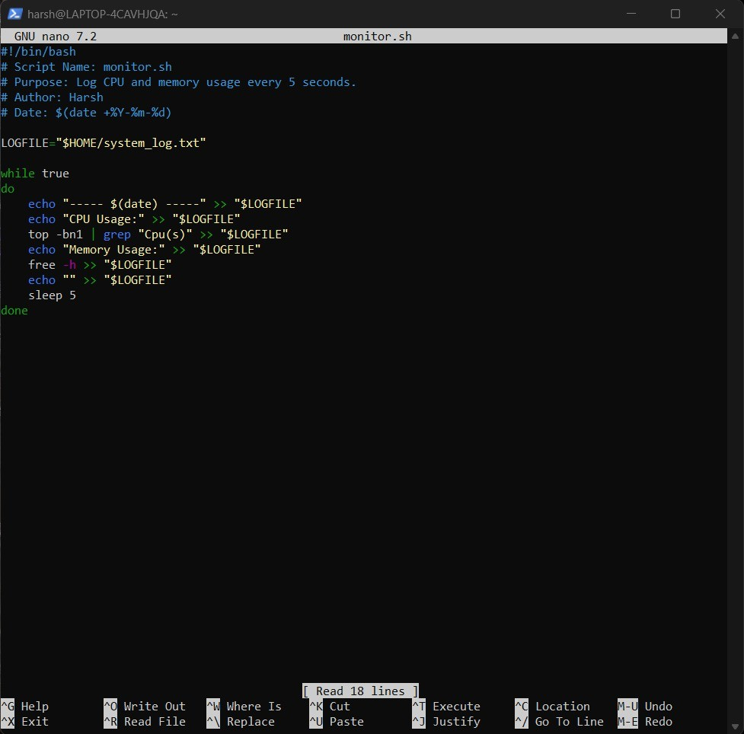

GitHub Repository
The scripts and screenshots have been uploaded to the GitHub repository.

GitHub Link:
<INSERT LINK HERE>

Reflection
Challenges Faced: During this assignment, I faced challenges regarding [understanding file permissions or configuring the virtual machine network settings]. I overcame this by researching the specific error codes and consulting the man (manual) pages for the commands.
Learning Outcomes: I successfully learned how to navigate the Linux file system using the command line interface (CLI) rather than a graphical interface. I also gained practical experience in writing Bash scripts to automate repetitive tasks, which saves time and reduces human error.
Real-World Application: These skills are directly applicable to real-world scenarios. For instance, the backup script written in this assignment mimics the automated backup solutions used by system administrators to protect enterprise data. Similarly, the monitoring script is a fundamental version of the tools used to maintain server health in data centers.

