

Prio

The personal assistant app



Alec hunt

# Concept idea

Description:

Consolidate fragmented time management tools into a cloud-based web application, providing users with intuitive tools for managing schedules and creating task lists in one unified platform.

Goals:  
Streamline users' productivity and organization, ensuring secure storage of user data and cross-platform accessibility.

Target Audience:

Busy individuals seeking to simplify their time management processes.

Research:

Current time management tools are fragmented, decreasing efficiency and user friendliness. There is a need for an integrated solution without excessive features.

# Concept breakdown:

## User Authentication

* User registration
* Login/Logout functionality

## Task Management

* Creating, reading, updating, and deleting lists and tasks
* Task categorization and prioritization
* Due date and reminder functionality

## Scheduling

* Calendar view (optional)
* Scheduling tasks and events

## Note-taking

* Creating, reading, updating, and deleting notes

## User Interface

* Dashboard overview
* Navigation and menu system
* Responsive design for cross-platform accessibility

## Data Storage and Security

* Cloud-based storage (AWS)
* Data encryption and secure storage

## Pages

* **Home/Dashboard**
* **Task List**
* **Calendar** (optional)
* **Note-taking**
* **Login/Register**

# Structure diagram:

For greater clarity, I’ll briefly explain the diagram. The application will allow for navigation from any one page to any one other page except when leaving the login page which will always redirect a user back to the home page.

# Wireframes:

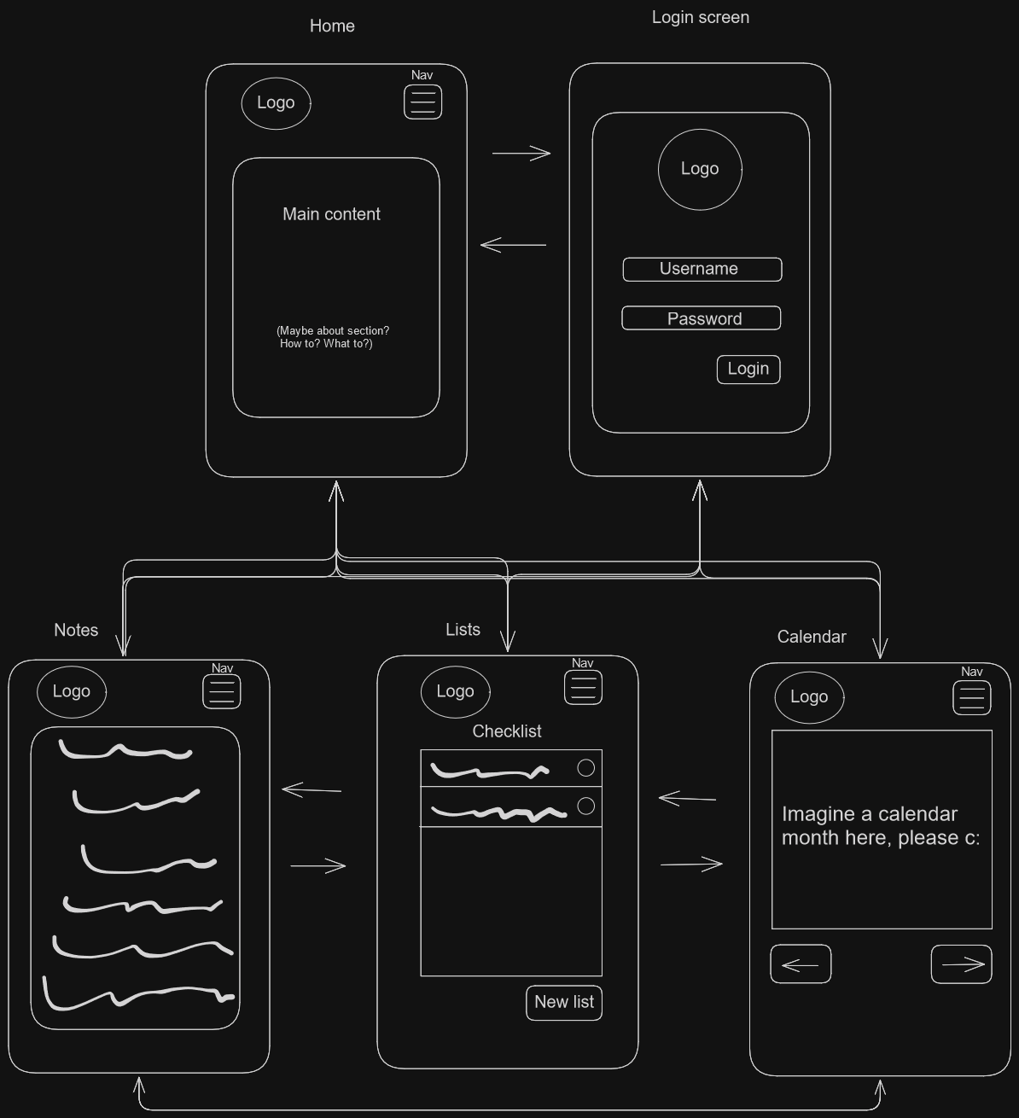

# Mood board:

# Prototype:

## Login screen:

Users will see this if they select the login option for the navigation or attempt to access the parts of the application that require authentication and authorization.

## Home page:

Users will be directed to this page after logging in, signing up, or logging out. New users will also arrive here.

## Hamburger menu unleashed:

The options that the user sees will exclude the page that they’re currently on. If they’re logged out, they’ll see a log in button and vice versa.

## Notepad:

## Checklist:

## Calendar:

