Music & Unemployment in 2020

*Tracy Ammann, Rosaicela Roman, Amber Royster*

*University of Arizona Continuing & Professional Education*

*Data Visualization Bootcamp*

1. **Main Question**: Was there an effect in listening/streaming trends by the events of 2020 using unemployment claims data as a proxy for a metric related to drastic social/economical changes?
   1. Was there a change in the total streaming numbers during the year?

It appears that the beginning of the year, in general, it had more streaming numbers than the rest of the year. There were some spikes around August. However, the changes appear minimal for the rest of the year.

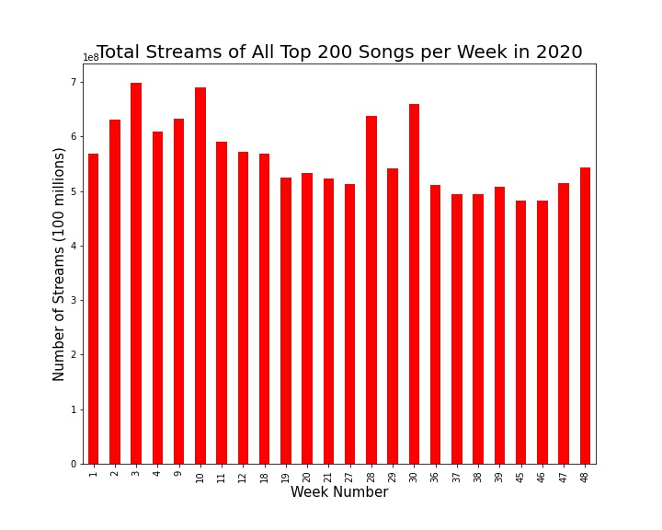

* 1. Was there a correlation between streaming changes and changes in unemployment?

Data shows little influence between unemployment claims and streaming. In general, there is a negative correlation between unemployment and streaming/listening. However, the line fit shows very high variability (r-squared: 0.07). The model is not good to predict streaming trends. Note: After data collection and analysis, it is evident the sampling method for the streaming could have missed a spike that could align better with the unemployment data.

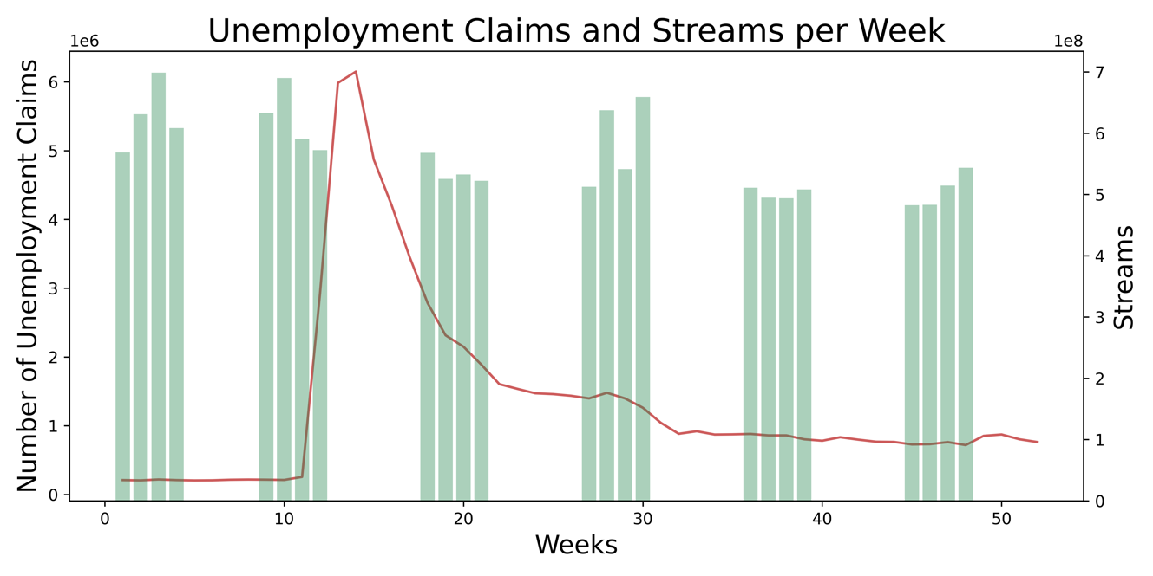

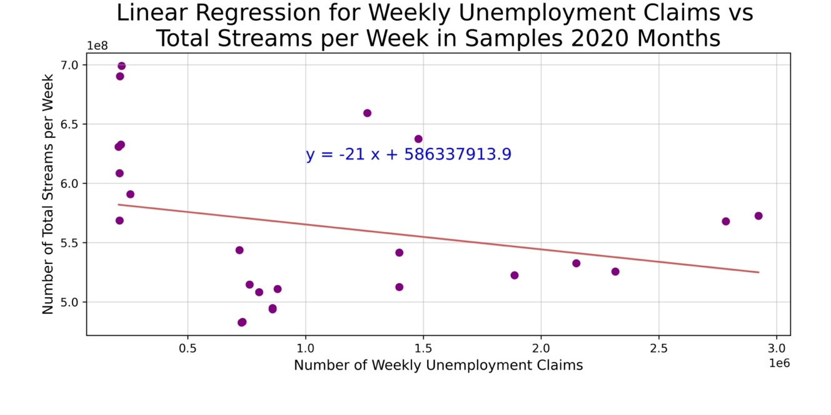

* 1. Were people’s genre tastes impacted through the course of 2020?

It does not appear people’s genre choices were altered throughout the year. Pop and hip hop/rap/trap were by far the most popular genre through 2020.

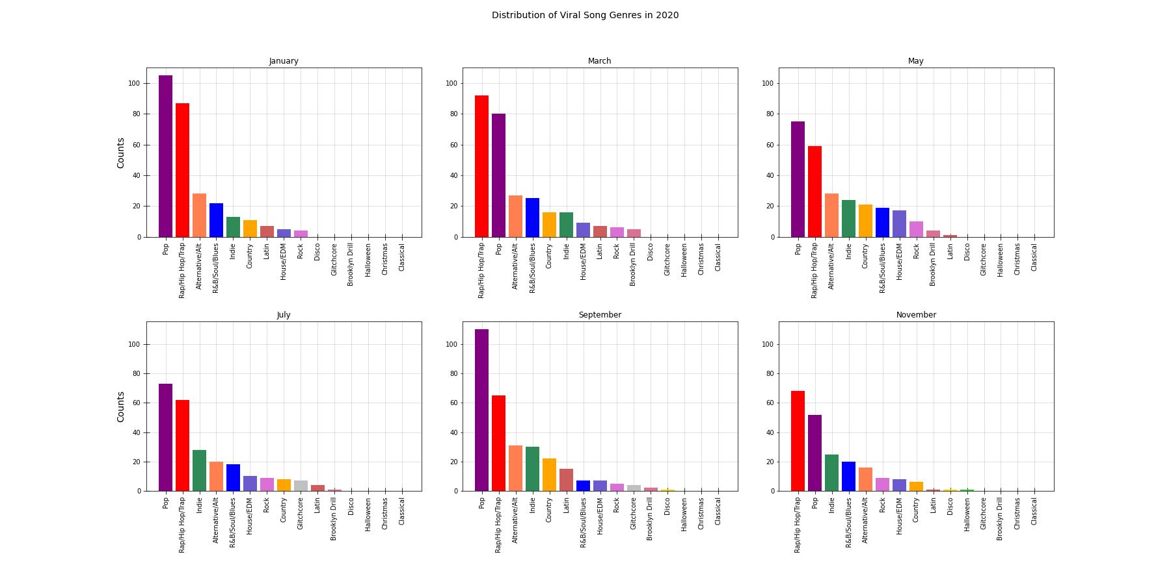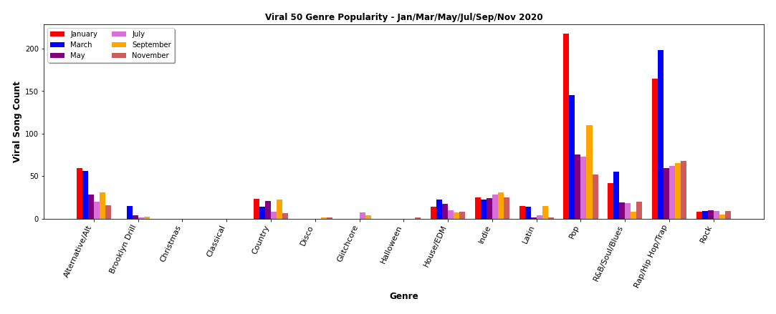

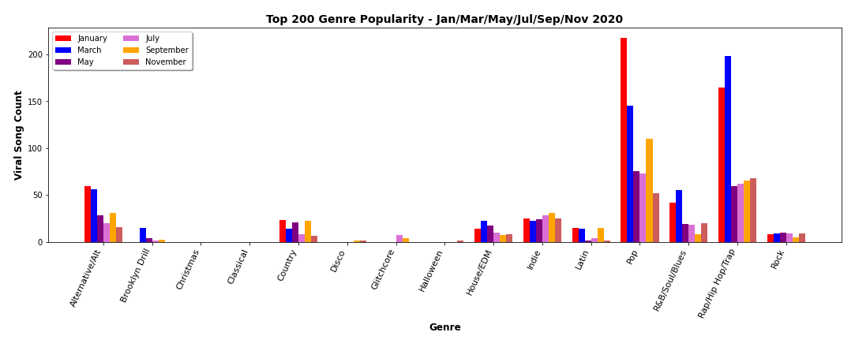

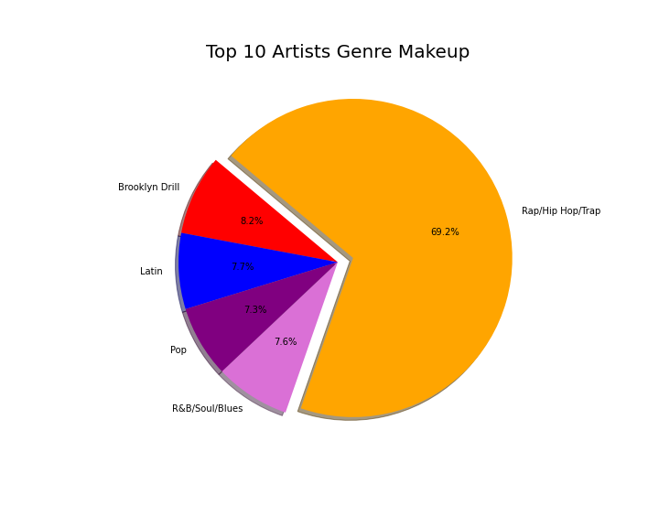

**Conclusion:**

2020 employment data when compared to streaming trends did not show a discernible relationship. Based on the data collected and the analysis made, it looks that unemployment claims data is not a good predictor of music streaming trends and genre taste.

