**CMP73010 – Assignment 1 exercise**

Remember that this is a public repository so your changes will be seen by anyone who looks!

Add some comments about Version management after this line, or just add some text so there is a change to this file. Remember that your GitHub user ID must be submitted in your assignment report!

>>> your stuff after this line >>>

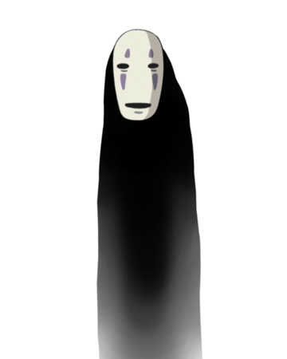Hannah’s contribution, featuring No Face ☺

Image sourced from <https://ghibli.fandom.com/wiki/No-Face>