2101

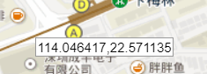

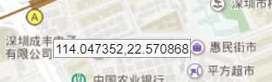

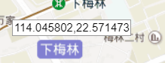

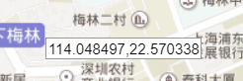

114.046417 114.048497

22.570338 22.571483

2155



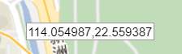

114.055832 114.054987

22.560339 22.559387

2103

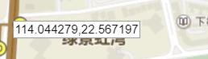

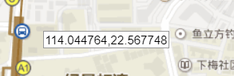

114.044279 114.044764

22.567197 22.567748

2044

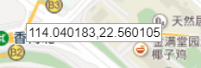

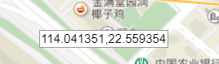

114.040183 114.041351

22.560105 22.559354

2043

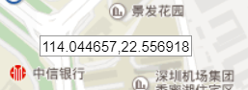

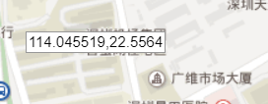

114.045519 114.044657

22.556918 22.5564

2046



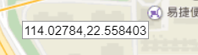

114.026888 114.02784

22.55907 22.558403



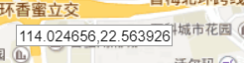

114.024656,114.014164

22.563926,22.559187



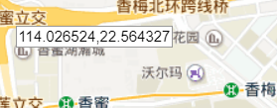

114.026524,114.020344

22.576475,22.564327



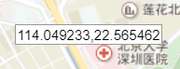

114.049233,114028465

22.565462,22.564327



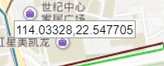

114.03328,114.026165

22.561991,22.547705