**ISYS3001 – Assignment 1 exercise**

Remember that this is a public repository so your changes will be seen by anyone who looks!

Add some comments about Version management after this line, or just add some text so there is a change to this file. Remember that your GitHub user ID must be submitted in your assignment report!

>>> your stuff after this line >>>

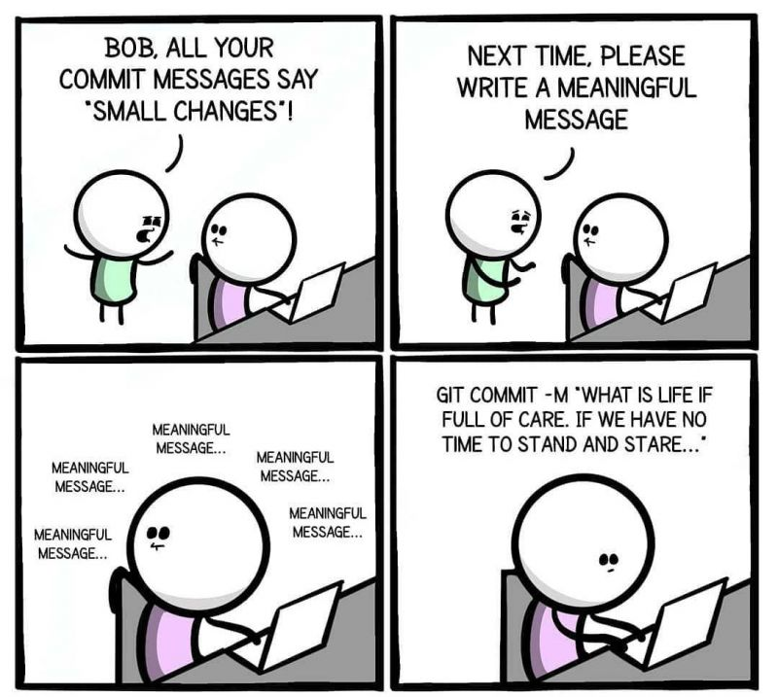

A cool quote by Dijkstra:

“*Computer science is no more about computers than astronomy is about telescopes.”*