# PART A Electronic Lodgment Declaration (Form I)

**This declaration is to be completed where a taxpayer elects to use an approved ATO electronic channel. It is the responsibility of the taxpayer to retain this declaration for a period of five years after the declaration is made, penalties may apply for failure to do so.**

**Privacy**

The ATO is authorised by the Taxation Administration Act 1953 to request your tax file number (TFN). We will use your TFN to identify you in our records. It is not an offence not to provide your TFN. However, you cannot lodge your income tax form electronically if you do not quote your TFN.

Taxation law authorises the ATO to collect information and to disclose it to other government agencies. For information about your privacy go to ato.gov.au/privacy

***Electronic funds transfer - direct debit***

Where you have requested an EFT direct debit some of your details will be provided to your financial institution and the Tax Office's sponsor bank to facilitate the payment of your taxation liability from your nominated account.

Year

Tax file number

Name

569 838 737

2021

MISS NAMRATA PUDASAINI

**Declaration**

**I declare that:**

· the information provided to my registered tax agent for the preparation of this tax return, including any applicable schedules is true and correct, and · the agent is authorised to lodge this tax return.

**Important: The tax law imposes heavy penalties for giving false or misleading information.**



Date

Signature

# PART B Electronic funds transfer consent

This declaration is to be completed when an electronic funds transfer (EFT) of a refund is requested and the tax return is being lodged through an approved ATO electronic lodgment channel .

The declaration must be signed by the taxpayer prior to the EFT details being transmitted to the Tax Office. If you elect for an EFT, all details below must be completed.

Important: Care should be taken when completing EFT details as the payment of any refund will be made to the account specified.



Agent's reference

number

Account Name:

S PUDASAINI

I authorise the refund to be deposited directly to the specified account as above.

Signature

Date

**Sensitive (when completed)** Client Ref: PUDA0002

Agent : 72540-009

|  |  |  |
| --- | --- | --- |
| **Individual tax return**  **1 July 2020 to 30 June 2021** |  | **2021** |

|  |
| --- |
| 569 838 737 |

**Your tax file number (TFN)Return year**

See the Privacy note in the Taxpayer's declaration on page 15 of this return.

|  |
| --- |
| N |

|  |
| --- |
| Y |

## Are you an Australian resident?Print Y for yes Have you included any attachments?Print Y for yes

To

From

|  |
| --- |
| 2021 |

or **N** for no.or **N** for no.

If NO please enter residency dates

|  |
| --- |
| MISS |

**Your name** Title - for example,

Mr, Mrs, Ms, Miss

|  |  |  |
| --- | --- | --- |
| PUDASAINI | |  |
| NAMRATA |  | |

Surname or family name

Given names

Has any part of your name

|  |
| --- |
| N |

|  |  |  |
| --- | --- | --- |
| 1 /12 GORDON RD | | |
|  | | |
| BOWRAL | NSW | 2576 |
|  | | |

changed since completingPrint **Y** for yes To find out how to update your name on our records, go to ato.gov.au/updatedetails your last tax return?or **N** for no. or phone 13 28 61.

Print

for no.

**N**

or

for

yes

**Y**

your last tax return?

changed since completing

Has your postal address

## Your postal address

|  |  |  |
| --- | --- | --- |
| 1 /12 GORDON RD | | |
|  | | |
| BOWRAL | NSW | 2576 |
|  | | |

## Your home address

If the same as your current postal address, print AS

ABOVE.

* to advise you of tax return lodgment options
* to correspond with you with regards to your taxation and superannuation affairs - to issue notices to you, or

Your contact details may be used by the ATO:

**Your email address**

**Your mobile phone number**

number above )

(

if different from your mobile phone

number

code

**Your daytime phone number**

Phone

Area

-

to conduct research and marketing.

tax return, print FINAL.

item A1 on page 5 of this tax return.

If you know this is your final

If you were under 18 years of age on

**Final tax return**

**Your date of birth**

30

June 2021 you must complete

N

23/10/1997

## Electronic funds transfer (EFT)

We need your financial institution details to pay any refund owing to you, even if you have provided them to us before. Write the BSB number, account number and account name below.

|  |
| --- |
| N |

|  |  |  |
| --- | --- | --- |
| 066003 | Account number | 10425361 |

Use Agent Trust Account?

BSB number

(must be six digits)

Account name (for example, JQ Citizen. Do not show the account type, such as cheque, savings, mortgage offset)

S PUDASAINI

|  |  |  |  |  |  |  |  |  |  |  |  |  |  |  |  |  |  |  |  |  |  |  |  |  |  |  |  |  |  |  |  |  |  |  |  |  |  |  |  |  |  |  |  |  |  |  |  |  |  |  |  |  |  |  |  |  |  |  |  |  |  |  |  |  |  |  |  |  |  |  |  |  |  |  |  |  |  |  |  |  |  |  |  |  |  |  |  |  |  |  |  |  |  |  |  |  |  |  |  |  |  |  |  |  |  |  |  |  |  |  |  |  |  |  |  |  |  |  |  |  |  |  |  |  |  |  |  |  |  |  |  |  |  |  |  |  |  |  |  |  |  |  |  |  |  |  |  |  |  |  |  |  |  |  |  |  |  |  |  |  |  |  |  |  |  |  |  |  |  |  |  |  |  |  |  |  |  |  |  |  |  |  |  |  |  |  |  |  |  |  |  |  |  |  |  |  |  |  |  |  |  |  |  |  |  |  |  |  |  |  |  |  |  |
| --- | --- | --- | --- | --- | --- | --- | --- | --- | --- | --- | --- | --- | --- | --- | --- | --- | --- | --- | --- | --- | --- | --- | --- | --- | --- | --- | --- | --- | --- | --- | --- | --- | --- | --- | --- | --- | --- | --- | --- | --- | --- | --- | --- | --- | --- | --- | --- | --- | --- | --- | --- | --- | --- | --- | --- | --- | --- | --- | --- | --- | --- | --- | --- | --- | --- | --- | --- | --- | --- | --- | --- | --- | --- | --- | --- | --- | --- | --- | --- | --- | --- | --- | --- | --- | --- | --- | --- | --- | --- | --- | --- | --- | --- | --- | --- | --- | --- | --- | --- | --- | --- | --- | --- | --- | --- | --- | --- | --- | --- | --- | --- | --- | --- | --- | --- | --- | --- | --- | --- | --- | --- | --- | --- | --- | --- | --- | --- | --- | --- | --- | --- | --- | --- | --- | --- | --- | --- | --- | --- | --- | --- | --- | --- | --- | --- | --- | --- | --- | --- | --- | --- | --- | --- | --- | --- | --- | --- | --- | --- | --- | --- | --- | --- | --- | --- | --- | --- | --- | --- | --- | --- | --- | --- | --- | --- | --- | --- | --- | --- | --- | --- | --- | --- | --- | --- | --- | --- | --- | --- | --- | --- | --- | --- | --- | --- | --- | --- | --- | --- | --- | --- | --- | --- | --- | --- | --- | --- | --- | --- | --- | --- | --- | --- |
| **Income**  **1 Salary or wages**  Your main salary and wage occupation   |  |  |  |  |  | | --- | --- | --- | --- | --- | | Nursing assistant or aide | Occupation code | **X** |  | 423312 |   Tax withheld  Lump D  CDEP  TYPE  Payer’s Name  Payer’s Australian business number  **Gross payment**  Tax withheld  Lump B  Lump A  Allowances  RESC  RFBA  72  TBG SENIOR LIVING SERVICES PTY LTD  61,007  10,924  63074316797  **K**  **Allowances, earnings, tips, director’s fees etc**  **2**  72  0  Allowances from Item 1  72  0  **$**  boxes.  Add up the  **Total tax withheld**  10,924   |  |  |  |  | | --- | --- | --- | --- | | **TOTAL INCOME OR LOSS** Add up the income amounts and deduct any loss amount in the boxes. | LOSS | | | | 61,079 | **/** |  |   **Deductions**   |  | | --- | | C |  |  |  |  | | --- | --- | --- | | **E** |  | 1,257 |  |  |  |  | | --- | --- | --- | | **J** |  | 50 |   CLAIM   |  |  | | --- | --- | |  | 494 |  |  | | --- | | **C** |   **D3 Work-related clothing, laundry and dry cleaning expenses/**  **D5 Other work-related expenses**  **D9 Gifts or donations**   |  |  | | --- | --- | | DONATIONS | 50 |   **D10 Cost of managing tax affairs** Interest charged by the ATO   |  |  |  | | --- | --- | --- | | **N** |  | 0 |  |  |  |  | | --- | --- | --- | | **L** |  | 0 |  |  |  |  | | --- | --- | --- | | **M** |  | 65 |   Litigation costs  Other expenses incurred in managing your tax affairs   |  |  |  |  |  |  |  |  |  |  |  |  |  |  |  |  |  |  |  |  |  | | --- | --- | --- | --- | --- | --- | --- | --- | --- | --- | --- | --- | --- | --- | --- | --- | --- | --- | --- | --- | --- | | TAX | | | | | |  | | |  | | | 65 | | | | | | | | | | **TOTAL DEDUCTIONS** | | | Items **D1** to | | | | | | | **D** - add up the | |  | | | | | |  | | | | | | | | | |  | boxes. | | | | | 1,866 | | | |  | | | | | | **SUBTOTAL** | | | **TOTAL INCOME OR LOSS** less **TOTAL DEDUCTIONS** | | | | | | | | | | | | | | | LOSS | | | | | | | | | | 59,213 | | | | **/** | |  | | | |  | | | |  | | | | **TAXABLE INCOME OR LOSS** | | |  | | | | Subtract amounts at **F** and **Z** item L1 from amount at SUBTOTAL | | | | | | | | **$** | | LOSS | | | | | | | | | | | 59,213 | | | | | **/** | | |  | | |  | |  | | | | |  | | | **TOTAL TAX OFFSETS** | | |  | | | Items T2 and **T** | | -add up the boxes. | | | | | | **U** | | 0 | | | | | |  | | | | | | |

**Medicare levy related items**

## M1 Medicare levy reduction or exemption

If you complete this item and you had a spouse during 2020-21 you must also complete Spouse details-married or de facto.

**Reduction based on family income**

**/**

TYPE

CLAIM

365

Number of dependent children and students **Exemption categories**

|  |
| --- |
| **V** |

|  |
| --- |
| **Y** |

Full 2.0% levy exemption - number of days

|  |
| --- |
| **W** |

Half 2.0% levy exemption - number of days

## M2 Medicare levy surcharge (MLS) THIS ITEM IS COMPULSORY.

**If you do not complete this item you may be charged the full Medicare levy surcharge.**

|  |
| --- |
| **E** |

|  |
| --- |
| N |

For the whole period 1 July 2020 to 30 June 2021, were you and all your dependantsPrint **Y** for yes (including your spouse) - if you had any - covered by private patient HOSPITAL cover?or **N** for no.

|  |
| --- |
| If the amount is zero, write 0. |

|  |
| --- |
| 365 |

|  |
| --- |
| **A** |

Number of days NOT liable for surcharge

**Income tests**

You must complete this section.

If you had a spouse during 2020-21 you must also complete Spouse details – married or de facto on page 7.

## IT1 Total reportable fringe benefits amounts

Total reportable fringe benefits amounts

|  |
| --- |
| 0 |

|  |
| --- |
| 0 |

|  |
| --- |
| 0 |

|  |
| --- |
| 0 |

|  |
| --- |
| 0 |

|  |
| --- |
| 0 |

|  |
| --- |
| 0 |

|  |
| --- |
| 0 |

|  |
| --- |
| 0 |

|  |
| --- |
| **V** |

|  |
| --- |
| **T** |

|  |
| --- |
| **U** |

|  |
| --- |
| **X** |

|  |
| --- |
| **Y** |

|  |
| --- |
| **Z** |

|  |
| --- |
| **N** |

|  |
| --- |
| **W** |

( for ATO validation only )

**/**

**/**

59,213

61,079

61,079

Employers exempt from FBT under section 57A of the FBTAA 1986

Employers not exempt from FBT under section 57A of the FBTAA 1986

## IT2 Reportable employer superannuation contributions

## IT3 Tax-free government pensions

## IT4 Target foreign income

## IT5 Net financial investment loss

## IT6 Net rental property loss

## IT7 Child support you paid

**( For ATO validation only )**

## Adjusted taxable income

## Estimated total income

## Estimated eligible income

## Non-resident foreign income

|  |
| --- |
| You must print Y at G if you had an amount of a capital gain from a trust. |

|  |
| --- |
| N |

|  |
| --- |
| **G** |

**18 Capital gains** Did you have a capital gainsPrint **Y** for yes tax event during the year?or **N** for no.

**N**

for no.

or

yes

for

**Y**

Print

**X**

withholding amounts

Credit for foreign resident capital gains

**/**

CODE

rollover or additional discount?

**M**

Have you applied an exemption,

**A**

**V**

**H**

Net capital gain

Total current year capital gains

to later income years

Net capital losses carried forward

Non-managed fund amounts

Non-managed fund amounts

Trustee or Trustees name

Non-resident trust name

**K**

**B**

**W**

**I**

in a controlled foreign company (CFC)?

Did you have either a direct or indirect interest

trust income

Transferor

services to a non-resident trust estate?

property-including

of

transfer

the

money-or

, either directly or indirectly, caused

**ever**

Have you

for no.

**N**

or

yes

for

**Y**

Print

CFC income

for no.

**N**

or

for

yes

**Y**

Print

**Foreign entities**

**19**

N

N

## 20 Foreign source income and foreign assets or property

|  |  |  |
| --- | --- | --- |
| **P** |  | N |

During the year did you own, or have an interest in, assets located outside Australia which hadPrint **Y** for yes a total value of AUD$50,000 or more? or **N** for no.

|  |  |  |  |
| --- | --- | --- | --- |
| LOSS | | | |
| Items 13 to 24 - add up the boxes for income amounts and deduct  **TOTAL SUPPLEMENT**  any loss amounts in the boxes.  **INCOME OR LOSS**  Transfer this amount to **I** on page 3. |  | **/** |  |
|  |  |

## Taxpayer’s declaration

Read and sign the declaration after completing your tax return, including the Supplementary section, Business and professional items section and other schedules if applicable.

boxes and transfer this amount to

add

-

up

the

**D15**

to

**D11**

Items

**TOTAL SUPPLEMENT DEDUCTIONS**

**D**

Transfer this amount to

-

add up the boxes.

Items T3 to T9

**TAX OFFSETS**

**TOTAL SUPPLEMENT**

**T**

**I declare that:**

* the information provided to my registered tax agent for the preparation of this tax return is true and correct, and
* I authorise my registered tax agent to lodge this tax return.

**Taxpayer's****Signature Date**

|  |  |  |
| --- | --- | --- |
| Day | Month | Year |

**Important:** The tax law imposes heavy penalties for giving false or misleading information.

**The ATO will issue your assessment based on your tax return. However, the ATO has some time to review your tax return, and issue an amended assessment if a review shows inaccuracies that change the assessment. The standard review period is two years but for some taxpayers it is four years.**

**Privacy:**

The ATO is authorised by the Taxation Administration Act 1953 to request your tax file number (TFN). We will use your TFN to identify you in our records. It is not an offence not to provide your TFN. However if you do not provide your TFN, your assessment may be delayed.

Taxation law authorises the ATO to collect information and to disclose it to other government agencies. For information about your privacy go to ato.gov.au/privacy

## Tax agent’s declaration

**I,**

|  |
| --- |
| HAI LING ZHAO |

declare that this tax return has been prepared in accordance with information supplied by the taxpayer, that the taxpayer has given me a declaration stating that the information provided to me is true and correct and that the taxpayer has authorised me to lodge the tax return.

Agent’s signature Date Client’s reference

|  |
| --- |
| 27/07/2021 |

Day Month Year

Agent’s telephone number

|  |
| --- |
| PUDA0002 |

Contact name Area code Telephone number Agent’s reference number

|  |  |  |  |  |  |  |
| --- | --- | --- | --- | --- | --- | --- |
| HELEN ZHAO |  | 02 |  | 96661228 |  | 72540009 |

Position held

**Work Related Expenses Schedule 2021**

|  |
| --- |
| 1,257 |

|  |
| --- |
| C |

**D3 Work related uniforms** Claim type code for main form I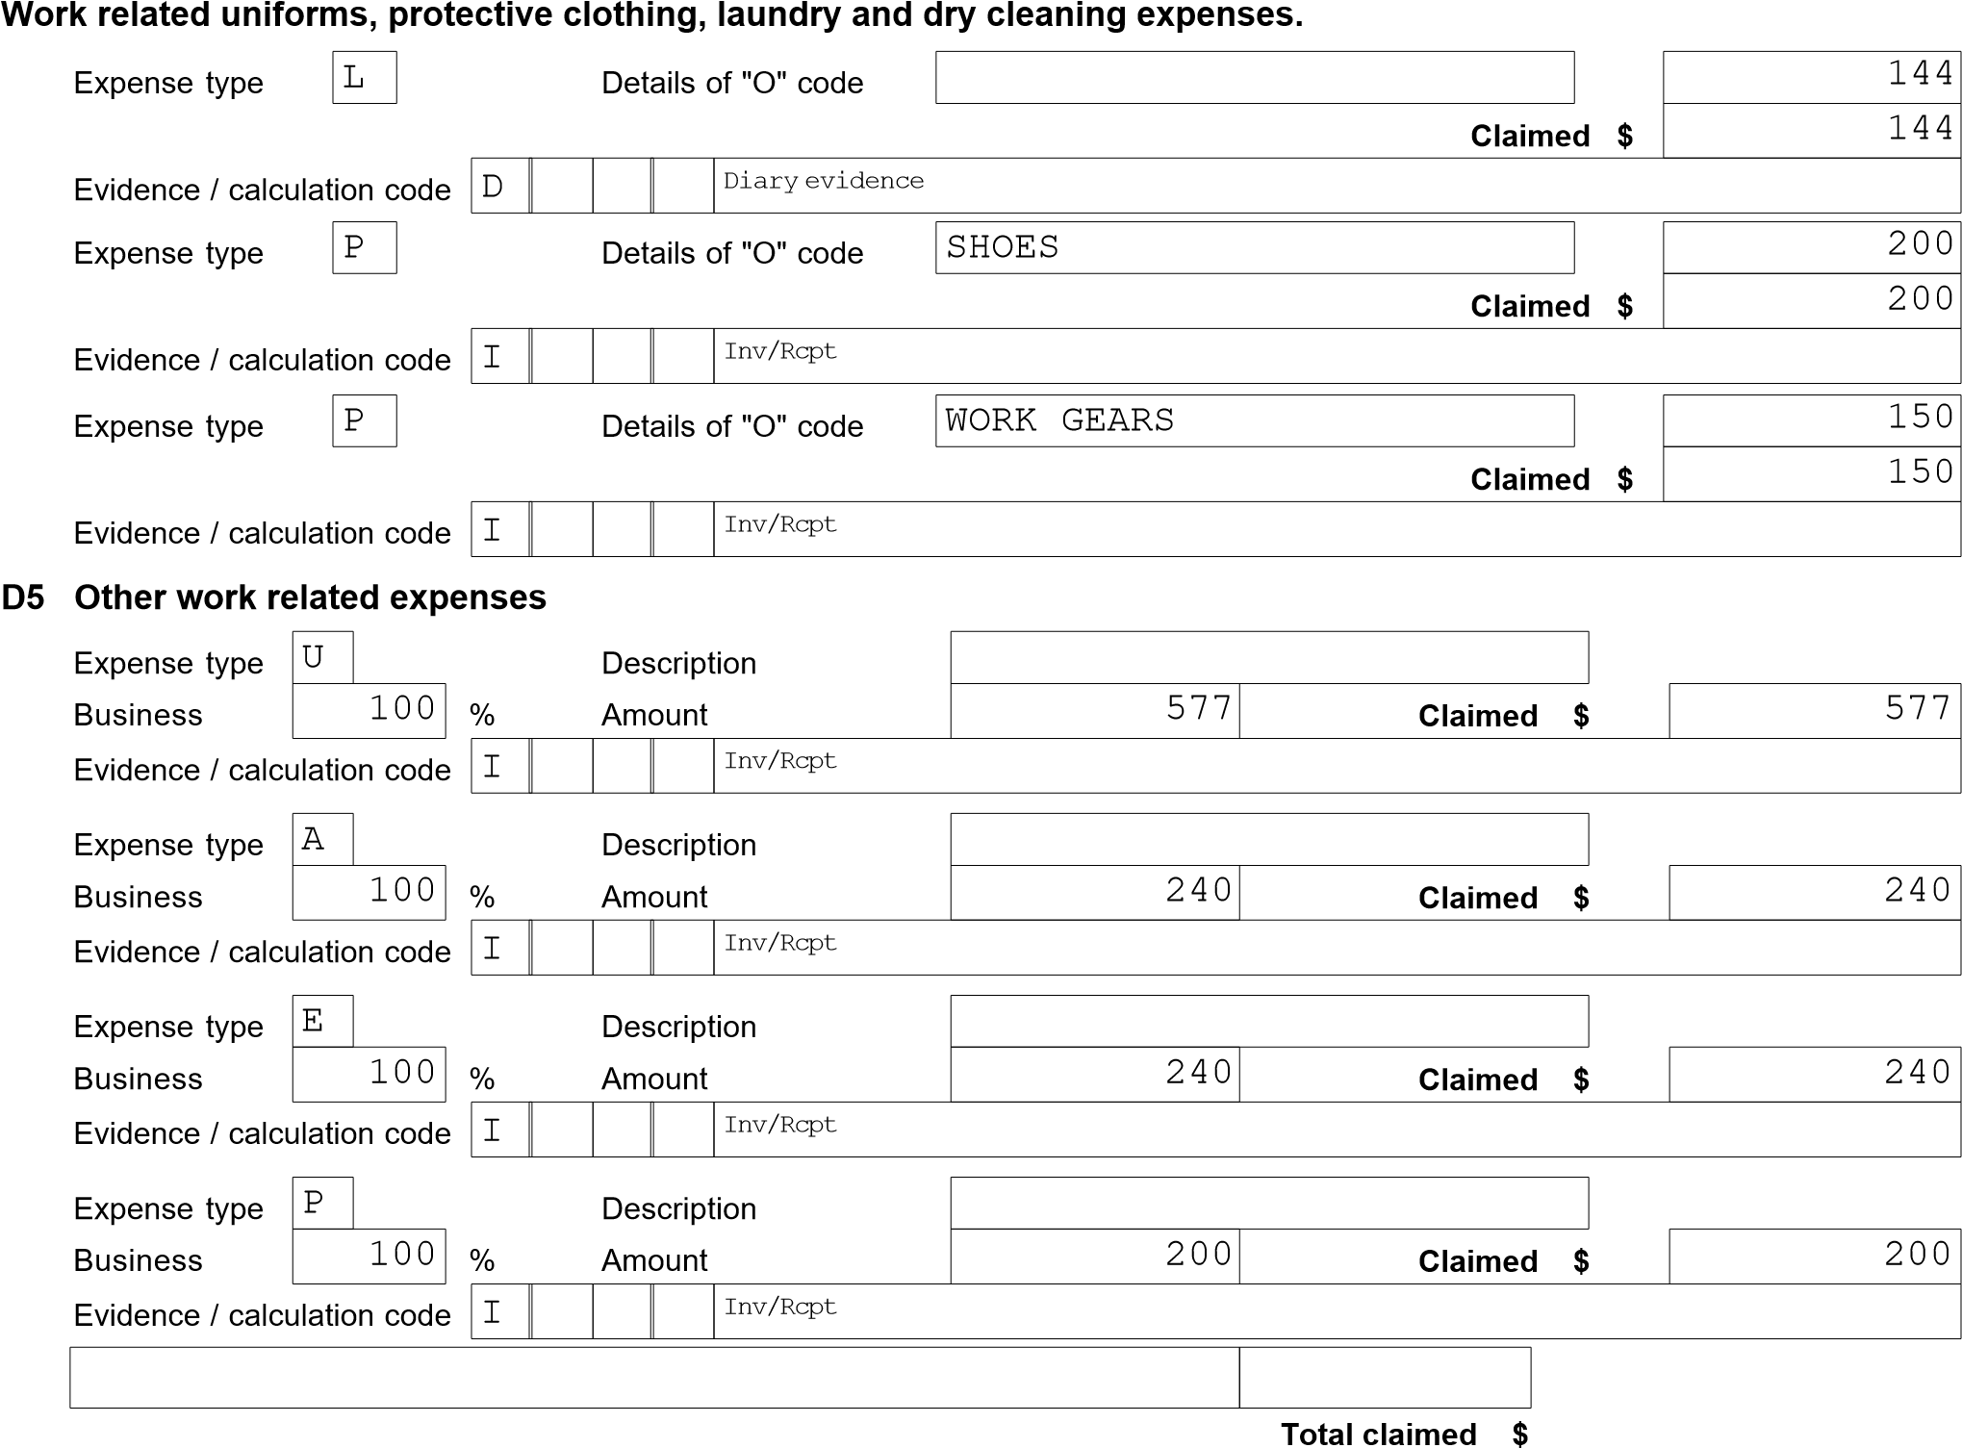

**Income Tax Return Tax Estimate 2021**

# MISS NAMRATA PUDASAINI TFN: 569 838 737

**Tax Payable for Individual**

Taxable Income 59,213

Tax Free Part 18,200

**Tax Payable on Taxable Income** 9,711.22

**Sub-Total $** 9,711.22

**Less Offsets:** Offsets (T2 to T9) 0.00

Private Health Insurance Offset 0.00

Seniors / Pension / Beneficiary Offset 0.00

Small business income offset 0.00

Low Income Offset 111.81

Low and Middle Income Offset 1,080.00

Lump Sum 0.00

Foreign Income Offset 0.00

Other Offsets 0.00

FHSS tax offset 0.00

**Sub-Total $** 1,191.81

8,519.41

**Plus:** Medicare Levy 0.00

**Sub-Total $** 0.00

8 ,519.41

**Less Credits:** Tax withheld - salary & wage type income 10,924.00

Arrears tax withheld 0.00

Foreign Tax Credits 0.00

TFN Amounts (credits) 0.00

Franking Tax Offset (refundable) 0.00

Other Refundable Credits 0.00

Other Amounts withheld - ABN,Vol,Labour,Foreign 0.00

FHSS tax withheld 0.00

PAYG Income Tax Instalments 0.00

**Sub-Total $**

2,404.59

10,924.00

## Estimated Tax Refund

DISCLAIMER

===========

This estimate is provided without warranty of any kind.

It is subject to legislative changes and includes estimates of currently unknown rates.

WARNING : Amounts shown may be adjusted by amounts not included in this return.