**ISYS3001 – Assignment 1 exercise**

Remember that this is a public repository - your changes could be seen by anyone who looks!

Add some comments about Version management outside this border, or just add some text so there is a change to this file.

Remember that your GitHub user ID must be submitted in your assignment report!

Once you’ve changed follow the next step in your assignment task.

# My GitHub account name：GreenHillWZY

**1.**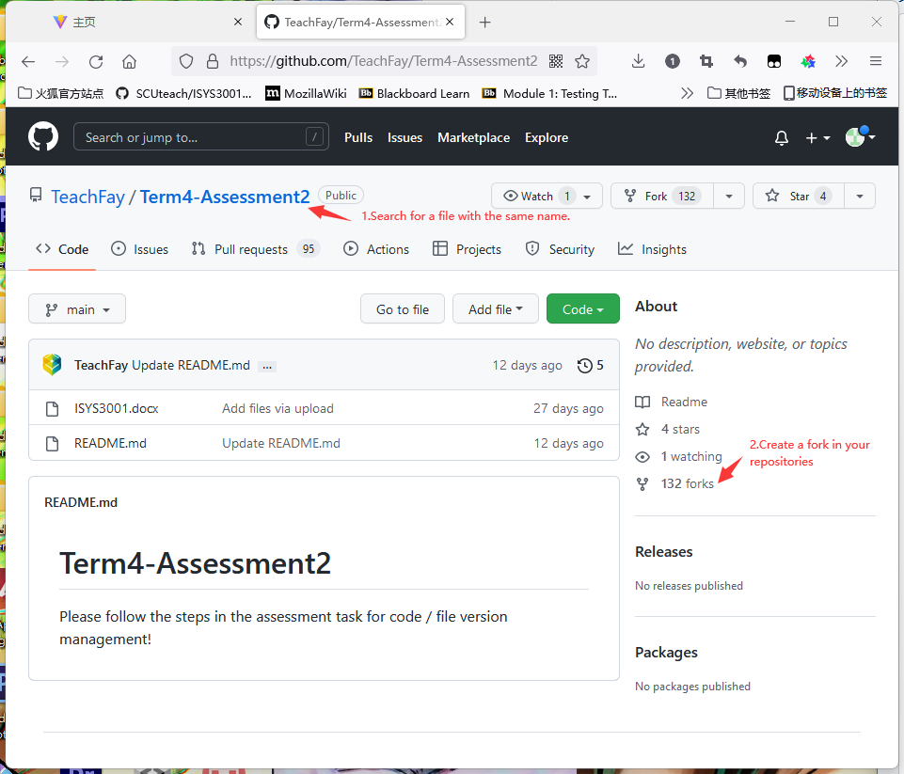

**2.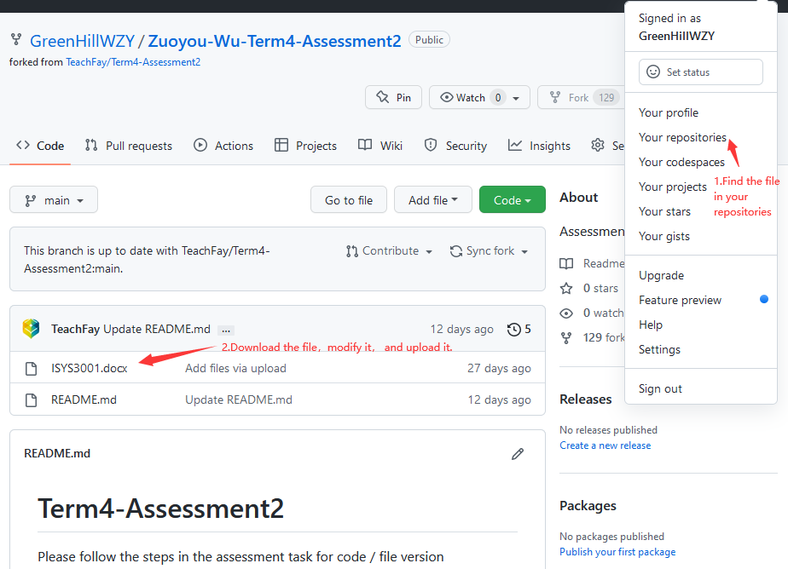3.**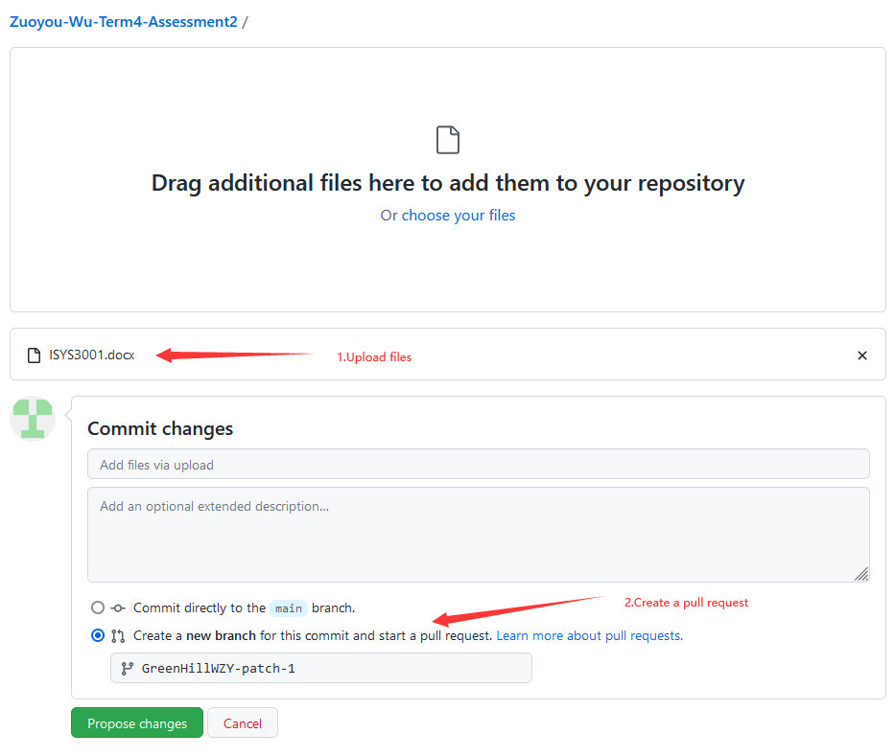

**4.**