1. **Introduction**

The program realized a library management system which has some useful functions. The system includes lending, returning, categorizing and inquiring books’ functions. Besides, we designed an Administrator system which is used to add and delete books. These all be shown in Figure 1.1, and Figure 1.2 show the design of our database system.

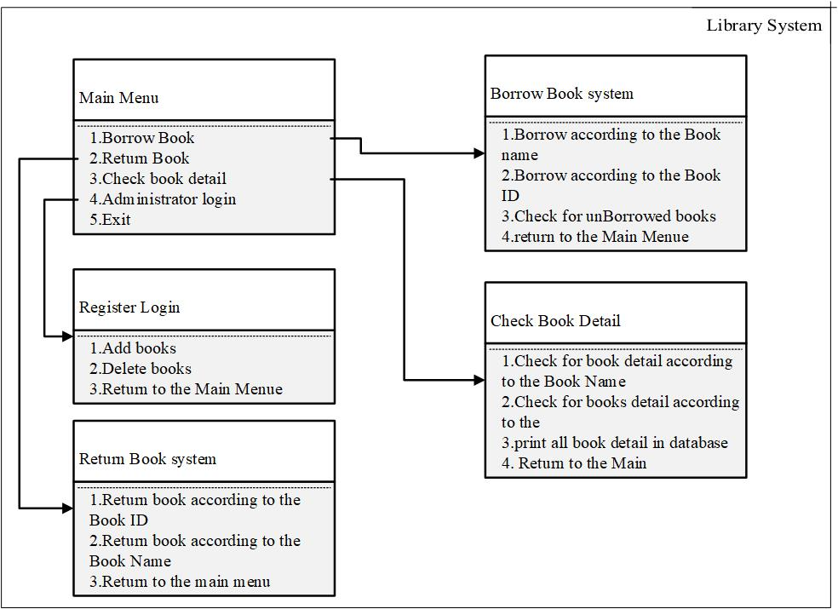

Figure 1.1 Library System

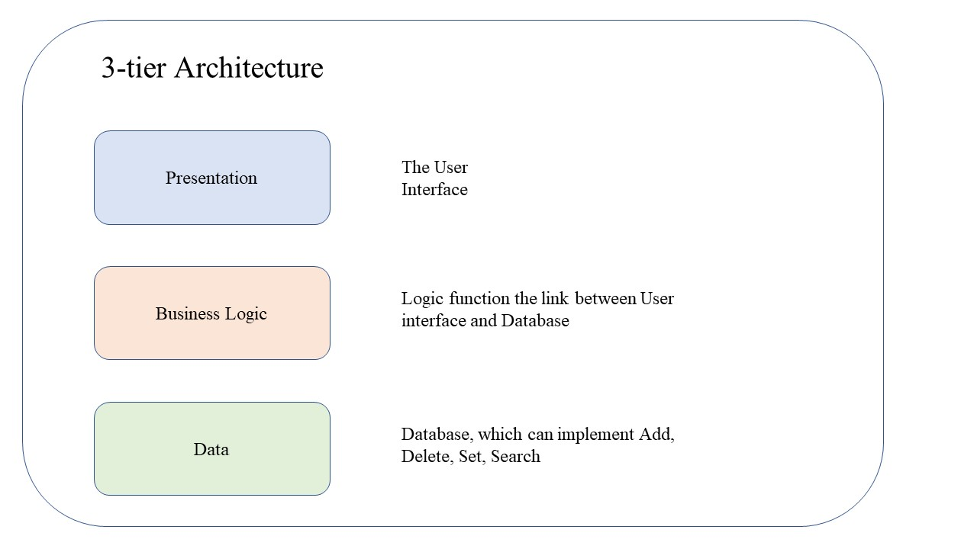

Figure 1.2 3-tier Architecture

1. **Function Analyze**

We divided our project in book, database, logic, menu and register five parts, and they will be shown in following sections in detail.

* 1. **Book**
     1. Introduction

The main function of ‘book.h’ is creating the fundamental information of books, including book name, book id, book category and lending state.

* + 1. Functions

1. setBookName(Book* pBook, char* name);
2. getBookName(Book pBook);
3. setBookID(Book* pBook, char* ID);
4. getBookID(Book pBook);
5. setBookBorrow(Book* pBook);
6. getBookBorrow(Book pBook);
   1. **Database**
      1. Introduction

The main function of ‘database.h’ is Creating and deleting information of books. Firstly, it can change book ID, name and lending state. Secondly, it can inquiry books by name or ID. Thirdly, it can print unborrowed book and detail information of books. Finally, it can update database after operating.

* + 1. Functions

1. AddtoBookindex(BookList* booklist, BookNode* booknode);

DeleteBook(BookList* booklist, Book book);

1. ChangeBookName(BookList* booklist, char* Old_bookname, char* New_bookname);

ChangeBookID(BookList* booklist, char* Old_bookid, char* New_bookid);

ChangeBookborrow(BookList* booklist, char* BookName);

1. searchfor_a_Book_Name(BookList* booklist, char* BookName);

searchfor_a_Book_ID(BookList* booklist, char* BookID);

1. PrintBook_unBorrowed(BookList booklist);

PrintDetailofBook(BookList* booklist);

1. Enter(FILE* file, BookList* booklist);
   1. **Logic**
      1. Introduction

The main function of ‘logic.h’ is business logic processing which is a bridge of database and user interface. Firstly, it shows the main menu which includes Borrow, Return, Detail and Register. Secondly, it can judge lending state. Finally, it can add or delete book.

* + 1. Functions

1. runMain(BookList* booklist);
2. runBorrow(BookList* booklist);

runReturn(BookList* booklist);

runDetail(BookList* booklist);

runRegister_superior(BookList* booklist);

1. Change_Book_Borrow(Book book, BookList* booklist);

Change_Book_return(Book book, BookList* booklist);

1. AddNewBook(BookList* List);

DeleteNewBook(BookList* List);

* 1. **Menu**
     1. Introduction

The main function of ‘menu.h’ is print UI which written in ‘logic.h’.

* + 1. Functions

1. mainMenue();
2. BorrowBookMenue();

ReturnBookMenue();

1. ShowDetailMenue();
2. Judge_Register_superior();

Register_superior();

1. scanfBookName();

scanfBookId();

* 1. **Register**
     1. Introduction

The main function of ‘register.h’ shows admin management system, including adding admin list, importing into document.

* + 1. Functions

1. AddtoSuperList(Superior_List* List, SuperiorNode* Node);
2. Add_INFO_List(Superior_List* List, SuperiorNode* Node);
   1. **Division**
3. Xie Xiao: database
4. Mao Chenhui: logic, book
5. Sang Haotian: register, menu
6. **Conclusion**

This part will show functions in UI and how to implement.

* 1. **Main Menu**

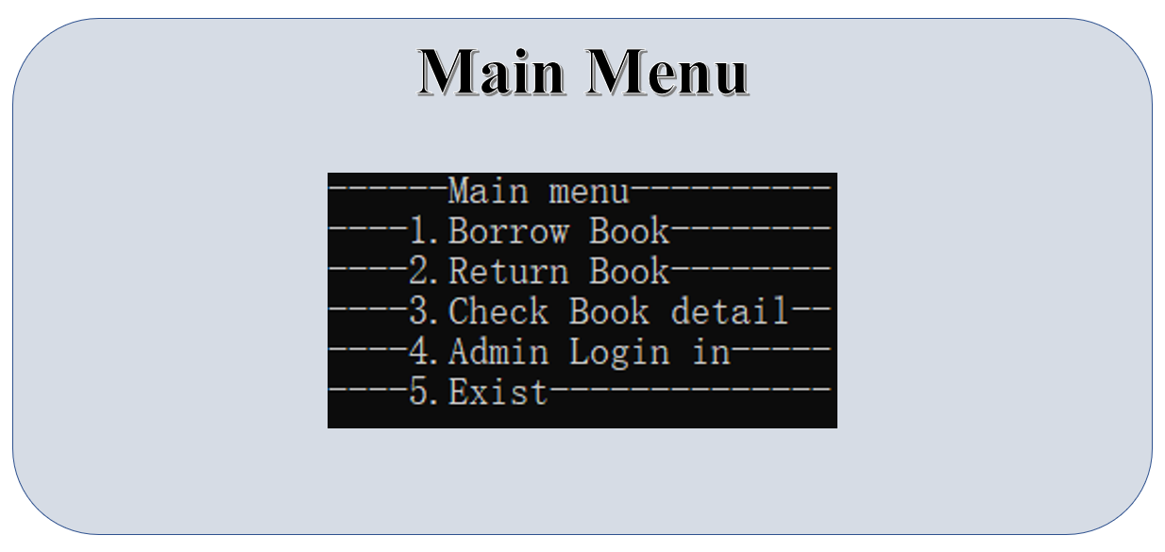

* 1. **Borrow Book**

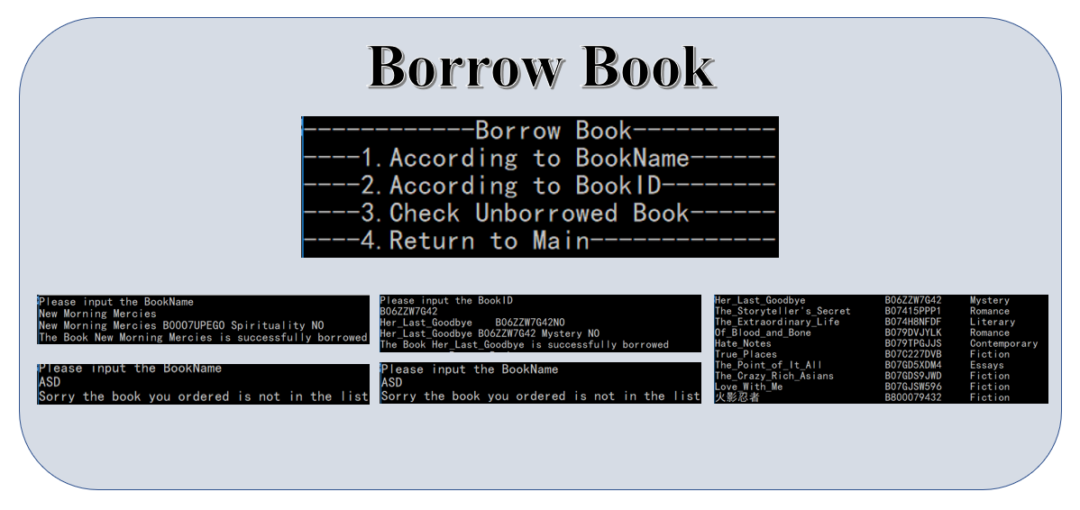

* 1. **Return Book**

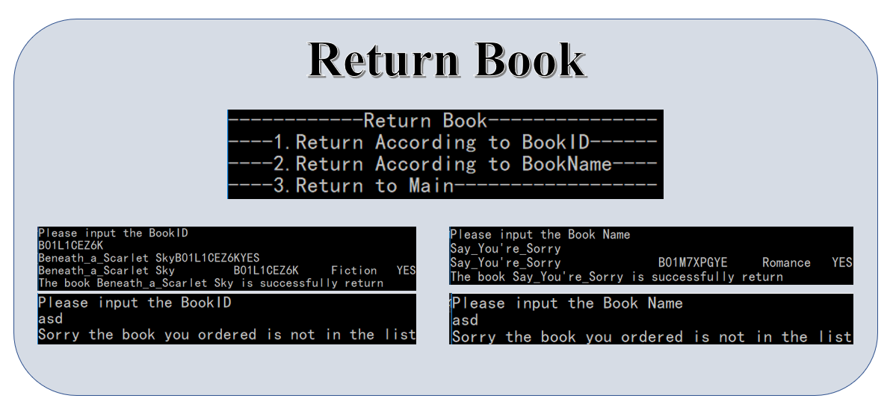

* 1. **Check Detail**

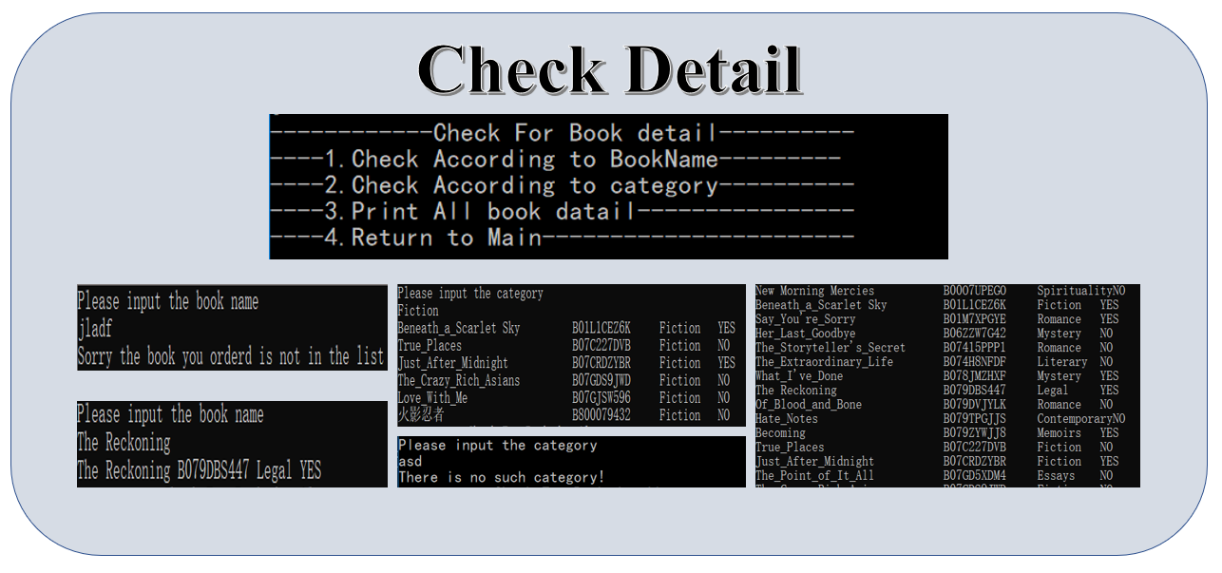

* 1. **Admin Login**

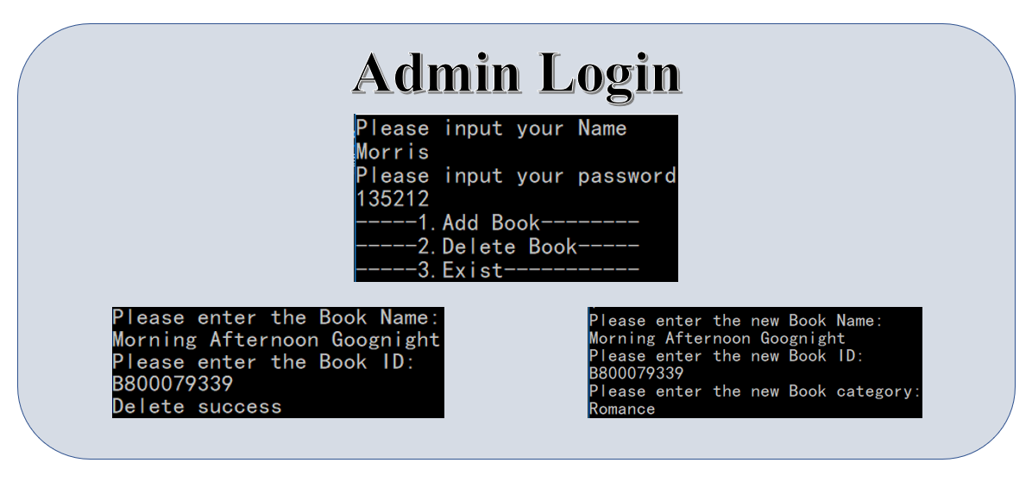

* 1. **Exit**