**Summary:**

We should appreciate the astounding amount of free service available to us from Tencent. At the same time, the businesses that run these free services have a responsibility to their users.

Tencent’s privacy policy has some pros and cons when it collects information, and how it uses and analyses the information. Thus, it includes the description of how user manage these data.

**Evaluation:**

1. **Register**

**Advantages:**

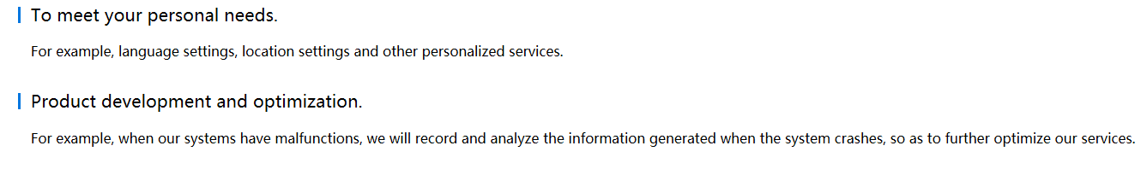

* Modify their products to meet consumer preferences, reducing overhead of products.
* Target advertising better, and to develop new services.
* Biological characteristic help verify user, identify malware

**Disadvantages:**

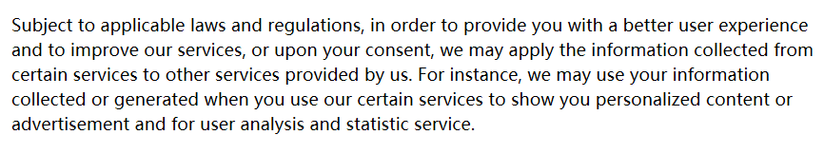

**//个人用户的信息在腾讯下的所有产品都通用**

* May find other uses such as business planning, tracking, marketing, or criminal investigations
* Biological characteristic decrease privacy which has uniqueness

1. **Social network**

**Advantages:**

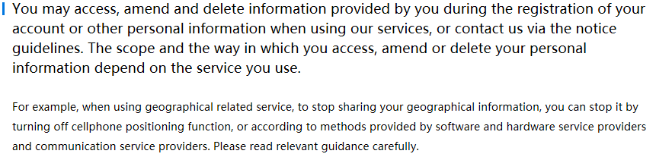

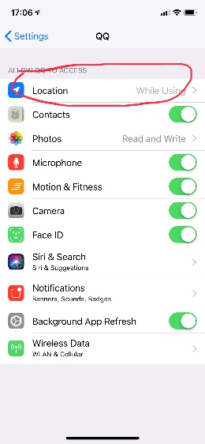 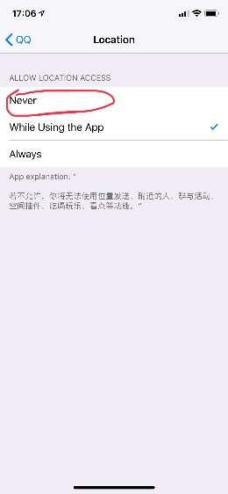

* Target advertising better, such as local services and disable the location share by simply close the located service on your smartphone

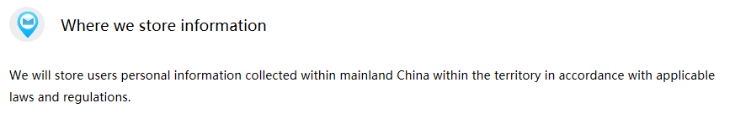



* Store users’ personal information collected within mainland of China, normally Tencent will only store information for a short period

**Disadvantages:**

* The period is ambiguous and under some regulation, Tencent will change the retention period.
* Tencent may use some of your information and apply advertisement in related website and other application
* Tencent provides value-added services may intrude the right to know



**Missing:**

* Information that others have posted about themselves that you would not reveal about yourself, Tencent do not mention how they deal with it
* Do not mention the information that you have removed still stored in database or not

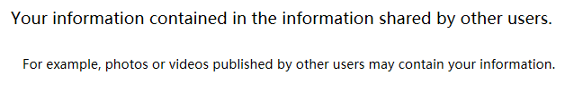

1. **Minors’ Information**

**Advantages:**

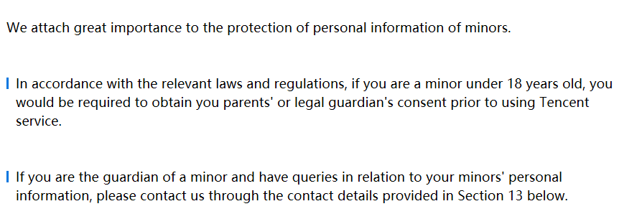

* (If the user is juvenile the usage of service requiring the approval of their statutory guardian, If you are statutory guardian of a service user, you are able to get information of that juvenile with contacting with Tencent.) Help statutory guardian ensure minors’ security
* The service for searching lost children or things using user’s Bluetooth and location



**Missing:**

* At what age does tracking become an invasion of the children’s privacy
* At what age does informed consent is a basic principle for children

1. **Others**

**Missing:**

* Do not have end-to-end encryption (surveillance, intercept)
* Do not promise the freedom of expression (provide some references)
* Do not disclose the government request for user data (User lose control of the data which are at risk of loss, theft, misuse by employees, accidental exposure, seizure by government agencies)
* Automatically subscribe some services

