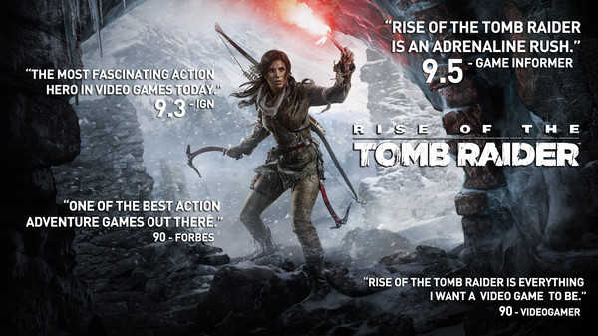

**What does the license agreement say about the number of copies you can make?**

1. One copy for your own private and domestic use only.
2. Can transfer the Software Product from one hard drive to another, it is used on only one 1 hard drive at any one time.
3. Can transfer the Software Product (complete with all components and documentation) and the benefit of this End User Software License Agreement (EULA) to another person (the person has agreed to accept the terms of this EULA and you contemporaneously transfer any permitted copies of the Software).

**Does it specify penalties for making unauthorized copies?**

1. Terminate this EULA immediately without notice.
2. Must destroy all copies of the Software Product and all of its component parts including any Software Product stored on the hard disk of any computing device.
3. If you acquired this Software Product in the EMEA region, any claim or dispute of whatever nature (including any non-contractual dispute) arising out of or relating to this EULA or the Software Product shall be governed by, and construed in accordance with, Japanese law(Asian Region: District Court of Tokyo Japanese Law).

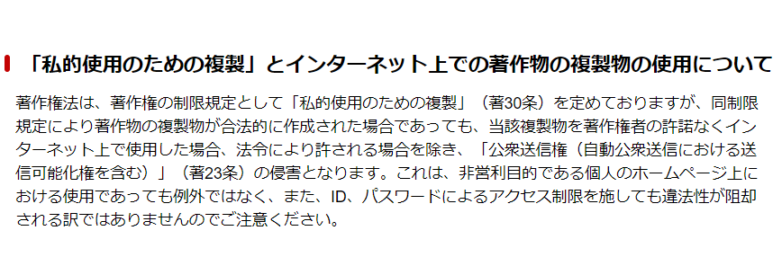 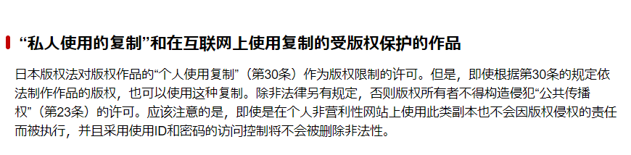

**Was the agreement easy to read before purchase (e.g., on the outside of the package or available on a website)?**

It will be shown at you install the software, and only can be installed till you agree with the EULA.

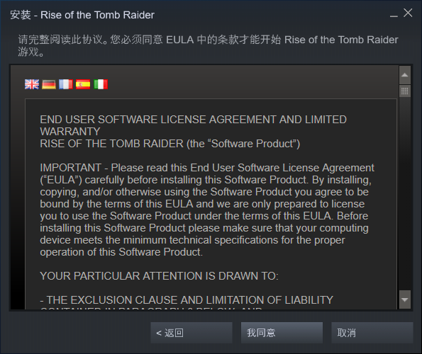

**Do you consider the license agreement to be clearly stated? Reasonable?**

1. It’s easy to read because the items are divided in different part, indicated in serial numbers and well-done subheadings

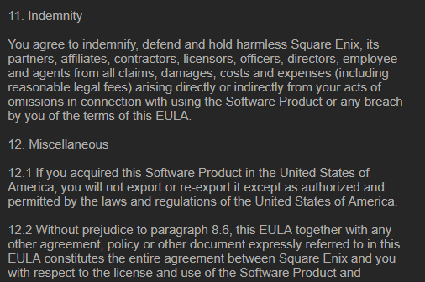

1. The key words are shown in capital letter and “Agree” and “Cancel” label is obvious.
2. Clearly indicate the age interval of minor, that is between 13-17, their purchasing will be under supervised by their guard.
3. Clear claims of restriction of what user can do and what not, and once users.
4. Clear claims of what kind of data will they collect. User name, gamertag, scores, rankings, results, achievements, profile image and any other
5. personal profile information which you may choose to make available for other players to see.
6. It has considered different countries and areas which is all-sided.

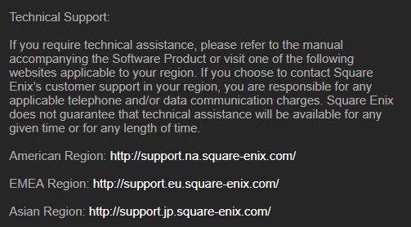 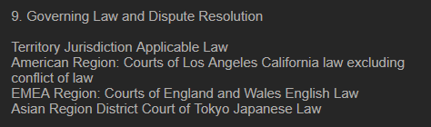

Unclear:

1. It would be better if there is content ahead of the license.
2. They did not give clear penalty statement relate to what will happen once user against the restriction.
3. Once a conflict among this license and Privacy Policies, Cookies Policies, Terms of Use, license will unresonably get control.
4. If you are disagree with any one item among the license, you are forbidden to install the game.